Faculty Introduction
===================================================================================
Satish Gupta
Full Stack Python & Full Stack Java
C++,C and Data Structures and Alg,UI Technologies (HTML,CSS,JavaScript)
20+ Years of Exp Teaching
============================================================================
Course Introduction
===================================================================================
Course Title: Full Stack Python with Prompt Engineering
===================================================================================
Full Stack Python (Python Developer and Python Web Developer and Full stack web devloper)
===============================================================================
Full Stack Python is divided into number of modules
==============================================================================
Module-1: Python
Core Python
Adv Python
Module-2: Python for Data Science
Numpy
Pandas
Matplotlib
Module-3: Frontend Module
HTML (Hyper Text Markup Language)
CSS (Casecading Style Sheets)
JavaScript (Scripting Language)
ReactJS (Java Script Framework)
Module-4: Database
MySQL
MongoDB
Module-5: Backend Module
Django
Flask
Rest API, DRF (Django Rest Framework)
Module-6: Tools
Testing
AWS Basics
Git and GitHUB
Docker
=========================================================================
JOBS
====
FrontEnd Developer
Backend Developer
API Developer
Testing
Database Developer
Full Stack Developer
Python Developer
DS/BA/DA
AI Eng
DE
=======================================================================
Data Science ==> Python
AI ==> Python & Python for DataScience
Data Engineering ==> Python,Database,Python for Datascience
==================================================================
Interviews
===================================================================
1. FAQ's
2. Assignments
3. Mock Interviews
4. Weekly Test
5. POC's
6. Capstone Projects
7. 2 Projects + 2project
8. Platforms (HackerRank,CodeChef,Leetcode)
9. Time Complexicity, Space complex
10. Placement Assist (freshers)
==========================================================================
Duration : 5Months
ClassTimings : 7:00pm -- 8:50pm (Mon-Sat)
==========================================================================
Python Module OR Python Programming Language
==========================================================================
Core Python
================================================================================
Chapter-1: Introduction to Programming Languages
Chapter-2: Introduction to Python
Chapter-3: Python Softwares
Chapter-4: Working with Python (Python working modes)
Chapter-5: Language Fundamentals (Keywords,Identifiers,Datatypes,Operators,Literal)
Chapter-6: Input and Output Statements
Chapter-7: Control Structures (Conditional,Looping Statements)
Chapter-8: Data Structures or Collections (sequences,sets,mapping)
Chapter-9: Functions
Chapter-10: Modules and Packages
===============================================================================
Adv Python
===========================================================================
Chapter-11: Object Oriented Programming (OOP)
Chapter-12: Exception Handling OR Error Handling
Chapter-13: File Handling
Chapter-14: Regular Expressions
Chapter-15: OS Module
Chapter-16: Datetime and Calendar Module
Chapter-17: Python Database Communication
Chapter-18: Garbage Collection
Chapter-19: Netowrk Programming
Chapter-20: Multithreading
Chapter-21: GUI Development using Tkinter
Chapter-22: random Module
=======================================================================
telegram: codewithsatishgupta (notes are uploaded)
email: pythonbygupta@gmail.com
=====================================================================
===================================================================================
Python Applications (OR) Realtime Application Python (OR) Python used by compaines for developing what type of softwares
===================================================================================
Python Applications are nothing but software companies uses python language for developing which type of software or applications
===================================================================================
Python+Libraries(pre-written programs),Framworks
A Language uses libraries for developing different types of applications
=================================================================================
1. Web Applications or Internet Applications (Django,Flask)
2. Mobile Applications (Kivy)
3. Desktop GUI Applications (Tkinter,PyQT,Kivy,WxPython)
4. Games (Pygame, Panda3d, Arcade)
5. Data Science/BA/DA (Numpy, Pandas, Scipy, Matplotlib,Pyspark,..)
6. AI (Machine Learning, Deep Learning) (keras,tensorflow,serborn,..)
7. Image Processing
8. Audio and Vedio Processing
9. Data Engineering
10. Cloud Computing (AWS, GCP, Azure)
11. Cyber Security
12. IOT
13. Embedded Applications
14. Block Chain
15. Software Devlopment
16. Language Development
17. Education
18. Automation
19. CAD/CAM
20. Scientific Applications
=========================================================================
Chapter-1: Introduction to Programming Languages
===================================================================================
1. What is programming language?
2. Why programming languages?
3. Types of programming languages
4. What is Translator
5. Types of Transalors
6. What is Scripting Language
7. Difference between programming language and scripting langauge
8. What is programming paradigm?
9. Types of programming paradigms
===================================================================================
What is language or programming language?
===================================================================================
Language is a medium of communication between user and computer.
Language provides set of instructions, to instruct or to communicate with computer to perform operations or task
===============================================================================
Why required programming languages?
===========================================================================
programming languages are required for developing softwares or interact with computer.
1. Mobile App
2. Web App
3. IOT (Internet of things)
4. DS and DA and BA
5. Automation
6. communicate with hardware
==================================================================================
Types of programming languages
=================================================================================
Programming languages are classified into 2 categories
=============================================================================
1. Low Level Programming Languages
2. High Level Programming Languages
===================================================================================
Low Level Programming Languages
===================================================================================
Computer understandable languages are called low level programming languages.
Computer is electronic device and understand 0's and 1's
Low level languages are 2 types
1. Machine Language
2. Assembly Language
===================================================================================
Machine Language
==================================================================================
Machine language instructions are given in the form of 0's and 1's
Machine language instructions are machine dependent or non portable.
It is not easy to understand
It is only language understand by computer
===================================================================================
Assembly Language
================================================================================
Assembly Language is a low level programming language but instructions are not given in 0's and 1's.
In assembly language instructions given using mnemonics(verbs)
for every machine language instruction there is mnemonic provided by assembly language
compare to machine langauge, assembly language easy to understand.
================================================================================
What is assembler?
========================================================================
assembler is a translator used by assembly language to convert/translate instructions of assembly language into machine language.
==================================================================================
The problem with low level programming langauges are,
1. they are hardware depedent or non portable
2. not easy to understand
==================================================================================
High Level Programming langauges
===================================================================================
All high level programming languages are english like and these languages are portable. it allows to write or develop applications irrespective of hardware.

1. C
2. C++
3. Java
4. Python
5. Java Script
===========================================================================
High level programming languages uses 2 translators

1. Interpreter
2. Compiler
===========================================================================

codewithsatishgupta --> telegram
===========================================================================
High Level Programming langauges
===================================================================================
All high level programming languages are english like and these languages are portable. it allows to write or develop applications irrespective of hardware.

1. C
2. C++
3. Java
4. Python
5. Java Script
===================================================================================
High level programming languages uses 2 translators

1. Interpreter
2. Compiler

What is source program or source code?
The program or instructions written in high level langauge is called source code.
source code is understand by programmer.

What is translator?
translator is a software, which converts instructions of one language to another language.

==================================================================================
What is interpreter?
=================================================================================
interpreter is translator which translates and execute instructions line by line.

Interpreter perform the following operations
============================================
1. Read
2. Tokenization
3. Syntax Verification
4. Translation
5. Execution

Interpreter stops, if there is an error in one line (OR) interpreter stops interpretion or translation if there is an error.
===================================================================================
Compiler
==========================================================================
Compiler is translator, which translates whole program and execute.
Compiler performs the following operations
1. Read
2. Tokenization
3. Syntax
4. Translation
5. Storing
6. Execution

Compiler shows all the errors exists within program.
It is does not required to compile everytime before execution.
==============================================================================
What is scirpting language?
=====================================================================

codewithsatishgupta : telegram
==================================================================================
What is scirpting language?
=================================================================================
Scripting language is a type of programming language. It is used to write scripts.
A script is small program executed inside another program.
Scripting languages are used for automation.
Scripting languages are embedded with other languages.
Scripting languages are interpreted languages (interpreter)

1. Java script
2. Typescript
3. PHP
4. Shell Script
5. Perl
==================================================================================
What is difference between programming language and scripting language?
==================================================================================
programming language scripting language
=================================================================================
1. programming languages are used 1. Scripting languages are used
for developing complex applications automation of existing softwares or
or softwares applications or tools
2. programming languages uses 2. scripting langauges uses
compiler as translator interpreter as translator
3. programming langauges cannot 3. scripting langauges can be embed with
integrate or embed with other other programming languages
programming languages
===============================================================================
What is programming paradigm?
==============================================================================
A programming paradigm defines set of rules and regulations for organization of instructions or code.

1. Procedrual Oriented Programming (POP)
2. Modular Oriented Programming (MOP)
3. Object Oriented Programming (OOP)
4. Aspect Oriented Programming (AOP)
5. Unstructured Programming
===================================================================================
Chapter-2 : Introduction Python
===================================================================================
1. What is python?
2. Python Features
3. Python Applications
4. Python History
5. Python softwares
6. Python Working Modes or Working Environemts
===================================================================================
What is python?
===================================================================================
Python is a programming language.
Python is high level programming language (Simple Enlish, Portable)
Python is object oriented programming language. Python also support other programming paradigms because of this, it is called multiparadigm programming language.
Python is a interpreted programming langauge. python is a programming language but having the features of scripting langauge.
Python is a general purpose programming language. A programming langauge which can be used for developing any type of software or applications is called general purpose programming language.

"python is high level, interpreted, multiparadigm and general purpose programming language"
==================================================================================
Python Features
==================================================================================
Features are nothing but facilites provided by python language to developers or python developers
===================================================================================
1. Simple,Easy
2. Free and Open Source
3. Large Set of Libraries
4. Platform Idependent
5. Dynamic
6. High Level
7. Portable
8. Interpreted
9. Embeddable
10. Extensible
11. Robust
===================================================================================
Free and Open Source
===================================================================================
Python software is free download. This software is provided by a non profitable organization called PSF (Python Software Foundation).

www.python.org

Current Version of Python is Python 3.14.0

Python software source code is given to public.
advantage of opensource
1. add new features and develope other langauges
2. integrated with existing techonologies
3. new frameworks
=================================================================================
Simple or Easy
===============================================================================

codewithsatishgupta : telegram

===========================================================================

=================================================================================
Simple or Easy
=================================================================================
Python simplifies the programmers job by providing the following facilities.
1. Less Coding: Python comes with large set of libraries (predefined program with predefined functionality/code).
2. Easy Syntax: Syntax of python is easy compare to other programming langauges like C,C++,Java,...
3. Automatic Memory Management: Memory management consist of 2 things
1. Allocation of memory
2. De-Allocation of memory
Allocation of memory is done by programmer
De-Allocation of memory is done by garbage collector
==================================================================================
Large Standard Libraries
==================================================================================
Python provides large number of numbers libraries for developing different types of applications.It makes application development easy and less coding.
Python libraries are placed in one repository www.pypi.org
===================================================================================
Platform Independent
===================================================================================
Programming langauges are classified into 2 categories
1. Platform dependent programming languages
2. Platform independnt programming langauges

What is platform?
platform is a software, which provides good environment for development and execution of applications or softwares.
Operating system is called platform. Without operating system, system cannot work.
operating system is software which provides environment for development and execution of applications or softwares.

What is platform dependence?
in platform dependent programming languages the development environment and execution environment must be same.
C,C++ are called platform dependent programming languages.

Why C,C++ are called platform dependent langauges?
1. C,C++ compilers generates native code. the code understand by operating system or executable machine or generate code respective to operating system.
2. Data representation is not same for all operating systems. it changes from one os to another os.

codewithsatishgupta : telegram
High Level
-----------------------------------------------------------------------------------
Programming languages are classified 2 categories
1. Low Level Programming Languages
2. High Level Programming Languages

Computer understandable languages are called low level programming languages
1. Machine Language
2. Assembly Language
Low Languages are not easy to understand and code.

High level languages are in simple english. It is easy to understand and code.
-----------------------------------------------------------------------------------
Portable
--------------------------------------------------------------------------------
Python is portable languages. python langauges code can written irrespective of hardware and operating systems (OR) Python portablility allows to develop and python application on different system architectures (OS+HARDWARE)
---------------------------------------------------------------------------------
Interpreted
-------------------------------------------------------------------------
Python uses 2 translators
1. compiler
2. interpreter

python compiler generates bytecode
python interpreter converts bytecode in machine code
python source code is compiled and interpreted line by line because of this it is called interpreted programming languages
---------------------------------------------------------------------------------
Robust
---------------------------------------------------------------------
A programming language is said as robust language if it supports error handling (OR) runtime error handling (OR) exception handling.

1. Syntax Error
2. Logical Error
3. Runtime Error
===================================================================================
Python History
==================================================================================
1. Python programming language conceived in the year 1980
2. Python langauge development or implementation was started in the year 1989
3. First version python is released to public in the year 1991
4. Python language was developed in C language
5. Python is developed to overcome the limitions of ABC langauge.
6. Python is developed at Centrum Wiskunde & Informatica (CWI), research center in Netherlands
7. Python language is maintained by a non profitable orgnization called PSF (Python Software Foundation)
8. Python language is developed by dutch programmer called "GUDIO VAN ROSSUM"
9. Python langauge name is taken from a popular comic serial broadcasting in BBC in 1980's whose name is "MONTY PYTHON FLYING CIRCUS".
========================================================================
Python Versions
======================================================================
Python Lanuage or Software released in differnt versions
1. Major Version
2. Minor Version
3. Micro Version
Platform Independence
=================================================================================
WORA ==> Write Once Run Any Where
CORA ==> Compile Once Run Any Where

In platform independent programming langauges the development environment and execution environment may not be same.
Example: Python,Java,.Net,..

What is bytecode?
compiled code of python source code or program is called byte code (OR) python compiler generated code is called byte code.
Bytecode is python virutal machine code
Bytecode is platform independent code
bytecode is collection of mnemonics(verbs), which understand by PVM

What is PVM?
PVM stands for Python Virtual Machine
PVM provides runtime environment for byte code
PVM having translator, which converts byte code to executable machine code.
PVM is provided OS vendors (OR) Python people.

What is difference between machine code and byte code?
Machine Code Byte Code

Platform Dependent YES NO
Representation 0's and 1's mnemonics
Understand by OS PVM
===================================================================================
Dynamic
===================================================================================
Programming languages are classified into 2 categories
1. Statically Typed Programming Langauges
2. Dynamically Typed Programming Langauges

Statically Typed Programming langauges
===================================================================================
C,C++,Java,C#.Net are called statically typed programming languages
In statically typed programming langauges type checking of variables are done at compile time.
In statically typed programming langauges compiler required variable declartion (variable+datatype).

Dynamically Typed Programming Langauges
=============================================================================
In Dynamically typed programming languages type cheching is done at runtime.
In dynamically typed programming langauges compiler does not required variable declaration (variable+datatype).

What is difference between statically typed and dynamically typed programming langauges?
Statically Typed Dynamically Typed

1. Type Checking Compiletime Runtime
2. Declaration YES NO
3. Type Safe YES NO
===================================================================================
Extensible
===================================================================================
Python is extensible programming langauge.
It allows to use the code of other programming languages inside python.
===================================================================================
Embeddable
===============================================================================
Python code can be embedded within other programmming langauges.

Python provides different implementations or softwares
1. jython (java+python)
2. ironpython (net+python)
3. cpython (c+Python)
==============================================================================

codewithsatishgupta : telegram (notes)
pythonbygupta@gmail.com
=======================================================================

Day-1 https://youtu.be/CXN364hNrgQ
Day-2 https://youtu.be/gF8tKln6F0k
Day-3 https://youtu.be/MzDXQERv-_g
Day-4 https://youtu.be/yPpqvL9uNz4
Day-5 https://youtu.be/FbSw1KFBI_8
Day-6 https://youtu.be/N4VUwFqKAE4
Day-7 https://youtu.be/vwMUoVp0-K4
Day-8 https://youtu.be/Gcc4dhyPjEI
Day-9 https://youtu.be/5naIdswiW04

Python Working Modes
Python developer work with python in 2 modes
- Interactive Mode
- Scripting Mode

Interactive mode

In interactive mode python developer works with python shell.
Python shell is a single line command line interface. It allows to interact with python by giving commands.

Python shell program or tool provided by python software.
Python shell is called REPL tool
R 🡪 Read
E 🡪 Evaluate
P 🡪 Print
L 🡪 Loop

Example:
>>> 10+20
30
>>> import pandas
Traceback (most recent call last):
File "<pyshell#1>", line 1, in <module>
import pandas
ModuleNotFoundError: No module named 'pandas'
>>>
Scripting mode
In scripting mode python developer write a program and saving with extension .py
Python program is a file, which contain set of instructions executed by computer.

IDLE
- File 🡪 New File
- Write Code
- File 🡪 Save File
- Run 🡪 Run Module

Python Language Fundamentals
- Character set of python
- Tokens
  - Keywords
  - Identifiers
  - Literals
  - Datatypes
  - Operators
- Input and Output Statements

Character set of python
Character set define set of character supported by python language.
Character set define encoding and decoding standards
There are 2 types of character sets
- ASCII (American Standard Code for Information Interchange)
- UNICODE (Universal code)

ASCII support 256 characters (0-255)
This include, alphabets in English (A-Z,a-z),digits(0-9) and special characters (+,-,./”’<>!#%^&*()

UNICODE support the characters not only in English it supports characters from other languages.
As of Unicode version 17.0, there are 297,334 assigned characters
Example:
print("Hello Python")
print("पैथन")
a=10
b=20
c=a+b
print(a,b,c)
अ=10
आ=20
इ=अ+आ
print(अ,आ,इ)
name="naresh"
print(name)
అ="నరెష"
print(అ)
print("Python is 💀")

Output
Hello Python
पैथन
10 20 30
10 20 30
naresh
నరెష
Python is 💀

Python is a universal language, it support characters not only in English it also support characters from other languages.
UNICODE is superset of ASCII code.

Tokens
A token is smallest individual unit within program.
- Keywords
- Identifiers
- Literals
- Data types
- Operators

Without tokens we cannot build (OR) write statement.

Keywords or Reserved words

Keywords are nothing language related word.
The meaning these words reserved by python language or python translator. Each word is used to perform specific task or operation.

How to find keyword list in python?
>>> import keyword
>>> keyword.kwlist
['False', 'None', 'True', 'and', 'as', 'assert', 'async', 'await', 'break', 'class', 'continue', 'def', 'del', 'elif', 'else', 'except', 'finally', 'for', 'from', 'global', 'if', 'import', 'in', 'is', 'lambda', 'nonlocal', 'not', 'or', 'pass', 'raise', 'return', 'try', 'while', 'with', 'yield']

Python 3.14 support 35 keywords

Soft keywords
There are 4 soft keywords

>>> keyword.softkwlist
['_', 'case', 'match', 'type']

Identifier
Identifier is a user defined word, which is used to identify programming elements.
- Variable names
- Function names
- Class names
- Program names
- Package names

pythonbygupta@gmail.com
Identifier
Identifier is a user defined word, which is used to identify programming elements.
- Variable names
- Function names
- Class names
- Program names
- Package names

Identifier is a user defined word, this word is created using alphabets (English A-Z,a-z or other languages), digits (0-9) and allows only special character _

Python is case-sensitive programming language and finds the difference between uppercase and lowercase.

Rules for creating identifier
- Keywords cannot be used as identifiers (OR) identifier should not be keyword

>>> rollno=1
>>> rollno
1
>>> pass=100
SyntaxError: invalid syntax
>>> PASS=1
>>> PASS
1
>>> A=10
>>> a=100
>>> A
10
>>> a
100

- Identifier should not start with digit, it can start with alphabet or _
>>> n1=50
>>> n1
50
>>> 2n=60
SyntaxError: invalid decimal literal
>>> number10=100
>>> 10number=200
SyntaxError: invalid decimal literal
>>> 2a=100
SyntaxError: invalid decimal literal
>>> _a=10
>>> a_=20
>>> __a=30
>>> _a
10
>>> a_
20
>>> __a
30

- There should not be any space between identifier, if identifier is having multiple word it is separated with _

>>> student rollno=1
SyntaxError: invalid syntax
>>> student_rollno=1
>>> customer id=100
SyntaxError: invalid syntax
>>> student_rollno=101

- Maximum length of identifier is unlimited

>>> aaaaaaaaaaaaaaaaaaaaaaaaaa=10
>>> bbbbbbbbbbbbbbbbbbbbbbbbbb=20
>>> aaaaaaaaaaaaaaaaaaaaaaaaaa+bbbbbbbbbbbbbbbbbbbbbbbbbb
30

How to find given name is a keyword or identifier?
>>> import keyword
>>> keyword.iskeyword('True')
True
>>> keyword.iskeyword('False')
True
>>> keyword.iskeyword('pass')
True
>>> keyword.iskeyword('PASS')
False
>>> keyword.iskeyword('roolno')
False

Data types and literals

Data types

Data types are used to represent data in memory.
Data types are used to create space or allocate memory for data.
Data types are to represent different types of data in memory (Main Memory/RAM).

Python data types are classified into 2 categories
- Scalar Data types
- Collection Data types

Scalar Data types
These data types are used to represent single value in memory (OR) these data types allocate or reserve space for one value.

- int
- float
- complex
- bool
- NoneType
Collection Data types (OR) Data Structures
These data types are used to represent more than one value in memory. Python collections are classified into 3 categories.
- Sequences
- Sets
- Mappings

- Sequences
  - List
  - Tuple
  - Str
  - Range
  - Bytes
  - Bytearray
- Sets
  - Set
  - Frozenset
- Mapping
  - Dict

Python support 14 standard data types (scalar + collection)

int datatype

int data type is used to represent integer values or integer literal in memory.

What is integer value?
An integer is numeric value without decimal.
Example: whole numbers, even, odd, natural numbers,…

Variable
Data types and literals

Data types

Data types are used to represent data in memory.
Data types are used to create space or allocate memory for data.
Data types are to represent different types of data in memory (Main Memory/RAM).

Python data types are classified into 2 categories
- Scalar Data types
- Collection Data types

Scalar Data types
These data types are used to represent single value in memory (OR) these data types allocate or reserve space for one value.

- int
- float
- complex
- bool
- NoneType
Collection Data types (OR) Data Structures
These data types are used to represent more than one value in memory. Python collections are classified into 3 categories.
- Sequences
- Sets
- Mappings

- Sequences
  - List
  - Tuple
  - Str
  - Range
  - Bytes
  - Bytearray
- Sets
  - Set
  - Frozenset
- Mapping
  - Dict

Python support 14 standard data types (scalar + collection)

int datatype

int data type is used to represent integer values or integer literal in memory.

What is integer value?
An integer is numeric value without decimal.
Example: whole numbers, even, odd, natural numbers,…

Variable
Variable is a named memory location which contain value
Variable is container which contains data/information/value
The value of variable can be changed.

How to create variable in python?
Variable is created in python by assigning value

variable-name=value

Python is dynamically typed programming language, there is no variable declaration.

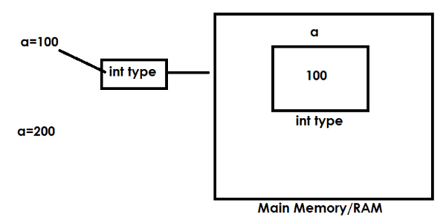

>>> a=100
>>> a
100
>>> b=200
>>> b
200
>>> c=a+b
>>> c
300

Python is derived or developed using features of the following programming languages,
- C (Procedural Oriented Programming)
- C++ (Object Oriented Programming)
- Modula-7 (Modular Programming)
- Perl (Scripting Language)

type()
type() is an in built-in function in python which returns type of variable.

Syntax: type(variable-name)

>>> x=10
>>> type(x)
<class 'int'>
>>> y=1.5
>>> type(y)
<class 'float'>

Python is an object oriented programming language.
In object oriented programming languages data is represented as objects and every data type is class.

The size of int data type in python is dynamic.

How to find size of variable or object?
“sys” module or library provides the function called getsizeof()
import sys
sys.getsizeof(variable-name)

>>> import sys
>>> sys.getsizeof(n1)
28
>>> n2=99999999
>>> sys.getsizeof(n2)
28
>>> n3=99999999999999999999999999
>>> sys.getsizeof(n3)
36
>>> n4=999999999999999999999999999999999999999999999999999999
>>> sys.getsizeof(n3)
36
>>> sys.getsizeof(n4)
48
>>> n5=9999999999999999999999999999999999999999999999999999999999999
>>> sys.getsizeof(n5)
52

In python integer values or literals represented in 4 formats
- Decimal Integer
- Octal Integer
- Hexadecimal Integer
- Binary Integer

Based on the base of the integer value it is classified into 4 categories or types. Base represents the number of digits used to construct number.

Decimal Integer
An integer value with base 10 is called decimal integer
This integer is created or constructed using digits range from 0-9
This integer value should not start with 0
Default representation is decimal format

>>> otp=44669
>>> type(otp)
<class 'int'>
>>> rollno=01234
SyntaxError: leading zeros in decimal integer literals are not permitted; use an 0o prefix for octal integers
>>> rollno=120
>>> type(rollno)
<class 'int'>
>>> n1=+45
>>> n1
45
>>> n2=-78
>>> n2
-78

Octal Integer
An integer value with base 8 is called octal integer
This integer value is constructed or created using digits range
from 0-7.
This integer value is prefix with 0o or 0O

>>> n1=0o45
>>> n1
37
>>> n2=0O67
>>> n2
55
>>> n3=0o78
SyntaxError: invalid digit '8' in octal literal
>>> n4=0o89
SyntaxError: invalid digit '8' in octal literal
>>> n5=0o921
SyntaxError: invalid digit '9' in octal literal

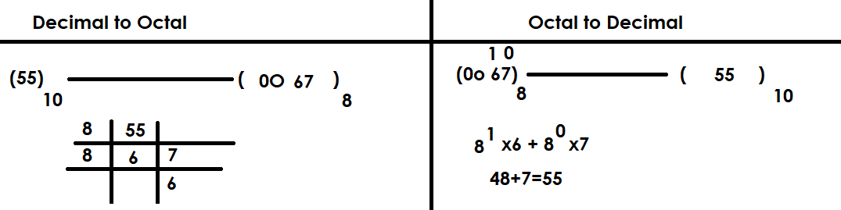

Applications of octal integer

codewithsatishgupta
Octal Integer
An integer value with base 8 is called octal integer
This integer value is constructed or created using digits range
from 0-7.
This integer value is prefix with 0o or 0O

>>> n1=0o45
>>> n1
37
>>> n2=0O67
>>> n2
55
>>> n3=0o78
SyntaxError: invalid digit '8' in octal literal
>>> n4=0o89
SyntaxError: invalid digit '8' in octal literal
>>> n5=0o921
SyntaxError: invalid digit '9' in octal literal

Applications of octal integer
- Operating System
- Networking (IP-Address)
- Assembly Language

Hexadecimal Integer
An integer value with base 16 is called hexadecimal integer
This integer value is created using digits range from 0-9,A-F/a-f
This integer value is prefix with 0x or 0X

Applications
- Color Values
- Memory Address
- Register Address
- UNICODE

If integer value is very large it is represented in hexadecimal format.

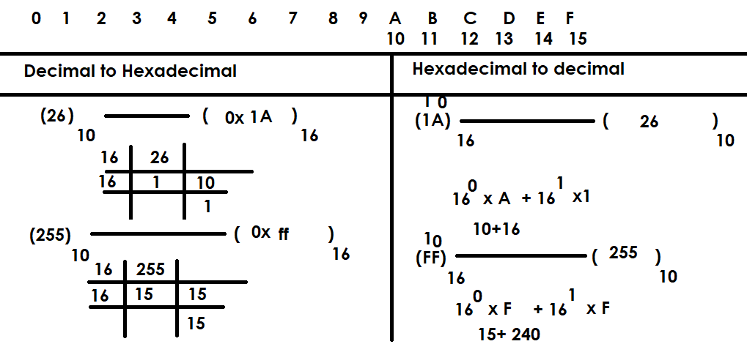

Example:
n1=0xA
n1
10
>>> n2=0XB
>>> n2
11
>>> n3=0xF
>>> n3
15
>>> n4=0xG
SyntaxError: invalid hexadecimal literal
>>> n5=0x1a
>>> n5
26
>>> n6=0xa1b
>>> n6
2587
>>> n7=0xff
>>> n7
255
>>> n1=0x5
>>> n1
5
>>> n2=0xbee
>>> n2
3054
>>> n3=0xbad
>>> n3
2989
>>> n4=0x1hb
SyntaxError: invalid hexadecimal literal

Binary Integer literals
An integer value with base 2 is called binary integer.
An integer value created using 2 digits 0 or 1
This integer value is prefix with 0b or 0B

Applications
- Image processing
- Machine Language
- Embedded applications
- Low Level Programming
- Memory Representation

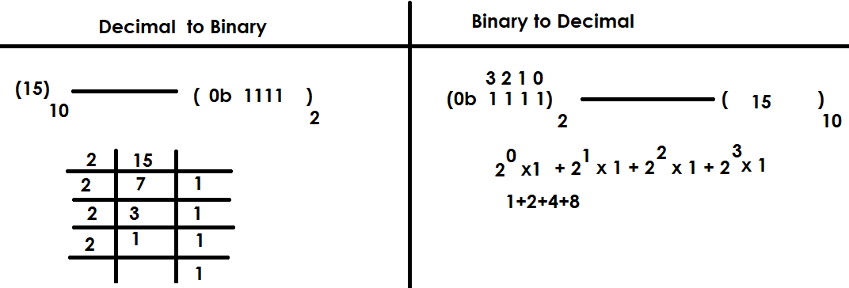
>>> num1=0b101
>>> num1
5
>>> num2=0b1010
>>> num2
10
>>> num3=0b120
SyntaxError: invalid digit '2' in binary literal

One special character is allowed inside integer literals or values called _.
This underscore is used for grouping digits
This number should not prefix or suffix with _

>>> amt=1,00,000
>>> amt
(1, 0, 0)
>>> type(amt)
<class 'tuple'>
>>> amt=1_00_000
>>> amt
100000
>>> x=10_
SyntaxError: invalid decimal literal
>>> y=_10
Traceback (most recent call last):
File "<pyshell#35>", line 1, in <module>
y=_10
NameError: name '_10' is not defined
>>> z=1_0_0_2_3_4
>>> z
100234

float data type and float literals

float data type is used to represent float value or float literal.

What is float value or literal?
A numeric value with decimal part or fractional part is called float value.

These float values in memory represented using float data type or class.

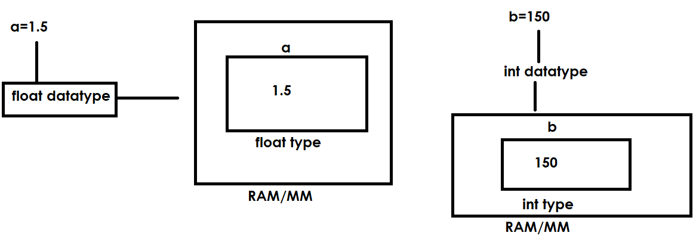

pi=3.147
pi
3.147
type(pi)
<class 'float'>
mean=2.5
mean
2.5
>>> type(mean)
<class 'float'>
>>> median=10.50
>>> median
10.5
>>> type(median)
<class 'float'>
>>> sub1=99.45
>>> sub1
99.45
>>> type(sub1)
<class 'float'>

In python float values or literals are represented in 2 formats or notations
- Fixed notation (OR) Decimal Notation (OR) Standard Notation
- Exponential (Scientific) notation

>>> pi=3.147
>>> pi
3.147
>>> type(pi)
<class 'float'>
>>> mean=2.5
>>> mean
2.5
>>> type(mean)
<class 'float'>
>>> median=10.50
>>> median
10.5
>>> type(median)
<class 'float'>
>>> sub1=99.45
>>> sub1
99.45
>>> type(sub1)
<class 'float'>
Exponential (Scientific) notation
In exponential notation float value uses a special character “e” or “E”. The value of “e” or “E” is 10.

>>> a=1.5
a
>>> 1.5
type(a)
<class 'float'>
>>> b=15e-1
>>> b
1.5
>>> type(b)
<class 'float'>
>>> c=125.567
>>> c
125.567
>>> type(c)
<class 'float'>
>>> d=125567e-3
>>> d
125.567
>>> e=1.2567e2
>>> e
125.67
>>> type(e)
<class 'float'>

The size of float data type or value is 64bits/8bytes

How to find information about float data type?
>>> import sys
>>> sys.float_info
sys.float_info(max=1.7976931348623157e+308, max_exp=1024, max_10_exp=308, min=2.2250738585072014e-308, min_exp=-1021, min_10_exp=-307, dig=15, mant_dig=53, epsilon=2.220446049250313e-16, radix=2, rounds=1)
>>> x=1.79e400
>>> x
Inf

Float datatype is developed by using standards given by IEEE.

Complex data type and complex literal or number
In python complex number is represented using complex data type.
Complex number is having 2 values
- Real
- Imaginary

In application development complex numbers used,
- Linear Equations
- Image, Audio, Video processing

In python complex number is represented with following syntax
a+bj
a 🡪 Real
b 🡪 Imaginary

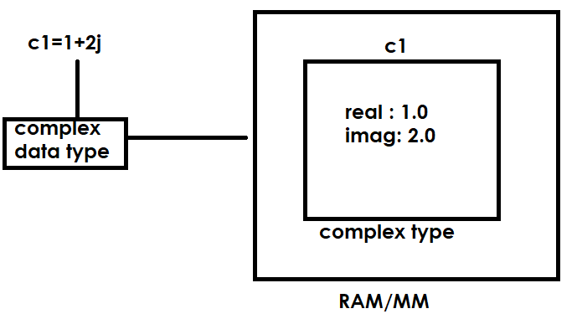
>>> c1=1+2j
>>> c1
(1+2j)
>>> c1.real
1.0
>>> c1.imag
2.0
>>> type(c1.real)
<class 'float'>
>>> type(c1.imag)
<class 'float'>
>>> type(c1)
<class 'complex'>
>>> c2=2j
>>> type(c2)
<class 'complex'>
>>> c2.real
0.0
>>> c2.imag
2.0
>>> c3=5
>>> type(c3)
<class 'int'>
>>> c3
5
>>> c5=1+2i
SyntaxError: invalid decimal literal
>>> c5=1+2j
>>> import math
>>> math.sqrt(9)
3.0
>>> math.sqrt(-9)
Traceback (most recent call last):
File "<pyshell#36>", line 1, in <module>
math.sqrt(-9)
ValueError: expected a nonnegative input, got -9.0
>>> import cmath
>>> cmath.sqrt(-9)
3j

bool datatype and boolean values or literals
boolean values in python are represented using 2 keywords
- True
- False
Bool datatype is used to create space or allocate memory for boolean values.

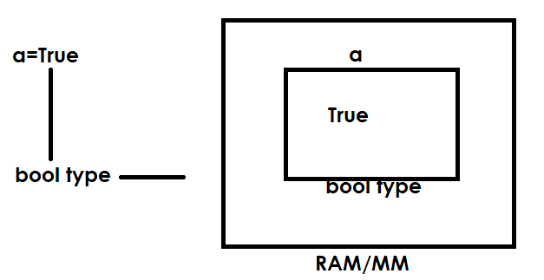

>>> a=True
>>> a
True
>>> type(a)
<class 'bool'>
>>> b=False
b
>>> False
>>> type(b)
<class 'bool'>
>>> True+True
2
>>> True+False
1
>>> False+False
0
>>> True-False
1

In python boolean values can be used to perform arithmetic operations. These boolean values represented as 1 byte integer value.

True 🡪 1
False 🡪 0
>>> rollno=1
>>> fee=9000.0
>>> fee_paid=True
>>> type(rollno)
<class 'int'>
>>> type(fee)
<class 'float'>
>>> type(fee_paid)
<class 'bool'>

NoneType and None value or literal

NoneType datatype is used to represent None value
In application development None values are used as,
- Missing values
- Create a variable by assigning no value

>>> empno=101
>>> ename=None
>>> job=None
>>> sal=5000.0
>>> type(empno)
<class 'int'>
>>> type(ename)
<class 'NoneType'>
>>> type(job)
<class 'NoneType'>
>>> type(sal)
<class 'float'>
>>> a=None
>>> a
>>> type(a)
<class 'NoneType'>

String (OR) str datatype

In python string is collection type.
String is sequence datatype. It organize string data in sequential order.
String is non numeric data type, we cannot perform arithmetic operations on string.
String is collection of characters. These characters can be alphabets, digits or special characters.
The string which contains only alphabets is alphabetic string
This string which contains alphabets and digits is called alphanumeric string.
1. Who developed the Python programming language?
- A) Dennis Ritchie
- B) Guido van Rossum
- C) James Gosling
- D) Bjarne Stroustrup
2. In which year was Python first released?
- A) 1991
- B) 1989
- C) 2000
- D) 1995
3. Python was developed at __________.
- A) Microsoft
- B) Bell Labs
- C) Google
- D) Centrum Wiskunde & Informatica (CWI), Netherlands
4. Python is named after __________.
- A) A snake species
- B) The British comedy group “Monty Python”
- C) A programming book
- D) The creator’s pet
5. What is the file extension of a Python file?
- A) .pt
- B) .py
- C) .pyt
- D) .pyc
6. Which of the following is not a feature of Python?
- A) Interpreted language
- B) High-level language
- C) Compiled language only
- D) Object-oriented
7. Python supports which type of programming paradigms?
- A) Object-oriented
- B) Procedural
- C) Functional
- D) All of the above

8. What makes Python a “high-level” language?
- A) Manual memory management
- B) Uses machine-level instructions
- C) Abstracts complex details
- D) Hardware-specific
9. Python code runs on which type of platform?
- A) Only Windows
- B) Only Linux
- C) Platform-independent
- D) Only Mac
10. The first version of Python (1.0) was released in:
- A) 1990
- B) 1991
- C) 1994
- D) 1999
12. Python 3.0 was released in which year?
- A) 2000
- B) 2008
- C) 2010
- D) 2015
13. Which feature allows Python to execute code line-by-line?
- A) Compiler
- B) Interpreter
- C) Linker
- D) Preprocessor
14. Python programs are easy to maintain because they are:
- A) Long and complex
- B) Platform dependent
- C) Readable and well-structured
- D) Machine-oriented
15. Which of the following is true about Python?
- A) Python is faster than C
- B) Python code is compiled into bytecode
- C) Python cannot run on
- mobile
- D) Python is a low-level language
16. The current major version of Python (as of 2025) is:
- A) Python 2
- B) Python 3
- C) Python 4
- D) Python 5
17. Python’s source code is converted into bytecode by:
- A) Interpreter
- B) Compiler
- C) Parser
- D) Assembler
18. Python’s design philosophy emphasizes:
- A) Code performance
- B) Readability and simplicity
- C) Complex syntax
- D) Hardware efficiency
19. Which statement best describes Python?
- A) Compiled and low-level
- B) Interpreted and high-level
- C) Markup language
- D) Database language

20. Python’s syntax is influenced by which language?
- A) Java
- B) ABC language
- C) C++
- D) Fortran

21. The official Python website is:
- A) www.python.org
- B) www.python.com
- C) www.python.net
- D) www.py.com
22. Python’s interactive shell is called:
- A) Terminal
- B) IDLE
- C) Jupyter
- D) Anaconda

23. Python is called a “glue language” because:
- A) It combines components written in different languages
- B) It is sticky
- C) It needs many dependencies
- D) It only works with C
24. Which of these is not a Python implementation?
- A) CPython
- B) PyPy
- C) Jython
- D) PyCode
25. Which feature makes Python ideal for beginners?
- A) Complex syntax
- B) Long structure
- C) Simple and readable syntax
- D) Strict typing
26. Which organization manages Python’s development today?
- A) Microsoft
- B) Python Software Foundation (PSF)
- C) Google
- D) Oracle
27. Python’s memory management is handled by:
- A) Manual allocation
- B) Automatic garbage collector
- C) User functions
- D) Libraries
28. The default Python implementation is:
- A) CPython
- B) Jython
- C) IronPython
- D) PyPy
29. Which feature allows Python to integrate with C/C++?
- A) Cython
- B) Jython
- C) PyPy
- D) Pydroid
30. Python supports dynamic typing, which means:
- A) You must declare variable types
- B) Type fixed at compile-time
- C) Type decided at runtime
- D) Type cannot change
31. Which of the following is not a Python framework?
- A) Django
- B) Flask
- C) Laravel
- D) Pyramid
32. The slogan “Batteries Included” means:
- A) Python has many built-in libraries
- B) Python needs no setup
- C) It’s used for electronics
- D) It’s low-level

33. Python’s typing system is:
- A) Static and strong
- B) Dynamic and strong
- C) Static and weak
- D) Dynamic and weak
34. Python was created to:
- A) Replace C
- B) Create a simple scripting language
- C) Make code more complex
- D) Build browsers
35. Python is used in:
- A) Web development
- B) Machine Learning
- C) Data Science
- D) All of the above
36. A major disadvantage of Python is:
- A) Complex syntax
- B) Slower speed than C/C++
- C) Hard debugging
- D) Small community
37. Python follows which principle?
- A) WET (Write Everything Twice)
- B) DRY (Don’t Repeat Yourself)
- C) REP
- D) JOT
38. Python’s source code is available under:
- A) Open-source license
- B) Commercial license
- C) Proprietary
- D) Academic
39. The latest Python version series (as of 2025) is:
- A) Python 2.x
- B) Python 3.x
- C) Python 4.x
- D) Python 5.x
40. The Zen of Python command is:
- A) help("zen")
- B) import this
- C) python --zen
- D) print("zen")
41. Python was made open-source in:
- A) 1991
- B) 2000
- C) 1995
- D) 1999
42. Indentation in Python:
- A) Optional
- B) Defines code blocks
- C) Causes syntax errors if omitted
- D) Both B and C
43. “Interpreted” in Python means:
- A) Line-by-line execution
- B) Direct machine code
- C) Compiled before running
- D) Requires linker
44. Which of these is not a valid use of Python?
- A) Web development
- B) Mobile app development (natively)
- C) Data analysis
- D) AI applications

45. Python was influenced by:
- A) C and Java
- B) ABC and Modula-3
- C) Pascal
- D) COBOL
46. The PSF is responsible for:
- A) Maintaining Python
- B) Designing CPUs
- C) Distributing Java
- D) Making games

48. The Python interpreter is written in:
- A) Python
- B) C
- C) Java
- D) C++
49. Python is extensible because:
- A) It can use C/C++ libraries
- B) It can’t be extended
- C) It writes compilers
- D) Only PSF can extend it
50. Which feature is not a Python advantage?
- A) Portability
- B) Open-source
- C) Complex syntax
- D) Large library
51. What is an identifier in Python?
A) A keyword
B) A function
C) A name used to identify variables, functions, or classes
D) A number
52. Which of the following is a valid identifier?
A) 1name
B) name_1
C) name-1
D) name@1
53. Which of the following characters is allowed in identifiers?
A) Letters, digits, and underscore
B) Spaces and symbols
C) Only letters
D) Only digits
54. Identifiers in Python are case-sensitive.
A) True
B) False
55. Which of the following is an invalid identifier?
A) name
B) name
C) my_name
D) my name
56. Which of the following identifiers is valid?
A) total-sum
B) total_sum
C) total sum
D) total@sum
57. Which identifier is invalid?
A) abc
B) abc
C) 2abc
D) abc2
58. Which character cannot be used in an identifier?
A) _
B) 9
C) $
D) A
59. Python identifiers cannot start with:
A) Letter
B) Underscore
C) Number
D) None of these
60. Which of the following is a valid identifier name?
A) my.name
B) my_name
C) my name
D) my-name
61. Are Python identifiers case-sensitive?
A) Yes
B) No
62. Which of the following can be used as an identifier?
A) for
B) while
C) True
D) myFor
63. What is the maximum length of an identifier in Python?
A) 31 characters
B) 63 characters
C) No fixed limit
D) 255 characters
64. Which of these identifiers is invalid in Python 3?
A) _private
B) init
C) try
D) name_1
65. Which of these identifiers is reserved for special purposes?
A) main
B) main
C) main
D) MAIN
66. Which of these is a valid identifier in Python?
A) class
B) Class
C) def
D) try
67. Which of these identifiers is invalid?
A) _value
B) value1
C) 123_value
D) value_123
68. What is the output of the following code?
x = 5
X = 10
print(x, X)
A) 10 10
B) 5 5
C) 5 10
D) Error
69. Which of the following is not a valid identifier?
A) var1
B) _var
C) var_2
D) @var
70. Which of these statements is true about identifiers?
A) They can start with digits
B) They can contain spaces
C) They can include underscores
D) They can include @
71. Which of the following identifiers is invalid?
A) _temp
B) temp_value
C) 5value
D) tempValue
72. Which identifier is valid according to Python naming rules?
A) var#1
B) _var1
C) 1_var
D) var 1
73. Can identifiers in Python start with an underscore (_)?
A) Yes
B) No
74. Which of these identifiers is typically used to indicate special behavior?
A) xyz
B) xyz
C) xyz
D) xyz
75. Which of the following is not a valid identifier?
A) total
B) total_sum
C) total.sum
D) total1
76. What happens if you use a Python keyword as an identifier?
A) It is allowed
B) Raises a SyntaxError
C) Treated as a normal name
D) Gives a warning
77. Which of the following is valid?
A) employee@id
B) employee_id
C) employee-id
D) employee id
78. Which of the following is not allowed in identifiers?
A) _underscore
B) numbers
C) symbols
D) letters
79. What will be the output of the following code?
Value = 10
value = 5
print(Value + value)
A) 10
B) 5
C) 15
D) Error
80. Which of these identifiers is not valid in Python 3?
A) my_var
B) myVar
C) my-var
D) myvar
81. Which of the following statements is true?
A) Identifiers can include special characters
B) Identifiers can include only letters, digits, and underscores
C) Identifiers can start with numbers
D) Identifiers can include spaces
82. Which of these is valid according to identifier naming conventions?
A) student name
B) student_name
C) student-name
D) student.name
83. Which naming style is generally used for variable names in Python?
A) snake_case
B) PascalCase
C) camelCase
D) kebab-case
84. Which identifier name is invalid?
A) val1
B) value_
C) _val
D) 2val

85. Which of these is an invalid identifier due to space?
A) name
B) my name
C) my_name
D) _name

86. Which of these identifiers denotes a dunder (double underscore) method?
A) len
B) len
C) len__
D) _len
87. Which naming rule is violated by the identifier 3name?
A) Cannot use underscore
B) Cannot start with a digit
C) Cannot include uppercase
D) Cannot use reserved words
String (OR) str datatype

In python string is collection type.
String is sequence datatype. It organize string data in sequential order.
String is non numeric data type, we cannot perform arithmetic operations on string.
String is collection of characters. These characters can be alphabets, digits or special characters.
The string which contains only alphabets is alphabetic string
This string which contains alphabets and digits is called alphanumeric string.

How to represent string in python?
In python string is created or represented,
- Within single quotes
- Within double quotes
- Within triple single quotes or double quotes

Within single quotes
Within single quotes we represent single line string.
In this, the string must begin and end with single quotes
Within single quotes double quotes can be embedded (inserted)

>>> course='python'
>>> type(course)
<class 'str'>
>>> course
'python'
>>> name='naresh'
>>> type(name)
<class 'str'>
>>> name
'naresh'
>>> s1='python"
SyntaxError: unterminated string literal (detected at line 1)
>>> s2='python
SyntaxError: unterminated string literal (detected at line 1)
>>> s2='15'
>>> type(s2)
<class 'str'>
>>> s2
'15'
>>> s3='A101'
>>> s3
'A101'
>>> type(s3)
<class 'str'>
>>> password='abc123@%$'
>>> type(password)
<class 'str'>
>>> password
'abc123@%$'
>>> s1='python is "easy" programming language'
>>> s1
'python is "easy" programming language'
>>> s2='python is 'easy' programming language'
SyntaxError: invalid syntax. Is this intended to be part of the string?
>>> s3='python''lanaguage'
>>> s3
'pythonlanaguage'

Within double quotes
Within double quotes we can represent single line string
In this, the string begins and ends with double quotes
Within double quotes we can insert single quotes

>>> str1="python"
>>> str1
'python'
>>> type(str1)
<class 'str'>
>>> str2="65"
>>> str2
'65'
>>> type(str2)
<class 'str'>
>>> str3="A65"
>>> str3
'A65'
>>> type(str3)
<class 'str'>
>>> str4="Python programming language"
>>> str4
'Python programming language'
>>> str5="Python "easy" programmin language"
SyntaxError: invalid syntax. Is this intended to be part of the string?
>>> str5="Python""Programming Language"
>>> str5
'PythonProgramming Language'
>>> str6="Python 'easy' programming langauge"
>>> str6
"Python 'easy' programming langauge"
>>> type(str6)
<class 'str'>

Triple quotes
Triple quotes are used for representing multiline string
These triple quotes can be,
- Triple single quotes
- Triple double quotes
The string open with triple single quotes must close with triple single quotes only
The string open with triple double quotes must close with triple double quotes only

>>> str1='''python
programming
language'''
>>> print(str1)
python
programming
language
>>> str1
'python\nprogramming\nlanguage'
address='''Naresh i Technologies,
Ameerpet,
Hyd-30'''
>>> print(address)
Naresh i Technologies,
Ameerpet,
Hyd-30
>>> str3="""python
programming
language"""
>>> print(str3)
python
programming
language
address="""Naresh i technologies,
Ameerpet,
Hyd"""
>>> print(address)
Naresh i technologies,
Ameerpet,
Hyd
>>> s1='''python
... programming
... langauge"""
... '
... '''
>>> print(s1)
python
programming
langauge"""
'

Escape Sequences or Backslash character values
These are special sequences or character having special meaning within string. These are represented within string.

Escape Sequence | Meaning
\n | New line
\t | Horizontal tab space
\v | Vertical tab space
\b | Backspace
\\ | \
\’ | ‘
\” | “

>>> s1='python \' programming langauge'
>>> print(s1)
python ' programming langauge
>>> s2='python \'programming\' language'
>>> print(s2)
python 'programming' language
>>> s3="python \" programming language"
>>> print(s3)
python " programming language
>>> s4="python \"programming\" language"
>>> print(s4)
python "programming" language
>>> s5='python\njava\noracle\nHTML'
>>> print(s5)
python
java
oracle
HTML
>>> s1="Monty Python's Flying Circus"
>>> print(s1)
Monty Python's Flying Circus
>>> s2='Monty Python\'s Flying Circus'
print(s2)
Monty Python's Flying Circus
>>> s3="\"
SyntaxError: unterminated string literal (detected at line 1); perhaps you escaped the end quote?
>>> s3="\\"
>>> print(s3)
\
url=c:\\nit"
SyntaxError: invalid syntax
>>> path="c:\\nit"
>>> print(path)
c:\nit
>>> path="c:\nit"
>>> print(path)
c:
it
>>> path="c:\\nit"
>>> print(path)
c:\nit
>>> s1="\trollno"
>>> print(s1)
rollno
>>> s2="rollno\tname\tcourse"
>>> print(s2)
rollno name course

Note: python does not support single character data type. In python single character also represented as string.

Comments in python
In python any statement begin with # is comment
Comments are ignored or not executed by python runtime system.
Comments are used to describe the statements or instructions.
Python support single line comment (#)

#comment
Statement #comment
Example:
'''Title: Calculator
Version :1.0
Author: Satish Gupta
Date Written : 10-11-2025
Date Last Updated : 10-11-2025'''

#rollno of student
rno=105
#student name
sname="naresh"
#course name
cname="java"
fee=5000 #fee
print(rno,sname,cname,fee)

Output
105 naresh java 5000

How to see documentation?
>>> import test6
105 naresh java 5000
>>> test6.__doc__
'Title: Calculator\nVersion :1.0\nAuthor: Satish Gupta\nDate Written : 10-11-2025\nDate Last Updated : 10-11-2025'
>>> print(test6.__doc__)
Title: Calculator
Version :1.0
Author: Satish Gupta
Date Written : 10-11-2025

What is indent in python?
Space given at beginning of the statement is called indentation.

In python statements should not begin with space
In python space is used for creating block
It is used to include statements within block.
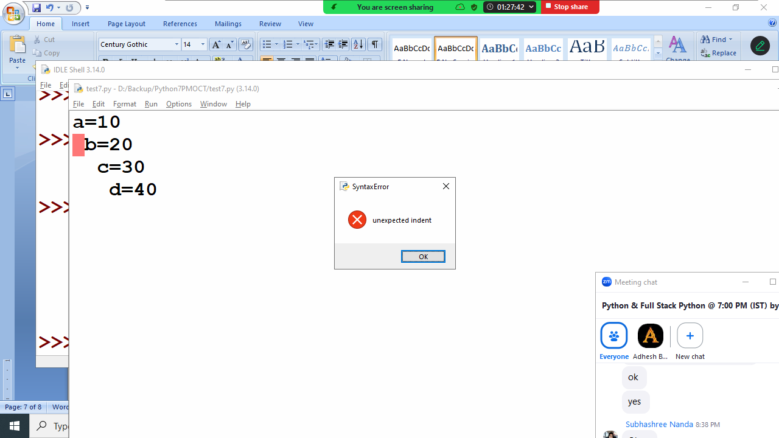

Every program required 3 things
- Input
- Process
- Output
Every program required 3 things
- Input
- Process
- Output

What is input?
Data or information given to the program is called input. This input given to the program using various sources (Keyboard, Scanner, OCR, Barcode Reader, files, database or programs)

What is Process?
Performing operations on input data is called process.

What is output?
Processed data is called output/result. This output is displayed on monitor, printer, file or database. The information given by program is called output.

print()
print() is in-built function in python, which is available in default module imported by python program (built-ins).

Note: to view content of any library use the following function
>>> dir(__builtins__)

What is function?
A function is small program within program.
A function is self contained block which contains set of instructions to perform operation
A function is named block
Python provides huge amount of built in functions available in different libraries.
Example: print(),max(),min(),sum(),input(),len(),….
A function takes input, process it and generate output
The input given to the function is called arguments.

Print function is having 5 parameters
- Values
- Sep
- End
- File
- Flush

Values: print function receives 0 or more values.
Example:
print(10)
print(100,200)
print(10,"naresh",5000.0)
print(1,2,3,4,5,6,7,8,9,10)
print()

Output
10
100 200
10 naresh 5000.0
1 2 3 4 5 6 7 8 9 10

Print function after printing values insert newline

Sep: when print function, prints more than on value it uses sep value. The default sep value used by print is space.

print(10,20,30)
print(10,20,30,sep=",")
print(10,20,30,40,50,sep="*")
print(10,20,30,sep="\t")
print(10,20,30,sep="\n")
print(1,"naresh","python",5000.0,sep=":")
print("rollno","name","course",sep="\t")
print(10,20,30,40,50)
print(10,20,30,40,50,sep="nit")

Output
10 20 30
10,20,30
10*20*30*40*50
10 20 30
10
20
30
1:naresh:python:5000.0
rollno name course
10 20 30 40 50
10nit20nit30nit40nit50

Example:
a=10
b=20
c=30
d=40
print(a,b,c,d)
print(a,b,c,d,sep="\t")
print(a,b,c,d,sep="\n")
print(a,sep=",")

Output
10 20 30 40
10 20 30 40
10
20
30
40
10

end
print function after printing all the values it print end value
the default of end is \n

Example:
print(10,20)
print("Python")
print(100,200,end='.')
print("JAVA")
print("ORACLE",end=' ')
print("MONGODB")

Output
10 20
Python
100 200.JAVA
ORACLE MONGODB

file:
print function receives all the values and print or write inside a file called stdout(standard output/console)
this parameter can be used to inside user defined file to store or save output permanently

flush:
print function print data inside buffer. In order to move data from buffer to file the value of flush=True.

Example:
fobj=open("output.txt","w")
print(10,20,30,40,50)
print(100,200,300,400,500,file=fobj)
print(1000,2000,3000,4000,5000,file=fobj,flush=True)

Output
10 20 30 40 50
Remaining print statements output is inside output.txt file

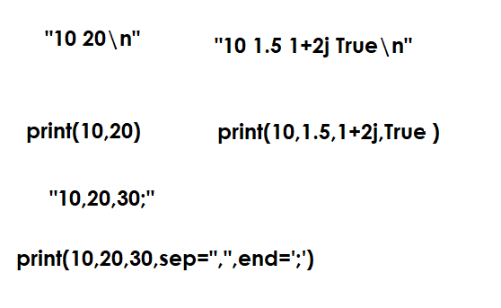
input() function

input() is an in-built function in python.
It is standard input function, which is used to input data during runtime using keyboard.
This function is used to input values using keyboard
Input() function is used to input/read string values

Syntax:
variable-name=input([prompt])

prompt is a message displayed before reading value

input() function allows to input single value/one value

Example:
# Write a program to add two integer numbers

num1=input("Number1:")
num2=input("Number2:")
print(type(num1),type(num2))
num3=num1+num2
print(num1,num2,num3)

Output
Number1:10
Number2:20
<class 'str'> <class 'str'>
10 20 1020

Example:
#Write program to input student details

#Input
rollno=input("Rollno:")
name=input("StudentName :")
course=input("StudentCourse:")
fee=input("StudentFee:")

#Output
print("Rollno:",rollno)
print("StudentName:",name)
print("StudentCourse:",course)
print("StudentFees:",fee)

Output
Rollno:2
StudentName :Suresh
StudentCourse:Java
StudentFee:2000
Rollno: 2
StudentName: Suresh
StudentCourse: Java
StudentFees: 2000

Type Conversion Functions or Type Casting

What type conversion or typecasting?
Type conversion or type casting is process of converting object of one type to another type. This type conversion is done using type conversion functions/class provided by python.

- int()
- float()
- complex()
- bool()
- str()
- list()
- tuple()
- bytes()
- bytesarray()
- set()
- frozenset()
- dict()
>>> a=10
>>> b=int(10)
>>> a
10
>>> b
10
>>> type(a)
<class 'int'>
>>> type(b)
<class 'int'>

int() function or class
Syntax-1: class int(number=0, /)
Syntax-2: class int(string, /, base=10)
Return an integer object constructed from a number or a string, or return 0 if no arguments are given.
This is used to perform the following conversions
- int to int
- float to int
- bool to int
- string to int

Example:
>>> a=10
>>> b=int(10)
>>> a
10
>>> b
10
>>> type(a)
<class 'int'>
>>> type(b)
<class 'int'>
>>> n1=int()
>>> print(n1,type(n1))
0 <class 'int'>
>>> n2=int(25)
>>> print(n2,type(n2))
25 <class 'int'>
>>> n3=int(1.5)
>>> print(n3,type(n3))
1 <class 'int'>
>>> n4=int(127.9999)
>>> print(n4,type(n4))
127 <class 'int'>
>>> n5=int("125")
>>> print(n5,type(n5))
125 <class 'int'>
>>> n6=int("abcd")
Traceback (most recent call last):
File "<pyshell#17>", line 1, in <module>
n6=int("abcd")
ValueError: invalid literal for int() with base 10: 'abcd'
>>> n7=int("1.5")
Traceback (most recent call last):
File "<pyshell#18>", line 1, in <module>
n7=int("1.5")
ValueError: invalid literal for int() with base 10: '1.5'
>>> n8=int("ab",base=16)
>>> print(n8,type(n8))
171 <class 'int'>
>>> n9=int("101",base=2)
>>> print(n9,type(n9))
5 <class 'int'>
>>> n10=int("102",base=2)
Traceback (most recent call last):
File "<pyshell#23>", line 1, in <module>
n10=int("102",base=2)
ValueError: invalid literal for int() with base 2: '102'
>>> n11=int(True)
>>> print(n11,type(n11))
1 <class 'int'>
>>> n12=int(False)
>>> print(n12,type(n12))
0 <class 'int'>

Example:
# Write a program to print sum of two integers

n1=int(input("Input First Integer Value :"))
n2=int(input("Input Second Integer Value :"))
n3=n1+n2
print(n1,n2,n3)
print(type(n1),type(n2),type(n3))

Output
Input First Integer Value :100
Input Second Integer Value :200
100 200 300
<class 'int'> <class 'int'> <class 'int'>

float() function or class
class float(number=0.0, /)
class float(string, /)
Return a floating-point number constructed from a number or a string.

This function or class is used to construct float object using integer, float or string.
It performs the following conversions
- float to float
- int to float
- string to float
- boolean to float

>>> a=float()
>>> print(a,type(a))
0.0 <class 'float'>
>>> b=float(1.5)
>>> print(b,type(b))
1.5 <class 'float'>
>>> c=float(15e-1)
>>> print(c,type(c))
1.5 <class 'float'>
>>> d=float(25)
>>> print(d,type(d))
25.0 <class 'float'>
>>> e=float("12.56")
>>> print(e,type(e))
12.56 <class 'float'>
>>> f=float("1256e-2")
>>> print(f,type(f))
12.56 <class 'float'>
>>> g=float("45")
>>> print(f,type(g))
12.56 <class 'float'>
>>> print(g,type(g))
45.0 <class 'float'>
>>> h=float(True)
>>> print(h,type(h))
1.0 <class 'float'>
>>> i=float(False)
>>> print(i,type(i))
0.0 <class 'float'>
>>> j=float(1+2j)
Traceback (most recent call last):
File "<pyshell#47>", line 1, in <module>
j=float(1+2j)
TypeError: float() argument must be a string or a real number, not 'complex'

Example
# Write a program to find area of triangle

#input
base=float(input("Base :"))
height=float(input("Height :"))

#process
area=0.5*base*height

#output
print("Area of Triangle is ",area)

Output
Base :1.5
Height :2.5
Area of Triangle is 1.875

bool() function or class
class bool(object=False, /)
Return a Boolean value, i.e. one of True or False.
This type or function is used to perform the following conversions
- bool to bool
- int to bool
- float to bool
- complex to bool
- string to bool

>>> b1=bool()
>>> print(b1,type(b1))
False <class 'bool'>
>>> b2=bool(True)
>>> print(b2,type(b2))
True <class 'bool'>
>>> b3=bool(0)
>>> print(b3,type(b3))
False <class 'bool'>
>>> b4=bool(5)
>>> print(b4,type(b4))
True <class 'bool'>
>>> b5=bool(0.0)
>>> print(b5,type(b5))
False <class 'bool'>
>>> b6=bool(2.0)
>>> print(b6,type(b6))
True <class 'bool'>
>>> b7=bool(0+0j)
>>> print(b7,type(b7))
False <class 'bool'>
>>> b8=bool(1+0j)
>>> print(b8,type(b8))
True <class 'bool'>
>>> b9=bool("A")
>>> print(b9,type(b9))
True <class 'bool'>
>>> b10=bool("0")
>>> print(b10,type(b10))
True <class 'bool'>
>>> b11=bool("")
>>> print(b11,type(b11))
False <class 'bool'>
>>> b12=bool("False")
>>> print(b12,type(b12))
True <class 'bool'>
str() class or function
It is used for creating string object (OR) constructing string object using other values

Syntax-1: str() 🡺 Creating empty string
Syntax-2: str(object) 🡺 This object can be string, int,float, complex,boolean or any other type. This function is used to convert any other object into string type

Example:
>>> s1=str(15)
>>> print(s1,type(s1))
15 <class 'str'>
>>> s2=str(15.25)
>>> print(s2,type(s2))
15.25 <class 'str'>
>>> s3=str(1+2j)
>>> print(s3,type(s3))
(1+2j) <class 'str'>
>>> s4=str(True)
>>> print(s4,type(s4))
True <class 'str'>
>>> s5=str("PYTHON")
>>> print(s5,type(s5))
PYTHON <class 'str'>
>>> s6=str()
>>> print(s6,type(s6))
<class 'str'>

Type casting or Type Conversions are 2 types
- Implicit Type Conversion or Implicit Type Casting
- Explicit Type Conversion of Explicit Type Casting

Implicit type conversion is done by python runtime system. This conversion is done when performed arithmetic operations.

Explicit type conversion is done by programmer using type conversion functions.(int(),float(),complex(),bool(),str(),…)

Operators
What is operator?
Operator is a special symbol, which is used to perform operations.
Operator performs operations using operands.
Based on the operands on which it performs operations, operators are classified into 3 categories.
- Unary operators : It required one operand to perform operation
- Binary operators: It required two operands to perform operation
- Ternary operators: It required three operands to perform operation
Types of operators
- Arithmetic Operators
- Relational Operators
- Logical Operators
- Membership Operators
- Identity Operators
- Assignment Operators
- Conditional Operators
- Bitwise Operators
- Walrus Operator

Arithmetic Operators
Arithmetic operators are binary operators and required 2 operands to perform operation.
- +
- –
- *
- /
- //
- %
- **

+ operator
This operator is used to perform 2 operations
- Addition of numbers
- Concatenation of sequences (str,list,tuple,bytes,bytearray,range)

If two operands are numeric type, it performs addition
If two operands are similar type sequences, it performs concatenation

Implicit type casting is done based on the following rules
- Int
- Float
- Complex
Complex>float>int>bool
Arithmetic operation returns result always in broader type

Example:
a=10
b=20
c=a+b
print("sum of",a,b,"is",c)
f1=1.5
f2=2.5
f3=f1+f2
print("sum of",f1,f2,"is",f3)
c1=1+2j
c2=1+4j
c3=c1+c2
print(c1,c2,"sum is",c3)
i=35
f=4.5
res=i+f
print(i,f,"sum is",res)
x=10
y=1.5
z=1+2j
res=x+y+z
print(x,y,z,"sum is",res)
b1=True
b2=True
b3=b1+b2
print(b1,b2,"sum is",b3)
x=100
y=True
z=x+y
print(x,y,"sum is ",z)
a=15
b=1.5
c=int(a+b)
print(a,b,"sum is ",c)
s1="python"
s2="programming"
s3=s1+s2
print(s1,s2,s3)
A=[10,20,30]
B=[40,50,60]
C=A+B
print(A,B,C)
#D=s1+A

Output
sum of 10 20 is 30
sum of 1.5 2.5 is 4.0
(1+2j) (1+4j) sum is (2+6j)
35 4.5 sum is 39.5
10 1.5 (1+2j) sum is (12.5+2j)
True True sum is 2
100 True sum is 101
15 1.5 sum is 16
python programming pythonprogramming
[10, 20, 30] [40, 50, 60] [10, 20, 30, 40, 50, 60]

Example:
# Write a program to input name and 3 subject marks
# calculate total marks

#input
name=input("StudentName :")
sub1=int(input("Subjet1Marks :"))
sub2=int(input("Subject2Marks :"))
sub3=int(input("Subject3Marks :"))

#process
total=sub1+sub2+sub3

#output
print("StudentName ",name)
print("Subject1Marks ",sub1)
print("Subject2Marks ",sub2)
print("Subject3Marks ",sub3)
print("Total Marks ",total)

Output
StudentName :Naresh
Subjet1Marks :80
Subject2Marks :79
Subject3Marks :98
StudentName Naresh
Subject1Marks 80
Subject2Marks 79
Subject3Marks 98
Total Marks 257

Example
a=10
b=-5
c=a+b
print(a,b,c)
x=-10
y=-5
z=x+y
print(x,y,z)

Output
10 -5 5
-10 -5 -15

-operator or arithmetic subtraction operator
This operator is used to perform arithmetic subtraction. It is binary operator and required 2 operands to perform operation.

Example:
a=10
b=5
c=a-b
print(a,b,c)
f1=1.5
f2=1.3
f3=f1-f2
print(f1,f2,f3)
x=-10
y=-5
z=x-y
print(x,y,z)
c1=1+2j
c2=1j
c3=c1-c2
print(c1,c2,c3)

Output
10 5 5
1.5 1.3 0.19999999999999996
-10 -5 -5
(1+2j) 1j (1+1j)

Example:
# Write a program to swap two numbers
# input two numbers and swap
a=int(input("First Number "))
b=int(input("Second Number "))

print("Before Swaping ",a,b)
#Method-1 Using third variable
c=a
a=b
b=c
print("After Swaping ",a,b)
#Method-2 Without using third variable
a=a+b
b=a-b
a=a-b
print("After Swaping ",a,b)
#Method-3
a,b=b,a
print("After Swaping ",a,b)

Output
First Number 100
Second Number 200
Before Swaping 100 200
After Swaping 200 100
After Swaping 100 200
After Swaping 200 100
*Multiplication Operator and repeating elements of sequence operator

It is a binary operator and required 2 operands to perform operation.

Example:
a=5
b=2
c=a*b
print(a,b,c)

f1=1.5
f2=1.2
f3=f1*f2

print(f1,f2,f3)

c1=1+2j
c2=1+3j
c3=c1*c2
print(c1,c2,c3)

b1=True
b2=False
b3=b1*b2
print(b1,b2,b3)

s1="a"
s2=s1*10
print(s1,s2)

A=[0]
B=A*5
print(A,B)

A=[1,2,3]
B=A*2
print(A,B)

Output
5 2 10
1.5 1.2 1.7999999999999998
(1+2j) (1+3j) (-5+5j)
True False 0
a aaaaaaaaaa
[0] [0, 0, 0, 0, 0]
[1, 2, 3] [1, 2, 3, 1, 2, 3]

Example:
# Write a program to find area of rectangle
# area=l*b

#Input
l=float(input("Enter Length of Rectangle :"))
b=float(input("Enter Breadth of Rectangle :"))
#Process
area=l*b
#Output
print("Area of rectangle is ",area)

Output
Enter Length of Rectangle :1.5
Enter Breadth of Rectangle :2.5
Area of rectangle is 3.75

Example:
# Write a program find bill
# input pname,qty,price

pname=input("ProductName: ")
qty=int(input("Qty :"))
price=float(input("Price :"))

bill=qty*price

print("ProductName ",pname)
print("Qty ",qty)
print("Price ",price)
print("Total Bill ",bill)

Output
ProductName: mouse
Qty :2
Price :500
ProductName mouse
Qty 2
Price 500.0
Total Bill 1000.0

Example:
# Write a program input hours
# convert into minutes and seconds

hours=int(input("Hours :"))

minutes=hours*60
seconds=minutes*60

print("Hours ",hours)
print("Minutes ",minutes)
print("Seconds ",seconds)

Output
Hours :2
Hours 2
Minutes 120
Seconds 7200

/ float division operator

This operator divides two numbers and returns quotient
This operator after dividing two numbers it return quotient in float type.
It is a binary operator and required 2 operands to perform operation.

Example:
n1=5
n2=2
n3=n1/n2
print(n1,n2,n3)
a=4
b=2
c=a/b
print(a,b,c)

Output
5 2 2.5
4 2 2.0

Example:
# Write a program to input name,3 subject marks
# calculate total marks,avg marks

name=input("Name :")
sub1=int(input("Subject1Marks :"))
sub2=int(input("Subject2Marks :"))
sub3=int(input("Subject3Marks :"))

total=sub1+sub2+sub3
avg=total/3

print("Name ",name)
print("Subject1Marks ",sub1)
print("Subject2Marks ",sub2)
print("Subject3Marks ",sub3)
print("Total Marks ",total)
print("Avg Marks ",avg)

Output
Name :naresh
Subject1Marks :60
Subject2Marks :70
Subject3Marks :80
Name naresh
Subject1Marks 60
Subject2Marks 70
Subject3Marks 80
Total Marks 210
Avg Marks 70.0

// floor division
This operator divides two numbers and returns quotient
This operator after dividing two numbers it return quotient in int type.
It is a binary operator and required 2 operands to perform operation.

Example:
a=5
b=2
c=a//b
print(a,b,c)
x=-5
y=2
z=x//y
print(x,y,z)

Output
5 2 2
-5 2 -3

Example:
# Write a program input seconds and convert into
# minutes and hours

seconds=int(input("Seconds :"))

minutes=seconds//60
hours=minutes//60

print("Hours ",hours)
print("Minutes ",minutes)
print("Seconds ",seconds)

Output
Seconds :7200
Hours 2
Minutes 120
Seconds 7200

Example:
# Currency Converter
# RS to Dollar
# Dollar to Rs

dollar=int(input("Dollars :"))
rs=dollar*88
dollar1=rs//88

print("RS :",rs)
print("Dollar :",dollar1)

Output
Dollars :5
RS : 440
Dollar : 5

% Division operator or Modulo operator
This operator divides two numbers and returns remainder
It is a binary operator and required 2 operands

Example:
a=8
b=3
c=a%b
print(a,b,c)
x=7
y=2
z=x%y
print(x,y,z)
p=6
q=3
r=p%q
print(p,q,r)

Output
8 3 2
7 2 1
6 3 0

** Exponential operator
It is binary operator and required 2 operands to perform operations
This operator is used to find power of a number

Example:
x=5
y=2
z=x**y
print(x,y,z)
p=10
q=-2
r=p**q
print(p,q,r)

Output
5 2 25
10 -2 0.01

Operator Precedence
1. What is the default value of the end parameter in print()?
A. "\n\n"
B. " "
C. ""
D. "\n"
2. What does the following code print?
print("Hello", "World")
A. HelloWorld
B. Hello World
C. "Hello" "World"
D. Hello, World
3. Which parameter is used to separate multiple values in print()?
A. sep
B. split
C. end
D. join
4. What will be the output?
print("A", "B", sep="-")
A. A B
B. A-B
C. A--B
D. -A-B
5. Which of the following is valid?
A. print()
B. print("")
C. print("Hello")
D. All of the above
6. What is printed?
print("Hello", end="")
print("World")
A. Hello
World
B. HelloWorld
C. Hello World
D. Hello
World
7. What will the following output?
print("X", "Y", "Z", sep="")
A. X Y Z
B. X-Y-Z
C. XYZ
D. X,Y,Z
8. print() belongs to which category?
A. User-defined function
B. Lambda function
C. Built-in function
D. Package function
9. What is the output?
print("Python", end="***")
print("Rocks")
A. Python Rocks
B. PythonRocks
C. PythonRocks
D. Python***
Rocks
10. The print() function automatically converts values into ___.
A. integers
B. strings
C. floats
D. booleans
11. What will this print?
print(10, 20, 30, sep=",")
A. 10 20 30
B. 10,20,30
C. 10,,20,,30
D. 102030
12. What is the output?
print("A\nB")
A. A B
B. A\nB
C.
A
B
D. AB
13. What will this output?
print("Hello\tPython")
A. Hello Python
B. HelloPython
C. Hello Python
D. Error
14. Which is correct for printing without a newline?
A. print("Hello", stop="")
B. print("Hello", end="")
C. print.end("Hello")
D. print("Hello", next="")
15. What is the output?
print("Hi", "There", sep="***")
A. Hi There
B. HiThere
C. HiThere
D. Hi* There

16. What happens if you write:
print(1, 2, 3, sep=None)
A. Prints 123
B. Prints 1None2None3
C. Prints 1 2 3
D. Error
17. Which of the following prints a blank line?
A. print("")
B. print()
C. Both A and B
D. None
18. What is the output?
print("A", end="\n\n")
print("B")
A.
A
B
B. A
B
C. A B
D. A\n\nB
19. What will this output?
print("5" + "5")
A. 10
B. 5 5
C. 55
D. Error
20. What will print?
print("5" * 3)
A. 15
B. 555
C. 5 5 5
D. Error

21. What is the output?
print("One", "Two", "Three", sep="---")
A. One Two Three
B. One---Two---Three
C. One--Two--Three
D. Error
22. Which of the following prints on the same line?
A. print("A")
print("B")
B. print("A", end=" ")
print("B")
C. print("A", finish=" ")
print("B")
D. print.end("A")
23. What will be printed?
print(True, False)
A. TRUE FALSE
B. true false
C. True False
D. Error
24. What is the output of this code?
print("Result:", 10 > 3)
A. Result: True
B. Result: 1
C. Result: 10 > 3
D. Error
25. What will be printed?
print("Hello", 10, 20.5)
- Hello 10 20.5
B. Hello1020.5
C. "Hello" 10 20.5
D. Error
26. What will be the output?
print("Hello", sep="-")
A. Hello
B. -Hello-
C. -Hello
D. Hello-

27. What does this print?
print("A", "B", end="&")
A. A B
B. A&B
C. A B&
D. A&B&
28. What is printed?
print()
print("Hi")
A. Hi
B. (blank line)
Hi
C. Error
D. Hi (blank line)
29. Which is correct syntax?
A. print["Hello"]
B. print("Hello")
C. print{"Hello"}
D. echo("Hello")
30. What will be the output?
print("C:\\newfolder")
A. C:\newfolder
B. C:newfolder
C. C:\newfolder
D. Error
31. What is printed by:
print("A\n\nB")
A. A B
B. A (blank line) B
C. A\n\nB
D. A B (same line)
32. What is the output?
print("1", "2", "3", sep="*")
A. 123
B. 123
C. 1 2 3
D. 1* 2* 3
33. What does print() return?
A. Returns printed text
B. Returns None
C. Returns True
D. Returns the number of characters printed
34. What is the output?
print("A", end=" ")
print("B", end=" ")
print("C")
A. A
B
C
B. A B C
C. A B C (same line)
D. A B
C
35. What is the output?
print("Python", "3.10", sep="")
A. Python 3.10
B. Python3.10
C. Python-3.10
D. Error
36. What will be printed?
print("Sum:", 5 + 5)
A. Sum: 10
B. Sum: 5 + 5
C. Sum:10
D. Error
37. What will the following print?
print("A", sep="--", end="*")
print("B")
A. A*B
B. A--B
C. A--B
D. A B
38. What does this output?
print("Hello" "World")
A. Hello World
B. HelloWorld
C. Hello,World
D. Error
39. What will print?
print(10,20,30,sep="---",end="#")
A. 10---20---30#
B. 10 20 30#
C. 10---20---30
D. Error
40. What is the output?
print("X", end="\t")
print("Y")
A. X Y (tab space)
B. XY
C. X Y
D. Error
41. Which argument is used to avoid automatic newline?
A. next
B. stop
C. end
D. last
42. What will be the output?
print("Hello", None)
A. Hello None
B. Hello
C. Error
D. None Hello
43. What is printed?
print(10 / 4)
A. 2
B. 2.0
C. 2.5
D. 2.50
44. What will be printed?
print("5" * 5)
A. 25
B. 55555
C. 5 * 5
D. Error
45. Output?
print("A", "B", "C", sep="@", end="@")
A. A@B@C
B. A@B@C@
C. A @ B @ C @
D. Error
46. What does this print?
print(1, True, "Hello")
A. 1TrueHello
B. 1 True Hello
C. 1, True, Hello
D. Error
47. Which print outputs:
HelloPython
A. print("Hello", "Python")
B. print("Hello", "Python", sep="")
C. print("Hello" + "Python")
D. Both B and C

48. What happens?
print("A", sep=None)
A. A
B. Error
C. NoneANone
D. A None
49. What will be printed?
print("Line1\nLine2\nLine3")
A.
Line1 Line2 Line3
B. Line1\nLine2\nLine3
C.
Line1
Line2
Line3
D. Error
50. What is the output?
print("Total =", 100, "%")
A. Total =100%
B. Total = 100 %
C. Total = 100%
D. Total =100 %
51. What is the output?
print(int(3.9))
A. 3
B. 4
C. 3.9
D. Error
52. What is the result of:
print(float(5))
A. 5
B. 5.0
C. 0.5
D. Error
53. What will bool(0) return?
A. True
B. False
C. 0
D. Error
54. What is the output?
print(bool(3))
A. True
B. False
C. 3
D. Error
55. What happens with:
print(int("20"))
A. "20"
B. 20
C. 20.0
D. Error
56. What is the output of:
print(float("2.5"))
A. "2.5"
B. 2.5
C. 2
D. Error
57. Which will raise an error?
A. int("15")
B. float("3.14")
C. int("3.14")
D. bool("False")
58. What is bool("")?
A. True
B. False
C. None
D. Error
59. What does this print?
print(bool("Hello"))
A. True
B. False
C. "Hello"
D. Error
60. What is the output?
print(int(True))
A. 0
B. 1
C. True
D. Error
61. What is the output?
print(float(False))
A. 1.0
B. 0.0
C. False
D. Error
62. Which statement is correct?
A. bool converts everything to True
B. bool returns False only for 0, 0.0, "", [], {}, None
C. bool returns False only for negative numbers
D. bool cannot convert strings
63. What is the output?
print(int(" 25"))
A. Error
B. 25
C. "25"
D. 0
64. What is the result of:
print(float("1e3"))
A. 100
B. 100.0
C. 1
D. Error
65. What will happen?
print(int("A25"))
A. A25
B. 25
C. Error
D. A
66. What is printed?
print(bool([]))
A. True
B. False
C. []
D. Error
67. What will be the output?
print(bool(0.0))
A. True
B. False
C. 0
D. Error
68. What is the output?
print(int(2.999))
A. 2
B. 3
C. 2.999
D. Error
69. What will float(True) return?
A. 1
B. 1.0
C. True
D. Error

70. What is the output?
print(bool("0"))
A. False
B. True
C. 0
D. Error
71. Which will fail?
A. float("56")
B. int("56")
C. float("56.78")
D. int("56.78")
72. What does this print?
print(bool(None))
A. True
B. False
C. None
D. Error
73. What is printed?
print(float("inf"))
A. Infinity
B. inf
C. Error
D. 0.0
74. What will this output?
print(int(False))
A. 0
B. 1
C. False
D. Error
75. What is the output?
print(int("-15"))
A. -15
B. 15
C. Error
D. 0
76. What is printed?
print(bool("False"))
A. False
B. True
C. "False"
D. Error
77. What does this output?
print(float(" 45.6 "))
A. Error
B. 45.6
C. "45.6"
D. 45
78. What happens here?
print(int(4/2))
A. Error
B. 2
C. 2.0
D. 4
79. What is the output?
print(float("3.0e2"))
A. 3
B. 300
C. 300.0
D. Error
80. Which one converts a float to nearest integer?
A. int()
B. round()
C. bool()
D. float()
Operator Precedence
Operator precedence tells the order of execution of operator.
The following table summarizes the operator precedence in Python, from highest precedence (most binding) to lowest precedence (least binding). Operators in the same box have the same precedence. Unless the syntax is explicitly given, operators are binary. Operators in the same box group left to right (except for exponentiation and conditional expressions, which group from right to left).

Operator | Description
(expressions...),  [expressions...], {key: value...}, {expressions...} | Binding or parenthesized expression, list display, dictionary display, set display
x[index], x[index:index], x(arguments...), x.attribute | Subscription, slicing, call, attribute reference
await x | Await expression
** | Exponentiation
+x, -x, ~x | Positive, negative, bitwise NOT
*, @, /, //, % | Multiplication, matrix multiplication, division, floor division, remainder
+, - | Addition and subtraction
<<, >> | Shifts
& | Bitwise AND
^ | Bitwise XOR
| | Bitwise OR
in, not in, is, is not, <, <=, >, >=, !=, == | Comparisons, including membership tests and identity tests
not x | Boolean NOT
and | Boolean AND
or | Boolean OR
if – else | Conditional expression
lambda | Lambda expression
:= | Assignment expression

Precedence of arithmetic operators
** | Exponentiation
*,@,/,//,% | Multiplication, matrix multiplication, division, floor division, remainder
+,- | Addition and subtraction

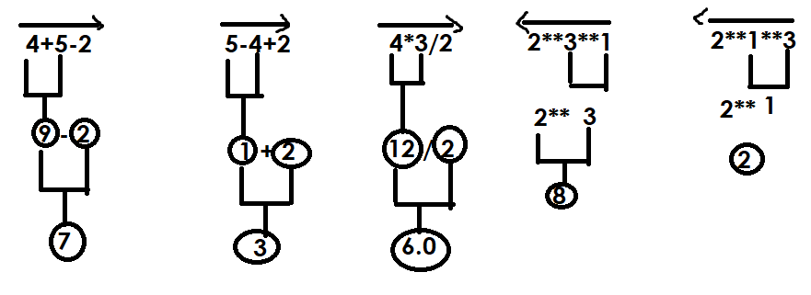
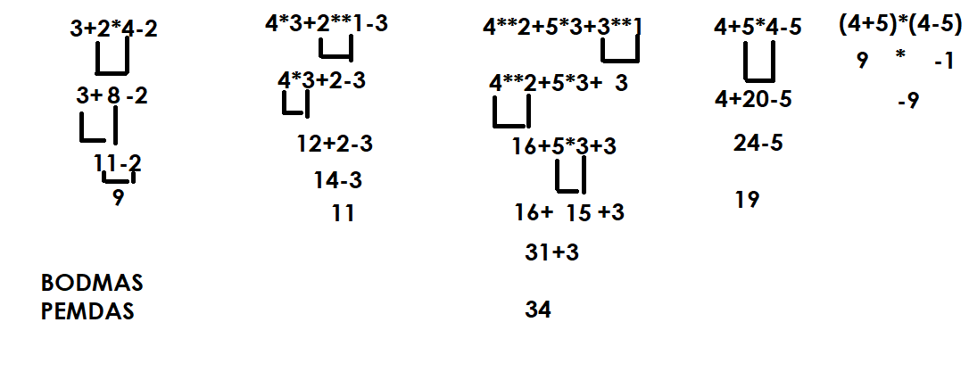

Relational Operations
These operators are used to for comparing values. The expression build using relational operators is called boolean expression. After evaluation of this expression it returns True or False.

Operators | Description
> | Greater than
< | Less than
>= | Greater than or equal
<= | Less than or equal
== | Equal
!= | Not Equal

All relational operators are binary operators and required 2 operands
Example:  r1=10>2  print(r1)  r2=10>=2  print(r2)  r3=10>=10  print(r3)  r4=10>=20  print(r4)  r5=10<20  print(r5)  r6=10<=20  print(r6)  r7=10<=10  print(r7)  r8=10<=5  print(r8)  r9=10<5  print(r9)  r10=10==10  print(r10)  r11=10==15  print(r11)  r12="nit"=="nit"  print(r12)  r13="nit"=="NIT"  print(r13)  r14=1==1.0  print(r14)  r15="nit"!="NIT"  print(r15)  r16="nit"!="nit"  print(r16) | Output  True  True  True  False  True  True  True  False  False  True  False  True  False  True  True  False
Example  res1=10>5>4  print(res1)  res2=10>5>20  print(res2)  res3=10>5<2  print(res3)  res4=10>5<20  print(res4)  n=5  res5=1<=n<=10  print(res5) | Output  True  False  False  True  True

Logical Operators
Logical operators are used for combining two or more boolean expressions.
In python logical operators are represented using 3 keywords
- and
- or
- not

and operator
Truth table of and operator
Opr1 | Opr2 | Opr1 and Opr2
True | True | True
False | False | False
False | True | False
True | False | False

Example:  a=True  b=False  c=True  r1=a and b  r2=b and c  r3=a and c  r4=b and b  print(r1,r2,r3,r4)  r6=10>5 and 10>20  print(r6)  r7=10>20 and 10>5  print(r7)  r8=10>5 and 10>9  print(r8)  #POC  r9=100 and 200  print(r9)  r10=100 and 0  print(r10)  r11=0 and 200  print(r11)  r12="A" and "B"  print(r12)  r13=100 and 200 and 300  print(r13)  r14=100 and 0 and 300  print(r14) | Output  False False True False  False  False  True  200  0  0  B  300  0

ord(), chr()

ord() function returns ascii value of given character
chr() function returns character value of given ascii value

>>> ord('A')
65
>>> ord('B')
66
>>> ord('a')
97
>>> ord('z')
122
>>> ord('Z')
90
>>> ord('0')
48
>>> ord('9')
57
>>> chr(65)
'A'
>>> chr(97)
'a'
>>> chr(90)
'Z'
>>> chr(122)
'z'
>>> chr(48)
'0'
>>> chr(57)
'9'

or operator

truth table of or operator
Opr1 | Opr2 | Opr1 or Opr2
True | True | True
False | True | True
True | False | True
False | False | False

Example:  a=True  b=False  c=True  r1=a or b  print(r1)  r2=b or c  print(r2)  r3=a or c  print(r3)  r4=b or b  print(r4)  r5=10>2 or 10>50  print(r5)  r6=10>20 or 10>5  print(r6)  # POC  r7=100 or 200  print(r7)  r8=0 or 200  print(r8)  r9=100 and 200  print(r9) | Output  True  True  True  False  True  True  100  200  200

not operator

It is a unary operator and required one operand to perform operation

Truth table
Opr1 | not opr1
True | False
False | True

Example:
>>> not True
False
>>> not False
True
>>> not 10>5
False
>>> not 10>20
True

Precedence of logical operators
- not
- and
- or
1. **Area of a Square**
Write a program that takes the side length of a square as input and prints its area.

2. **Area of a Rectangle**
Input width and height. Calculate the area.

3. **Area of a Circle**
Input radius. Use π = 3.14 to find the area.

4. **Area of a Triangle (Base × Height)**
Input base and height; find the area.

5. **Area of a Parallelogram**
Input base and vertical height.

6. **Area of a Rhombus**
Input diagonals d1 and d2.

7. **Area of a Trapezium**
Input parallel sides a, b and height h.

8. **Area of a Isosceles Triangle**
Input equal sides and base; use suitable formula.

9. **Area of a Right-angled Triangle**
Input perpendicular and base.

10. **Area of a Circle (User chooses π)**
Ask user: “Enter π as 3.14 or 22/7”, then compute.

11. **Menu-Driven Area Calculator**
Show menu of shapes; compute area based on user choice.

12. **Area of Circle with Math Library**
Use `math.pi` instead of constant 3.14.

13. **Calculate Cost Based on Area**
A painter charges ₹10 per sq.ft; find total cost for a rectangular wall.

14. **Garden Plot Area**
A rectangular garden has a circular fountain cut out in the center. Find the remaining area.

15. **Room Flooring Calculator**
Given room dimensions and tile area, find number of tiles needed.

16. **Area of Polygon (User enters number of sides & side length)**
Use formula for regular polygon.

17. **Land Area Converter**
Input land dimensions in meters; output area in sq.m, sq.ft, and acres.

18. **Area from Command-Line Arguments**
Read rectangle width & height from command-line (use `sys.argv`).

19. **Find Area Based on User’s Shape Name**
User enters shape name as text (circle, triangle, square, etc.); compute area.

20. **Compare Areas of Two Shapes**
Input two shapes and show which one is larger.

21. **Area of Sector of a Circle**
Input radius and angle (in degrees or radians).

22. **Paint Area Calculator**
Calculate wall area excluding windows and doors.

23. **Area of Oval (Ellipse)**
Input two radii a and b; area = πab.

24. **Area of a Kite**
Use diagonal-based formula.

25. **Area of Triangle using Heron’s Formula**
Input 3 sides and compute area.

=====================================================================================
1. **Celsius to Fahrenheit Converter**
Input temperature in °C and convert to °F.

2. **Kilometers to Meters & Centimeters**
Input distance in km; display meters and centimeters.

3. **Minutes to Hours**
Input total minutes; convert into hours and remaining minutes.

4. **Grams to Kilograms**
Convert given weight in grams to kilograms.

5. **Meters to Feet**
Convert given length in meters to feet.

6. **Liters to Milliliters**
Convert liquid quantity from L to mL.

7. **Fahrenheit to Kelvin**
Convert using formula K = (F − 32) × 5/9 + 273.15.

8. **Rupees to Paise**
Convert rupees to paise.

9. **Days to Weeks and Days**
Input number of days; convert to weeks + extra days.

10. **Simple Speed Conversion**
Convert speed from km/h to m/s.
=====================================================================================
Precedence of logical operators
- not
- and
- or

Example:
>>> 100 and 200 or 300
200
>>> 100 or 200 and 300
100
>>> not 100 and 200 or 300
300

Conditional Operator
Conditional operator is a ternary operator and required 3 operands to perform operations.
Conditional operator used for creating conditional expression.
Conditional operator is used for evaluating expressions based on condition or boolean expression.

Syntax: opr1 if opr2 else opr3
Syntax: true-expression if condition else false-expression

If condition is True, python evaluates true-expression
If condition is False, python evaluates false-expression

Example:
print("Hello") if True else print("Bye")
print("PYTHON") if False else print("AI")

Output
Hello
AI

Example:
# Write a program to find input number is even or odd
num=int(input("Enter any number "))
r=num%2
print("Even") if r==0 else print("Odd")

Output
Enter any number 4
Even

Example:
# Write a program to find input amount is
# multiples of 500 or not

print("******ATM************")
amt=int(input("Amount to Withdraw :"))
print("Amount withdraw is done") if amt%500==0 else print("Please input amount in multiples of 500")

Output
******ATM************
Amount to Withdraw :2500
Amount withdraw is done

******ATM************
Amount to Withdraw :2100
Please input amount in multiples of 500

Example:
# Write a program to find input character is vowel or not

ch=input("Enter any letter :")
print("Vowel") if ch=='a' or ch=='A' or ch=='u' or ch=='e' or ch=='i' or ch=='o' else print("not vowel")

Output
Enter any letter :A
not vowel

Enter any letter :A
Vowel

Enter any letter :k
not vowel

Example:
# Write a program to input name and 2 subject marks
# calculate total,avg
# and result (pass/fail)

#input
name=input("Enter Name :")
sub1=int(input("Subject1Marks :"))
sub2=int(input("Subject2Marks :"))
#process
total=sub1+sub2
avg=total/2
result="pass" if sub1>=40 and sub2>=40 else "fail"
#output
print("Student Name ",name)
print("Subject1Marks ",sub1)
print("Subject2Marks ",sub2)
print("Total Marks ",total)
print("Avg Marks ",avg)
print("Result ",result)

Output
Enter Name :naresh
Subject1Marks :70
Subject2Marks :80
Student Name naresh
Subject1Marks 70
Subject2Marks 80
Total Marks 150
Avg Marks 75.0
Result pass

Example:
# Write a program to login with OTP number

import random
otp=random.randint(1000,9999)
print(otp,"use otp to login")
iotp=int(input("Enter OTP to Login :"))
print("Login Done") if iotp==otp else print("Invalid OTP")

Output
4004 use otp to login
Enter OTP to Login :4004
Login Done

3779 use otp to login
Enter OTP to Login :3778
Invalid OTP

Example:
# Write a program to login with username and password

print("********LOGIN*********")
user=input("USER NAME :")
pwd=input("PASSWORD :")
print("Welcome") if user=="nit" and pwd=="n123" else print("invalid username or password")

Output
********LOGIN*********
USER NAME :nit
PASSWORD :n123
Welcome

********LOGIN*********
USER NAME :nit
PASSWORD :abc
invalid username or password
Multiple conditional operators
Condition expression is constructed using one or more than one conditional operators. This allows to verify more than one condition.

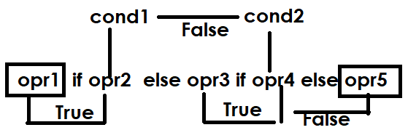

Example:
print("A") if True else print("B") if True else print("C")
print("A") if False else print("B") if True else print("C")
print("A") if False else print("B") if False else print("C")

Output
A
B
C

Example:
# Write a program to find input number is +ve,-ve or zero

num=int(input("Enter any number "))
print("+ve") if num>0 else print("-ve") if num<0 else print("zero")

Output
Enter any number 5
+ve
Enter any number -15
-ve
Enter any number 0
Zero

Example:
# Write a program to input rollno,name 2 subject marks
# calculate total,avg and grade
# grade is given based on avg
# avg>=80 ---> A
# avg>=60<80 --> B
# avg>=40<60 --> C
# avg<40 --> D

#input
rno=int(input("Rollno :"))
name=input("StudentName :")
sub1=int(input("Subject1Marks :"))
sub2=int(input("Subject2Marks :"))

#Process
total=sub1+sub2
avg=total/2
grade="A" if avg>=80 else "B" if avg>=60 and avg<80 else "C" if avg>=40 and avg<60 else "D"

#Output
print("Rollno ",rno)
print("StudentName ",name)
print("Subject1Marks ",sub1)
print("Subject2Marks ",sub2)
print("Total Marks ",total)
print("Avg Marks ",avg)
print("Grade ",grade)

Output
Rollno :3
StudentName :ramesh
Subject1Marks :30
Subject2Marks :30
Rollno 3
StudentName ramesh
Subject1Marks 30
Subject2Marks 30
Total Marks 60
Avg Marks 30.0
Grade D

Membership Operator
Membership operator is used for searching given value exist in collection of values.
Membership is used for collection data type.
Membership operator is binary operator and required 2 operands to perform operation.
Membership operator returns boolean value True/False
Membership operator is represented using 2 keywords

- in
- not in
Membership Operator
Membership operator is used for searching given value exist in collection of values.
Membership is used for collection data type.
Membership operator is binary operator and required 2 operands to perform operation.
Membership operator returns boolean value True/False
Membership operator is represented using 2 keywords

- in
- not in

>>> "a" in "java"
True
>>> "av" in "java"
True
>>> 10 in [100,200,300,400]
False
>>> "nit@gmail.com" in ["naresh@nareshit.com","nit@gmail.com"]
True
>>> "a" in "python"
False
>>> "a" not in "python"
True
>>> "y" not in "python"
False

Example:
# write a program to find input letter is vowel or not

ch=input("input any letter")
print("Vowel") if ch in "aeiouAEIOU" else print("Not Vowel")

Output
input any lettera
Vowel

input any letterI
Vowel
input any letterx
Not Vowel

Bitwise Operators
Bitwise operators perform operations on binary data (0’s and 1’s)
Bitwise operators are applied only on integer data type
Python supports the following bitwise operators

- shift operators
  - left shift operator <<
  - right shift operator >>
- Bitwise & (and) operator
- Bitwise | (or) operator
- Bitwise ^ (XOR) operator
- Bitwise ~ (not) operator

Applications of bitwise operators
- Perform arithmetic operations
- Memory management
- Embedded applications/Low Level Programming
- Encryption and decryption
- Images, audio and video processing

Shift Operators
Shifting operators are binary operators and required 2 operands to perform operations.

Left shift operator <<
This operator is used to shift n bits towards left side.
In left shift operation n bits are added at right side
Left shift operator performs the following arithmetic operation
opr*2 pow n

Syntax: opr<<n

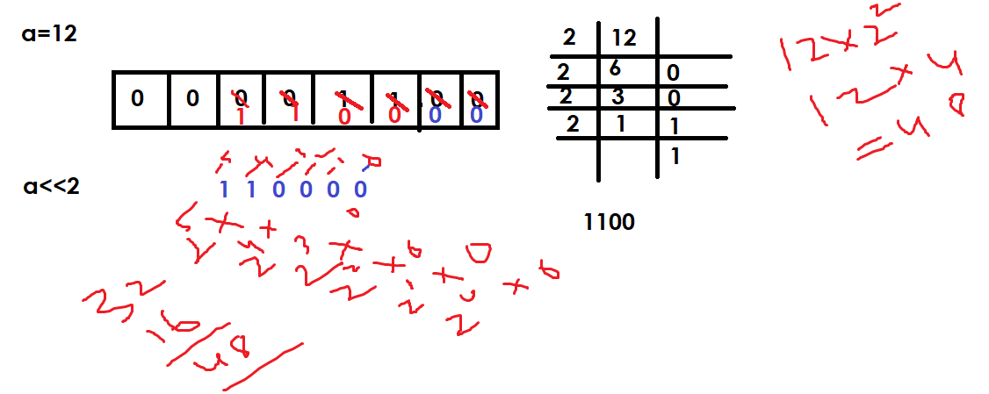
>>> a=12
>>> b=a<<2
>>> print(a,b)
12 48
>>> print(bin(a),bin(b))
0b1100 0b110000
>>> x=0b1100
>>> y=x<<2
>>> print(x,y)
12 48
>>> print(bin(x),bin(y))
0b1100 0b110000
>>> a=0b1
>>> b=a<<2
>>> print(bin(a),bin(b))
0b1 0b100
>>> print(a,b)
1 4

>> Right shift operator
This operator shift n bits towards right side
By shifting n bits right side the bits shifted are deleted
This operator performs the division operation
Opr/2 pow n

Syntax: opr>>n
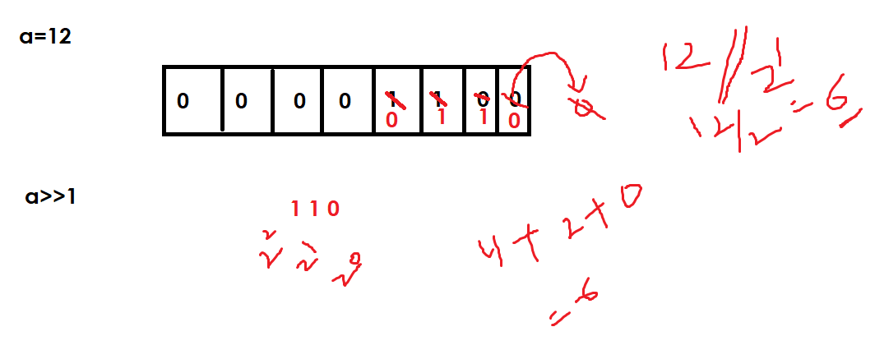

>>> a=12
>>> b=a>>1
>>> print(a,b)
12 6
>>> print(bin(a),bin(b))
0b1100 0b110
>>> x=0b1100
>>> y=x>>2
>>> print(bin(x),bin(y))
0b1100 0b11
>>> print(x,y)
12 3

Bitwise (&) Operator
Bitwise & (and) operator is used to apply and gate
Truth table of & (and) operator

Opr1 | Opr2 | Opr1 & Opr2
1 | 1 | 1
0 | 1 | 0
1 | 0 | 0
0 | 0 | 0

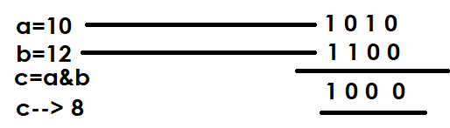
>>> a=10
>>> b=12
>>> c=a&b
>>> print(bin(a),bin(b),bin(c))
0b1010 0b1100 0b1000
>>> x=0b101
>>> y=0b100
>>> z=x&y
>>> print(bin(x),bin(y),bin(z))
0b101 0b100 0b100
>>> print(x,y,z)
5 4 4
>>> a=0xa
>>> b=0xc
>>> c=a&b
>>> print(a,b,c)
10 12 8
>>> print(hex(a),hex(b),hex(c))
0xa 0xc 0x8

Bitwise | (or) operator
This operator is used to apply logical or gate
Truth table or | operator

Opr1 | Opr2 | Opr1|Opr2
0 | 0 | 0
1 | 1 | 1
0 | 1 | 1
1 | 0 | 1
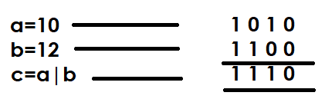

>>> a=10
>>> b=12
>>> c=a|b
>>> print(a,b,c)
10 12 14
>>> print(bin(a),bin(b),bin(c))
0b1010 0b1100 0b1110
>>> x=0b101
>>> y=0b110
>>> z=x|y
>>> print(bin(x),bin(b),bin(z))
0b101 0b1100 0b111
>>> print(x,y,z)
5 6 7
Bitwise (^) XOR operator
This operator is used for applying XOR gate.
Truth table of XOR gate or operator
Opr1 | Opr2 | Opr1 ^ Opr2
0 | 0 | 0
1 | 1 | 0
1 | 0 | 1
0 | 1 | 1

>>> a=0b1010
>>> b=0b1100
>>> c=a^b
>>> print(a,b,c)
10 12 6
>>> print(bin(a),bin(b),bin(c))
0b1010 0b1100 0b110
>>> x=10
>>> y=12
>>> z=x^y
>>> print(x,y,z)
10 12 6
>>> print(bin(x),bin(y),bin(z))
0b1010 0b1100 0b110

~ not operator
It is a unary operator and required one operand to perform operation.
Truth table of not operator
Opr1 | ~opr1
1 | 0
0 | 1

-(opr+1) 🡺 Formula

>>> a=5
>>> b=~a
>>> print(a,b)
5 -6
>>> print(bin(a),bin(b))
0b101 -0b110
>>> c=~b
>>> print(b,c)
-6 5
>>> x=0
>>> y=~x
>>> print(x,y)
0 -1
>>> print(bin(x),bin(y))
0b0 -0b1
>>> p=1
>>> q=~p
>>> print(bin(p),bin(q))
0b1 -0b10
>>> n1=0b101
>>> n2=~n1
>>> print(bin(n1),bin(n2))
0b101 -0b110
>>> a=0
>>> b=~a
>>> print(bin(a),bin(b))
0b0 -0b1
>>> x=0b11
>>> y=~x
>>> print(bin(x),bin(y))
0b11 -0b100

Example:
#Write a program to find given number is even or odd

num=int(input("Enter any number "))
b=num&1
print("Even") if b==0 else print("Odd")

Output
Enter any number 5
Odd

Example:
# Write a program to multiply and divide number with 2
# without using * and /
# using bitwise operators

num=int(input("Enter any number "))
res1=num<<1
res2=num>>1
print(num,res1,res2)

Output
Enter any number 5
5 10 2

Example:
# Write a program to swap two numbers using bitwise
# operators

n1=int(input("Enter first number "))
n2=int(input("Enter second number "))

print("Before Swaping ",n1,n2)
n1=n1^n2
n2=n1^n2
n1=n1^n2

print("After Swaping ",n1,n2)

Output
Enter first number 10
Enter second number 20
Before Swaping 10 20
After Swaping 20 10

# permissions

rwx=0b111

r=0b100
w=0b010
x=0b001

rw=rwx^x
print(bin(rwx),bin(rw))
rx=rwx^w
print(bin(rwx),bin(rx))

Output
0b111 0b110
0b111 0b101
Walrus Operator (OR) Assignment Expression Operator

Walrus operator is a binary operator and required 2 operands to perform operation.
Walrus operator is introduced in python 3.8 version
Walrus operator is also called assignment expression operator.
This operator is represented using :=
Walrus operator is as a part of expression.

A single expression contains only one assignment operator.
In order to use multiple assignment operators within expression we are using walrus operator.

Example:
>>> c:=100
SyntaxError: invalid syntax
>>> a=5
>>> b=2
>>> c=(d=a+b)*(e=a-b)
SyntaxError: invalid syntax. Maybe you meant '==' or ':=' instead of '='?
>>> c=(d:=a+b)*(e:=a-b)
>>> print(a,b,c,d,e)
5 2 21 7 3

Assignment Operators OR augmented assignment statements
A single operator which perform two operations
- Assignment operation
- Binary operation

Augmented assignment operators combine an arithmetic or bitwise operation with an assignment operator in a single, shorthand statement.
Augmented assignment operators are called update operator.

Operator | Description
+= | a=10  a=a+5 (OR) a+=5  b=5  b=b+1 (OR) b+=1
-= | x=10  x=x-5 (OR) x-=5
*= | a=5  a=a*2 (OR) a*=2
/= | a=10  a=a/2 (OR) a/=2
//= | a=10  a=a//2 (OR) a//=2
%= | a=5  a=a%2 (OR) a%=2
**= | a=5  a=a**3 (OR) a**=3
>>= | a=10  a=a>>1 (OR) a>>=1
<<= | a=10  a=a<<1 (OR) a<<=1
&= | a=10  b=5  a=a&b (OR) a&=b
|= | a=10  b=5  a=a|b (OR) a|=b
^= | a=10  b=5  a=a^b (OR) a=a^b

Example:
a=10
print("Before updating the value of a=",a)
a>>=1
print("After updating the value of a=",a)
b=15
print("Before updating the value of b=",b)
b<<=1
print("After updating the value of b=",b)
c=12
print("Before updating the value of c=",c)
c*=5
print("After updating the value of c=",c)

Output
Before updating the value of a= 10
After updating the value of a= 5
Before updating the value of b= 15
After updating the value of b= 30
Before updating the value of c= 12
After updating the value of c= 60

Example:
# Find output
a=5
b=7
a+=b
print(a,b)
x=10
y=5
z=2
x*=y+z
print(x,y,z)
p=5
q=2
r=4
p+=q*r
print(p,q,r)

Output
12 7
70 5 2
13 2 4
Identity operator
In python identity operator is represented using keyword
- is
- is not

Python is an object oriented programming language and data is represented as objects. Every object in memory is identified with a unique number called address.

How find address of an object?
Address of object can be find using id() function

>>> a=10
>>> id(a)
140716412937624

“is” operator is used to compare two variables are pointing to same object in memory or not.

Example:
a=10
b=20
c=a
print(id(a),id(b),id(c))
print(a,b,c)
print(a is b)
print(a is c)
print(a==b)
print(a==c)

Output
140716412937624 140716412937944 140716412937624
10 20 10
False
True
False
True

Python data types are classified into 2 categories
Mutable Types | Immutable Types
Mutable types allow to do changes within same object or memory location. | Immutable types does allows to do changes within same object or same memory location
Collections  - Sequences  List  - Sets  Set  - Mapping  dictionary (OR) dict type | All scalar datatypes are immutables  - int  - float  - complex  - bool  - NoneType  Collections  - Sequences  Tuple,str,range,bytes,bytearray  - Set  frozenset
Python data types are classified into 2 categories
Mutable Types | Immutable Types
Mutable types allow to do changes within same object or memory location. | Immutable types does allows to do changes within same object or same memory location
Collections  - Sequences  List  - Sets  Set  - Mapping  dictionary (OR) dict type | All scalar datatypes are immutables  - int  - float  - complex  - bool  - NoneType  Collections  - Sequences  Tuple,str,range,bytes,bytearray  - Set  frozenset

Immutable objects are sharable.

Example:
a=10
b=10
c=10
print(a,b,c)
print(id(a),id(b),id(c))
x=100
print(x,id(x))
x=200
print(x,id(x))

Output
10 10 10
140717143860632 140717143860632 140717143860632
100 140717143863512
200 140717143866712

Note: An immutable type does not provide any methods or functions to modify object value.

Example:
a=[10,20,30]
print(a,id(a))
a.append(40)
print(a,id(a))
x=[10,20,30]
y=[10,20,30]
print(id(x),id(y))
p=100
q=100
print(id(p),id(q))
print(x==y)
print(x is y)
z=x
print(x is z)

Output
[10, 20, 30] 1859568857344
[10, 20, 30, 40] 1859568857344
1859612966592 1859612861504
140717143863512 140717143863512
True
False
True

What is difference between == and is operator in python?
Feature | == (Equality Operator) | is (Identity Operator)
Purpose | Compares values/content | Compares object identity/memory address
Checks for | If objects have the same value | If variables refer to the same object
Use Case | General value comparison | Checking if two variables are the same instance of an object
Control Statements
Topics:
Conditional Control Statements
If
If..else
If..elif..else (if..else ladder)
Nested if
Match statement
Looping Control Statements
While
For
Branching statements
Break
Continue
Pass
Control statements are used to control the flow of execution of program.

Conditional Control Statements
Conditional control statements are used to execute block of statements based on condition.
Conditional control statements are also decision making statements.
Python support 2 types of conditional control statements
- if statement
- match statement

if statement
if is a keyword which represents condition control statement
if conditional control statement allows to execute block of statements based on condition.

Python support 4 types of if statements
- simple if
- if..else
- if..elif..else (if..else ladder)
- nested if

simple if
if without else is called simple if
this syntax allows only if block without else block

Syntax:
If <condition>:
Statement-1
Statement-2
Statement-3

If condition is True, Python runtime executes statement-1,statement-2 and statement-3
If condition is False, python runtime executes only statement-3
if True:  print("Python")  print("JAVA") | Output  Python  JAVA
if False:  print("Python")  print("JAVA") | Output

If..else
This syntax is having two blocks
- if block
- else block
if condition:
statement-1
statement-2
else:
statement-3
statement-4

statement-5

If..else
This syntax is having two blocks
- if block
- else block
if condition:  statement-1  statement-2  else:  statement-3  statement-4  statement-5 | 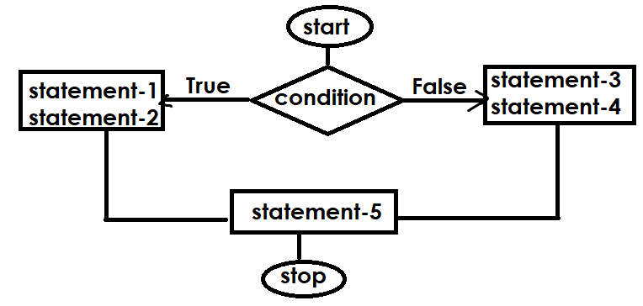

# Write a program to find input number is even or odd

num=int(input("Enter any number "))
if num%2==0:
print(num,"is even")
else:
print(num,"is odd")

Output
Enter any number 5
5 is odd

Enter any number 8
8 is even

Example:
# Write a program to find max of two numbers

n1=int(input("Enter First Number "))
n2=int(input("Enter Second Number "))
if n1>n2:
print(n1,"is max")
else:
print(n2,"is max")
Output
Enter First Number 10
Enter Second Number 20
20 is max

Enter First Number 30
Enter Second Number 20
30 is max

Example:
# Write a program to find input number is 3 digit or not
num=int(input("Enter any number "))
if num>=100 and num<=999:
print(num,"is 3 digit number ")
else:
print(num,"is not 3 digit number")

Output
Enter any number 450
450 is 3 digit number

Enter any number 1400
1400 is not 3 digit number

Example:
# Write a program to find last digit of input number
# is divisible with 3 or not

num=int(input("Enter any number "))
last_digit=num%10
if last_digit%3==0:
print(num,"last digit is divisible with 3")
else:
print(num,"last digit is not divisible with 3")

Output
Enter any number 126
126 last digit is divisible with 3

Enter any number 179
179 last digit is divisible with 3

Enter any number 125
125 last digit is not divisible with 3

https://www.codechef.com/problems/CHRISTGREET
day=int(input())
if day==25:
print("CHRISTMAS")
else:
print("ORDINARY")

https://www.codechef.com/problems/IDESM
# cook your dish here
day=int(input())
if day==15:
print("YES")
else:
print("NO")

https://www.codechef.com/problems/MANGOLASSI
temp=int(input())
if temp>35:
print("YES")
else:
print("NO")

https://www.codechef.com/problems/CHEFPAROLE
days=int(input())
if days>=7:
print("YES")
else:
print("NO")

https://www.codechef.com/problems/ADVITIYA1
day=int(input())
if day>=1 and day<=18:
print("ADVITIYA")
else:
print("WAITING FOR ADVITIYA")

if..elif..else (if..else ladder)
This syntax allows checking multiple conditions.
Syntax:  if condition1:  statement-1  elif condition2:  statement-2  elif condition3:  statement-3  ….  else:  statement-n  if condition1 is True, python runtime executes statement-1  if condition1 is False, condition2 True  python runtime executes statement-2  if condition1,condition2 are False and condition3 is True, python runtime executes statement-3  if all conditions are False, python runtime executes statement-n | 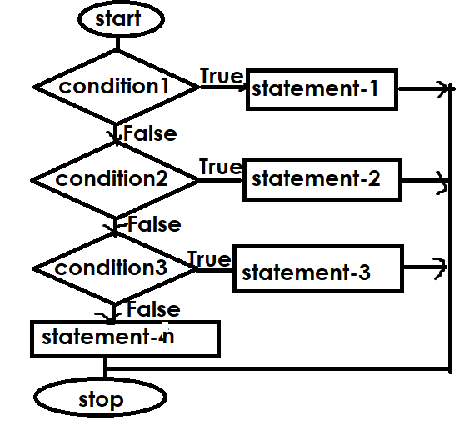

https://csiplearninghub.com/python-if-else-conditional-statement-practice/

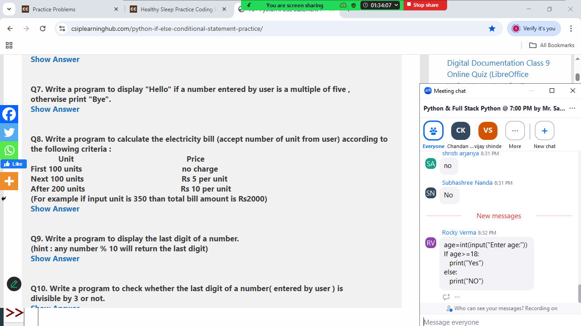

units=int(input("Units :"))
if units<=100:
bill=0
elif units>100 and units<=200:
bill=(units-100)*5
else:
bill=0+500+(units-200)*10

print("Bill Amount is ",bill)

Example:
# Write a program to find input number is +ve,-ve or zero

num=int(input("Enter Number :"))
if num>0:
print("+ve")
elif num<0:
print("-ve")
else:
print("zero")

Output
Enter Number :100
+ve
Enter Number :-100
-ve
Enter Number :0
zero
#Write a program to find input letter is alphabet
# digit or special character

ch=input("Enter any character")
if (ch>='A' and ch<='Z') or (ch>='a' and ch<='z'):
print("Alphabet")
elif ch>='0' and ch<='9':
print("Digit")
else:
print("Special Character")

Output
Enter any character7
Digit

Enter any character$
Special Character

Enter any characterB
Alphabet

Example:
# Write a program to convert input alphaet from
# uppercase to lowercase
# lowercase to uppercase

ch=input("Enter any letter ")
if ch>='A' and ch<='Z':
ch=chr(ord(ch)+32)
elif ch>='a' and ch<='z':
ch=chr(ord(ch)-32)
else:
print("input only alphabets")

print(ch)

Output
Enter any letter D
d

Enter any letter d
D

# Write a program to find input year is leap or not

year=int(input("Year :"))
if (year%4==0 and year%100!=0) or (year%400==0):
print(year,"leap year")
else:
print(year,"not leap year")

Output
Year :2024
2024 leap year

Year :2021
2021 not leap year

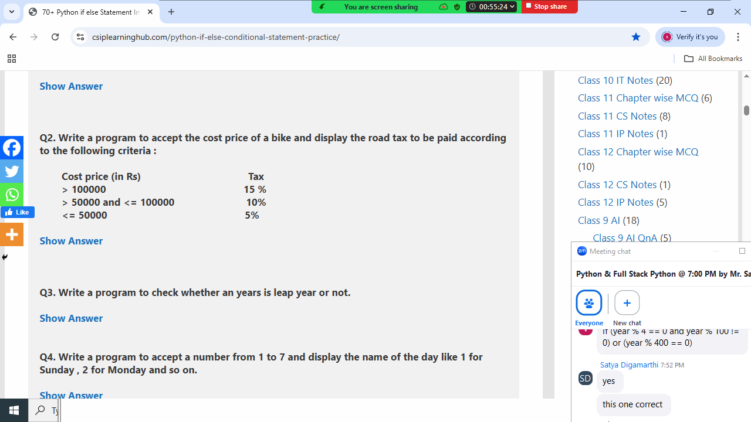

price=int(input("Bike Price :"))
if price>100000:
tax=price*15/100
elif price>50000 and price<=100000:
tax=price*10/100
else:
tax=price*5/100

print("Bike Price ",price)
print("Tax ",tax)
print("Total Cost ",price+tax)

Output
Bike Price :70000
Bike Price 70000
Tax 7000.0
Total Cost 77000.0

Bike Price :45000
Bike Price 45000
Tax 2250.0
Total Cost 47250.0

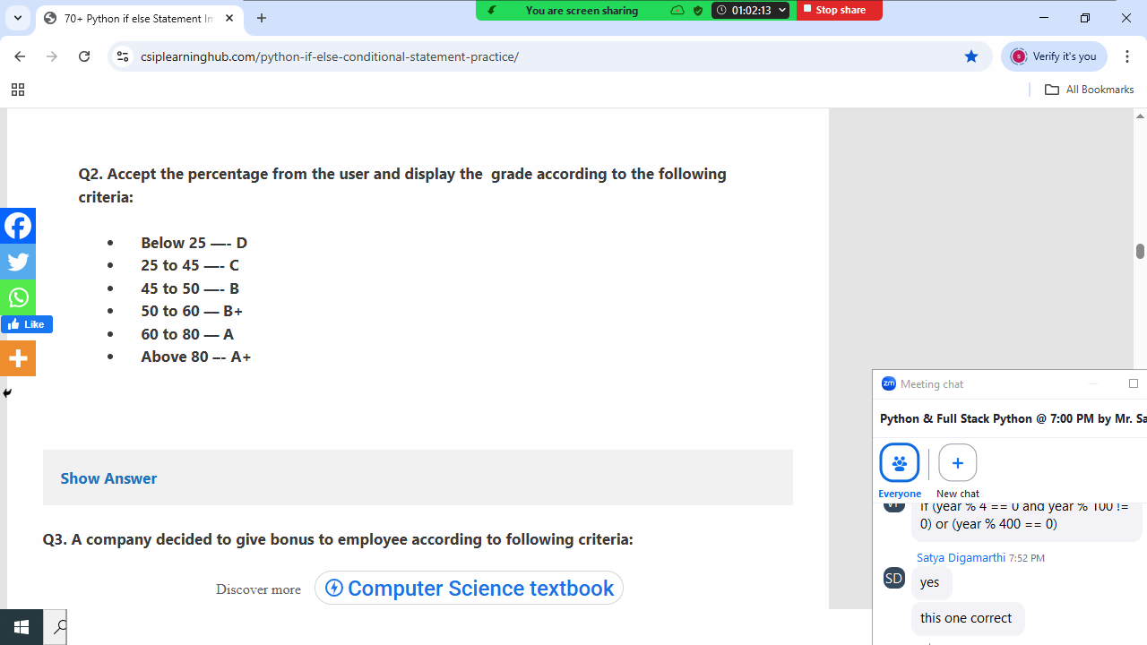
p=int(input("Percentage :"))
if p>80:
print("A+")
elif p>60 and p<=80:
print("A")
elif p>50 and p<=60:
print("B+")
elif p>45 and p<=50:
print("B")
elif p>=25 and p<=45:
print("C")
else:
print("D")

Output
Percentage :98
A+

Percentage :70
A

Percentage :30
C

Example:
# Write a program to find max of 3 numbers

n1=int(input("input first number "))
n2=int(input("input second number "))
n3=int(input("input third number "))
if n1>=n2 and n1>=n3:
print(n1,"is max")
elif n2>=n1 and n2>=n3:
print(n2,"is max")
elif n3>=n1 and n3>=n2:
print(n3,"is max")

Output
input first number 100
input second number 200
input third number 200
200 is max

input first number 100
input second number 100
input third number 100
100 is max

Nested if
Defined if inside if is called nested if (OR)
If followed by another if is called nested if (OR)
If within if is called nested if

Syntax:
If condition1:
If condition2:
Statement-1
else:
Statement-2
elif condition3:
If condition4:
Statement-3
Else:
Statement-4
else:
Statement-5

# Login application

user=input("UserName :")
pwd=input("Password :")
if user=="nit":
if pwd=="n123":
print("Welcome")
else:
print("Invalid password")
else:
print("invalid username")

Output
UserName :nit
Password :n123
Welcome

UserName :nit
Password :nit123
Invalid password

UserName :abc
Password :n123
invalid username

Example:
# Write a program to find input year is leap or not
# without using and, or operators

year=int(input("Enter any year :"))
if year%4==0:
if year%100==0:
if year%400==0:
print(year,"leap year")
else:
print(year,"not leap year")
else:
print(year,"leap year")
else:
print(year,"not leap year")

Output
Enter any year :2024
2024 leap year

Enter any year :2025
2025 not leap year

Match statement
match statement

match statement is introduced in python 3.10 version
match is conditional control statement.
match is similar to switch statement in C,C++ and java programming languages.
The Python match statement allows you to compare values against patterns. Its structure is similar to the switch-case statement in other programming languages.

Syntax of match statement

match subject:
case pattern_1:
# Code to execute if subject matches pattern_1
case pattern_2:
# Code to execute if subject matches pattern_2
# ...
case _:
# Code to execute if no other pattern matches (default case)

match subject::
The match keyword initiates the statement, followed by the
subject – the value or expression to be matched against various patterns.
case pattern::
Each case clause specifies a pattern to compare against the subject. If a pattern matches the subject, the corresponding code block is executed. Only the first matching case block is executed, and then the match statement concludes.
case _::
The underscore (_) acts as a wildcard pattern, serving as a default case. If no other case pattern matches the subject, the code block associated with case _ will be executed.

Literal Patterns: Matching against specific values (e.g., numbers, strings).
x=4
match x:
case 1:
print("ONE")
case 2:
print("TWO")
case 3:
print("THREE")
case 4:
print("FOUR")
case 5:
print("FIVE")
case _:
print("Invalid Number")

Output
FOUR

Example:
signal=input("Signal Color ")
match signal:
case "red"|"RED":
print("STOP")
case "green"|"GREEN":
print("GO")
case "yellow"|"YELLOW":
print("SLOW")

Output
Signal Color RED
STOP
Signal Color YELLOW
SLOW

Example:
#Simple Calculator
n1=int(input("Enter First Number "))
n2=int(input("Enter Second Number "))
opr=input("Enter Operator :")
match opr:
case '+':
print("Sum of ",n1,n2,"is",n1+n2)
case '-':
print("Diff of ",n1,n2,"is",n1-n2)
case '*':
print("Product of ",n1,n2,"is",n1*n2)
case '/':
print("Division of ",n1,n2,"is",n1/n2)
case _:
print("Invalid Operator")

Output
Enter First Number 5
Enter Second Number 2
Enter Operator :/
Division of 5 2 is 2.5

Enter First Number 10
Enter Second Number 5
Enter Operator :**
Invalid Operator

Example:
balance=45000
print("****ATM*****")
print("1. Deposit ")
print("2. Withdraw")
print("3. Check Balance")
print("4. Exit")
opt=int(input("Enter Your Option :"))
match opt:
case 1:
amt=int(input("Amount to Deposit :"))
balance=balance+amt
print("Balance available is ",balance)
case 2:
amt=int(input("Amount to Withdraw :"))
if amt<balance:
balance=balance-amt
print("Balance available is ",balance)
else:
print("Insuff balance")
case 3:
print("Balance is ",balance)
case 4:
print("Thanks for using ATM")
case _:
print("Invalid Option")

Output
****ATM*****
1. Deposit
2. Withdraw
3. Check Balance
4. Exit
Enter Your Option :2
Amount to Withdraw :10000
Balance available is 35000

****ATM*****
1. Deposit
2. Withdraw
3. Check Balance
4. Exit
Enter Your Option :2
Amount to Withdraw :60000
Insuff balance

# Simple Area Calculator

print("1.Area of Circle")
print("2.Area of Triangle")
print("3.Area of Rectangle")
print("4.Exit")
opt=int(input("Enter your option "))
match opt:
case 1:
radious=float(input("Enter Radious of Circle :"))
area=3.147*radious*radious
print("Area of circle is ",round(area,2))
case 2:
base=float(input("Enter Base of triangle :"))
height=float(input("Enter Height of triangle :"))
area=0.5*base*height
print("Area of triangle is",round(area,2))
case 3:
l=float(input("Enter Length of rectangle "))
b=float(input("Enter Breadth of rectangle "))
area=l*b
print("Area of rectangle is",round(area,2))
case 4:
print("Bye")
case _:
print("Invalid Option")

Output
1.Area of Circle
2.Area of Triangle
3.Area of Rectangle
4.Exit
Enter your option 2
Enter Base of triangle :1.5
Enter Height of triangle :1.8
Area of triangle is 1.35

1.Area of Circle
2.Area of Triangle
3.Area of Rectangle
4.Exit
Enter your option 1
Enter Radious of Circle :1.5
Area of circle is 7.08

Example:
# Write a program to find input alphabet is vowel or not
ch=input("Enter any alphabet")
match ch:
case 'a'|'e'|'i'|'o'|'u':
print("Vowel")
case 'A'|'E'|'I'|'O'|'U':
print("Vowel")
case _:
print("Not Vowel")

Output
Enter any alphabetu
Vowel

Enter any alphabetI
Vowel

Enter any alphabetx
Not Vowel

Conditional pattern
Defining pattern using if statement or condition.
If condition is True, it execute case block else compare with next case or pattern.

match subject:
case if condition:
statement
case if condition:
statement
…
case _:
statement

Example:
# Write a program to find input number is even or odd
num=int(input("Enter any number "))
match num:
case num if num%2==0:
print("Even")
case num if num%2!=0:
print("Odd")

Output
Enter any number 5
Odd

Enter any number 4
Even

Example:
# finding grade (A,B,C)
name=input("Enter Name ")
sub1=int(input("Subject1Marks :"))
sub2=int(input("Subject2Marks "))
total=sub1+sub2
avg=total/2
print("Name :",name)
print("Subject1Marks :",sub1)
print("Sujbect2Marks :",sub2)
print("Total Marks :",total)
print("Avg Marks :",avg)
match avg:
case avg if avg>70:
print("Grade:A")
case avg if 50<avg<=70:
print("Grade:B")
case avg if 40<avg<=50:
print("Grade:C")
case _:
print("Grade:D")

Output
Enter Name kiran
Subject1Marks :20
Subject2Marks 20
Name : kiran
Subject1Marks : 20
Sujbect2Marks : 20
Total Marks : 40
Avg Marks : 20.0
Grade:D

Formatting String (OR) formatting output

Formatting string allows insert values within string dynamically
This format string is done in different ways
- f-string
- format method/function
- old-style string format
Formatting String (OR) formatting output

Formatting string allows insert values within string dynamically
This format string is done in different ways
- f-string (python 3.6)
- format method/function (python 2.6)
- old-style string format

f-string
f-string or formatted string is introduced in python 3.6 version.
f-string allows to insert values within string
f-string is prefix with f or F, followed by single or double or triple quotes
Key Features
Embedding variables and expression
It allows embed/insert variables and expression within string using special symbol {} (place holders)

Using formatting character
It allows displaying or inserting data in different formats using formatting characters

Syntax: f’characters {variable}/{expression}’

Example:
a=10
b=5
print(f'value of a={a}')
print(f'value of b={b}')
print(f'sum of {a} and {b} is {a+b}')
print(f'{a+b} is sum of {a} and {b}')

Output
value of a=10
value of b=5
sum of 10 and 5 is 15
15 is sum of 10 and 5
Example:
# Write a program to find simple intrest
# si=ptr/100

#input
p=float(input("Amount :"))
t=int(input("Time :"))
r=float(input("Rate :"))

#process
si=p*t*r/100

#output
print(f"""Amount={p}
Time={t}
Rate={r}
Simple Interest={si}""")

Output
Amount :9000
Time :12
Rate :1.5
Amount=9000.0
Time=12
Rate=1.5
Simple Interest=1620.0

Example:
# write a program to find total,avg of student marks

name=input("Name :")
s1=int(input("Subject1Marks :"))
s2=int(input("Subject2Marks :"))

total=s1+s2
avg=total/2

print(f"StudentName:{name}")
print(f"Subject1Marks:{s1}")
print(f"Subject2Marks:{s2}")
print(f"""TotalMarks:{total}
AvgMarks:{avg}""")

Output
Name :naresh
Subject1Marks :70
Subject2Marks :80
StudentName:naresh
Subject1Marks:70
Subject2Marks:80
TotalMarks:150
AvgMarks:75.0

Formatting characters
Formatting characters defines the type in which value to be inserted within string.

d : decimal
o:octal
x:hexadecimal
b:binary
f:float in fixed
e:float in exponent
s:string

Example:
a=12
print(f"value of a={a:d}")
print(f"value of a={a:o}")
print(f"value of a={a:x}")
print(f"value of a={a:b}")

b=1.5
print(f"value of b={b:f}")
print(f"value of b={b:e}")
print(f"value of b={b:.2f}")
print(f"value of b={b:.4f}")
print(f"value of b={b:.3e}")

c=65
print(f"value of c={c:c}")
print(f"value of c={c:d}")

d='A'
e="naresh"
print(f"value of d={d:s}")
print(f"value of e={e:s}")

Output
value of a=12
value of a=14
value of a=c
value of a=1100
value of b=1.500000
value of b=1.500000e+00
value of b=1.50
value of b=1.5000
value of b=1.500e+00
value of c=A
value of c=65
value of d=A
value of e=naresh

format method or format function of string
before f-string, string formatting is done using format method or format function.
- Introduced in Python 2.6 as an improvement over the old % operator.
- Uses curly braces {} as placeholders within the string, which are then replaced by arguments passed to the .format() method.
- Placeholders can be empty {}, indexed {0}, {1}, or named {name}.

Example:
a=10
b=5
print("the value of a={}".format(a))
print("the value of b={}".format(b))
print("the sum of {} and {} is {}".format(a,b,a+b))
print("{} is sum of {},{}".format(a+b,a,b))

Output
the value of a=10
the value of b=5
the sum of 10 and 5 is 15
15 is sum of 10,5

Example:
a=10
b=20
c=30
d=40
print("{},{},{},{}".format(a,b,c,d))
print("{0},{1},{2},{3}".format(a,b,c,d))
print("{2},{0},{3},{1}".format(a,b,c,d))
print("{0},{1},{2},{3}".format(b,d,a,c))
print("{p},{q},{r},{t}".format(p=a,q=b,r=c,t=d))
x=65
print("{p:d},{p:o},{p:x},{p:b}".format(p=x))

Output
10,20,30,40
10,20,30,40
30,10,40,20
20,40,10,30
10,20,30,40
65,101,41,1000001
Example:
# Write a program to find area of triangle

base=float(input("Input Base of Triangle "))
height=float(input("Input Height of Triangle "))

area=0.5*base*height

print("""Area of triangle with
base={} and height={} is {:.2f}""".format(base,height,area))

Output
Input Base of Triangle 1.5
Input Height of Triangle 1.2
Area of triangle with
base=1.5 and height=1.2 is 0.90

old-style string formatting
old-style string formatting is also called c-style string formatting
In this style, string formatting using string interpolation operator (%)

Syntax: “formatting characters”%(variable,….)

%d 🡪 decimal integer
%o 🡪 octal integer
%x 🡪 Hexadecimal Integer
%s 🡪 String
%c 🡪 Single Character
%f 🡪 float in fixed notation
%e 🡪 float in exponent notation

Example:
a=10
b=20
c=30
print("a=%d,b=%d,c=%d"%(a,b,c))
print("sum of %d,%d,%d is %d"%(a,b,c,a+b+c))
print("%d,%o,%x"%(a,a,a))

Looping control statements
Looping control statements are used for repeating one or more than one statement number of times or until given condition.
Python support the following types of looping control statements
- while loop
- for loop

Note: python does not support do..while

while loop

“while” is a keyword, which represents while loop
In application development while loop is used to repeat block of statements until given condition.

Syntax1: | Syntax2:
while condition:  statement-1  statement-2  Python repeats statement-1, statement-2 until given condition is False. | while condition:  statement-1  statement-2  else:  statement-3  statement-4  Python repeats statement-1,statement-2 until given condition is False  Python execute else block if condition is False.

While loop required 3 statements
- initialization statement
- condition
- update statement
Looping control statements
Looping control statements are used for repeating one or more than one statement number of times or until given condition.
Python support the following types of looping control statements
- while loop
- for loop

Note: python does not support do..while

while loop

“while” is a keyword, which represents while loop
In application development while loop is used to repeat block of statements until given condition.

Syntax1: | Syntax2:
while condition:  statement-1  statement-2  Python repeats statement-1, statement-2 until given condition is False. | while condition:  statement-1  statement-2  else:  statement-3  statement-4  Python repeats statement-1,statement-2 until given condition is False  Python execute else block if condition is False.

While loop required 3 statements
- initialization statement
- condition
- update statement

Initialization statement: This statement defines initial value of condition
condition : It is a boolean expression, which defines how many times loop has to be repeated

Update statement: It is a statement which updates condition

Example:
i=1 # init statement
while i<=5: # condition
print("Hello")
i=i+1 # update statement

Output
Hello
Hello
Hello
Hello
Hello

# Write a program to print numbers from 1 to 10
# using while loop

num=1
while num<=10:
print(num,end=' ')
num=num+1

# Write a program to print numbers from 10 to 1
# using while loop

print()
num=10
while num>=1:
print(num,end=' ')
num=num-1

# write a program to print even numbers from 2 to 20
# using while loop
print()
num=2
while num<=20:
print(num,end=' ')
num=num+2

print()
# write program to print odd numbers from 1 to 20
num=1
while num<=20:
print(num,end=' ')
num=num+2

Example:
# Write a program to print sum of 5 numbers
# input 5 numbers from keyboard

i=1
s=0
while i<=5:
num=int(input("enter any number "))
s=s+num
i=i+1

print(f'Sum is {s}')
Output
enter any number 6
enter any number 1
enter any number 4
enter any number 9
enter any number 3
Sum is 23

Example:
# Write a program to print math table of input number

num=int(input("enter any number "))

i=1
while i<=10:
p=num*i
print(f'{num}x{i}={p}')
i=i+1

Output
enter any number 9
9x1=9
9x2=18
9x3=27
9x4=36
9x5=45
9x6=54
9x7=63
9x8=72
9x9=81
9x10=90

Example:
# Write a program to find maximum value of input 5 values

i=1
m=0
while i<=5:
num=int(input("enter any number "))
if num>m:
m=num
i=i+1

print(f'Maximum number is {m}')

Output
enter any number 9
enter any number 2
enter any number 5
enter any number 7
enter any number 2
Maximum number is 9

# Write a program to find input number is prime or not

num=int(input("Enter any number "))
c=0
i=1
while i<=num:
if num%i==0:
c=c+1
i=i+1

if c==2:
print(f'{num} is prime')
else:
print(f'{num} is not prime')

Output
Enter any number 4
4 is not prime

Enter any number 5
5 is prime

Example:
# Write a program to find length of number (count of digits)

num=int(input("Enter any number "))
c=0
while num>0:
c=c+1
num=num//10

print(f'Count of digits {c}')

Output
Enter any number 123
Count of digits 3

Enter any number 69457
Count of digits 5

Example:
# Write a program to print sum of digits

num=int(input("enter any number "))
s=0
while num>0:
d=num%10
s=s+d
num=num//10
print(f'Sum of digits {s}')

Output
enter any number 125
Sum of digits 8

enter any number 7891
Sum of digits 25
Example:
# Write a program to find input number is
# armstrong number or not

num=int(input("enter any 3 digit number "))
num1=num
s=0
while num>0:
d=num%10
s=s+(d**3)
num=num//10

if s==num1:
print(f'{num1} is armstrong number ')
else:
print(f'{num1} is not armstrong number')

Output
enter any 3 digit number 370
370 is armstrong number

enter any 3 digit number 371
371 is armstrong number

enter any 3 digit number 372
372 is not armstrong number
#Write a program to reverse number

num=int(input("Enter any number "))
rev=0

while num>0:
d=num%10
rev=(rev*10)+d
num=num//10

print(f'Reverse Number is {rev}')

Output
Enter any number 153
Reverse Number is 351

Example:
# Write a program to find input number is palindrome or not
# if reverse number is equal to original number it is called
# palindorme
num=int(input("Enter any number "))
num1=num
rev=0

while num>0:
d=num%10
rev=(rev*10)+d
num=num//10

if num1==rev:
print(f'{num1} is palindrome')
else:
print(f'{num1} is not palindrome')

Output
Enter any number 121
121 is palindrome

Enter any number 123
123 is not palindrome

Example
# Write a program input decimal number and convert into
# binary number

num=int(input("Enter any number "))

binary=""
while num>0:
r=num%2
binary=binary+str(r)
num=num//2

print("0b"+binary[::-1])

Output
Enter any number 5
0b101

Example:
# Write a program input decimal number and convert into
# octal number

num=int(input("Enter any number "))

octal=""
while num>0:
r=num%8
octal=octal+str(r)
num=num//8

print("0O"+octal[::-1])

Output
Enter any number 12
0O14

Example:
# Write a program input decimal number and convert into
# hexadecimal number

num=int(input("Enter any number "))
hexa=''

while num>0:
r=num%16
match r:
case 10:
hexa=hexa+"A"
case 11:
hexa=hexa+"B"
case 12:
hexa=hexa+"C"
case 13:
hexa=hexa+"D"
case 14:
hexa=hexa+"E"
case 15:
hexa=hexa+"F"
case _:
hexa=hexa+str(r)
num=num//16

print(f'0x{hexa[::-1]}')

Output
Enter any number 42
0x2A

Example:
# Write a program to find factorial of input number

num=int(input("Enter any number "))
i=1
fact=1
while i<=num:
fact=fact*i
i=i+1

print(f'factorial of {num} is {fact}')

Output
Enter any number 4
factorial of 4 is 24

Enter any number 5
factorial of 5 is 120

for loop
“for” is a keyword which represents for loop
The for statement is used to iterate over the elements of a sequence (such as a string, tuple or list) or other iterable object:

Syntax:
for variable-name in iterable-object/collection:
statement-1
statement-2

- for loop each time read a value from collection and assign to variable.
- After assigning to variable, it execute block of statements

For loop repeat statement-1,statement-2 until read all the values from collection or iterable.

Example:
for x in "PYTHON":
print(x)

for y in [10,20,30,40,50]:
print(y,end=' ')

Output
P
Y
T
H
O
N
10 20 30 40 50

range datatype
range is an immutable sequence data type
range data type is used for generating sequence of integer values in increment or decrement order.
The range type represents an immutable sequence of numbers and is commonly used for looping a specific number of times in for loops.
range data type is used for arithmetic progression, arithmetic sequence or linear sequence is a sequence of numbers such that the difference from any succeeding term to its preceding term remains constant throughout the sequence. The constant difference is called common difference of that arithmetic progression. For instance, the sequence 5, 7, 9, 11, 13, 15, ... is an arithmetic progression with a common difference of 2.

range datatype required 3 input
- Start
- Stop
- Step

Start: starting value of sequence or range, which is included
Stop: stop value of sequence of range, which is excluded (stop-1)
Step: difference between values within sequence, this is nothing but increment value or decrement value

Syntax-1: range(stop)
Syntax-2: range(start,stop,step)

Syntax-1: range(stop)
This syntax create sequence with default start=0,step=1
Syntax-2: range(start,stop,step)
This syntax create sequence with given start,stop,step values
If step value is not given it uses default step as 1

Example:
r=range(5)

for x in r:
print(x,end=' ')

for y in range(10):
print("PYTHON")

Output
0 1 2 3 4 PYTHON
PYTHON
PYTHON
PYTHON
PYTHON
PYTHON
PYTHON
PYTHON
PYTHON
PYTHON
Syntax-1 always generates sequence of integers in increment order. It always generates +ve sequence of integers

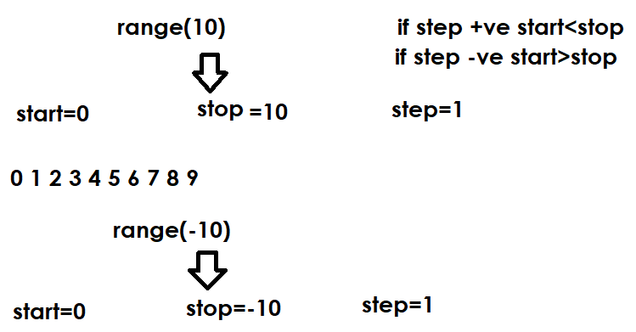

Range data type given start and stop values based on step value
If step is +ve , start<stop
If step is –ve, start>stop

Syntax-2: range(start,stop,[step=1])

Example:
for value in range(1,11): # start=1,stop=11,step=1
print(value,end=' ')

print()
for value in range(-10,0): # start=-10,stop=0,step=1
print(value,end=' ')

print()
for value in range(10,0,-1): # start=10,stop=0,step=-1
print(value,end=' ')

print()
for value in range(-1,-11,-1): # start=-1,stop=-11,step=-1
print(value,end=' ')

# generate 2 4 6 8 10 12 14 16 18 20

print()
for value in range(2,21,2):
print(value,end=' ')

# generate 1 3 5 7 9 11 13 15 17 19
print()
for value in range(1,20,2):
print(value,end=' ')
#gnerate -5 -4 -3 -2 -1 0 1 2 3 4 5
print()
for value in range(-5,6,1):
print(value,end=' ')
#generate 5 4 3 2 1 0 -1 -2 -3 -4 -5
print()
for value in range(5,-6,-1):
print(value,end=' ')
#generate 1 4 9 16 25 36 49 64 81 100
print()
for value in range(1,11,1): # 1 2 3 4 5 6 7 8 9 10
print(value**2,end=' ')
#generate A B C D E F G .... Z
print()
for value in range(65,91,1):
print(chr(value),end=' ')
#generate a b c d e f g .... z
print()
for value in range(97,123,1):
print(chr(value),end=' ')

Output
1 2 3 4 5 6 7 8 9 10
-10 -9 -8 -7 -6 -5 -4 -3 -2 -1
10 9 8 7 6 5 4 3 2 1
-1 -2 -3 -4 -5 -6 -7 -8 -9 -10
2 4 6 8 10 12 14 16 18 20
1 3 5 7 9 11 13 15 17 19
-5 -4 -3 -2 -1 0 1 2 3 4 5
5 4 3 2 1 0 -1 -2 -3 -4 -5
1 4 9 16 25 36 49 64 81 100
A B C D E F G H I J K L M N O P Q R S T U V W X Y Z
a b c d e f g h i j k l m n o p q r s t u v w x y z

Example:
# Write a program to generate math table
# for given input number

# 5x1=5
# 5x2=10
# 5x3=15
#...
# 5x10=50

num=int(input("Enter any number "))
for i in range(1,11): # 1 2 3 4 5 6 7 8 9 10
p=num*i
print(f'{num}x{i}={p}')

Output
Enter any number 9
9x1=9
9x2=18
9x3=27
9x4=36
9x5=45
9x6=54
9x7=63
9x8=72
9x9=81
9x10=90
Example:
# Write a program to find input number is
# prime number or not using for loop

num=int(input("Enter any number "))
c=0
for i in range(1,num+1):
if num%i==0:
c=c+1

if c==2:
print(f'{num} is prime')
else:
print(f'{num} is not prime')

Output
Enter any number 5
5 is prime

Enter any number 4
4 is not prime

Example:
# Write a program to find factorial of
# input number

num=int(input("enter any number "))

fact=1
for i in range(1,num+1):
fact=fact*i

print(f'factorial of {num} is {fact}')

Output
enter any number 4
factorial of 4 is 24

enter any number 7
factorial of 7 is 5040

What is difference between while and for loop?
While | For
While loop is used to repeat a block of statements until given condition | For loop is used to repeat a block of statements number of times

Branching statements
Branching statements are used to control the execution of looping control statements (while and for)
Python supports 2 branching statements
- break
- continue

Note: break,continue are called keywords in python

break
“break” is keyword which represents branching statement
This statement is used inside looping control statements like while and for loop
This statement is used to terminate execution of for loop or while loop in between or unconditionally.

Example:
for x in range(1,6):
print("PYTHON")
break

i=1
while i<=5:
print("DJANGO")
i=i+1
break

Output
PYTHON
DJANGO
# Write a program to print first 10 even numbers
num=1
c=0
while True:
if num%2==0:
print(num,end=’ ‘)
c=c+1
if c==10:
break
num=num+1

Output
2 4 6 8 10 12 14 16 18 20

Example:
# Write a program to find input number is prime or not

num=int(input("Enter any number "))
c=0

for i in range(1,num+1):
if num%i==0:
c=c+1
if c>2:
break

if c==2:
print(f'{num} is prime')
else:
print(f'{num} is not prime')

Output
Enter any number 6
6 is not prime

Example:
while True:
uname=input("UserName :")
pwd=input("Password :")
if uname=="nit" and pwd=="n123":
print("welcome")
break
print("invalid username or password")

Output
UserName :aaa
Password :bbb
invalid username or password
UserName :bbb
Password :ccc
invalid username or password
UserName :nit
Password :n123
Welcome

Example:
balance=50000
while True:
print("*****ATM******")
print("1.Deposit")
print("2.Withdraw")
print("3.CheckBalance")
print("4.Exit")
opt=int(input("Enter Your Option:"))
if opt==1:
amt=int(input("Amount :"))
balance=balance+amt
print("Transaction Completed")
elif opt==2:
amt=int(input("Amount :"))
if amt<balance:
balance=balance-amt
print("Transaction Completed")
else:
print("Insuff Balance")
elif opt==3:
print(f'Balance {balance}')
elif opt==4:
break
else:
print("Invalid Option Try Again")

Output
*****ATM******
1.Deposit
2.Withdraw
3.CheckBalance
4.Exit
Enter Your Option:3
Balance 45000
*****ATM******
1.Deposit
2.Withdraw
3.CheckBalance
4.Exit
Enter Your Option:2
Amount :80000
Insuff Balance

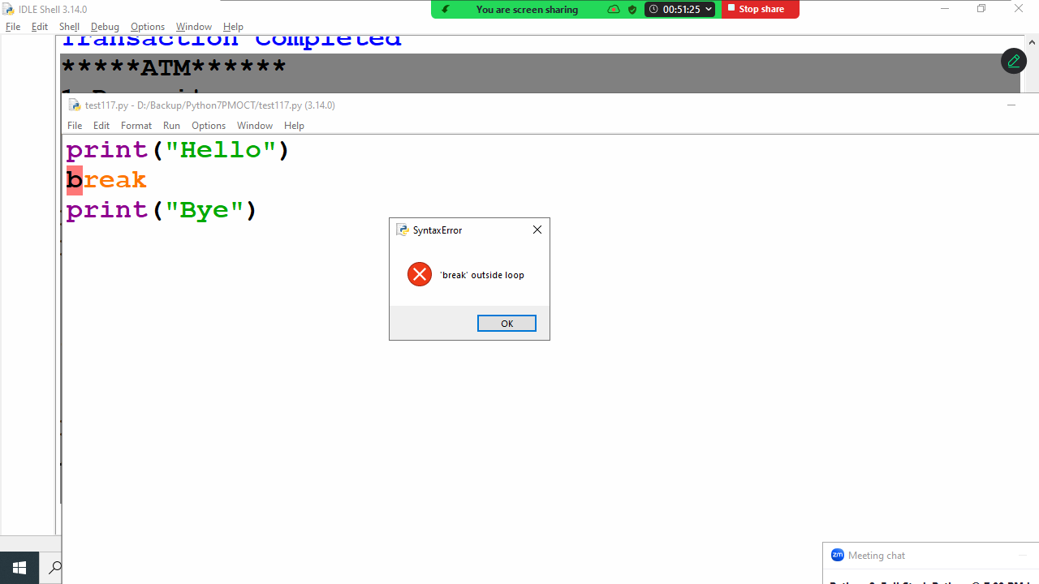

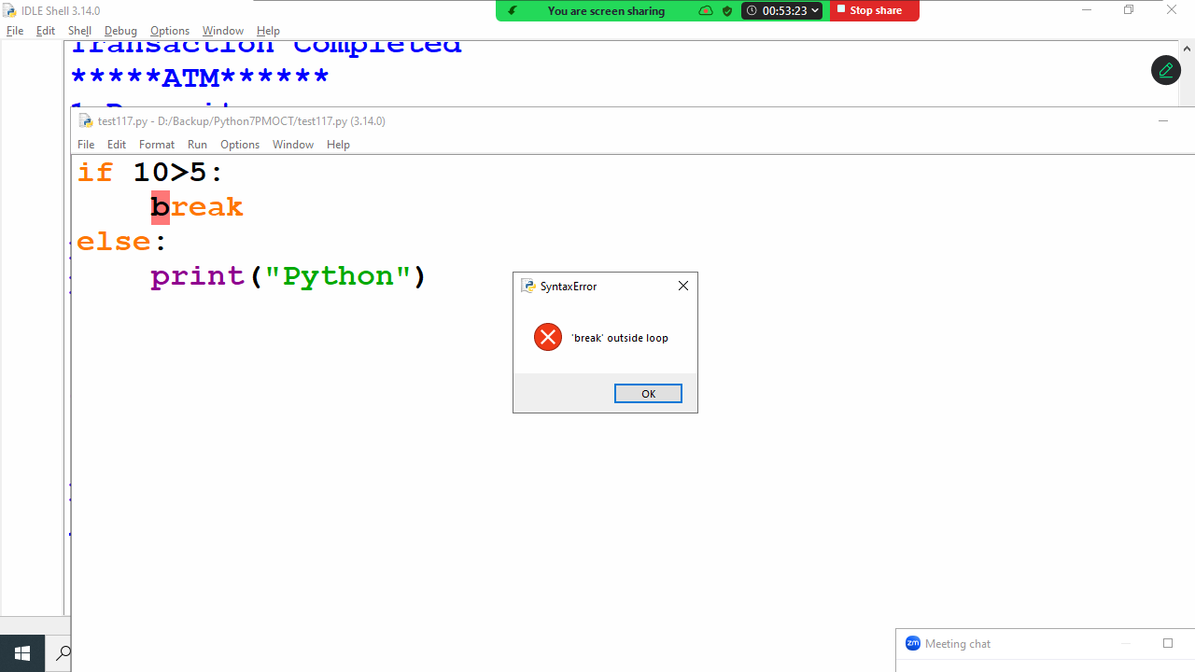
Example:
# write a program to print sum of numbers until sum becomes
# 100, input numbers from keyboard
s=0
while True:
num=int(input("Enter any number "))
s=s+num
if s==100:
break

Output
Enter any number 50
Enter any number 100
Enter any number 200
Enter any number -250

continue
“continue” is a keyword which represents branching control statement.
This statement is used inside looping control statements (while loop and for loop)
continue statement, continue execution of while or for loop without executing the statements written after continue statement.

Example:
for i in range(1,6): # 1 2 3 4 5
print("PYTHON")
break
print("JAVA")

for i in range(1,6): # 1 2 3 4 5
print("PYTHON")
continue
print("JAVA")

Output
PYTHON
PYTHON
PYTHON
PYTHON
PYTHON
PYTHON

Example:
for i in range(1,11):
if i%2==0:
continue
print(i,end=' ')

Output
1 3 5 7 9

pass keyword
python does not allows empty blocks.
A block must have at least one statement.
In python a block with pass statement is called empty block
This block does not perform any operation
Pass indicates null operation or no operation

Example:
if 10>2:
pass
print("PYTHON")

for i in range(5): # 0 1 2 3 4
pass
print("DJANGO")

if 10>2:
pass
else:
print("DATABASE")

Output
PYTHON
DJANGO

Nested Loops
A looping control statement within looping control statement is called nested looping control statement
- Nested while loop
- Nested for loop

While loop inside while loop is called nested while
For loop inside for loop is called nested for

Example:
for num in range(1,11): # 1 2 3 4 5 6 7 8 9 10
for i in range(1,11): # 1 2 3 4 5 6 7 8 9 10
print(f'{num}x{i}={num*i}')

Output
1x1=1
1x2=2
1x3=3
1x4=4
1x5=5
1x6=6
1x7=7
1x8=8
1x9=9
1x10=10
2x1=2
2x2=4
2x3=6
2x4=8
2x5=10
2x6=12
2x7=14
2x8=16
2x9=18
2x10=20
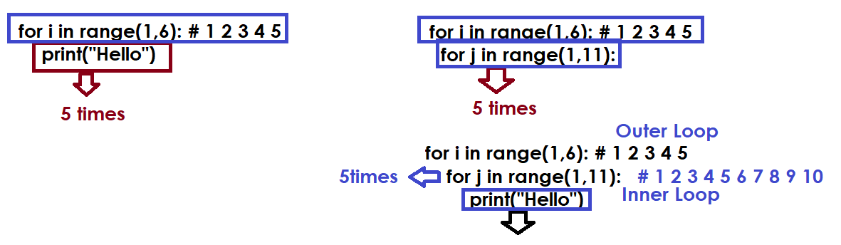

Write a program to generate the following output (OR) generate tables (1-10).

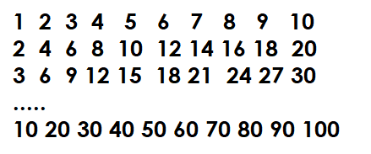

for num in range(1,11): # 1 2 3 4 5 6 7 8 9 10
for i in range(1,11): # 1 2 3 4 5 6 7 8 9 10
p=num*i
print(p,end=' ')
print()

# Write a program to find prime numbers between 2 to 100

for num in range(2,101): # 2 3 4 5 6 7 8 9 10 11 ...
c=0
for i in range(1,num+1):
if num%i==0:
c=c+1
if c==2:
print(num,end=' ')

Output
2 3 5 7 11 13 17 19 23 29 31 37 41 43 47 53 59 61 67 71 73 79 83 89 97

Example:
# Write a program to generate factorials of all
# numbers from 1 to 10

for num in range(1,11): # 1 2 3 4 5 6 7 8 9 10
fact=1
for i in range(1,num+1):
fact=fact*i
print(f'{num}={fact}')

Output
1=1
2=2
3=6
4=24
5=120
6=720
7=5040
8=40320
9=362880
10=3628800

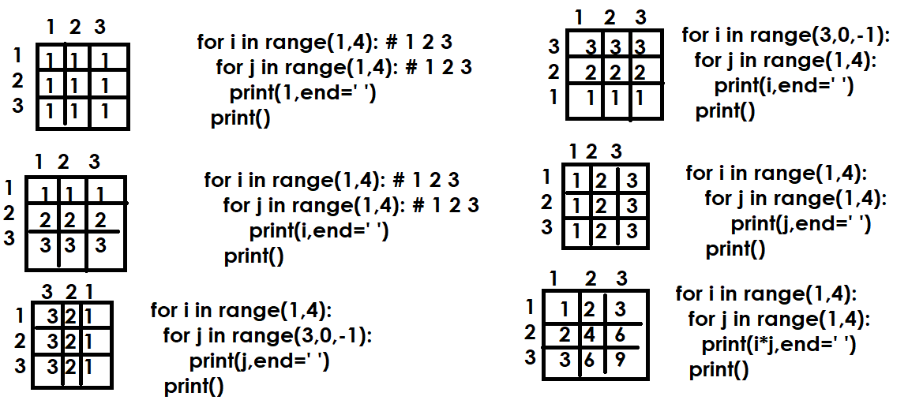
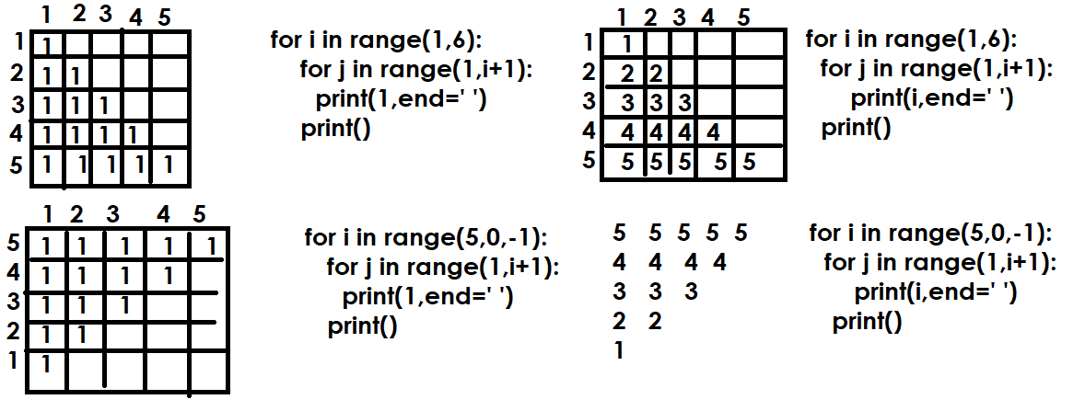

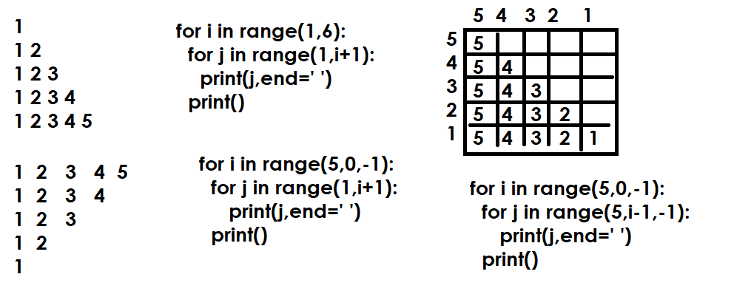
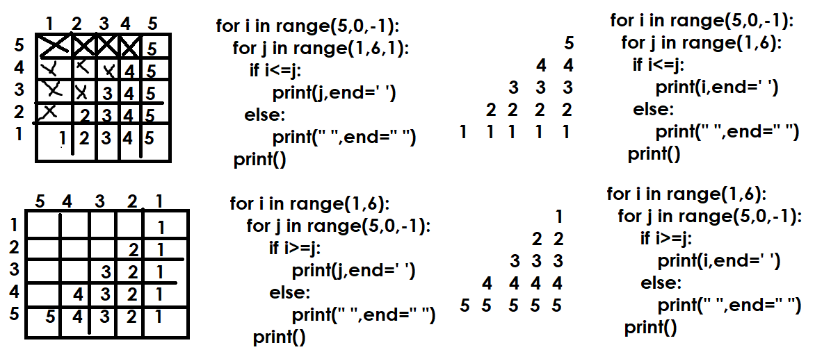
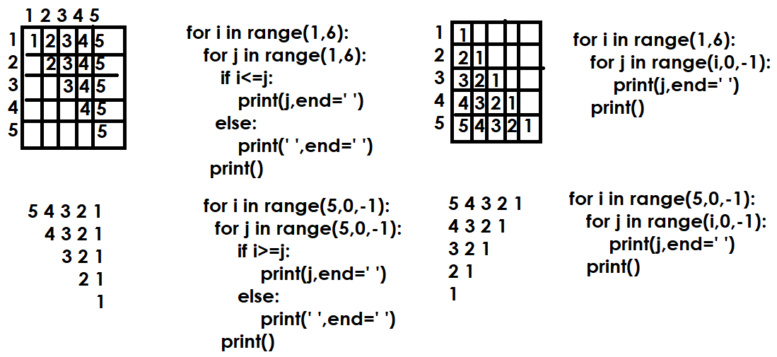

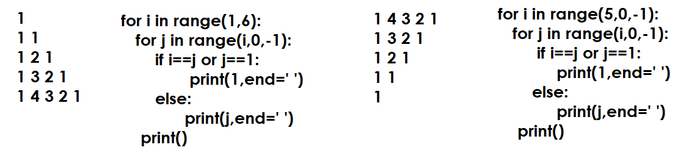
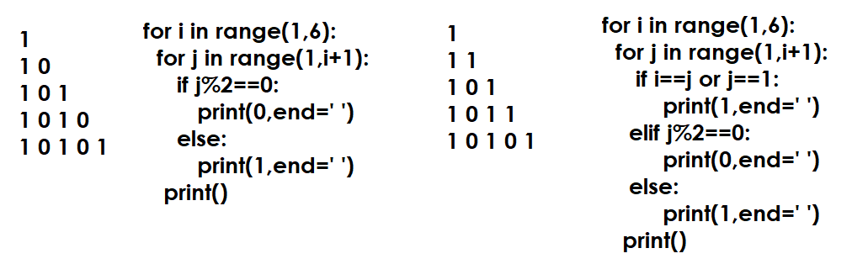

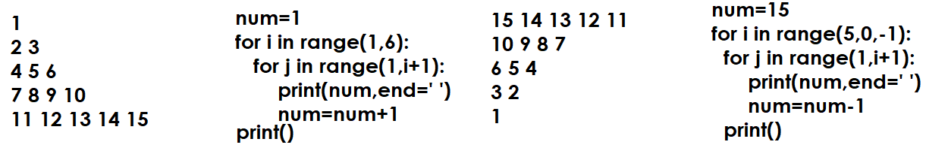
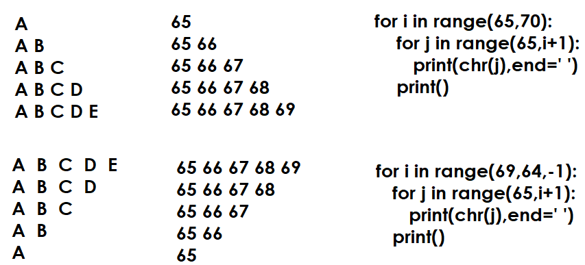

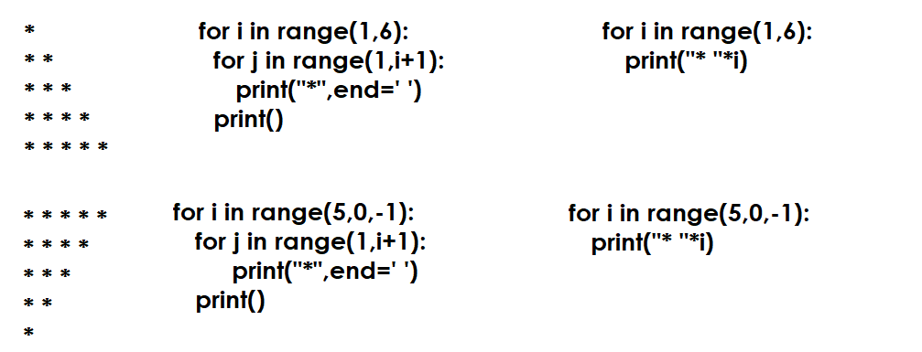
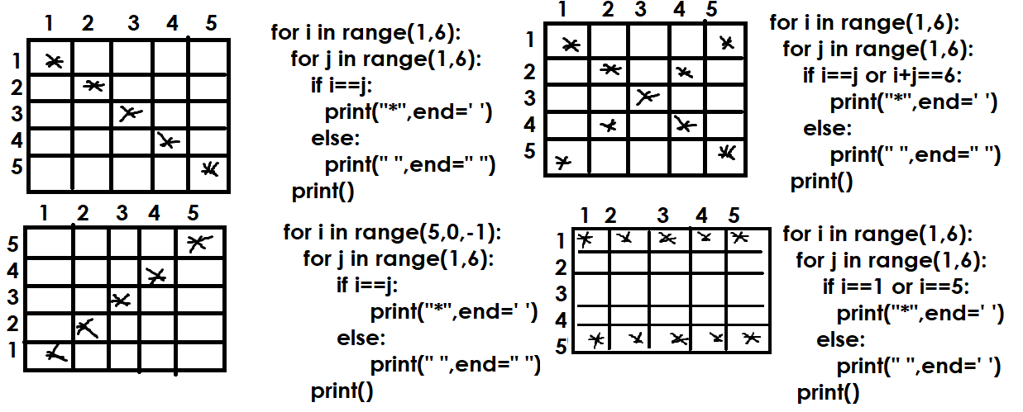
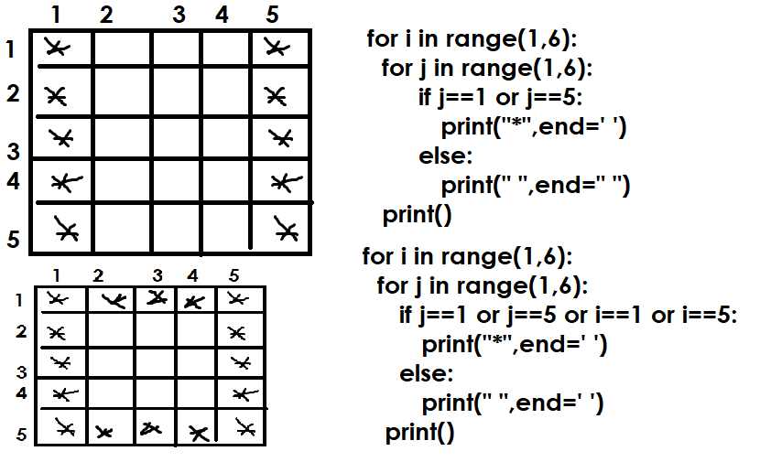
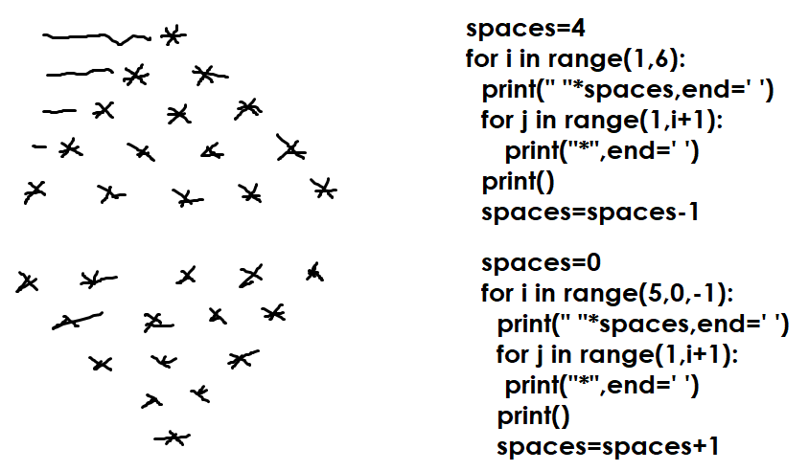

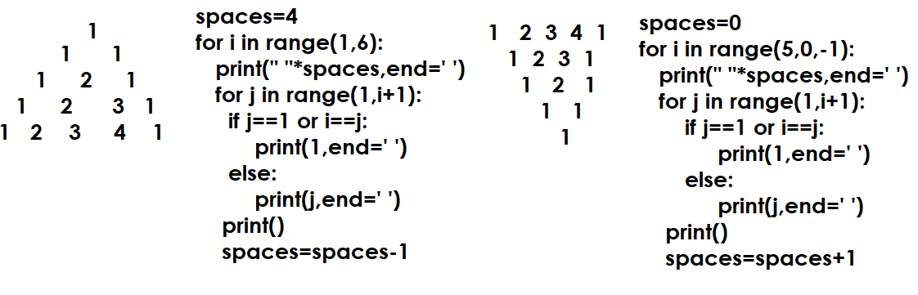
Nested While
While loop inside while loop is called nested while.

Syntax:

while condition: 🡺 Outer while loop
while condition: 🡺 Inner while loop
statement-1
statement-2

Example:
# Write a program to find Armstrong’s from 100 to 999

num=100
while num<=999:
num1=num
s=0
while num1>0:
d=num1%10
s=s+(d**3)
num1=num1//10
if s==num:
print(num)
num=num+1

Output
153
370
371
407

# Write a program to find palindrom numbers from 100-999

num=100
while num<=999:
rev=0
num1=num
while num1>0:
d=num1%10
rev=(rev*10)+d
num1=num1//10
if rev==num:
print(f'{num} is palindrom')
num=num+1

Output
101 is palindrom
111 is palindrom
121 is palindrom
131 is palindrom
141 is palindrom
151 is palindrom
161 is palindrome
….

Example:
# Write a program to generate prime numbers from 2 to 50
# using nested while

num=2
while num<=50:
i=1
c=0
while i<=num:
if num%i==0:
c=c+1
i=i+1
if c==2:
print(num,end=' ')
num=num+1

Output
2 3 5 7 11 13 17 19 23 29 31 37 41 43 47

Collection Data Types or Data Structures of Python

Python data types are classified into 2 categories
- Scalar data types
- Collection data types

Scalar data types are used to represent single value in memory
- Int
- Float
- Complex
- Bool
- NoneType

Collection Data types
Collection data types are used to represent multiple values or more than one value inside memory. Python collection data types are classified into 3 categories
- Sequences
  - List
  - Tuple
  - Str
  - Range
  - Bytes
  - Bytearray
- Sets
  - Set
  - Frozenset
- Mapping
  - Dict

Why Collections or collection data types?
- Not required to create multiple variables to represent multiple values
- It allows to refer all the values with one name
- Collections uses data structures for organizing of data
- Collections are dynamic in size
- Collections allows to group individual objects and represent as one object

Sequence data types
Python's sequence data types are ordered collections of items, allowing for efficient storage and manipulation of multiple values.

Common characteristics of sequence data types
- Index based : Each value or element in sequence is identified with numeric index
- Slicing : It allows to read sub sequences using slicing
- Iterable: It allows to iterate or read values using iterators or for loop
- Duplicates: it allows duplicate values/elements
- Ordered collection : The insertion order is preserved or same

List data type
List is a mutable sequence data type, after creating list changes can be done.
List is ordered collection where insertion order is preserved
List allows duplicates
List is index based collection
In application development list is used to represent group of individual objects where insertion order is preserved and reading, writing is done sequentially and randomly and allows duplicate values.
“list” data type or class represents list object
List can be homogenous (similar type of values) or heterogeneous (diff types of values)

How to create list?
List can be created in different ways
- Empty list is created using empty square brackets []

>>> A=[]
>>> A
[]
>>> type(A)
<class 'list'>

- List can be created with values represented with square brackets with each value separated with comma ,

[value,value,value,value,value,…]

>>> B=[10,20,30,40,50]
>>> print(B)
[10, 20, 30, 40, 50]
>>> print(type(B))
<class 'list'>
>>> C=[1.5,2.5,3.5]
>>> print(C)
[1.5, 2.5, 3.5]
>>> print(type(C))
<class 'list'>
>>> stud=[1,"naresh","python",9000.0]
>>> print(stud)
[1, 'naresh', 'python', 9000.0]
>>> print(type(stud))
<class 'list'>
>>> email_list=["abc@gamil.com",
... "xyz@nareshit.com",
... "naresh@gmail.com"]
>>> print(email_list)
['abc@gamil.com', 'xyz@nareshit.com', 'naresh@gmail.com']
>>> print(type(email_list))
<class 'list'>
>>>

- List can be created using list type or list function

list() 🡺 empty list
list(iterable) 🡺 This allows to create list using values or data of other collections (OR) it allows to convert other collection types into list type

>>> list1=list()
>>> print(list1)
[]
>>> print(type(list1))
<class 'list'>
>>> list2=list(range(1,6))
>>> print(list2)
[1, 2, 3, 4, 5]
>>> list3=list(range(10,110,10))
>>> print(list3)
[10, 20, 30, 40, 50, 60, 70, 80, 90, 100]
>>> list4=list(range(100,0,-10))
>>> print(list4)
[100, 90, 80, 70, 60, 50, 40, 30, 20, 10]
>>> list5=list("PYTHON")
>>> print(list5)
['P', 'Y', 'T', 'H', 'O', 'N']
>>> list6=list([10,20,30,40,50])
>>> print(list6)
[10, 20, 30, 40, 50]
>>> list7=list(10)
Traceback (most recent call last):
File "<pyshell#34>", line 1, in <module>
list7=list(10)
TypeError: 'int' object is not iterable

How to read content of list?
The content of list can be read in different ways
- Indexing
- Slicing
- For loop
- Iterator
- Enumerate

Note: The content of any sequence is read using above 5 approaches

Indexing

What is index?
Index is an integer value, which represent value location
Every location or value in list or sequence is identified with unique number called index.
This index can be used to data sequentially or randomly.
This index is used as a subscript to read data from sequence or list.

Syntax: list-name[index] (OR) sequence-name[index]

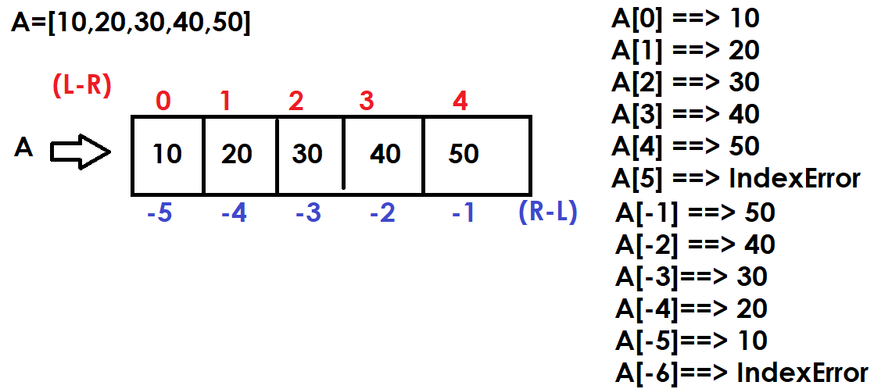

Example:
# Reading values from list using index  A=[10,20,30,40,50]  print(A[0],A[1],A[2],A[3],A[4])  print(A[-1],A[-2],A[-3],A[-4],A[-5])  print("Left to Right")  for i in range(5):  print(A[i])  print("Right to Left")  for i in range(-1,-6,-1):  print(A[i])  print("Right to Left")  for i in range(4,-1,-1):  print(A[i])  print("Left to Right")  for i in range(-5,0):  print(A[i]) | Output  10 20 30 40 50  50 40 30 20 10  Left to Right  10  20  30  40  50  Right to Left  50  40  30  20  10  Right to Left  50  40  30  20  10  Left to Right  10  20  30  40  50

len() : it predefined function in python. This returns count of values exists within collection (sequences,sets or mapping).

Syntax: len(iterable/collection)

>>> A=[10,20,30]
>>> len(A)
3
>>> B=[10,20,30,40,50,60]
>>> len(B)
6

# Write a program to sum of values or elements or items of list

A=[10,70,20,80,11,36,87,34,10,67,83,20]

s=0
for i in range(len(A)):
s=s+A[i]

print(f'List is {A}')
print(f'Sum of Elements of list {s}')

Output
List is [10, 70, 20, 80, 11, 36, 87, 34, 10, 67, 83, 20]
Sum of Elements of list 528

Example:
# Write a program to count even and odd numbers exists within
# list

A=[7,10,48,14,56,78,98,34,54,76,45,52,35,59,13,7,9,3]

ec=0
oc=0
for i in range(len(A)):
if A[i]%2==0:
ec+=1
else:
oc+=1

print(f'List is {A}')
print(f'Even Numbers Count {ec}')
print(f'Odd Numbers Count {oc}')

Output
List is [7, 10, 48, 14, 56, 78, 98, 34, 54, 76, 45, 52, 35, 59, 13, 7, 9, 3]
Even Numbers Count 10
Odd Numbers Count 8

Slicing
Slicing is a process of reading multiple elements or values from sequence. Slicing generates multiple indexes to reading more than one value.

What is difference between indexing and slicing?
Indexing accesses a single element using its specific position (index), while slicing extracts a sequence (or subset) of elements using a range of indices. Indexing returns one item, whereas slicing always returns a new sequence (e.g., a new list, string, or tuple) of the same type as the original, even if only one element is retrieved.

How to slicing is done?
Slicing is done using 2 approaches
- Using slice operator
- Using slice object

Slice operator or slice object generates multiple indexes to read multiple values.

Slice operator
Slice operator generates multiple indexes to read multiple values

Syntax: sequence-name[start-index:stop-index:step]

Internally slice operator uses range for generating multiple indexes

Example:  A=[10,20,30,40,50,60,70,80,90,100]  print(A)  B=A[0:5:1]  print(B)  C=A[5:10:1]  print(C)  D=A[0:10:2]  print(D)  E=A[1:10:2]  print(E)  F=A[0:10:1]  print(F)  G=A[-1:-6:-1]  print(G)  H=A[-6:-11:-1]  print(H)  I=A[-1:-11:-1]  print(I)  J=A[-1:-11:-2]  print(J) | Output  [10, 20, 30, 40, 50, 60, 70, 80, 90, 100]  [10, 20, 30, 40, 50]  [60, 70, 80, 90, 100]  [10, 30, 50, 70, 90]  [20, 40, 60, 80, 100]  [10, 20, 30, 40, 50, 60, 70, 80, 90, 100]  [100, 90, 80, 70, 60]  [50, 40, 30, 20, 10]  [100, 90, 80, 70, 60, 50, 40, 30, 20, 10]  [100, 80, 60, 40, 20]

Syntax-1: sequence-name[::] (OR) sequence[:]
In this syntax default start=0,stop=len(sequence),step=1
This syntax create copy of sequence by reading all the elements from left to right.

Example:
A=list(range(10,110,10))
print(A)
B=A[::]
print(B)
C=A[:]
print(C)

Output
[10, 20, 30, 40, 50, 60, 70, 80, 90, 100]
[10, 20, 30, 40, 50, 60, 70, 80, 90, 100]
[10, 20, 30, 40, 50, 60, 70, 80, 90, 100]

Syntax-2: sequence-name[::step]
In this syntax start,stop values are taken based on step value
If step is +ve, start=0,stop=len(sequence)
If step is –ve, start=-1,stop=-len(sequence)

Example:
A=list("PROGRAMMING")
print(A)
B=A[::1]
print(B)
C=A[::2]
print(C)
D=A[::-1]
print(D)
E=A[::-2]
print(E)

Output
['P', 'R', 'O', 'G', 'R', 'A', 'M', 'M', 'I', 'N', 'G']
['P', 'R', 'O', 'G', 'R', 'A', 'M', 'M', 'I', 'N', 'G']
['P', 'O', 'R', 'M', 'I', 'G']
['G', 'N', 'I', 'M', 'M', 'A', 'R', 'G', 'O', 'R', 'P']
['G', 'I', 'M', 'R', 'O', 'P']

Syntax3: sequence-name[start:stop]
In this syntax default step value is 1

Example:
A=[10,20,30,40,50,60,70,80,90,100]
print(A)
B=A[3:8]
print(B)
C=A[3:-3]
print(C)
D=A[2:-2]
print(D)

Output
[10, 20, 30, 40, 50, 60, 70, 80, 90, 100]
[40, 50, 60, 70, 80]
[40, 50, 60, 70]
[30, 40, 50, 60, 70, 80]

Syntax-4: sequence-name[start::] (OR) sequence-name[start:]
In this syntax default step is 1 and stop till end of the sequence
This syntax read elements from left to right

Example:
A=[10,20,30,40,50,60,70,80,90,100]
print(A)
B=A[3:]
print(B)
C=A[-5:]
print(C)

Output
[10, 20, 30, 40, 50, 60, 70, 80, 90, 100]
[40, 50, 60, 70, 80, 90, 100]
[60, 70, 80, 90, 100]

Syntax-5: sequence-name[:stop:]
In this syntax default start=0,step=1

A=[10,20,30,40,50,60,70,80,90,100]
print(A)
B=A[:5]
print(B)
C=A[:-5]
print(C)

Output
[10, 20, 30, 40, 50, 60, 70, 80, 90, 100]
[10, 20, 30, 40, 50]
[10, 20, 30, 40, 50]
nHow to read content of list?
The content of list can be read in different ways
- Indexing
- Slicing
- For loop
- Iterator
- Enumerate

Note: The content of any sequence is read using above 5 approaches

Indexing

What is index?
Index is an integer value, which represent value location
Every location or value in list or sequence is identified with unique number called index.
This index can be used to data sequentially or randomly.
This index is used as a subscript to read data from sequence or list.

Syntax: list-name[index] (OR) sequence-name[index]

Example:
# Reading values from list using index  A=[10,20,30,40,50]  print(A[0],A[1],A[2],A[3],A[4])  print(A[-1],A[-2],A[-3],A[-4],A[-5])  print("Left to Right")  for i in range(5):  print(A[i])  print("Right to Left")  for i in range(-1,-6,-1):  print(A[i])  print("Right to Left")  for i in range(4,-1,-1):  print(A[i])  print("Left to Right")  for i in range(-5,0):  print(A[i]) | Output  10 20 30 40 50  50 40 30 20 10  Left to Right  10  20  30  40  50  Right to Left  50  40  30  20  10  Right to Left  50  40  30  20  10  Left to Right  10  20  30  40  50

len() : it predefined function in python. This returns count of values exists within collection (sequences,sets or mapping).

Syntax: len(iterable/collection)

>>> A=[10,20,30]
>>> len(A)
3
>>> B=[10,20,30,40,50,60]
>>> len(B)
6

# Write a program to sum of values or elements or items of list

A=[10,70,20,80,11,36,87,34,10,67,83,20]

s=0
for i in range(len(A)):
s=s+A[i]

print(f'List is {A}')
print(f'Sum of Elements of list {s}')

Output
List is [10, 70, 20, 80, 11, 36, 87, 34, 10, 67, 83, 20]
Sum of Elements of list 528

Example:
# Write a program to count even and odd numbers exists within
# list

A=[7,10,48,14,56,78,98,34,54,76,45,52,35,59,13,7,9,3]

ec=0
oc=0
for i in range(len(A)):
if A[i]%2==0:
ec+=1
else:
oc+=1

print(f'List is {A}')
print(f'Even Numbers Count {ec}')
print(f'Odd Numbers Count {oc}')

Output
List is [7, 10, 48, 14, 56, 78, 98, 34, 54, 76, 45, 52, 35, 59, 13, 7, 9, 3]
Even Numbers Count 10
Odd Numbers Count 8

Slicing
Slicing is a process of reading multiple elements or values from sequence. Slicing generates multiple indexes to reading more than one value.

What is difference between indexing and slicing?
Indexing accesses a single element using its specific position (index), while slicing extracts a sequence (or subset) of elements using a range of indices. Indexing returns one item, whereas slicing always returns a new sequence (e.g., a new list, string, or tuple) of the same type as the original, even if only one element is retrieved.

How to slicing is done?
Slicing is done using 2 approaches
- Using slice operator
- Using slice object

Slice operator or slice object generates multiple indexes to read multiple values.

Slice operator
Slice operator generates multiple indexes to read multiple values

Syntax: sequence-name[start-index:stop-index:step]

Internally slice operator uses range for generating multiple indexes

Example:  A=[10,20,30,40,50,60,70,80,90,100]  print(A)  B=A[0:5:1]  print(B)  C=A[5:10:1]  print(C)  D=A[0:10:2]  print(D)  E=A[1:10:2]  print(E)  F=A[0:10:1]  print(F)  G=A[-1:-6:-1]  print(G)  H=A[-6:-11:-1]  print(H)  I=A[-1:-11:-1]  print(I)  J=A[-1:-11:-2]  print(J) | Output  [10, 20, 30, 40, 50, 60, 70, 80, 90, 100]  [10, 20, 30, 40, 50]  [60, 70, 80, 90, 100]  [10, 30, 50, 70, 90]  [20, 40, 60, 80, 100]  [10, 20, 30, 40, 50, 60, 70, 80, 90, 100]  [100, 90, 80, 70, 60]  [50, 40, 30, 20, 10]  [100, 90, 80, 70, 60, 50, 40, 30, 20, 10]  [100, 80, 60, 40, 20]

Syntax-1: sequence-name[::] (OR) sequence[:]
In this syntax default start=0,stop=len(sequence),step=1
This syntax create copy of sequence by reading all the elements from left to right.

Example:
A=list(range(10,110,10))
print(A)
B=A[::]
print(B)
C=A[:]
print(C)

Output
[10, 20, 30, 40, 50, 60, 70, 80, 90, 100]
[10, 20, 30, 40, 50, 60, 70, 80, 90, 100]
[10, 20, 30, 40, 50, 60, 70, 80, 90, 100]

Syntax-2: sequence-name[::step]
In this syntax start,stop values are taken based on step value
If step is +ve, start=0,stop=len(sequence)
If step is –ve, start=-1,stop=-len(sequence)

Example:
A=list("PROGRAMMING")
print(A)
B=A[::1]
print(B)
C=A[::2]
print(C)
D=A[::-1]
print(D)
E=A[::-2]
print(E)

Output
['P', 'R', 'O', 'G', 'R', 'A', 'M', 'M', 'I', 'N', 'G']
['P', 'R', 'O', 'G', 'R', 'A', 'M', 'M', 'I', 'N', 'G']
['P', 'O', 'R', 'M', 'I', 'G']
['G', 'N', 'I', 'M', 'M', 'A', 'R', 'G', 'O', 'R', 'P']
['G', 'I', 'M', 'R', 'O', 'P']

Syntax3: sequence-name[start:stop]
In this syntax default step value is 1

Example:
A=[10,20,30,40,50,60,70,80,90,100]
print(A)
B=A[3:8]
print(B)
C=A[3:-3]
print(C)
D=A[2:-2]
print(D)

Output
[10, 20, 30, 40, 50, 60, 70, 80, 90, 100]
[40, 50, 60, 70, 80]
[40, 50, 60, 70]
[30, 40, 50, 60, 70, 80]

Syntax-4: sequence-name[start::] (OR) sequence-name[start:]
In this syntax default step is 1 and stop till end of the sequence
This syntax read elements from left to right

Example:
A=[10,20,30,40,50,60,70,80,90,100]
print(A)
B=A[3:]
print(B)
C=A[-5:]
print(C)

Output
[10, 20, 30, 40, 50, 60, 70, 80, 90, 100]
[40, 50, 60, 70, 80, 90, 100]
[60, 70, 80, 90, 100]

Syntax-5: sequence-name[:stop:]
In this syntax default start=0,step=1

A=[10,20,30,40,50,60,70,80,90,100]
print(A)
B=A[:5]
print(B)
C=A[:-5]
print(C)

Output
[10, 20, 30, 40, 50, 60, 70, 80, 90, 100]
[10, 20, 30, 40, 50]
[10, 20, 30, 40, 50]
for loop
for loop is used to iterate the values of collections or iterables.

Syntax:
for variable-name in iterable/collection:
statement-1
statement-2

for loop each time read value generated by iterable or collection and assign to variable. After assigning to variable it execute statement-1,statement-2.

For loop repeats statement-1,statement-2 until read all the values generated by iterable.

Example:  A=[10,20,30,40,50]  for x in A:  print(x,end=' ')  print()  for y in A[::-1]:  print(y,end=' ')  print()  for z in A[:3]:  print(z,end=' ')  print()  for p in A[2:]:  print(p,end=' ') | Output  10 20 30 40 50  50 40 30 20 10  10 20 30  30 40 50
Example  # Write a program to count +ve,-ve and zero's  A=[10,20,-30,-40,0,0,50,-60,-70,-80,100,200,0,-10,-20]  pc=0  nc=0  zc=0  for value in A:  if value>0:  pc=pc+1  elif value<0:  nc=nc+1  else:  zc=zc+1  print(f'List is {A}')  print(f'+ve values count {pc}')  print(f'-ve values count {nc}')  print(f'zero values count {zc}') | Output  List is [10, 20, -30, -40, 0, 0, 50, -60, -70, -80, 100, 200, 0, -10, -20]  +ve values count 5  -ve values count 7  zero values count 3
# Write a program to find maximum value in given list  A=[10,50,80,40,30,60,70]  max_value=A[0]  for value in A:  if value>max_value:  max_value=value  print(f'List is {A}')  print(f'Maximum value {max_value}') | Output  List is [10, 50, 80, 40, 30, 60, 70]  Maximum value 80
Example:  # Write a program to find minimum value in given list  A=[10,50,80,40,30,60,70,5,100,25,-5,8,9]  min_value=A[0]  for value in A:  if value<min_value:  min_value=value  print(f'List is {A}')  print(f'Minimum value {min_value}') | Output  List is [10, 50, 80, 40, 30, 60, 70, 5, 100, 25, -5, 8, 9]  Minimum value -5

iter() function (OR) iterator
The content of sequence can be read using iterator object.

How to create iterator object?
Iterator object is created using iter() function

Syntax: iter(iterable)

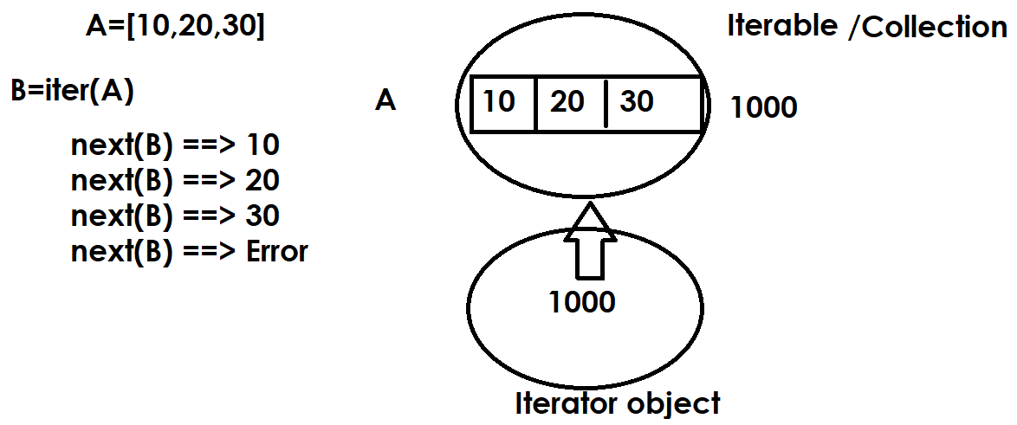
Example:  A=[100,200,300,400,500]  x=iter(A)  value1=next(x)  value2=next(x)  value3=next(x)  value4=next(x)  value5=next(x)  print(value1,value2,value3,value4,value5)  y=iter(A)  for value in y:  print(value,end=' ') | Output  100 200 300 400 500  100 200 300 400 500

enumerate(iterable, start=0)
Return an enumerate object. iterable must be a sequence, an iterator, or some other object which supports iteration.
enumerate() returns a tuple containing a count (from start which defaults to 0) and the values obtained from iterating over iterable.

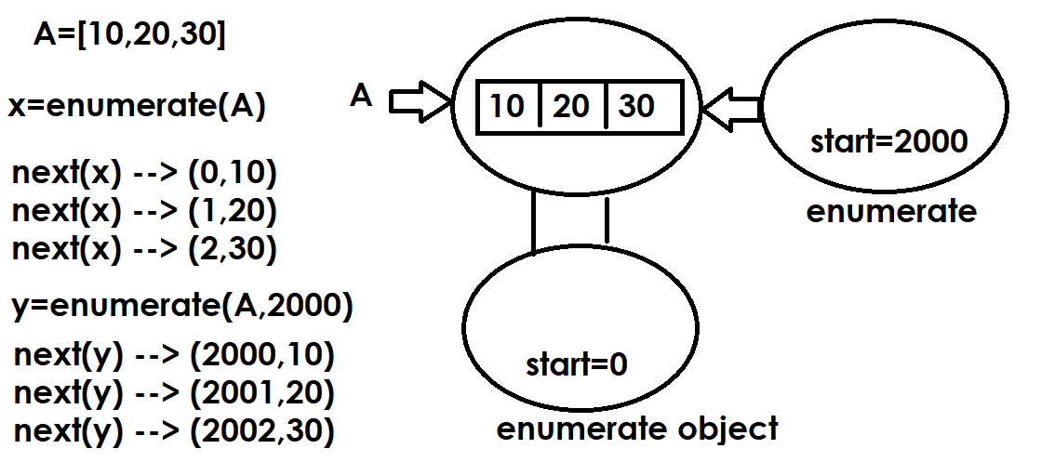

Example:  sales=[10000,20000,30000,40000,50000]  e=enumerate(sales,2010)  for x in e:  print(x) | Output  (2010, 10000)  (2011, 20000)  (2012, 30000)  (2013, 40000)  (2014, 50000)

Mutable Operations of list
After creating list changes can be done within list using mutable operations/methods provided by list.

append()
This method is used to add or append an element at end of list.

Syntax: list-name.append(element/object)

Example:
>>> A=[]
>>> print(A)
[]
>>> A.append(10)
>>> A.append(20)
>>> A.append(30)
>>> print(A)
[10, 20, 30]
>>> A.append(40)
>>> print(A)
[10, 20, 30, 40]
>>> id(A)
2373514598720
>>> A.append(50)
>>> print(A)
[10, 20, 30, 40, 50]
>>> id(A)
2373514598720
>>> A.append(100,200)
Traceback (most recent call last):
File "<pyshell#12>", line 1, in <module>
A.append(100,200)
TypeError: list.append() takes exactly one argument (2 given)

Example:
# Write a program to add n values into list and display

A=[]
n=int(input("How many values?"))

for _ in range(n):
value=int(input("Enter value "))
A.append(value)

print(f'List is {A}')

Output
How many values?3
Enter value 100
Enter value 200
Enter value 300
List is [100, 200, 300]

Example:
# Write a program to read name and n subject marks
# find total marks,avg marks
name=input("StudentName :")
n=int(input("How many subject Marks?"))
marks=[]

for i in range(n):
s=int(input(f'Subject{i+1}Marks:'))
marks.append(s)

print(f'StudentName {name}')
print(f'Marks {marks}')
total_marks=0
for value in marks:
total_marks=total_marks+value

print(f'Total Marks {total_marks}')
avg_marks=total_marks/n
print(f'Avg Marks {avg_marks}')

Output
StudentName :Naresh
How many subject Marks?3
Subject1Marks:60
Subject2Marks:70
Subject3Marks:80
StudentName Naresh
Marks [60, 70, 80]
Total Marks 210
Avg Marks 70.0

Example:
# Write a program to separate even and odd numbers
# from the following list

A=[1,7,9,12,67,3,54,13,31,22,25,56,89,98,77,65,64,82,21]
B=[]
C=[]

for value in A:
if value%2==0:
B.append(value)
else:
C.append(value)

print(f'List is {A}')
print(f'Even List is {B}')
print(f'Odd List is {C}')

Output
List is [1, 7, 9, 12, 67, 3, 54, 13, 31, 22, 25, 56, 89, 98, 77, 65, 64, 82, 21]
Even List is [12, 54, 22, 56, 98, 64, 82]
Odd List is [1, 7, 9, 67, 3, 13, 31, 25, 89, 77, 65, 21]

Example:
A=[1,2,3,4,1.5,2.5,"naresh","suresh",1+2j]
B=[]
C=[]
for value in A:
if isinstance(value,(int,)):
B.append(value)
elif isinstance(value,(str,)):
C.append(value)

print(A)
print(B)
print(C)

Output
[1, 2, 3, 4, 1.5, 2.5, 'naresh', 'suresh', (1+2j)]
[1, 2, 3, 4]
['naresh', 'suresh']

extend() function
This function of list allows appending more than one value

Syntax: list-name.extend(iterable)

>>> A=[10,20,30]
>>> print(A)
[10, 20, 30]
>>> A.extend([40,50])
>>> print(A)
[10, 20, 30, 40, 50]
>>> A.extend(range(60,110,10))
>>> print(A)
[10, 20, 30, 40, 50, 60, 70, 80, 90, 100]
>>> A.extend("PYTHON")
>>> print(A)
[10, 20, 30, 40, 50, 60, 70, 80, 90, 100, 'P', 'Y', 'T', 'H', 'O', 'N']
A.extend(55,66)
Traceback (most recent call last):
File "<pyshell#21>", line 1, in <module>
A.extend(55,66)
TypeError: list.extend() takes exactly one argument (2 given)
>>> A.extend([55,66])
>>> print(A)
[10, 20, 30, 40, 50, 60, 70, 80, 90, 100, 'P', 'Y', 'T', 'H', 'O', 'N', 55, 66]

What is difference between append() and extend()?
append method is able add only one object
extend method is able add more than one object
for loop
for loop is used to iterate the values of collections or iterables.

Syntax:
for variable-name in iterable/collection:
statement-1
statement-2

for loop each time read value generated by iterable or collection and assign to variable. After assigning to variable it execute statement-1,statement-2.

For loop repeats statement-1,statement-2 until read all the values generated by iterable.

Example:  A=[10,20,30,40,50]  for x in A:  print(x,end=' ')  print()  for y in A[::-1]:  print(y,end=' ')  print()  for z in A[:3]:  print(z,end=' ')  print()  for p in A[2:]:  print(p,end=' ') | Output  10 20 30 40 50  50 40 30 20 10  10 20 30  30 40 50
Example  # Write a program to count +ve,-ve and zero's  A=[10,20,-30,-40,0,0,50,-60,-70,-80,100,200,0,-10,-20]  pc=0  nc=0  zc=0  for value in A:  if value>0:  pc=pc+1  elif value<0:  nc=nc+1  else:  zc=zc+1  print(f'List is {A}')  print(f'+ve values count {pc}')  print(f'-ve values count {nc}')  print(f'zero values count {zc}') | Output  List is [10, 20, -30, -40, 0, 0, 50, -60, -70, -80, 100, 200, 0, -10, -20]  +ve values count 5  -ve values count 7  zero values count 3
# Write a program to find maximum value in given list  A=[10,50,80,40,30,60,70]  max_value=A[0]  for value in A:  if value>max_value:  max_value=value  print(f'List is {A}')  print(f'Maximum value {max_value}') | Output  List is [10, 50, 80, 40, 30, 60, 70]  Maximum value 80
Example:  # Write a program to find minimum value in given list  A=[10,50,80,40,30,60,70,5,100,25,-5,8,9]  min_value=A[0]  for value in A:  if value<min_value:  min_value=value  print(f'List is {A}')  print(f'Minimum value {min_value}') | Output  List is [10, 50, 80, 40, 30, 60, 70, 5, 100, 25, -5, 8, 9]  Minimum value -5

iter() function (OR) iterator
The content of sequence can be read using iterator object.

How to create iterator object?
Iterator object is created using iter() function

Syntax: iter(iterable)

Example:  A=[100,200,300,400,500]  x=iter(A)  value1=next(x)  value2=next(x)  value3=next(x)  value4=next(x)  value5=next(x)  print(value1,value2,value3,value4,value5)  y=iter(A)  for value in y:  print(value,end=' ') | Output  100 200 300 400 500  100 200 300 400 500

enumerate(iterable, start=0)
Return an enumerate object. iterable must be a sequence, an iterator, or some other object which supports iteration.
enumerate() returns a tuple containing a count (from start which defaults to 0) and the values obtained from iterating over iterable.

Example:  sales=[10000,20000,30000,40000,50000]  e=enumerate(sales,2010)  for x in e:  print(x) | Output  (2010, 10000)  (2011, 20000)  (2012, 30000)  (2013, 40000)  (2014, 50000)

Mutable Operations of list
After creating list changes can be done within list using mutable operations/methods provided by list.

append()
This method is used to add or append an element at end of list.

Syntax: list-name.append(element/object)

Example:
>>> A=[]
>>> print(A)
[]
>>> A.append(10)
>>> A.append(20)
>>> A.append(30)
>>> print(A)
[10, 20, 30]
>>> A.append(40)
>>> print(A)
[10, 20, 30, 40]
>>> id(A)
2373514598720
>>> A.append(50)
>>> print(A)
[10, 20, 30, 40, 50]
>>> id(A)
2373514598720
>>> A.append(100,200)
Traceback (most recent call last):
File "<pyshell#12>", line 1, in <module>
A.append(100,200)
TypeError: list.append() takes exactly one argument (2 given)

Example:
# Write a program to add n values into list and display

A=[]
n=int(input("How many values?"))

for _ in range(n):
value=int(input("Enter value "))
A.append(value)

print(f'List is {A}')

Output
How many values?3
Enter value 100
Enter value 200
Enter value 300
List is [100, 200, 300]

Example:
# Write a program to read name and n subject marks
# find total marks,avg marks
name=input("StudentName :")
n=int(input("How many subject Marks?"))
marks=[]

for i in range(n):
s=int(input(f'Subject{i+1}Marks:'))
marks.append(s)

print(f'StudentName {name}')
print(f'Marks {marks}')
total_marks=0
for value in marks:
total_marks=total_marks+value

print(f'Total Marks {total_marks}')
avg_marks=total_marks/n
print(f'Avg Marks {avg_marks}')

Output
StudentName :Naresh
How many subject Marks?3
Subject1Marks:60
Subject2Marks:70
Subject3Marks:80
StudentName Naresh
Marks [60, 70, 80]
Total Marks 210
Avg Marks 70.0

Example:
# Write a program to separate even and odd numbers
# from the following list

A=[1,7,9,12,67,3,54,13,31,22,25,56,89,98,77,65,64,82,21]
B=[]
C=[]

for value in A:
if value%2==0:
B.append(value)
else:
C.append(value)

print(f'List is {A}')
print(f'Even List is {B}')
print(f'Odd List is {C}')

Output
List is [1, 7, 9, 12, 67, 3, 54, 13, 31, 22, 25, 56, 89, 98, 77, 65, 64, 82, 21]
Even List is [12, 54, 22, 56, 98, 64, 82]
Odd List is [1, 7, 9, 67, 3, 13, 31, 25, 89, 77, 65, 21]

Example:
A=[1,2,3,4,1.5,2.5,"naresh","suresh",1+2j]
B=[]
C=[]
for value in A:
if isinstance(value,(int,)):
B.append(value)
elif isinstance(value,(str,)):
C.append(value)

print(A)
print(B)
print(C)

Output
[1, 2, 3, 4, 1.5, 2.5, 'naresh', 'suresh', (1+2j)]
[1, 2, 3, 4]
['naresh', 'suresh']

extend() function
This function of list allows appending more than one value

Syntax: list-name.extend(iterable)

>>> A=[10,20,30]
>>> print(A)
[10, 20, 30]
>>> A.extend([40,50])
>>> print(A)
[10, 20, 30, 40, 50]
>>> A.extend(range(60,110,10))
>>> print(A)
[10, 20, 30, 40, 50, 60, 70, 80, 90, 100]
>>> A.extend("PYTHON")
>>> print(A)
[10, 20, 30, 40, 50, 60, 70, 80, 90, 100, 'P', 'Y', 'T', 'H', 'O', 'N']
A.extend(55,66)
Traceback (most recent call last):
File "<pyshell#21>", line 1, in <module>
A.extend(55,66)
TypeError: list.extend() takes exactly one argument (2 given)
>>> A.extend([55,66])
>>> print(A)
[10, 20, 30, 40, 50, 60, 70, 80, 90, 100, 'P', 'Y', 'T', 'H', 'O', 'N', 55, 66]

What is difference between append() and extend()?
append method is able add only one object
extend method is able add more than one object
How to append multiple values without using append and extend methods?
This can be done using slice operator.
Syntax: list-name[len(list-name):]=iterable/collection

Example:
>>> A=[10,20,30]
>>> print(A)
[10, 20, 30]
>>> A[3:]=[40,50,60]
>>> print(A)
[10, 20, 30, 40, 50, 60]
>>> A[6:]=[1,2]
>>> print(A)
[10, 20, 30, 40, 50, 60, 1, 2]
>>> A[len(A):]=[100,200,300]
>>> print(A)
[10, 20, 30, 40, 50, 60, 1, 2, 100, 200, 300]

Update or Replace values of List
Replacing or updating values of list is done in different ways
- Using index
- Using slicing
Using index
Using index only one value can be replaced

Syntax: list-name[index]=value

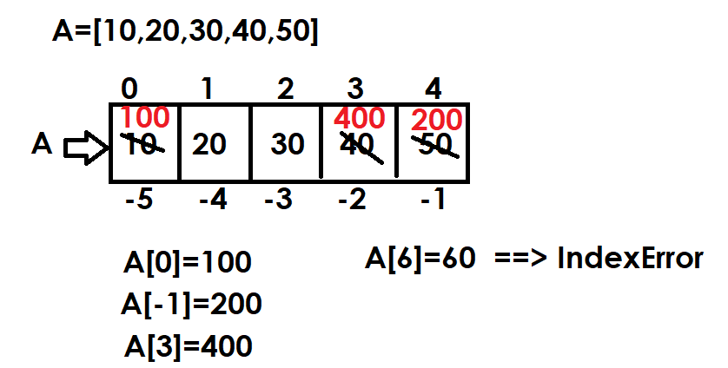
Example:
A=[10,20,30,40,50]
print(f'Before Replacing {A}')
A[0]=100
print(f'After Replacing {A}')
A[-1]=200
print(f'After Replacing {A}')
A[3]=400
print(f'After Replacing {A}')
#A[6]=600

Output
Before Replacing [10, 20, 30, 40, 50]
After Replacing [100, 20, 30, 40, 50]
After Replacing [100, 20, 30, 40, 200]
After Replacing [100, 20, 30, 400, 200]

Example:
# Write a program to swap first and last elements/values in a
# given list

A=[10,20,30,40,50]

print(f'Before Swaping Elements {A}')
temp=A[0]
A[0]=A[-1]
A[-1]=temp
print(f'After Swaping Elements {A}')

Output
Before Swaping Elements [10, 20, 30, 40, 50]
After Swaping Elements [50, 20, 30, 40, 10]

Example:
# Write a program to sort elements or values of list in
# ascending order using bubble sort/exchange sort
A=[5,9,1,4,2,8,7,3,6]

print(f'Before Sorting {A}')

for i in range(len(A)):
for j in range(len(A)-1):
if A[j]>A[j+1]:
temp=A[j]
A[j]=A[j+1]
A[j+1]=temp

print(f'After Sorting in Ascending Order {A}')

#Descending Logic
for i in range(len(A)):
for j in range(len(A)-1):
if A[j]<A[j+1]:
temp=A[j]
A[j]=A[j+1]
A[j+1]=temp

print(f'After Sorting in Descending Order {A}')

Output
Before Sorting [5, 9, 1, 4, 2, 8, 7, 3, 6]
After Sorting in Ascending Order [1, 2, 3, 4, 5, 6, 7, 8, 9]
After Sorting in Descending Order [9, 8, 7, 6, 5, 4, 3, 2, 1]

Example:
# Write a program to find second maximum element or value
# from list

A=[5,9,1,4,2,8,7,3,6]

for i in range(len(A)):
for j in range(len(A)-1):
if A[j]<A[j+1]:
A[j],A[j+1]=A[j+1],A[j]

print('After Sorting List in Descending Order')
print(A)
print(f'First Maximum is {A[0]}')
print(f'Second Maximum is {A[1]}')

Output
After Sorting List in Descending Order
[9, 8, 7, 6, 5, 4, 3, 2, 1]
First Maximum is 9
Second Maximum is 8

Example:
# Write a program to remove duplicates from list
A=[10,20,30,10,10,40,50,20]
B=[]

for value in A:
if value not in B:
B.append(value)

print(A)
print(B)

Output
[10, 20, 30, 10, 10, 40, 50, 20]
[10, 20, 30, 40, 50]

Example:
# Write a program to find second maximum element or value
# from list

A=[5,9,1,4,2,8,7,3,6,8,9,9]

for i in range(len(A)):
for j in range(len(A)-1):
if A[j]<A[j+1]:
A[j],A[j+1]=A[j+1],A[j]

print('After Sorting List in Descending Order')
print(A)
B=[]
for value in A:
if value not in B:
B.append(value)
print(f'First Maximum is {B[0]}')
print(f'Second Maximum is {B[1]}')

Output
After Sorting List in Descending Order
[9, 9, 9, 8, 8, 7, 6, 5, 4, 3, 2, 1]
First Maximum is 9
Second Maximum is 8

Using Slicing
Slicing is used for replacing or updating multiple values.
Slice operator generates multiple indexes which are used for replacing multiple values.

Syntax: list-name[start:stop:step]=iterable/collection

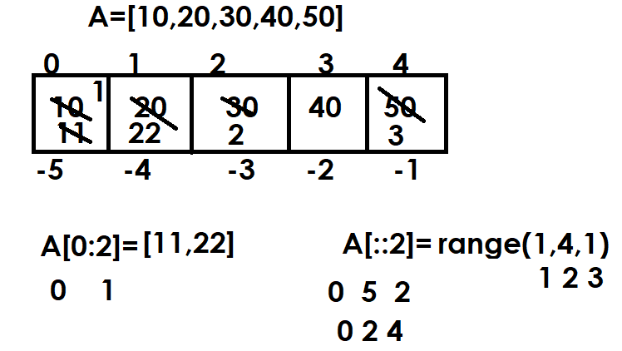

Example
A=[10,20,30,40,50,60,70,80,90,100]
print(A)
A[:3]=[1,2,3]
print(A)
A[-3:]=[8,9,10]
print(A)
A[3:-3]=[4,5,6,7]
print(A)
A[::2]=[10,20,30,40,50]
print(A)
A[::-1]=[0,0,0,0,0,0,0,0,0,0]
print(A)
A[::-2]=[1,2,3,4,5]
print(A)

Output
[10, 20, 30, 40, 50, 60, 70, 80, 90, 100]
[1, 2, 3, 40, 50, 60, 70, 80, 90, 100]
[1, 2, 3, 40, 50, 60, 70, 8, 9, 10]
[1, 2, 3, 4, 5, 6, 7, 8, 9, 10]
[10, 2, 20, 4, 30, 6, 40, 8, 50, 10]
[0, 0, 0, 0, 0, 0, 0, 0, 0, 0]
[0, 5, 0, 4, 0, 3, 0, 2, 0, 1]

Example:
# Write a program swap first 2 values with last 2 values

A=[10,20,30,40,50,60,70]
print(f'Before Swaping {A}')
A[:2],A[-2:]=A[-2:],A[:2]
print(f'After Swaping {A}')

Output
Before Swaping [10, 20, 30, 40, 50, 60, 70]
After Swaping [60, 70, 30, 40, 50, 10, 20]

Deleting elements or values from list
Deleting elements or values from list are done in different ways
- del keyword
- remove() method
- pop() method

“del” keyword
“del” keyword is used for deleting one or more than one value or element.

“del” keyword required 2 things
- index 🡪 for deleting single element or value
- slicing 🡪 for deleting multiple elements or values

using index
“del” keyword uses index for deleting single element or value

Syntax: del list-name[index]

If index within range, it delete element/value
If index is not within range, it raises IndexError

Example:
>>> A=[10,20,30,40,50]
>>> print(A)
[10, 20, 30, 40, 50]
>>> del A[0]
>>> print(A)
[20, 30, 40, 50]
>>> del A[-1]
>>> print(A)
[20, 30, 40]
>>> del A[1]
>>> print(A)
[20, 40]
>>> del A[3]
Traceback (most recent call last):
File "<pyshell#16>", line 1, in <module>
del A[3]
IndexError: list assignment index out of range

Using Slicing
Slicing is used for deleting or removing multiple elements or values

Syntax: del list-name[start:stop:step]
Using Slicing
Slicing is used for deleting or removing multiple elements or values

Syntax: del list-name[start:stop:step]

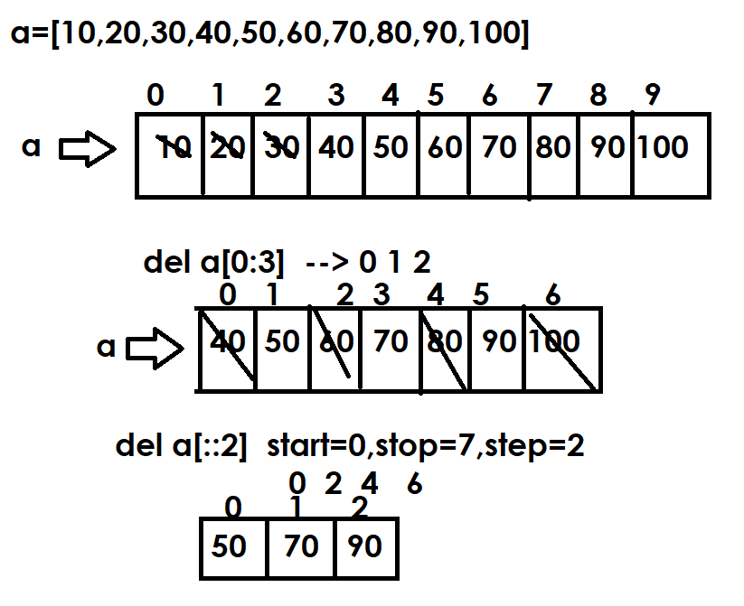
>>> A=[10,20,30,40,50,60,70,80,90,100]
>>> print(A)
[10, 20, 30, 40, 50, 60, 70, 80, 90, 100]
>>> del A[:3]
>>> print(A)
[40, 50, 60, 70, 80, 90, 100]
>>> del A[::2]
>>> print(A)
[50, 70, 90]
>>> del A[::]
>>> print(A)
[]
>>> A=[10,20,30,40,50,60,70,80,90,100]
>>> print(A)
[10, 20, 30, 40, 50, 60, 70, 80, 90, 100]
>>> del A[::-2]
>>> print(A)
[10, 30, 50, 70, 90]

Using remove() method
This method is used to remove to delete value from list using value not using index.

Syntax: list-name.remove(value)

If value exists within list, it removes the first occurrence of value
If value not exists within list, it raises ValueError

>>> A=[10,20,30,40,30,30,50]
>>> print(A)
[10, 20, 30, 40, 30, 30, 50]
>>> A.remove(30)
>>> print(A)
[10, 20, 40, 30, 30, 50]
>>> A.remove(50)
>>> print(A)
[10, 20, 40, 30, 30]
>>> A.remove(50)
Traceback (most recent call last):
File "<pyshell#19>", line 1, in <module>
A.remove(50)
ValueError: list.remove(x): x not in list

Example:
# Write a program to all occurences of given value
# from the given list

A=[10,20,30,10,10,10,40,50,10,30,10,50]
value=10

while True:
if value in A:
A.remove(value)
else:
break

print(A)

Output
[20, 30, 40, 50, 30, 50]

Example:
# Write a program to all occurences of given value
# from the given list

A=[10,20,30,10,10,10,40,50,10,30,10,50]
value=10

while value in A:
A.remove(value)

print(A)

Output
[20, 30, 40, 50, 30, 50]

pop() method
pop() method of list, perform 2 operations
- Return
- Remove
Pop() method by default return and remove last element from list
Pop() is operation belongs to stack data structure (LIFO).
Syntax: variable-name=list-name.pop(index=-1)

Example:
A=[10,20,30,40,50]
print(f"Before Deleting {A}")
value1=A.pop()
print(value1)
print(A)
value2=A.pop()
print(value2)
print(A)
value3=A.pop(0)
print(value3)
print(A)

Output
Before Deleting [10, 20, 30, 40, 50]
50
[10, 20, 30, 40]
40
[10, 20, 30]
10
[20, 30]

Example:
# Write a program to implement stack data structure
# Stack data structure uses LIFO (Last In First Out).
# The element inserted Last is Removed First
# stack allows 2 operations 1.push (add) 2.pop (removing)

stack=[]
while True:
print("1.Push")
print("2.Pop")
print("3.Display")
print("4.Exit")
opt=int(input("Enter Your Option:"))
if opt==1:
ele=int(input("Enter Element to Push:"))
stack.append(ele)
print("Element pushed inside stack")
elif opt==2:
if len(stack)==0:
print("Stack is empty")
else:
ele=stack.pop()
print(f'{ele} is removed from stack')
elif opt==3:
print(stack)
elif opt==4:
break
else:
print("invalid option")

Output
1.Push
2.Pop
3.Display
4.Exit
Enter Your Option:1
Enter Element to Push:10
Element pushed inside stack

clear() method
This method is used for removing or deleting all the elements from list (OR) empty list

>>> A=list(range(10,110,10))
>>> print(A)
[10, 20, 30, 40, 50, 60, 70, 80, 90, 100]
>>> A.clear()
>>> print(A)
[]
>>> A=list(range(10,110,10))
>>> print(A)
[10, 20, 30, 40, 50, 60, 70, 80, 90, 100]
>>> del A[::]
>>> print(A)
[]

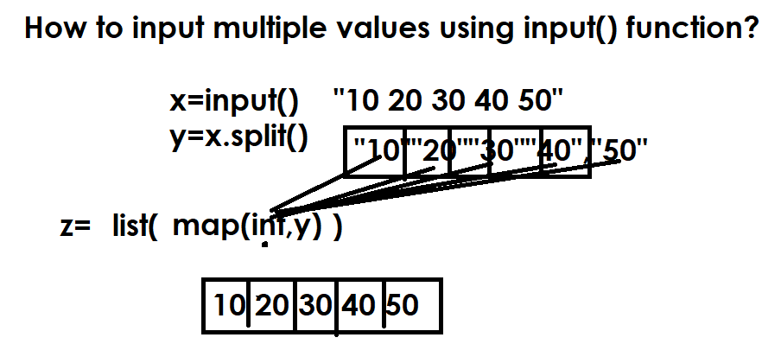

https://www.hackerrank.com/challenges/find-second-maximum-number-in-a-list/problem?isFullScreen=false

n=int(input())
A=list(map(int,input().split()))
A.sort()
B=[]
for value in A:
if value not in B:
B.append(value)

print(B[-2])

inserting elements within list

Adding element in between elements list is called insertion.
Inserting element within list is done using,
- Insert() method
- Slicing

insert() method
This method of list is used for inserting single element or value at the given index/position.

Syntax: list-name.insert(index,element)

If the index is not within range, it inserts value/element at beginning or ending.

>>> A=[10,20,30,40,50]
>>> print(A)
[10, 20, 30, 40, 50]
>>> A.insert(2,60)
>>> print(A)
[10, 20, 60, 30, 40, 50]
>>> A.insert(4,100)
>>> print(A)
[10, 20, 60, 30, 100, 40, 50]
A.insert(10,99)
print(A)
[10, 20, 60, 30, 100, 40, 50, 99]
A.insert(-5,66)
>>> print(A)
[10, 20, 60, 66, 30, 100, 40, 50, 99]
>>> A.insert(-15,500)
>>> print(A)
[500, 10, 20, 60, 66, 30, 100, 40, 50, 99]
>>> A.insert(1,11,22,33)
Traceback (most recent call last):
File "<pyshell#40>", line 1, in <module>
A.insert(1,11,22,33)
TypeError: insert expected 2 arguments, got 4

Inserting multiple elements are done using slicing
Inserting multiple elements are done using slicing
Multiple elements or values can be inserting using slice operator.

Syntax: list-name[startindex:stopindex]=iterable

Note: start-index and stop-index must be same

>>> A=[10,20,30,40,50]
>>> print(A)
[10, 20, 30, 40, 50]
>>> A.insert(0,99)
>>> print(A)
[99, 10, 20, 30, 40, 50]
>>> A[2:2]=[11,22,33]
>>> print(A)
[99, 10, 11, 22, 33, 20, 30, 40, 50]
>>> A[4:4]="AB"
>>> print(A)
[99, 10, 11, 22, 'A', 'B', 33, 20, 30, 40, 50]
>>> A[0:0]=range(1,6)
>>> print(A)
[1, 2, 3, 4, 5, 99, 10, 11, 22, 'A', 'B', 33, 20, 30, 40, 50]

reverse()
reversing elements of list
reverse is mutable operation of list, it reverse the element in place (OR) in same list

Syntax: list-name.reverse()

>>> A=[10,20,30,40,50]
>>> A.reverse()
>>> print(A)
>>> A=[10,20,30,40,50]
>>> print(A)
[10, 20, 30, 40, 50]
>>> B=A[::-1]
>>> print(B)
[50, 40, 30, 20, 10]
>>> print(A)
[10, 20, 30, 40, 50]

Sort()
Sorting is a process of arranging elements/values of list in ascending or descending order. It is a mutable operation of list. This method sorts elements in place (OR) in same list.

Syntax: list-name.sort(key=None,reverse=False)

Sort method arranges by default elements or value in ascending order. In order to sort elements in descending order the value of reserverse=True.

Example:
A=[8,2,5,3,6,4,1,7,10,9]
print(f'Before Sorting {A}')
A.sort()
print(f'After Sorting {A}')
A.sort(reverse=True)
print(f'After Sorting {A}')
print(f'First Maximum {A[0]}')
print(f'Second Maximum {A[1]}')
print(f'First Minimum {A[-1]}')
print(f'Second Minimum {A[-2]}')

Output
Before Sorting [8, 2, 5, 3, 6, 4, 1, 7, 10, 9]
After Sorting [1, 2, 3, 4, 5, 6, 7, 8, 9, 10]
After Sorting [10, 9, 8, 7, 6, 5, 4, 3, 2, 1]
First Maximum 10
Second Maximum 9
First Minimum 1
Second Minimum 2

Example:
A=["a","b","c","A","B","C"]
print(f'Before Sorting {A}')
A.sort()
print(f'After Sorting in Ascending Order {A}')
A.sort(reverse=True)
print(f'After Sorting in Descending Order {A}')
A.sort(key=str.upper)
print(f'After Sorting in Ascending Order {A}')
A.sort(key=str.upper,reverse=True)
print(f'After Sorting in Descending Order {A}')
B=["ab","a","abcde","abc","abcd"]
print(f'Before Sorting {B}')
B.sort(key=len)
print(f'After Sorting in Ascending Order {B}')
B.sort(key=len,reverse=True)
print(f'After Sorting in Descending Order {B}')

Output
Before Sorting ['a', 'b', 'c', 'A', 'B', 'C']
After Sorting in Ascending Order ['A', 'B', 'C', 'a', 'b', 'c']
After Sorting in Descending Order ['c', 'b', 'a', 'C', 'B', 'A']
After Sorting in Ascending Order ['a', 'A', 'b', 'B', 'c', 'C']
After Sorting in Descending Order ['c', 'C', 'b', 'B', 'a', 'A']
Before Sorting ['ab', 'a', 'abcde', 'abc', 'abcd']
After Sorting in Ascending Order ['a', 'ab', 'abc', 'abcd', 'abcde']
After Sorting in Descending Order ['abcde', 'abcd', 'abc', 'ab', 'a']

Common Operations applied on sequence data types or other collections
- in operator

“in” is called membership operator, this operator is used for searching element within list or collection
If given the element exists within collection, it returns True else False.

# Write a program to add n unique elements within list

n=int(input("How Many Elements?"))
A=[]

for _ in range(n):
ele=int(input("Enter Value "))
if ele not in A:
A.append(ele)

print(A)

Output
How Many Elements?5
Enter Value 1
Enter Value 2
Enter Value 2
Enter Value 3
Enter Value 3
[1, 2, 3]

Example:
>>> A=[10,20,30,40,50]
>>> 10 in A
True
>>> 50 in A
True
>>> 100 in A
False
>>> 100 not in A
True
>>> 10 not in A
False

+ operator
+ operator is used for concatenation of lists

>>> A=[10,20,30]
>>> B=[40,50,60]
>>> C=A+B
>>> print(A,B,C,sep="\n")
[10, 20, 30]
[40, 50, 60]
[10, 20, 30, 40, 50, 60]
>>> D=[10,20]
>>> E="AB"
>>> F=D+E
Traceback (most recent call last):
File "<pyshell#34>", line 1, in <module>
F=D+E
TypeError: can only concatenate list (not "str") to list

*Operator
This operator allows to repeat elements of sequence n times

>>> A=[0]
>>> B=A*10
>>> print(A)
[0]
>>> print(B)
[0, 0, 0, 0, 0, 0, 0, 0, 0, 0]
>>> C=[1,2,3,4,5]
>>> D=C*2
>>> print(C)
[1, 2, 3, 4, 5]
>>> print(D)
[1, 2, 3, 4, 5, 1, 2, 3, 4, 5]
>>> E=["abcd","xyz","pqr"]
>>> F=4*E
>>> print(E)
['abcd', 'xyz', 'pqr']
>>> print(F)
['abcd', 'xyz', 'pqr', 'abcd', 'xyz', 'pqr', 'abcd', 'xyz', 'pqr', 'abcd', 'xyz', 'pqr']
min()
This function returns minimum value
max()
This function returns maximum value

>>> A=[10,20,30,40,50]
>>> max(A)
50
>>> min(A)
10

https://www.hackerrank.com/challenges/python-lists/problem?isFullScreen=false

n=int(input())
A=[]

for _ in range(n):
cmd=input().split()
if cmd[0]=="insert":
A.insert(int(cmd[1]),int(cmd[2]))
elif cmd[0]=="append":
A.append(int(cmd[1]))
elif cmd[0]=="remove":
A.remove(int(cmd[1]))
elif cmd[0]=="reverse":
A.reverse()
elif cmd[0]=="sort":
A.sort()
elif cmd[0]=="print":
print(A)
elif cmd[0]=="pop":
A.pop()

https://www.codechef.com/problems/PRACTICEPERF

A=list(map(int,input().split()[:4]))
count=0
for p in A:
if p>=10:
count+=1

print(count)

https://www.codechef.com/problems/TODOLIST

T=int(input())
for _ in range(T):
N=int(input())
P=list(map(int,input().split()))
c=0
for value in P:
if value>=1000:
c+=1
print(c)

Nested List
List within list is called nested list
Defining list as element within list is called nested list
Nested list is used to represent data in the form of rows and columns (matrix)

Syntax:[[nested-list-1],[nested-list-2],….]
Nested List
List within list is called nested list
Defining list as element within list is called nested list
Nested list is used to represent data in the form of rows and columns (matrix)

Syntax:[[nested-list-1],[nested-list-2],….]

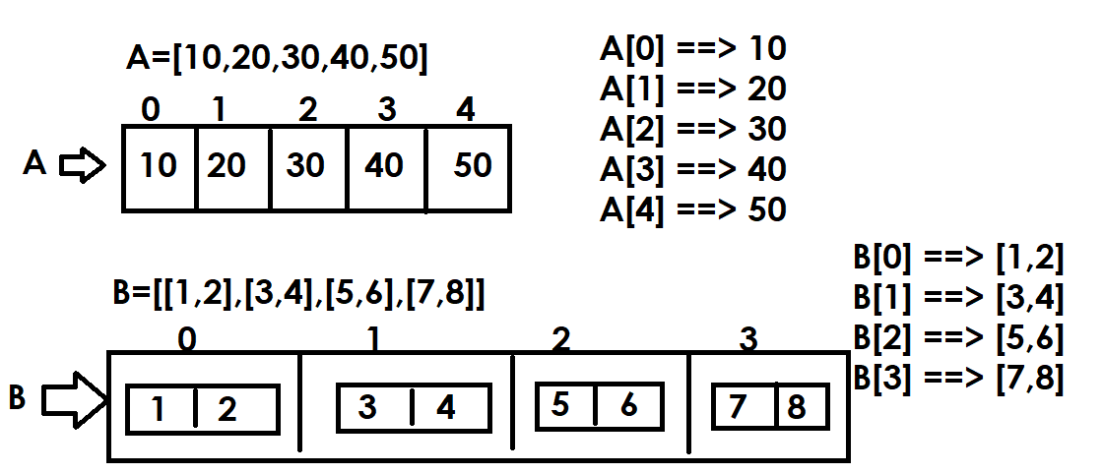

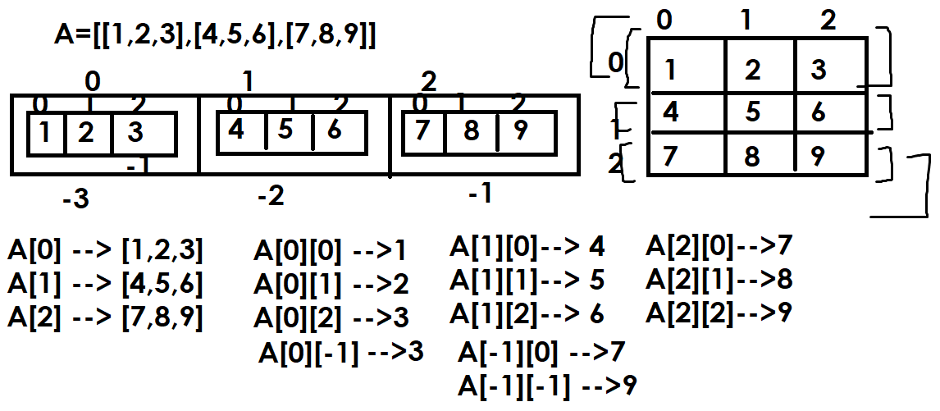

Example:
#Reading content of nested list
A=[[1,2,3],[4,5,6],[7,8,9]]
#Reading with index
for i in range(3): #0 1 2
print(A[i])

for i in range(3): # 0 1 2
for j in range(3): # 0 1 2
print(A[i][j],end=' ')
print()

#Reading elements without using index
for x in A:
print(x)

for x in A:
for y in x:
print(y,end=' ')
print()

Output
[1, 2, 3]
[4, 5, 6]
[7, 8, 9]
1 2 3
4 5 6
7 8 9
[1, 2, 3]
[4, 5, 6]
[7, 8, 9]
1 2 3
4 5 6
7 8 9

Example:
# Printing sum of rows and columns
A=[[1,2,3],[4,5,6],[7,8,9]]
for row in A:
for col in row:
print(col,end=' ')
print()
#Print sum of rows
for row in A:
print(sum(row))

#Print sum of columns
for i in range(3): # 0 1 2
s=0
for j in range(3): # 0 1 2
s=s+A[j][i]
print(s)

Output
1 2 3
4 5 6
7 8 9
6
15
24
12
15
18

Example:
# Write a program to print upper and lower triangle of matrix
A=[[1,2,3],[4,5,6],[7,8,9]]
print("Upper Triangle")
for i in range(3):
for j in range(3):
if i<=j:
print(A[i][j],end=' ')
else:
print(" ",end=' ')
print()

print("Lower Triangle")
for i in range(3):
for j in range(3):
if i>=j:
print(A[i][j],end=' ')
else:
print(" ",end=" ")
print()

Output
Upper Triangle
1 2 3
5 6
9
Lower Triangle
1
4 5
7 8 9

Example:
# Write a program to print transpose of matrix

A=[[1,2,3],[4,5,6],[7,8,9]]

print("Transpose of Matrix")
for i in range(3):
for j in range(3):
print(A[j][i],end=' ')
print()

Output
Transpose of Matrix
1 4 7
2 5 8
3 6 9

Example:
# Write a program to find determent of matrix
# ad-bc
A=[[1,2],[3,4]]

d=A[0][0]*A[1][1]-A[0][1]*A[1][0]

for row in A:
for col in row:
print(col,end=' ')
print()

print(d)

Output
1 2
3 4
-2

Example:
# Write a program to read 3x3 matrix and display

matrix=[]

for i in range(3):
row=[]
for j in range(3):
value=int(input("Enter value :"))
row.append(value)

matrix.append(row)

print(matrix)

Output
Enter value :1
Enter value :2
Enter value :3
Enter value :4
Enter value :5
Enter value :6
Enter value :7
Enter value :8
Enter value :9
[[1, 2, 3], [4, 5, 6], [7, 8, 9]]

Example:
# Write a program to read 3 students 3 subject marks
# calcualte total,avg and result(pass/fail)
stud=[]
for i in range(3):
marks=[]
for j in range(3):
s=int(input(f'Student{i+1} Subject{j+1} Marks'))
marks.append(s)
stud.append(marks)

for marks in stud:
total=sum(marks)
avg=total/3
result="pass"
for s in marks:
if s<40:
result="fail"
break
print(f'{marks}\t{total}\t{avg}\t{result}')

Output
Student1 Subject1 Marks60
Student1 Subject2 Marks70
Student1 Subject3 Marks80
Student2 Subject1 Marks30
Student2 Subject2 Marks70
Student2 Subject3 Marks80
Student3 Subject1 Marks70
Student3 Subject2 Marks80
Student3 Subject3 Marks90
[60, 70, 80] 210 70.0 pass
[30, 70, 80] 180 60.0 fail
[70, 80, 90] 240 80.0 pass

Example:
# Write a program to print sum of two matrices
A=[]
B=[]
C=[]
print("Input Elements of Matrix1")
for i in range(2):
row=[]
for j in range(2):
value=int(input("Enter value "))
row.append(value)
A.append(row)

print("Input Elements of Matrix2")
for i in range(2):
row=[]
for j in range(2):
value=int(input("Enter Value "))
row.append(value)
B.append(row)

for i in range(2):
row=[]
for j in range(2):
row.append(A[i][j]+B[i][j])
C.append(row)

print(A,B,C,sep="\n")
Output
Input Elements of Matrix1
Enter value 1
Enter value 2
Enter value 3
Enter value 4
Input Elements of Matrix2
Enter Value 5
Enter Value 6
Enter Value 7
Enter Value 8
[[1, 2], [3, 4]]
[[5, 6], [7, 8]]
[[6, 8], [10, 12]]

List Comprehension
List Comprehension

Q: What is comprehension?
Comprehensions in Python provide a concise and efficient way to create new collections (lists, dictionaries, sets, or generators) from existing ones in a single line of code, offering a readable and "Pythonic" alternative to traditional loops. They encapsulate the logic for iteration, transformation, and filtering.

Types of comprehension
Types of comprehension are nothing but comprehension is used for which type of collections.
- List Comprehension
- Set Comprehension
- Dictionary Comprehension

List Comprehension
List comprehension offers a shorter syntax when you want to create a new list based on the values of an existing iterable or collection.
List comprehension allows to write logic of iteration, transformation and filtering within [] (Square Brackets)

A=[10,20,30,40,50] 🡺 List with elements or Values
B=[] 🡺 Empty list

Syntax1: [expression for variable in iterable]
Syntax2: [expression for variable in iterable if test]

Syntax1: [expression for variable in iterable/iterator]
In this syntax after iterating each value generated by iteable, it evaluates expression.

Expression is evaluated and stored inside list based on number of values generated by iterable or iterator.

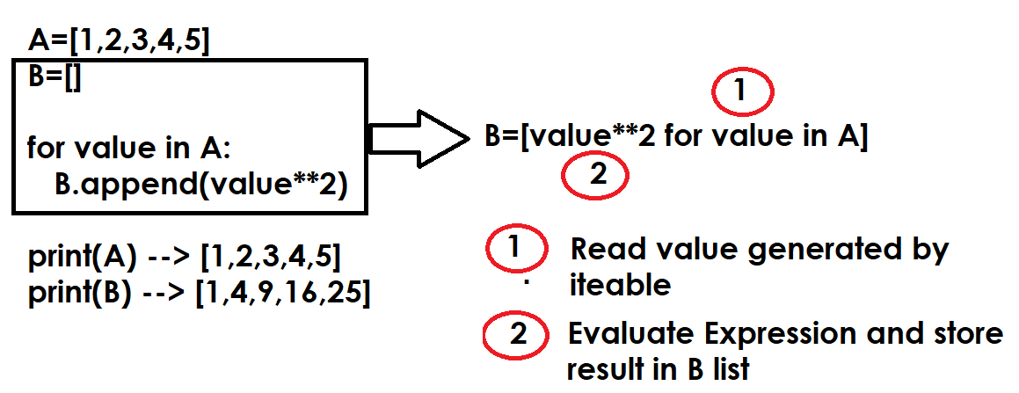
Example:
# Creating list using list comprehension

A=[num for num in range(1,11)]
print(A)
B=[num**2 for num in range(1,11)]
print(B)
C=[chr(n) for n in range(65,91)]
print(C)
D=[chr(n) for n in range(97,123)]
print(D)
E=[[n,chr(n)] for n in range(65,91)]
print(E)
F=[[num,num**2] for num in range(1,11)]
print(F)

Output
[1, 2, 3, 4, 5, 6, 7, 8, 9, 10]
[1, 4, 9, 16, 25, 36, 49, 64, 81, 100]
['A', 'B', 'C', 'D', 'E', 'F', 'G', 'H', 'I', 'J', 'K', 'L', 'M', 'N', 'O', 'P', 'Q', 'R', 'S', 'T', 'U', 'V', 'W', 'X', 'Y', 'Z']
['a', 'b', 'c', 'd', 'e', 'f', 'g', 'h', 'i', 'j', 'k', 'l', 'm', 'n', 'o', 'p', 'q', 'r', 's', 't', 'u', 'v', 'w', 'x', 'y', 'z']
[[65, 'A'], [66, 'B'], [67, 'C'], [68, 'D'], [69, 'E'], [70, 'F'], [71, 'G'], [72, 'H'], [73, 'I'], [74, 'J'], [75, 'K'], [76, 'L'], [77, 'M'], [78, 'N'], [79, 'O'], [80, 'P'], [81, 'Q'], [82, 'R'], [83, 'S'], [84, 'T'], [85, 'U'], [86, 'V'], [87, 'W'], [88, 'X'], [89, 'Y'], [90, 'Z']]
[[1, 1], [2, 4], [3, 9], [4, 16], [5, 25], [6, 36], [7, 49], [8, 64], [9, 81], [10, 100]]

Example:
# Write a program to create 2x2 matrix and display

# Without Comprehension
A=[]

for i in range(2):
row=[]
for j in range(2):
value=int(input("Enter value "))
row.append(value)

A.append(row)

print(A)

# with comprehension
B=[[int(input("Enter Value")) for j in range(2)] for i in range(2)]
print(B)

Output
Enter value 1
Enter value 2
Enter value 3
Enter value 4
[[1, 2], [3, 4]]
Enter Value5
Enter Value6
Enter Value7
Enter Value8
[[5, 6], [7, 8]]

Example:
A=["naresh","ramesh","kishore","rajesh","kiran"]
B=[name.upper() for name in A]
print(A)
print(B)
C=[]
for name in A:
C.append(name.upper())
print(C)

Output
['naresh', 'ramesh', 'kishore', 'rajesh', 'kiran']
['NARESH', 'RAMESH', 'KISHORE', 'RAJESH', 'KIRAN']
['NARESH', 'RAMESH', 'KISHORE', 'RAJESH', 'KIRAN’]

Syntax2: [expression for variable in iterable if test]
Syntax2 is used for filtering data
Syntax2 allows evaluating expression based on condition.

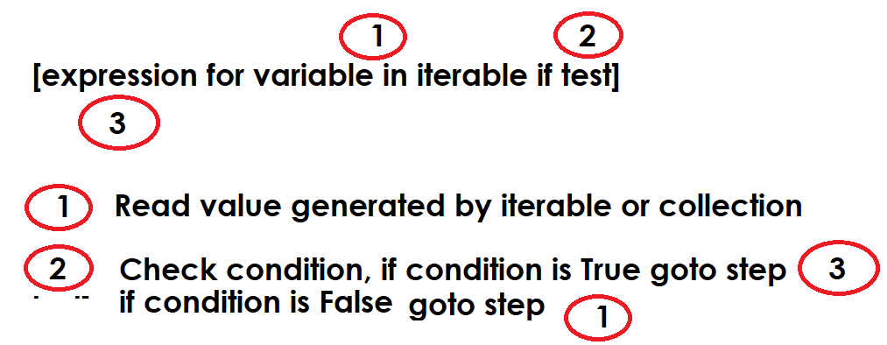

Example:
A=[1,8,23,76,98,5,7,9,21,37,75,89,98,67,44,63]
print(f'List is {A}')
#Filter Even Numbers
B=[num for num in A if num%2==0]
print(f'Even Numbers List {B}')
#Filter Odd Numbers
C=[num for num in A if num%2!=0]
print(f'Odd Numbers List {C}')

Output
List is [1, 8, 23, 76, 98, 5, 7, 9, 21, 37, 75, 89, 98, 67, 44, 63]
Even Numbers List [8, 76, 98, 98, 44]
Odd Numbers List [1, 23, 5, 7, 9, 21, 37, 75, 89, 67, 63]

Example:
grade_list=[['naresh','A'],
['suresh','B'],
['ramesh','A'],
['rajesh','A'],
['rakesh','B'],
['kiran','C']]

print(grade_list)
grade_listA=[stud for stud in grade_list if stud[1]=='A']
grade_listB=[stud for stud in grade_list if stud[1]=='B']
grade_listC=[stud for stud in grade_list if stud[1]=='C']

print(grade_listA)
print(grade_listB)
print(grade_listC)

Output
[['naresh', 'A'], ['suresh', 'B'], ['ramesh', 'A'], ['rajesh', 'A'], ['rakesh', 'B'], ['kiran', 'C']]
[['naresh', 'A'], ['ramesh', 'A'], ['rajesh', 'A']]
[['suresh', 'B'], ['rakesh', 'B']]
[['kiran', 'C']]

Example:
# Write a program to add 2x2 matrices using list comprehension

print("Enter Elements of first matrix")
A=[[int(input("Enter value ")) for j in range(2)] for i in range(2)]
print("Enter Elements of second matrix")
B=[[int(input("Enter Value ")) for j in range(2)] for i in range(2)]
C=[[A[i][j]+B[i][j] for j in range(2)] for i in range(2)]

print(A)
print(B)
print(C)

Output
Enter Elements of first matrix
Enter value 1
Enter value 2
Enter value 3
Enter value 4
Enter Elements of second matrix
Enter Value 5
Enter Value 6
Enter Value 7
Enter Value 8
[[1, 2], [3, 4]]
[[5, 6], [7, 8]]
[[6, 8], [10, 12]]

Tuple
Tuple is an immutable sequence data type.
After creating tuple changes cannot done.
Tuple does not support mutable operations like,
- Append()
- Extend()
- Remove()
- Sort()
- Insert()
- Replace()
- Del keyword
In application development tuple is used to represent immutable list.
Tuple
Tuple is an immutable sequence data type.
After creating tuple changes cannot done.
Tuple does not support mutable operations like,
- append()
- extend()
- remove()
- sort()
- insert()
- replace()
- del keyword
In application development tuple is used to represent immutable list.

How to create tuple?
Tuples may be constructed in a number of ways:
- Using a pair of parentheses to denote the empty tuple: ()

>>> t1=()
>>> print(t1,type(t1))
() <class 'tuple'>
>>> x=[]
>>> print(x,type(x))
[] <class 'list'>

- Using a trailing comma for a singleton tuple: a, or (a,)

>>> t2=(10)
>>> print(t2,type(t2))
10 <class 'int'>
>>> t2=(10,)
>>> print(t2,type(t2))
(10,) <class 'tuple'>
>>> t3=10,
>>> print(t3,type(t3))
(10,) <class 'tuple'>
>>> t4=("naresh",)
>>> t5="python",
>>> print(t4,t5,type(t4),type(t5))
('naresh',) ('python',) <class 'tuple'> <class 'tuple'>
>>>

- Separating items with commas: a, b, c or (a, b, c)

>>> t6=(10,20,30,40,50)
>>> t7=10,20,30,40,50
>>> print(t6,t7,type(t6),type(t7))
(10, 20, 30, 40, 50) (10, 20, 30, 40, 50) <class 'tuple'> <class 'tuple'>
>>> stud=(1,"naresh","python",6000.0)
>>> print(stud,type(stud))
(1, 'naresh', 'python', 6000.0) <class 'tuple'>

- Using the tuple() built-in: tuple() or tuple(iterable)

tuple() : This create empty tuple.
tuple(iterable): This create tuple using other collections (OR) it will convert other collection into tuple type.

>>> t8=tuple()
>>> print(t8,type(t8))
() <class 'tuple'>
>>> t9=tuple(range(1,6))
>>> print(t9,type(t9))
(1, 2, 3, 4, 5) <class 'tuple'>
>>> t10=tuple([10,20,30])
>>> print(t10,type(t10))
(10, 20, 30) <class 'tuple'>
>>> t11=tuple("NIT")
>>> print(t11,type(t11))
('N', 'I', 'T') <class 'tuple'>
>>> t12=tuple((1,2,3,4,5))
>>> print(t12,type(t12))
(1, 2, 3, 4, 5) <class 'tuple'>

# Reading the content of tuple
t1=(10,20,30,40,50,60,70,80,90,100)
print(t1)

# Using index
for i in range(len(t1)):
print(t1[i],end=' ')

#Using for loop
print()
for value in t1:
print(value,end=' ')

#Using slicing
print()
t2=t1[:5]
t3=t1[5:]
t4=t1[::-1]
t5=t1[3:-3]

print(t2,t3,t4,t5,sep="\n")

Output
(10, 20, 30, 40, 50, 60, 70, 80, 90, 100)
10 20 30 40 50 60 70 80 90 100
10 20 30 40 50 60 70 80 90 100
(10, 20, 30, 40, 50)
(60, 70, 80, 90, 100)
(100, 90, 80, 70, 60, 50, 40, 30, 20, 10)
(40, 50, 60, 70)

Example:
# Python program to Find the size of a Tuple
import sys
A=list(range(100000))
T=tuple(range(100000))

print(f'Size of List is {sys.getsizeof(A)}')
print(f'Size of Tuple is {sys.getsizeof(T)}')

Output
Size of List is 800056
Size of Tuple is 800048

sorted(iterable, /, *, key=None, reverse=False)
Return a new sorted list from the items in iterable.

>>> t = (2, 4, 3, 6, 8, 11, 1, 9)
>>> A=sorted(t)
>>> print(A)
[1, 2, 3, 4, 6, 8, 9, 11]
>>> B=sorted(t,reverse=False)
>>> print(B)
[1, 2, 3, 4, 6, 8, 9, 11]
>>> C=sorted(t,reverse=True)
>>> print(C)
[11, 9, 8, 6, 4, 3, 2, 1]

Example:
# Python – Maximum and Minimum K elements in Tuple
'''
Given a tuple of numeric elements and an integer K,
the task is to find the K smallest and K largest
elements from the tuple.

Example:

Input:
t = (2, 4, 3, 6, 8, 11, 1, 9)
k=2

Output:
min = 1, 2
max = 9, 11
'''
t=(2, 4, 3, 6, 8, 11, 1, 9)
k=2
A=tuple(sorted(t))
print(t)
print(A)
min_values=A[:k]
max_values=A[-k:]
print(min_values)
print(max_values)

Example:
'''
Create a List of Tuples with Numbers and Their Cubes - Python

Given a list of numbers, the task is to
create a list of tuples where each tuple contains
a number and its cube. For example:

Input: [1, 2, 3]
Output: [(1, 1), (2, 8), (3, 27)]
'''

A=[1,2,3]
B=[(num,num**3) for num in A]

print(A)
print(B)

Example:
'''
Python - Adding Tuple to List and Vice - Versa

Given a list and a tuple (or vice versa) and the
task is to combine them.

A=[1,2,3,4,5]
T=(6,7,8,9,10)

Output:
[1,2,3,4,5,6,7,8,9,10]
(6,7,8,9,10,1,2,3,4,5)
'''

A=[1,2,3,4,5]
T=(6,7,8,9,10)

B=A+list(T)
print(B)
C=T+tuple(A)
print(C)

Example:
'''
Python - Sum of tuple elements

The original tuple is : (7, 8, 9, 1, 10, 7)
The summation of tuple elements are : 42
'''

T=(7, 8, 9, 1, 10, 7)
print(f'Sum is {sum(T)}')
s=0
for value in T:
s=s+value
print(f'Sum is {s}')

Example:
'''
Python - Modulo of tuple elements

The original tuple 1 : (10, 4, 5, 6)
The original tuple 2 : (5, 6, 7, 5)
The modulus tuple : (0, 4, 5, 1)
'''

tuple1=(10, 4, 5, 6)
tuple2=(5, 6, 7, 5)
A=[]

for i in range(4): # 0 1 2 3
A.append(tuple1[i]%tuple2[i])

tuple3=tuple(A)
print(tuple1)
print(tuple2)
print(tuple3)

'''
Python - Row-wise element Addition in Tuple Matrix

Sometimes, while working with Python tuples,
we can have a problem in which we need to perform
Row-wise custom elements addition in Tuple matrix.
This kind of problem can have application in data domains

Input : test_list = [[('Gfg', 3)], [('best', 1)]]
cus_eles = [1, 2]
Output : [[('Gfg', 3, 1)], [('best', 1, 2)]]
'''

test_list = [[('Gfg', 3)], [('best', 1)]]
cus_eles = [1, 2]
k=0
for i in range(2):
for j in range(1):
A=list(test_list[i][j])
A.append(cus_eles[k])
test_list[i][j]=tuple(A)
k=k+1

print(test_list)

Example:
''''
Python | Multiply Adjacent elements

The original tuple : (1, 5, 7, 8, 10)
Resultant tuple after multiplication : (5, 35, 56, 80)
'''

T= (1, 5, 7, 8, 10)
A=[]
for i in range(len(T)-1):
A.append(T[i]*T[i+1])

print(T)
print(tuple(A))

'''
Python - Join Tuples If Similar Initial Element

Input: [(5, 6), (5, 7), (5, 8), (6, 10), (7, 13)]
Output: [(5, 6, 7, 8), (6, 10), (7, 13)]

'''

A=[(5, 6), (5, 7), (5, 8), (6, 10), (7, 13)]
B=[]
l1=len(A)
i=0
while i<l1:
x=list(A[i])
j=i+1
while j<l1:
y=A[j]
if y[0]==x[0]:
x.append(y[1])
del A[j]
l1=l1-1
continue
j=j+1

B.append(tuple(x))
i=i+1

print(B)

Strings

String is a collection of characters and these characters can be alphabets, digits or special characters.
String is an immutable sequence data type. After creating string changes cannot done. String does not provide the following operations.
- append()
- insert()
- remove()
- pop()
- del
- extend()
- sort()
- replacing
“str” class or data type is used for representing string object.
String is non numeric data type and we cannot perform arithmetic operations.

How to create string or representing string?
String can be created in different ways
- within single quotes
- within double quotes
- within triple single quotes or double quotes
- str() datatype or function

Example:
str1='python'
str2="python"
str3='python "programming" language'
str4="python 'programming' language"
str5='''python
programming
language'''
str6="""python
programming
language"""
print(str1,str2,str3,str4,str5,str6,sep="\n")
str7='python \'programming\' language'
str8="python \"programming\" language"
print(str7,str8,sep="\n")

Output
python
python
python "programming" language
python 'programming' language
python
programming
language
python
programming
language
python 'programming' language
python "programming" language

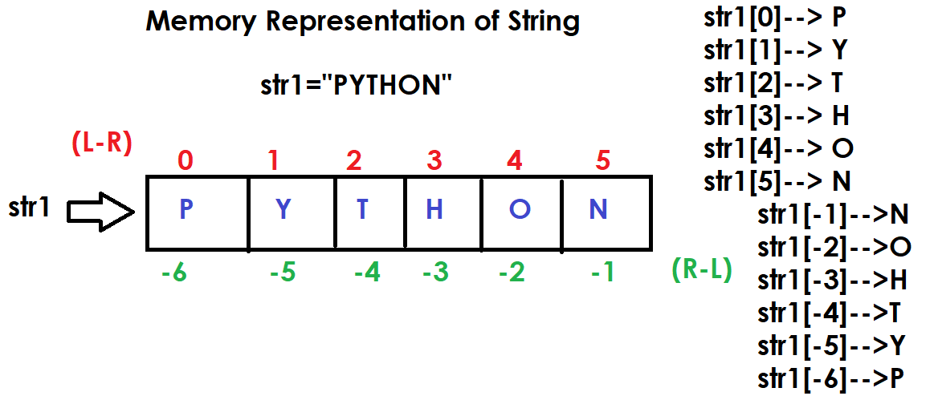
>>> str1="PYTHON"
>>> print(str1)
PYTHON
>>> str1[0]="J"
Traceback (most recent call last):
File "<pyshell#2>", line 1, in <module>
str1[0]="J"
TypeError: 'str' object does not support item assignment
>>> del str1[0]
Traceback (most recent call last):
File "<pyshell#3>", line 1, in <module>
del str1[0]
TypeError: 'str' object doesn't support item deletion
>>> str1.append("A")
Traceback (most recent call last):
File "<pyshell#4>", line 1, in <module>
str1.append("A")
AttributeError: 'str' object has no attribute 'append'

How to read content of string?
The content of string can be read in different ways
- using index
- using slicing
- using for loop
- using iterator
- using enumerate

Example:
str1="programming"

# Using index
for i in range(len(str1)):
print(str1[i],end=' ')

#Using Slicing
print()
str2=str1[0:4]
print(str2)
str3=str1[::-1]
print(str3)
str4=str1[::2]
print(str4)
str5=str1[2:-2]
print(str5)
str6=str1[4:]
print(str6)

#Using for loop
for ch in str1:
print(ch,end=' ')
print()
for ch in str1[::-1]:
print(ch,end=' ')

Output
p r o g r a m m i n g
prog
gnimmargorp
pormig
ogrammi
ramming
p r o g r a m m i n g
g n i m m a r g o r p

Example:
# Write a program input string and count vowels

str1=input("Enter any String ")
count=0
for ch in str1:
if ch in "aeiousAEIOU":
count=count+1

print(f'String is {str1}')
print(f'Vowel Count is {count}')

Output
Enter any String apple
String is apple
Vowel Count is 2

Enter any String programming
String is programming
Vowel Count is 3

Example:
# Write a program to input string and count
# alphabets, digits and special characters

str1=input("Enter any string")
ac=0
dc=0
sc=0

for ch in str1:
if (ch>='A' and ch<='Z') or (ch>='a' and ch<='z'):
ac=ac+1
elif ch>='0' and ch<='9':
dc=dc+1
else:
sc=sc+1

print(f'Alphabet Count {ac}')
print(f'Digit Count {dc}')
print(f'Special Character Count {sc}')

Output
Enter any stringpython 3.14
Alphabet Count 6
Digit Count 3
Special Character Count 2

Example:
# Write a program to find input string palindrome or not

str1=input("Enter any string ")
str2=str1[::-1]
print(str1,str2)
if str1==str2:
print("String is Palindrome")
else:
print("String is not Palindrome")

Output
Enter any string madam
madam madam
String is Palindrome

Enter any string java
java avaj
String is not Palindrome

Example:
#Check Whether the String is Symmetrical or Palindrome
'''
A string is symmetrical if the first half matches the second
half (ignoring the middle character for odd-length strings).
A string is a palindrome if it reads the same forwards and backwards.
For example:

s = "amaama" -> symmetrical (ama matches ama) and palindrome.
s = "abcba" -> palindrome but not symmetrical (ab ≠ ba).
'''

s=input("Enter any String ")

if s==s[::-1]:
print("Palindrome")
else:
print("Not Palindrome")

if len(s)%2==0:
fh=s[0:len(s)//2]
sh=s[len(s)//2:]
if fh==sh:
print("Symmetrical")
else:
print("Not Symmetrical")
else:
fh=s[0:len(s)//2]
sh=s[len(s)//2+1:]
if fh==sh:
print("Symmetrical")
else:
print("Not Symmetrical")

Output
Enter any String khokho
Not Palindrome
Symmetrical

Enter any String abcab
Not Palindrome
Symmetrical

Enter any String bacba
Not Palindrome
Symmetrical

Example:
# Find Length of String in Python
# without using len() function

str1=input("Enter any string ")
c=0

for ch in str1:
c=c+1

print(f'String is {str1}')
print(f'Count or Length of String {c}')
print(f'Length of string is {len(str1)}')
Output
Enter any string java
String is java
Count or Length of String 4
Length of string is 4
Methods of str class/datatype

Case conversion methods
- upper()
- lower()
- capitalize()
- title()
- swapcase()

upper(): This method return string by converting into uppercase

string-object.upper()

#Program to convert string into uppercase
str1="python"
str2=str1.upper()
print(str1,str2,sep="\n")

Output
python
PYTHON

Example:
# Write a program to convert string into uppercase
# without using upper() method

str1=input("Enter any string ")
str2=""

for ch in str1:
if ch>='a' and ch<='z':
str2=str2+chr(ord(ch)-32)
else:
str2=str2+ch

print(str1)
print(str2)
Output
Enter any string python 3.14
python 3.14
PYTHON 3.14

lower(): This method return string by converting into lowercase

# Write a program to convert string into lowercase
str1=input("Enter any string ")
str2=str1.lower()
print(str1)
print(str2)

Output
Enter any string PYTHON
PYTHON
Python

Example:
# Write a program to convert string into uppercase
# without using lower() method

str1=input("Enter any string ")
str2=""

for ch in str1:
if ch>='A' and ch<='Z':
str2=str2+chr(ord(ch)+32)
else:
str2=str2+ch

print(str1)
print(str2)

Output
Enter any string PYTHON
PYTHON
python

capitalize()
This method returns first letter of string in uppercase and remaining all in lowercase.

# write a program to capitalize string
str1="python"
str2=str1.capitalize()
print(str1,str2)
str3="PYTHON"
str4=str3.capitalize()
print(str3,str4)
str5="1abc"
str6=str5.capitalize()
print(str5,str6)
student_name=["naresh","RAMESH","kishore","RAMAN"]
for name in student_name:
print(name.capitalize())

Output
python Python
PYTHON Python
1abc 1abc
Naresh
Ramesh
Kishore
Raman

Example:
# Write a program to capitalize string without using
# capitalize method
# use only chr,ord,len
str1=input("Enter any string ")
str2=""

for i in range(len(str1)):
if i==0:
if str1[i]>='a' and str1[i]<='z':
str2=str2+chr(ord(str1[i])-32)
else:
str2=str2+str1[i]
elif str1[i]>='A' and str1[i]<='Z':
str2=str2+chr(ord(str1[i])+32)
else:
str2=str2+str1[i]

print(str1)
print(str2)

Output
Enter any string PYTHON PROGRAMMING 3.14
PYTHON PROGRAMMING 3.14
Python programming 3.14

title() : This method return string by converting each word first letter into uppercase and remaining into lowercase

Example:

str1="python programming"
str2=str1.title()
print(str1)
print(str2)
str3="PYTHON PROGRAMMING"
str4=str3.title()
print(str3)
print(str4)

output
python programming
Python Programming
PYTHON PROGRAMMING
Python Programming

# Write a program to convert string into titlecase
# using only chr,ord,len functions

# python programming language
# Python Programming Language

str1=input("Enter any string :")
str2=''
i=0
while i<len(str1):
if i==0:
if str1[i]>='a' and str1[i]<='z':
str2=str2+(chr(ord(str1[i])-32))
else:
str2=str2+str1[i]
elif str1[i]==' ':
i=i+1
str2=str2+" "
if str1[i]>='a' and str1[i]<='z':
str2=str2+chr(ord(str1[i])-32)
else:
str2=str2+str1[i]
elif str1[i]>='A' and str1[i]<='Z':
str2=str2+chr(ord(str1[i])+32)
else:
str2=str2+str1[i]
i=i+1

print(str1)
print(str2)

Output
Enter any string :PYTHON PROGRAMMING
PYTHON PROGRAMMING
Python Programming

swapcase() : This method return string by converting uppercase letters to lowercase and lowercase to uppercase.

Example:
str1="aBcDEFg"
str2=str1.swapcase()
print(str1,str2,sep="\n")

Output
aBcDEFg
AbCdefG

# Write a program input string and swapcase
# without using swapcase method

str1=input("Enter any string ")
str2=""
for ch in str1:
if ch>='A' and ch<='Z':
str2=str2+chr(ord(ch)+32)
elif ch>='a' and ch<='z':
str2=str2+chr(ord(ch)-32)
else:
str2=str2+ch

print(str1)
print(str2)

Output
Enter any string AbCdEF
AbCdEF
aBcDef

split methods
- split()
- rsplit()

str.split(sep=None, maxsplit=-1)
Return a list of the words in the string, using sep as the delimiter string. If maxsplit is given, at most maxsplit splits are done (thus, the list will have at most maxsplit+1 elements). If maxsplit is not specified or -1, then there is no limit on the number of splits (all possible splits are made).

Example
>>> str1="a,b,c,d,e"
>>> A=str1.split(sep=",")
>>> print(A)
['a', 'b', 'c', 'd', 'e']
>>> str2="a b c d e"
>>> B=str2.split()
>>> print(str2)
a b c d e
>>> print(B)
['a', 'b', 'c', 'd', 'e']
>>> C=str1.split(sep=",",maxsplit=2)
>>> print(C)
['a', 'b', 'c,d,e']
>>> str3="10 20 30 40 50"
>>> D=str3.split()
>>> print(D)
['10', '20', '30', '40', '50']
nMethods of str class/datatype

Case conversion methods
- upper()
- lower()
- capitalize()
- title()
- swapcase()

upper(): This method return string by converting into uppercase

string-object.upper()

#Program to convert string into uppercase
str1="python"
str2=str1.upper()
print(str1,str2,sep="\n")

Output
python
PYTHON

Example:
# Write a program to convert string into uppercase
# without using upper() method

str1=input("Enter any string ")
str2=""

for ch in str1:
if ch>='a' and ch<='z':
str2=str2+chr(ord(ch)-32)
else:
str2=str2+ch

print(str1)
print(str2)
Output
Enter any string python 3.14
python 3.14
PYTHON 3.14

lower(): This method return string by converting into lowercase

# Write a program to convert string into lowercase
str1=input("Enter any string ")
str2=str1.lower()
print(str1)
print(str2)

Output
Enter any string PYTHON
PYTHON
Python

Example:
# Write a program to convert string into uppercase
# without using lower() method

str1=input("Enter any string ")
str2=""

for ch in str1:
if ch>='A' and ch<='Z':
str2=str2+chr(ord(ch)+32)
else:
str2=str2+ch

print(str1)
print(str2)

Output
Enter any string PYTHON
PYTHON
python

capitalize()
This method returns first letter of string in uppercase and remaining all in lowercase.

# write a program to capitalize string
str1="python"
str2=str1.capitalize()
print(str1,str2)
str3="PYTHON"
str4=str3.capitalize()
print(str3,str4)
str5="1abc"
str6=str5.capitalize()
print(str5,str6)
student_name=["naresh","RAMESH","kishore","RAMAN"]
for name in student_name:
print(name.capitalize())

Output
python Python
PYTHON Python
1abc 1abc
Naresh
Ramesh
Kishore
Raman

Example:
# Write a program to capitalize string without using
# capitalize method
# use only chr,ord,len
str1=input("Enter any string ")
str2=""

for i in range(len(str1)):
if i==0:
if str1[i]>='a' and str1[i]<='z':
str2=str2+chr(ord(str1[i])-32)
else:
str2=str2+str1[i]
elif str1[i]>='A' and str1[i]<='Z':
str2=str2+chr(ord(str1[i])+32)
else:
str2=str2+str1[i]

print(str1)
print(str2)

Output
Enter any string PYTHON PROGRAMMING 3.14
PYTHON PROGRAMMING 3.14
Python programming 3.14

title() : This method return string by converting each word first letter into uppercase and remaining into lowercase

Example:

str1="python programming"
str2=str1.title()
print(str1)
print(str2)
str3="PYTHON PROGRAMMING"
str4=str3.title()
print(str3)
print(str4)

output
python programming
Python Programming
PYTHON PROGRAMMING
Python Programming

# Write a program to convert string into titlecase
# using only chr,ord,len functions

# python programming language
# Python Programming Language

str1=input("Enter any string :")
str2=''
i=0
while i<len(str1):
if i==0:
if str1[i]>='a' and str1[i]<='z':
str2=str2+(chr(ord(str1[i])-32))
else:
str2=str2+str1[i]
elif str1[i]==' ':
i=i+1
str2=str2+" "
if str1[i]>='a' and str1[i]<='z':
str2=str2+chr(ord(str1[i])-32)
else:
str2=str2+str1[i]
elif str1[i]>='A' and str1[i]<='Z':
str2=str2+chr(ord(str1[i])+32)
else:
str2=str2+str1[i]
i=i+1

print(str1)
print(str2)

Output
Enter any string :PYTHON PROGRAMMING
PYTHON PROGRAMMING
Python Programming

swapcase() : This method return string by converting uppercase letters to lowercase and lowercase to uppercase.

Example:
str1="aBcDEFg"
str2=str1.swapcase()
print(str1,str2,sep="\n")

Output
aBcDEFg
AbCdefG

# Write a program input string and swapcase
# without using swapcase method

str1=input("Enter any string ")
str2=""
for ch in str1:
if ch>='A' and ch<='Z':
str2=str2+chr(ord(ch)+32)
elif ch>='a' and ch<='z':
str2=str2+chr(ord(ch)-32)
else:
str2=str2+ch

print(str1)
print(str2)

Output
Enter any string AbCdEF
AbCdEF
aBcDef

split methods
- split()
- rsplit()

str.split(sep=None, maxsplit=-1)
Return a list of the words in the string, using sep as the delimiter string. If maxsplit is given, at most maxsplit splits are done (thus, the list will have at most maxsplit+1 elements). If maxsplit is not specified or -1, then there is no limit on the number of splits (all possible splits are made).

Example
>>> str1="a,b,c,d,e"
>>> A=str1.split(sep=",")
>>> print(A)
['a', 'b', 'c', 'd', 'e']
>>> str2="a b c d e"
>>> B=str2.split()
>>> print(str2)
a b c d e
>>> print(B)
['a', 'b', 'c', 'd', 'e']
>>> C=str1.split(sep=",",maxsplit=2)
>>> print(C)
['a', 'b', 'c,d,e']
>>> str3="10 20 30 40 50"
>>> D=str3.split()
>>> print(D)
['10', '20', '30', '40', '50']
str.rsplit(sep=None, maxsplit=-1)
Return a list of the words in the string, using sep as the delimiter string. If maxsplit is given, at most maxsplit splits are done, the rightmost ones. If sep is not specified or None, any whitespace string is a separator.

>>> str1="a,b,c,d,e"
>>> A=str1.split(sep=",")
>>> print(A)
['a', 'b', 'c', 'd', 'e']
>>> B=str1.rsplit(sep=",")
>>> print(B)
['a', 'b', 'c', 'd', 'e']
>>> C=str1.split(sep=",",maxsplit=2)
>>> print(C)
['a', 'b', 'c,d,e']
>>> D=str1.rsplit(sep=",",maxsplit=2)
>>> print(D)
['a,b,c', 'd', 'e']
>>> str2="a b c d e"
>>> A=str2.split()
>>> print(A)
['a', 'b', 'c', 'd', 'e']
>>> B=str2.rsplit()
>>> print(B)
['a', 'b', 'c', 'd', 'e']
>>> C=str2.rsplit(maxsplit=3)
>>> print(C)
['a b', 'c', 'd', 'e']

str.join(iterable, /)
Return a string which is the concatenation of the strings in iterable

Example
A=["x","y","z"]
s1=",".join(A)
print(A)
print(s1)
s2="".join(A)
print(s2)
s3=":".join(A)
print(s3)
B=["naresh","i","technologies"]
s4=" ".join(B)
print(B)
print(s4)

Output
['x', 'y', 'z']
x,y,z
xyz
x:y:z
['naresh', 'i', 'technologies']
naresh i technologies

#Reverse Words in a Given String in Python

'''
Given a string, the task is to reverse the words in it without
changing the words themselves.
For example, for "Learning Python is easy",
the reversed string would be "easy is Python Learning"
(words in reverse order).'''

str1="Learning Python is easy"
A=str1.split()
print(A)
A=A[::-1]
print(A)
str2=" ".join(A)
print(str2)
print(str1)

Example:
# Write a program to reverse each word in a given string
# "abc xyz pqr"
# "cba zyx rqp"

str1="abc xyz pqr"
A=str1.split()
B=[]
for s in A:
B.append(s[::-1])

print(A)
print(B)

str2=" ".join(B)
print(str1)
print(str2)

Output
['abc', 'xyz', 'pqr']
['cba', 'zyx', 'rqp']
abc xyz pqr
cba zyx rqp

Justification methods or alignment methods
String provides 3 justifications methods
- ljust()
- rjust()
- center()
These methods are used to format the string or output the given string with alignment.

str.ljust(width, fillchar=' ', /)
Return the string left justified in a string of length width. Padding is done using the specified fillchar (default is an ASCII space).

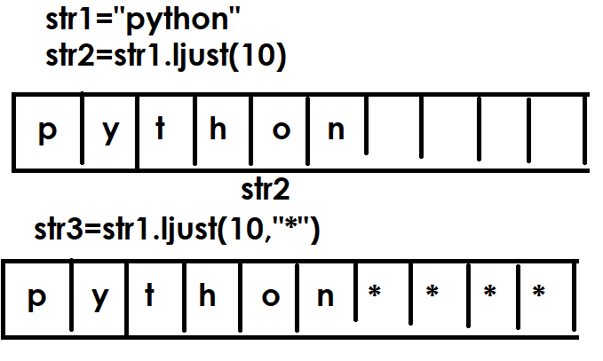

names=["naresh","kishore","kiran","raju","ramesh"]
for name in names:
print(name.ljust(15,"*"))

Output
naresh*********
kishore********
kiran**********
raju***********
ramesh*********

str.rjust(width, fillchar=' ', /)
Return the string right justified in a string of length width. Padding is done using the specified fillchar (default is an ASCII space)

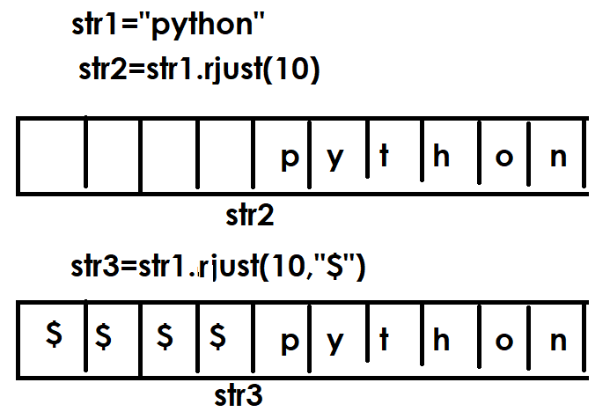
names=["naresh","kishore","kiran","raju","ramesh"]
for name in names:
print(name.rjust(15,"*"))

Output
*********naresh
********kishore
**********kiran
***********raju
*********ramesh

str.center(width, fillchar=' ', /)
Return centered in a string of length width. Padding is done using the specified fillchar (default is an ASCII space).

Example:
str1="abc"
str2=str1.center(9)
print(str1)
print(str2)
str3=str1.center(9,"*")
print(str3)
str4=str1.center(10,"$")
print(str4)

Output
abc
abc
***abc***
$$$abc$$$$

persons=[["naresh","nareshit@nareshit.com"],
["suresh","suresh@gmail.com"],
["kiran","kiran@nareshit.com"],
["raman","raman@gmail.com"]]
print("---------------------------------------------")
print("Name".ljust(10),"EmailID".center(20))
print("---------------------------------------------")
for p in persons:
print(p[0].ljust(10),p[1].center(20))

print("---------------------------------------------")

strip methods
string provides the following strip methods
- lstrip()
- rstrip()
- strip()

strip methods are used for removing or deleting leading or trailing spaces or given characters.

str.lstrip(chars=None, /)
Return a copy of the string with leading characters removed. The chars argument is a string specifying the set of characters to be removed. If omitted or None, the chars argument defaults to removing whitespace. The chars argument is not a prefix; rather, all combinations of its values are stripped:

>>> str1=" nit"
>>> print(len(str1))
7
>>> str2=str1.lstrip()
>>> print(str2)
nit
>>> print(str1)
nit
>>> print(len(str2))
3
>>> str3="******nit"
>>> str4=str3.lstrip("*")
>>> print(str3)
******nit
>>> print(str4)
nit
>>> str5="**&&&$$**nit"
>>> str6=str5.lstrip("*$&")
>>> print(str5)
**&&&$$**nit
>>> print(str6)
nit
>>> str7="n*i*t"
>>> str8=str7.lstrip("*")
>>> print(str7)
n*i*t
>>> print(str8)
n*i*t

str.rstrip(chars=None, /)
Return a copy of the string with trailing characters removed. The chars argument is a string specifying the set of characters to be removed. If omitted or None, the chars argument defaults to removing whitespace. The chars argument is not a suffix; rather, all combinations of its values are stripped

>>> str1="nit "
>>> str2=str1.rstrip()
>>> print(str1,len(str1))
nit 9
>>> print(str2,len(str2))
nit 3
>>> str3="nit****"
>>> str4=str3.rstrip("*")
>>> print(str4)
nit
>>> print(str3)
nit****
>>> str5="nit**%%$$**"
>>> str6=str5.rstrip("*%$")
>>> print(str5)
nit**%%$$**
>>> print(str6)
nit

str.strip(chars=None, /)
Return a copy of the string with the leading and trailing characters removed. The chars argument is a string specifying the set of characters to be removed. If omitted or None, the chars argument defaults to removing whitespace. The chars argument is not a prefix or suffix; rather, all combinations of its values are stripped

>>> str1=" nit "
>>> str2=str1.strip()
>>> print(str1,len(str1))
nit 10
>>> print(str2,len(str2))
nit 3
>>> str3="****nit*****"
>>> str4=str3.strip("*")
>>> print(str3,len(str3))
****nit***** 12
p
>>> print(str4,len(str4))
nit 3
>>> str5="**$$&&nit##@@**&"
>>> str6=str5.strip("*$&@#")
>>> print(str5)
**$$&&nit##@@**&
>>> print(str6)
nit
Searching Methods
- startswith()
- endswith()
- find()
- rfind()

str.startswith(prefix[, start[, end]])
Return True if string starts with the prefix, otherwise return False. prefix can also be a tuple of prefixes to look for. With optional start, test string beginning at that position. With optional end, stop comparing string at that position.

>>> str1="naresh"
>>> str1.startswith('n')
True
>>> str1.startswith('k')
False
>>> str1.startswith('r',2,5)
True

Example:
names=["naresh","ramesh","kishore","suresh","kiran","raman"]
for name in names:
if name.startswith('k'):
print(name)
print("===================================")
for name in names:
if name.startswith(('k','s')):
print(name)

Output
kishore
kiran
===================================
kishore
suresh
kiran
str.endswith(suffix[, start[, end]])
Return True if the string ends with the specified suffix, otherwise return False. suffix can also be a tuple of suffixes to look for. With optional start, test beginning at that position. With optional end, stop comparing at that position.

>>> str1="python"
>>> str1.endswith("n")
True
>>> str1.endswith("m")
False
>>> str1.endswith("on")
True
>>> str1.endswith("h",1,4)
True

Example
names=["naresh","ramesh","kishore","suresh","kiran","raman"]
for name in names:
if name.endswith('h'):
print(name)
print("============================================")
for name in names:
if name.endswith(("e","n")):
print(name)

Output
naresh
ramesh
suresh
============================================
kishore
kiran
raman

str.find(sub[, start[, end]])
Return the lowest index in the string where substring sub is found within the slice s[start:end]. Optional arguments start and end are interpreted as in slice notation. Return -1 if sub is not found.

>>> str1="python java mysql java oracle"
>>> n=str1.find("java")
>>> print(n)
7
>>> n=str1.find("php")
>>> print(n)
-1

str.rfind(sub[, start[, end]])
Return the highest index in the string where substring sub is found, such that sub is contained within s[start:end]. Optional arguments start and end are interpreted as in slice notation. Return -1 on failure.

>>> str1="python java mysql java oracle"
>>> print(str1.rfind("java"))
18

str.replace(old, new, /, count=-1)
Return a copy of the string with all occurrences of substring old replaced by new. If count is given, only the first count occurrences are replaced. If count is not specified or -1, then all occurrences are replaced.

>>> str1="python java mysql java oracle"
>>> str2=str1.replace("java","jython")
>>> print(str1)
python java mysql java oracle
>>> print(str2)
python jython mysql jython oracle
>>> str3=str1.replace("java","jython",1)
>>> print(str3)
python jython mysql java oracle

# Write a program to print the following output

# input: abcaabcd
# output: 3a2b2c1d
str1="abcaabcd"
str2=""
for ch in str1:
if ch not in str2:
str2=str2+ch

print(str1)
print(str2)
str3=""
for ch in str2:
n=str1.count(ch)
str3=str3+str(n)+ch

print(str3)

# Write a program to print the following output

# input: 3a2b2c1d
# output: aaabbccd

str1="3a2b2c1d"
result=""
i=0
while i<len(str1):
n=int(str1[i])
i=i+1
ch=str1[i]
result=result+(ch*n)
i=i+1

print(str1)
print(result)

String examine methods
The following methods are string examine methods and these methods returns boolean value (True/False)

- isalpha()
- isalnum()
- isdigit()
- isupper()
- islower()
- istitle()
- isspace()

isalpha()
This methods return True, if all letters within string are alphabets else returns False

>>> str1="python"
>>> str1.isalpha()
True
>>> str2="python3.14"
>>> str2.isalpha()
False
>>> name="naresh"
>>> name.isalpha()
True

Example:
# Write a program to find input string is alphabetic string
# or not without using isalpha method

str1=input("Enter any string ")
ans=True
for ch in str1:
if (ch>='A' and ch<='Z') or (ch>='a' and ch<='z'):
pass
else:
ans=False
break
print(str1)
print(ans)

Output
Enter any string naresh
naresh
True

Enter any string python3.14
python3.14
False

Isalnum()
This method returns True if string is alphanumeric string else False
A string alphanumeric string if it consist of,
- only alphabets
- only numbers
- alphabets and numbers

>>> str1="abc"
>>> str1.isalnum()
True
>>> str2="123"
>>> str2.isalnum()
True
>>> str3="abc123"
>>> str3.isalnum()
True
>>> str4="abc123$@"
>>> str4.isalnum()
False

isdigit()
This method returns True if string contains only digits else False

>>> s1="123"
>>> s1.isdigit()
True
>>> s2="a123"
>>> s2.isdigit()
False
>>> a=int("123")
>>> b=int("abc")
Traceback (most recent call last):
File "<pyshell#44>", line 1, in <module>
b=int("abc")
ValueError: invalid literal for int() with base 10: 'abc'
>>>

isspace()
This returns True, if string contains only space characters.

>>> str1=" "
>>> str1.isspace()
True
>>> str2=""
>>> str2.isspace()
False
>>> str3="a b c d"
>>> str3.isspace()
False

Isupper()
This method returns True, if string contains only uppercase letter else False

>>> str1="PYTHON"
>>> str1.isupper()
True
>>> str2="Python"
>>> str2.isupper()
False
Sets
Sets are unordered collections.
Unordered means where insertion order is not preserved or not same.
Insertion order changes from one insertion of value to another.
Sets does not allows duplicate values.
Sets are non index based collections, where reading and writing cannot done using index. Sets does not support indexing and slicing.
In application development sets are used to group individual objects where duplicates not allowed and perform mathematical set operations like union(), intersection(), difference(), symmetric_difference(),.. and removing duplicates from sequences and membership testing.

Python provides 2 types of sets.
- Set
- Frozenset

Set is mutable collection
Frozenset is immutable collection

set
set is mutable collection. After creating set changes can be done.
Properties set
- Duplicates are not allowed
- Does not allows indexing and slicing
- Unordered collection

In set data is organized using hashing data structure (OR) set is hashable object.
Set does not allows all the objects, it allows only immutable objects.
“set” class or datatype represents set object

How to create set?
Set is created in different ways
- Set is created with elements separated with , within curly braces
{ele,ele,ele,ele,…}
>>> A={10,20,30,40,50}
>>> print(A)
{50, 20, 40, 10, 30}
>>> B={10,10,10,10,10}
>>> print(B,type(B))
{10} <class 'set'>
>>> C={10,20,30,10,20,30,40,50,40,50,60,70}
>>> print(C,type(C))
{50, 20, 70, 40, 10, 60, 30} <class 'set'>
>>> D={1,"naresh","python",4000.0}
>>> print(D)
{4000.0, 1, 'python', 'naresh'}

Note: Empty set cannot create using empty {}, in python empty curly braces also used for representing dictionary

>>> E={}
>>> print(E,type(E))
{} <class 'dict'>

- Set type or function also used for creating set object
- Set() : This create empty set
- Set(iterable) : This create set by converting existing collections or iterable (OR) create a set using elements of existing collection (OR) it allows to convert other collections into set

>>> S1=set()
>>> print(S1)
set()
>>> print(type(S1))
<class 'set'>
>>>L1=[10,20,30,40,50,10,20,30]
>>>S2=set(L1)
>>>print(L1)
[10, 20, 30, 40, 50, 10, 20, 30]
>>>print(S2)
{40, 10, 50, 20, 30}
>>>str1="JAVA"
>>>S3=set(str1)
>>> print(str1)
JAVA
>>> print(S3)
{'A', 'J', 'V'}
>>> T1=(10,20,30,40,50,60)
>>> S4=set(T1)
>>> print(T1,type(T1))
(10, 20, 30, 40, 50, 60) <class 'tuple'>
>>> print(S4,type(S4))
{40, 10, 50, 20, 60, 30} <class 'set'>
>>> S5=set({10,20,30,40,50})
>>> print(S5)
{50, 20, 40, 10, 30}
>>> S6=set(range(10,110,10))
>>> print(S6)
{100, 70, 40, 10, 80, 50, 20, 90, 60, 30}
>>> A={10,1.5,1+2j,True,None}
>>> print(A)
{None, True, 1.5, (1+2j), 10}
>>> B={(10,20),"NIT"}
>>> print(B)
{'NIT', (10, 20)}
>>> C={[10,20]}
Traceback (most recent call last):
File "<pyshell#34>", line 1, in <module>
C={[10,20]}
TypeError: cannot use 'list' as a set element (unhashable type: 'list')

How to read content of set?
Set is non index based collection; it does not support indexing and slicing.

>>> A={10,20,30,40,50}
>>> A[0]
Traceback (most recent call last):
File "<pyshell#36>", line 1, in <module>
A[0]
TypeError: 'set' object is not subscriptable
>>> A[::-1]
Traceback (most recent call last):
File "<pyshell#37>", line 1, in <module>
A[::-1]
TypeError: 'set' object is not subscriptable

The content of set can be read using “for” loop.

# Reading content of set using for loop
A={10,20,30,40,50}
for value in A:
print(value)

Output
50
20
40
10
30

Mutable Operations of set
After creating set changes can be done using mutable functions provided by set
- add()
- remove()
- discard()
- clear()
- pop()

Note: we cannot replace or update values of set because set is non index based collection.

add()
This method add an element within set

set-name.add(ele)

Example:
>>> S1=set()
>>> S1.add(10)
>>> print(S1)
{10}
>>> S1.add(20)
>>> print(S1)
{10, 20}
>>> S1.add(30)
>>> print(S1)
{10, 20, 30}
>>> S1.add(40)
>>> print(S1)
{40, 10, 20, 30}
>>> S1.add(50)
>>> print(S1)
{40, 10, 50, 20, 30}

https://www.hackerrank.com/challenges/py-set-add/problem?isFullScreen=false

N=int(input())
A=set()
for i in range(N):
country=input()
A.add(country)

print(len(A))

Example:
# Write a program input n mobileno into set

n=int(input("How many mobileno's?"))
A=set()

for _ in range(n):
value=int(input("MobileNo :"))
A.add(value)

print(A)

Output
How many mobileno's?3
MobileNo :9988744556
MobileNo :8877655443
MobileNo :8877655443
{8877655443, 9988744556}

remove()
This method is used to remove single element from set
If element exists within set, it removes
If element not exists within set, it raises KeyError

>>> A={10,20,30,40,50,60}
>>> print(A)
{50, 20, 40, 10, 60, 30}
>>> A.remove(10)
>>> print(A)
{50, 20, 40, 60, 30}
>>> A.remove(20)
>>> print(A)
{50, 40, 60, 30}
>>> A.remove(60)
>>> print(A)
{50, 40, 30}
>>> A.remove(100)
Traceback (most recent call last):
File "<pyshell#60>", line 1, in <module>
A.remove(100)
KeyError: 100
>>> A.remove(20)
Traceback (most recent call last):
File "<pyshell#61>", line 1, in <module>
A.remove(20)
KeyError: 20
>>>

discard()
discard method of set remove single value
discard method remove if element exists
if element not exists it raises any error.

>>> A={10,20,30,40,50,60}
>>> print(A)
{50, 20, 40, 10, 60, 30}
>>> A.discard(10)
>>> print(A)
{50, 20, 40, 60, 30}
>>> A.discard(30)
>>> print(A)
{50, 20, 40, 60}
>>> A.discard(10)

clear()
This method remove/delete all the elements from set

Syntax:
set-name.clear()

>>> S1=set(range(10,110,10))
>>> print(S1)
{100, 70, 40, 10, 80, 50, 20, 90, 60, 30}
>>> S1.clear()
>>> print(S1)
set()
set.pop()
Remove and return an arbitrary element from the set. Raises KeyError if the set is empty.

>>> A={10,20,30,40,50}
>>> print(A)
{50, 20, 40, 10, 30}
>>> x=A.pop()
>>> print(x)
50
>>> print(A)
{20, 40, 10, 30}
>>> y=A.pop()
>>> print(y)
20
>>> print(A)
{40, 10, 30}
>>> B=set()
>>> B.pop()
Traceback (most recent call last):
File "<pyshell#9>", line 1, in <module>
B.pop()
KeyError: 'pop from an empty set'

Mathematical set operations
set.union(*others)
set | other | ...
Return a new set with elements from the set and all others.

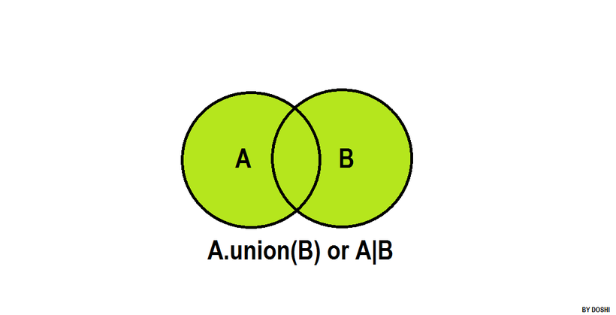
>>> A={10,20,30,40}
>>> B={50,60,70,80}
>>> C=A.union(B)
>>> print(A,B,C,sep="\n")
{40, 10, 20, 30}
{80, 50, 60, 70}
{70, 40, 10, 80, 50, 20, 60, 30}
>>> D=A|B
>>> print(D)
{70, 40, 10, 80, 50, 20, 60, 30}
>>> S1={1,2,3,4,5}
>>> L1=[1,2,3,6,7]
>>> S2=S1.union(L1)
>>> print(S1,L1,S2,sep="\n")
{1, 2, 3, 4, 5}
[1, 2, 3, 6, 7]
{1, 2, 3, 4, 5, 6, 7}

https://www.hackerrank.com/challenges/py-set-union/problem?isFullScreen=false

n=int(input())
eng=set(map(int,input().split()))
b=int(input())
fr=set(map(int,input().split()))
eng_fr=eng.union(fr)
print(len(eng_fr))

set.intersection(*others)
set & other & ...
Return a new set with elements common to the set and all others.

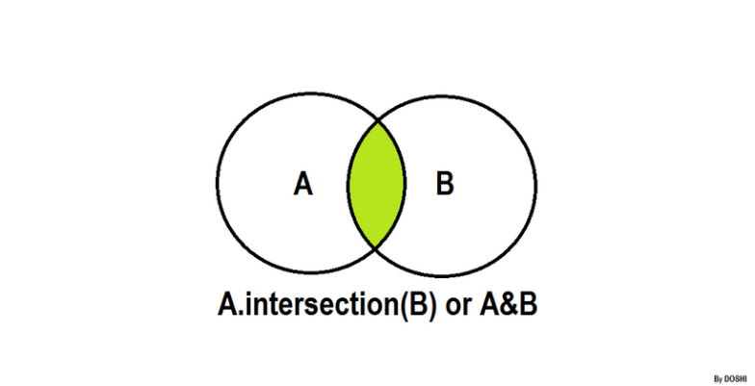
>>> A={1,2,3,4,5}
>>> B={1,2,3,6,7}
>>> C=A.intersection(B)
>>> print(A,B,C)
{1, 2, 3, 4, 5} {1, 2, 3, 6, 7} {1, 2, 3}
>>>java_student={'naresh','ramesh','kishore','raman'}
>>> python_student={'ramesh','rajesh','raman','kiran'}
>>> print(java_student)
{'kishore', 'ramesh', 'naresh', 'raman'}
>>> print(python_student)
{'ramesh', 'rajesh', 'raman', 'kiran'}
>>> java_python=java_student&python_student
>>> print(java_python)
{'ramesh', 'raman'}
>>>
>>> A={1,2,3}
>>> B={1,2,4,5}
>>> C={2,3,5,6}
>>> D=A&B&C
>>> print(A)
{1, 2, 3}
>>> print(B)
{1, 2, 4, 5}
>>> print(C)
{2, 3, 5, 6}
>>> print(D)
{2}

set.difference(*others)
set - other - ...
Return a new set with elements in the set that are not in the others.
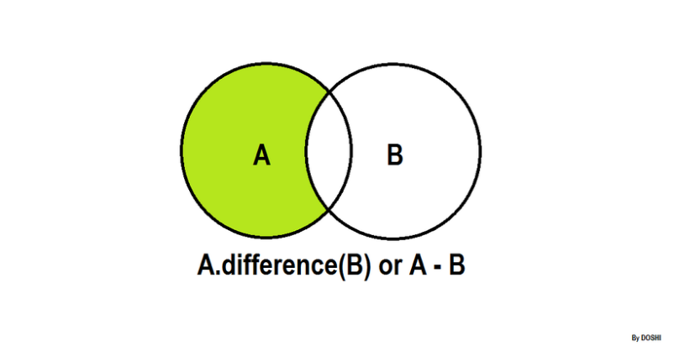

>>> A={1,2,3,4,5,6,7,8}
>>> B={1,6,7,2}
>>> C=A.difference(B)
>>> print(A)
{1, 2, 3, 4, 5, 6, 7, 8}
>>> print(B)
{1, 2, 6, 7}
>>> print(C)
{8, 3, 4, 5}
>>> python_stud={'naresh','ramesh','kishore','raman'}
>>> java_stud={'kiran','raman','rajesh','naresh'}
>>> print(python_stud)
{'naresh', 'kishore', 'raman', 'ramesh'}
>>> print(java_stud)
{'naresh', 'kiran', 'raman', 'rajesh'}
>>> only_python=python_stud.difference(java_stud)
>>> print(only_python)
{'kishore', 'ramesh'}
>>> only_java=java_stud-python_stud
>>> print(only_java)
{'kiran', 'rajesh'}

set.symmetric_difference(other, /)
set ^ other
Return a new set with elements in either the set or other but not both.

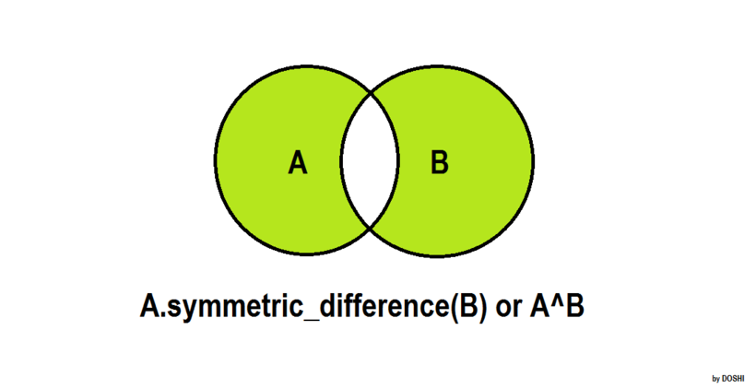

>>> A={1,2,3,4,5}
>>> B={1,2,3,6,7}
>>> C=A.symmetric_difference(B)
>>> print(A,B,C,sep="\n")
{1, 2, 3, 4, 5}
{1, 2, 3, 6, 7}
{4, 5, 6, 7}
>>> D=A^B
>>> print(D)
{4, 5, 6, 7}

https://www.hackerrank.com/challenges/py-set-symmetric-difference-operation/problem?isFullScreen=false

n=int(input())
eng=set(map(int,input().split()))
b=int(input())
fr=set(map(int,input().split()))
print(len(eng.symmetric_difference(fr)))

Mathematical set mutable operations
set.update(*others)
set |= other | ...
Update the set, adding elements from all others.

>>> A={1,2,3,4,5}
>>> B={1,2,3,6,7,8}
>>> print(A)
{1, 2, 3, 4, 5}
>>> print(B)
{1, 2, 3, 6, 7, 8}
>>> A.update(B)
>>> print(A)
{1, 2, 3, 4, 5, 6, 7, 8}
>>> S1={1,2,3}
>>> S2={4,5,6}
>>> S1|=S2
>>> print(S1)
{1, 2, 3, 4, 5, 6}

set.intersection_update(*others)
set &= other & ...
Update the set, keeping only elements found in it and all others.

>>> A={1,2,3,4}
>>> B={1,3,5,6}
>>> print(A)
{1, 2, 3, 4}
>>> print(B)
{1, 3, 5, 6}
>>> A.intersection_update(B)
>>> print(A)
{1, 3}
>>> X={1,2,3}
>>> Y={1,2,5,6}
>>> X&=Y
>>> print(X)
{1, 2}

set.difference_update(*others)
set -= other | ...
Update the set, removing elements found in others.

>>> A={1,2,3,4,5,6,7,8,9}
>>> B={1,6,3,8,10,12}
>>> print(A)
{1, 2, 3, 4, 5, 6, 7, 8, 9}
>>> print(B)
{1, 3, 6, 8, 10, 12}
>>> A.difference_update(B)
>>> print(A)
{2, 4, 5, 7, 9}
>>> X={1,2,3,4,5}
>>> Y={1,5,7,8}
>>> X-=Y
>>> print(X)
{2, 3, 4}

set.symmetric_difference_update(other, /)
set ^= other
Update the set, keeping only elements found in either set, but not in both.

>>> A={1,2,3,4,5}
>>> B={1,3,4,6,7}
>>> print(A)
{1, 2, 3, 4, 5}
>>> print(B)
{1, 3, 4, 6, 7}
>>> A.symmetric_difference_update(B)
>>> print(A)
{2, 5, 6, 7}

Set examine methods

set.isdisjoint(other, /)
Return True if the set has no elements in common with other. Sets are disjoint if and only if their intersection is the empty set.

>>> A={1,2,3,4,5}
>>> B={6,7,8,9,10}
>>> A.isdisjoint(B)
True
>>> C={1,2,8,9,10}
>>> A.isdisjoint(C)
False

set.issubset(other, /)
set <= other
Test whether every element in the set is in other.

>>> A={1,2,3,4,5}
>>> B={1,2,3,4,5,6,7,8,9,10}
>>> A.issubset(B)
True
>>> B={1,2,3,6,7,8}
>>> A.issubset(B)
False
>>> A<=B
False

set.issuperset(other, /)
set >= other
Test whether every element in other is in the set.

>>> A={1,2,3,4,5,6,7,8,9,10}
>>> B={1,7,9,4,5}
>>> A.issuperset(B)
True
>>> C={1,2,3,4,20,30}
>>> A.issuperset(C)
False
>>> A>=B
True
>>> A>=C
False

>>> A={{1,2},{3,4}}
Traceback (most recent call last):
File "<pyshell#68>", line 1, in <module>
A={{1,2},{3,4}}
TypeError: cannot use 'set' as a set element (unhashable type: 'set')

frozenset
frozenset is an immutable set.
After creating frozenset changes cannot done (OR) frozenset does not support mutable operations.

In application development frozenset is used,
- For representing immutable set
- For representing set inside set(nested sets)
How to create frozenset?
- frozenset() : create empty frozenset
- frozenset(iterable): create frozenset using elements of existing collections or iterables

>>> fs1=frozenset()
>>> print(fs1)
frozenset()
>>> fs1.add(10)
Traceback (most recent call last):
File "<pyshell#71>", line 1, in <module>
fs1.add(10)
AttributeError: 'frozenset' object has no attribute 'add'
fs1=frozenset()
>>> print(fs1)
frozenset()
>>> fs1.add(10)
Traceback (most recent call last):
File "<pyshell#71>", line 1, in <module>
fs1.add(10)
AttributeError: 'frozenset' object has no attribute 'add'
>>> fs2=frozenset(range(10,110,10))
>>> print(fs2)
frozenset({100, 70, 40, 10, 80, 50, 20, 90, 60, 30})
>>> fs3=frozenset("PYTHON")
>>> print(fs3)
frozenset({'O', 'T', 'P', 'N', 'Y', 'H'})
>>> fs4=frozenset([10,20,30,40,50])
>>> print(fs4)
frozenset({40, 10, 50, 20, 30})

Example of nested sets
A={frozenset(range(1,6)),frozenset(range(10,60,10))}
print(A)
for x in A:
print(x)

for x in A:
for y in x:
print(y,end=' ')
print()

Output
{frozenset({1, 2, 3, 4, 5}), frozenset({40, 10, 50, 20, 30})}
frozenset({1, 2, 3, 4, 5})
frozenset({40, 10, 50, 20, 30})
1 2 3 4 5
40 10 50 20 30
scenario-based coding challenges on the Python set data type
Remove Duplicate User IDs from Login Logs
Description
A system records user login IDs in a list, but duplicates exist due to multiple logins.
Write a program to remove duplicates using a set and display unique user IDs in sorted order.
Conditions
- Use only set operations
- Output must be sorted
Input Format
N
id1 id2 id3 ... idN
Output Format
Unique user IDs (sorted)
Test Case
Input
6
101 102 103 101 104 102
Output
101 102 103 104

Find Common Students Attending Two Workshops
Description
Two workshops have separate student lists.
Find students who attended both workshops.
Conditions
- Use set intersection
- Maintain ascending order in output
Input Format
N
list1
M
list2
Output Format
Common students
Test Case
Input
5
1 2 3 4 5
4
3 4 6 7
Output
3 4

3️⃣ Identify New Customers in Current Month
Description
You are given last month’s and this month’s customer IDs.
Print customers who are new this month.
Conditions
- Use set difference
- Do not print duplicates
Input Format
LastMonthCount
LastMonthIDs
CurrentMonthCount
CurrentMonthIDs
Output Format
New customer IDs
Test Case
Input
4
10 20 30 40
5
20 30 40 50 60
Output
50 60

Check if Two IP Address Lists are Identical
Description
Two servers store IP addresses.
Check whether both servers have exactly the same IPs.
Conditions
- Order should not matter
- Use set equality
Input Format
List1
List2
Output Format
True / False
Test Case
Input
192.168.1.1 192.168.1.2
192.168.1.2 192.168.1.1
Output
True

Find Unsubscribed Email IDs
Description
An email campaign has subscribers and unsubscribers.
Print active subscribers after removing unsubscribed users.
Conditions
- Use set subtraction
- Output sorted list
Input Format
Subscribers
Unsubscribed
Output Format
Active subscribers
Test Case
Input
a@mail.com b@mail.com c@mail.com
b@mail.com
Output
a@mail.com c@mail.com

Count Unique Product Categories Sold
Description
An e-commerce site tracks sold product categories in a list.
Find the number of unique categories sold.
Conditions
- Use set()
- Print only the count
Input Format
Categories
Output Format
Unique category count
Test Case
Input
electronics fashion electronics books fashion
Output
3

Validate Allowed File Extensions
Description
Given allowed extensions and uploaded file extensions,
find invalid file extensions.
Conditions
- Use set difference
- Output sorted invalid extensions
Input Format
AllowedExtensions
UploadedExtensions
Output Format
Invalid extensions
Test Case
Input
jpg png pdf
jpg exe png doc
Output
doc exe

Detect Duplicate Roll Numbers
Description
Given roll numbers of students appearing for an exam,
detect duplicates using sets.
Conditions
- Use set logic only
- Output duplicate values
Input Format
RollNumbers
Output Format
Duplicate roll numbers
Test Case
Input
1 2 3 2 4 5 3
Output
2 3

Union of Skills from Two Employees
Description
Two employees list their technical skills.
Find all unique skills known by both.
Conditions
- Use set union
- Output sorted skills
Input Format
Employee1Skills
Employee2Skills
Output Format
Combined skills
Test Case
Input
python java sql
java c++ python
Output
c++ java python sql

Check Mandatory Permissions
Description
Check whether a user has all mandatory permissions.
Conditions
- Use issubset()
- Output True or False
Input Format
MandatoryPermissions
UserPermissions
Output Format
True / False
Test Case
Input
read write
read write execute
Output
True

Detect Suspicious Login IPs Across Multiple Days
Description
A security system logs login IP addresses for multiple days.
Identify IPs that appear every single day, as these may indicate automated access.
Conditions
- Use set intersection
- No hard-coding number of days
- Handle large datasets efficiently
Input Format
D
IPs_day1
IPs_day2
...
IPs_dayD
Output Format
Suspicious IPs
Test Case
Input
3
1.1.1.1 2.2.2.2 3.3.3.3
2.2.2.2 3.3.3.3 4.4.4.4
2.2.2.2 3.3.3.3
Output
2.2.2.2 3.3.3.3

Identify Users with Exactly One Purchase
Description
An e-commerce platform tracks user IDs for each purchase event.
Identify users who made exactly one purchase.
Conditions
- Use set logic combined with frequency tracking
- Do not use external libraries
Input Format
UserIDs
Output Format
User IDs with exactly one purchase
Test Case
Input
101 102 101 103 104 103 105
Output
102 104 105

Find Mutually Exclusive Skills Between Teams
Description
Two teams submit skill lists.
Find skills that belong only to one team and not both.
Conditions
- Use symmetric difference
- Output sorted skills
Input Format
TeamA_Skills
TeamB_Skills
Output Format
Exclusive skills
Test Case
Input
python java sql
java c++ python
Output
c++ sql

Validate Complete Access Coverage
Description
An organization has mandatory access rights.
Multiple employees together must cover all required permissions.
Conditions
- Use set union
- Return True/False
Input Format
RequiredPermissions
EmployeeCount
Employee1Permissions
...
EmployeeNPermissions
Output Format
True / False
Test Case
Input
read write execute
2
read write
execute
Output
True

Identify Inactive Features Across Releases
Description
Each software release lists active features.
Find features that were active initially but never used again.
Conditions
- Use set difference
- Handle multiple releases
Input Format
InitialFeatures
R
Release1Features
...
ReleaseRFeatures
Output Format
Inactive features
Test Case
Input
login search payment profile
2
login search
search payment
Output
profile

Find First Common Dataset Intersection Failure
Description
A data pipeline merges datasets sequentially.
Identify the step at which intersection becomes empty.
Conditions
- Use incremental set intersection
- Stop processing early
Input Format
N
Dataset1
Dataset2
...
DatasetN
Output Format
Step number OR -1
Test Case
Input
3
1 2 3
2 3
4 5
Output
3

Detect Policy Violations Using Blacklist
Description
Users attempt operations listed in logs.
Identify users performing blacklisted actions.
Conditions
- Use set intersection
- Return unique user IDs
Input Format
BlacklistedActions
N
UserID Action
...
Output Format
Violating user IDs
Test Case
Input
delete drop
4
101 view
102 delete
103 edit
101 drop
Output
101 102

Find Minimum Group Cover
Description
Each server handles specific services.
Determine minimum number of servers required to handle all services.
Conditions
- Use greedy strategy with sets
- Print minimum count
Input Format
Services
N
Server1Services
...
ServerNServices
Output Format
Minimum servers needed
Test Case
Input
A B C D
3
A B
C
D
Output
3

Detect Users Active in Exactly K Systems
Description
Users log into multiple systems.
Identify users active in exactly K systems.
Conditions
- Use set intersections
- Efficient counting
Input Format
K
N
System1Users
...
SystemNUsers
Output Format
User IDs
Test Case
Input
2
3
1 2 3
2 3 4
3 4 5
Output
2

Validate Data Consistency Across Microservices
Description
Each microservice maintains a cache of entity IDs.
Check whether all microservices store identical data.
Conditions
- Use set equality
- Optimize for early failure
Input Format
N
Service1Data
...
ServiceNData
Output Format
Consistent / Inconsistent
Test Case
Input
3
1 2 3
3 2 1
1 2 3
Output
Consistent
scenario-based coding challenges on the Python set data type
Remove Duplicate User IDs from Login Logs
Description
A system records user login IDs in a list, but duplicates exist due to multiple logins.
Write a program to remove duplicates using a set and display unique user IDs in sorted order.
Conditions
- Use only set operations
- Output must be sorted
Input Format
N
id1 id2 id3 ... idN
Output Format
Unique user IDs (sorted)
Test Case
Input
6
101 102 103 101 104 102
Output
101 102 103 104

Find Common Students Attending Two Workshops
Description
Two workshops have separate student lists.
Find students who attended both workshops.
Conditions
- Use set intersection
- Maintain ascending order in output
Input Format
N
list1
M
list2
Output Format
Common students
Test Case
Input
5
1 2 3 4 5
4
3 4 6 7
Output
3 4

3️⃣ Identify New Customers in Current Month
Description
You are given last month’s and this month’s customer IDs.
Print customers who are new this month.
Conditions
- Use set difference
- Do not print duplicates
Input Format
LastMonthCount
LastMonthIDs
CurrentMonthCount
CurrentMonthIDs
Output Format
New customer IDs
Test Case
Input
4
10 20 30 40
5
20 30 40 50 60
Output
50 60

Check if Two IP Address Lists are Identical
Description
Two servers store IP addresses.
Check whether both servers have exactly the same IPs.
Conditions
- Order should not matter
- Use set equality
Input Format
List1
List2
Output Format
True / False
Test Case
Input
192.168.1.1 192.168.1.2
192.168.1.2 192.168.1.1
Output
True

Find Unsubscribed Email IDs
Description
An email campaign has subscribers and unsubscribers.
Print active subscribers after removing unsubscribed users.
Conditions
- Use set subtraction
- Output sorted list
Input Format
Subscribers
Unsubscribed
Output Format
Active subscribers
Test Case
Input
a@mail.com b@mail.com c@mail.com
b@mail.com
Output
a@mail.com c@mail.com

Count Unique Product Categories Sold
Description
An e-commerce site tracks sold product categories in a list.
Find the number of unique categories sold.
Conditions
- Use set()
- Print only the count
Input Format
Categories
Output Format
Unique category count
Test Case
Input
electronics fashion electronics books fashion
Output
3

Validate Allowed File Extensions
Description
Given allowed extensions and uploaded file extensions,
find invalid file extensions.
Conditions
- Use set difference
- Output sorted invalid extensions
Input Format
AllowedExtensions
UploadedExtensions
Output Format
Invalid extensions
Test Case
Input
jpg png pdf
jpg exe png doc
Output
doc exe

Detect Duplicate Roll Numbers
Description
Given roll numbers of students appearing for an exam,
detect duplicates using sets.
Conditions
- Use set logic only
- Output duplicate values
Input Format
RollNumbers
Output Format
Duplicate roll numbers
Test Case
Input
1 2 3 2 4 5 3
Output
2 3

Union of Skills from Two Employees
Description
Two employees list their technical skills.
Find all unique skills known by both.
Conditions
- Use set union
- Output sorted skills
Input Format
Employee1Skills
Employee2Skills
Output Format
Combined skills
Test Case
Input
python java sql
java c++ python
Output
c++ java python sql

Check Mandatory Permissions
Description
Check whether a user has all mandatory permissions.
Conditions
- Use issubset()
- Output True or False
Input Format
MandatoryPermissions
UserPermissions
Output Format
True / False
Test Case
Input
read write
read write execute
Output
True

Detect Suspicious Login IPs Across Multiple Days
Description
A security system logs login IP addresses for multiple days.
Identify IPs that appear every single day, as these may indicate automated access.
Conditions
- Use set intersection
- No hard-coding number of days
- Handle large datasets efficiently
Input Format
D
IPs_day1
IPs_day2
...
IPs_dayD
Output Format
Suspicious IPs
Test Case
Input
3
1.1.1.1 2.2.2.2 3.3.3.3
2.2.2.2 3.3.3.3 4.4.4.4
2.2.2.2 3.3.3.3
Output
2.2.2.2 3.3.3.3

Identify Users with Exactly One Purchase
Description
An e-commerce platform tracks user IDs for each purchase event.
Identify users who made exactly one purchase.
Conditions
- Use set logic combined with frequency tracking
- Do not use external libraries
Input Format
UserIDs
Output Format
User IDs with exactly one purchase
Test Case
Input
101 102 101 103 104 103 105
Output
102 104 105

Find Mutually Exclusive Skills Between Teams
Description
Two teams submit skill lists.
Find skills that belong only to one team and not both.
Conditions
- Use symmetric difference
- Output sorted skills
Input Format
TeamA_Skills
TeamB_Skills
Output Format
Exclusive skills
Test Case
Input
python java sql
java c++ python
Output
c++ sql

Validate Complete Access Coverage
Description
An organization has mandatory access rights.
Multiple employees together must cover all required permissions.
Conditions
- Use set union
- Return True/False
Input Format
RequiredPermissions
EmployeeCount
Employee1Permissions
...
EmployeeNPermissions
Output Format
True / False
Test Case
Input
read write execute
2
read write
execute
Output
True

Identify Inactive Features Across Releases
Description
Each software release lists active features.
Find features that were active initially but never used again.
Conditions
- Use set difference
- Handle multiple releases
Input Format
InitialFeatures
R
Release1Features
...
ReleaseRFeatures
Output Format
Inactive features
Test Case
Input
login search payment profile
2
login search
search payment
Output
profile

Find First Common Dataset Intersection Failure
Description
A data pipeline merges datasets sequentially.
Identify the step at which intersection becomes empty.
Conditions
- Use incremental set intersection
- Stop processing early
Input Format
N
Dataset1
Dataset2
...
DatasetN
Output Format
Step number OR -1
Test Case
Input
3
1 2 3
2 3
4 5
Output
3

Detect Policy Violations Using Blacklist
Description
Users attempt operations listed in logs.
Identify users performing blacklisted actions.
Conditions
- Use set intersection
- Return unique user IDs
Input Format
BlacklistedActions
N
UserID Action
...
Output Format
Violating user IDs
Test Case
Input
delete drop
4
101 view
102 delete
103 edit
101 drop
Output
101 102

Find Minimum Group Cover
Description
Each server handles specific services.
Determine minimum number of servers required to handle all services.
Conditions
- Use greedy strategy with sets
- Print minimum count
Input Format
Services
N
Server1Services
...
ServerNServices
Output Format
Minimum servers needed
Test Case
Input
A B C D
3
A B
C
D
Output
3

Detect Users Active in Exactly K Systems
Description
Users log into multiple systems.
Identify users active in exactly K systems.
Conditions
- Use set intersections
- Efficient counting
Input Format
K
N
System1Users
...
SystemNUsers
Output Format
User IDs
Test Case
Input
2
3
1 2 3
2 3 4
3 4 5
Output
2

Validate Data Consistency Across Microservices
Description
Each microservice maintains a cache of entity IDs.
Check whether all microservices store identical data.
Conditions
- Use set equality
- Optimize for early failure
Input Format
N
Service1Data
...
ServiceNData
Output Format
Consistent / Inconsistent
Test Case
Input
3
1 2 3
3 2 1
1 2 3
Output
Consistent
Dictionary View Objects
The objects returned by dict.keys(), dict.values() and dict.items() are view objects. They provide a dynamic view on the dictionary’s entries, which means that when the dictionary changes, the view reflects these changes.

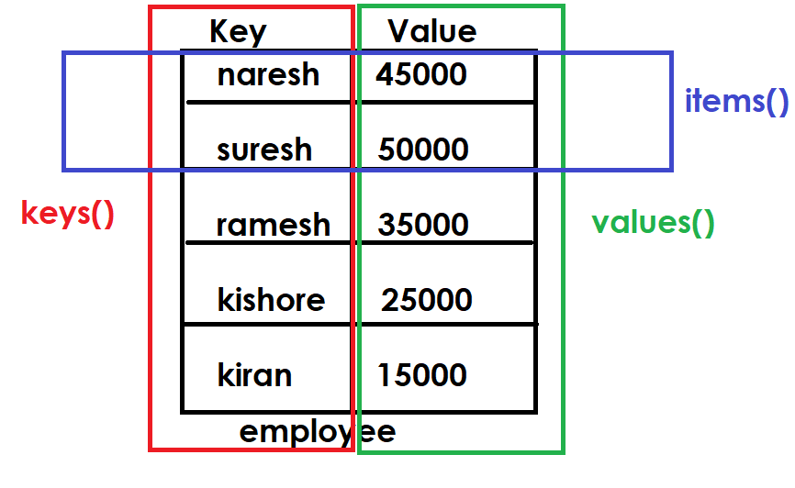
Example:
employee={'naresh':45000,
'suresh':50000,
'ramesh':25000,
'kiran':15000}

print(employee)
names=employee.keys()
print(names)
for name in names:
print(name)
salaries=employee.values()
print(salaries)
for sal in salaries:
print(sal)

emp=employee.items()
print(emp)
for e in emp:
print(e)

Output
{'naresh': 45000, 'suresh': 50000, 'ramesh': 25000, 'kiran': 15000}
dict_keys(['naresh', 'suresh', 'ramesh', 'kiran'])
naresh
suresh
ramesh
kiran
dict_values([45000, 50000, 25000, 15000])
45000
50000
25000
15000
dict_items([('naresh', 45000), ('suresh', 50000), ('ramesh', 25000), ('kiran', 15000)])
('naresh', 45000)
('suresh', 50000)
('ramesh', 25000)
('kiran', 15000)

setdefault(key, default=None, /)
If key is in the dictionary, return its value. If not, insert key with a value of default and return default. default defaults to None.

>>> dict1={}
>>> print(dict1)
{}
>>> v1=dict1.setdefault(1)
>>> print(dict1)
{1: None}
>>> print(v1)
None
>>> v2=dict1.setdefault(1)
>>> print(v2)
None
>>> v3=dict1.setdefault(2,20)
>>> print(v3)
20
>>> print(dict1)
{1: None, 2: 20}

reversed(d)
Return a reverse iterator over the keys of the dictionary.

Example:
dict1=dict(zip(range(1,6),range(10,60,10)))
print(dict1)

for k in reversed(dict1):
print(k,dict1[k])

Output
{1: 10, 2: 20, 3: 30, 4: 40, 5: 50}
5 50
4 40
3 30
2 20
1 10

Mutable Operations of dictionary
After creating dictionary changes can be done using mutable operations.

- Adding or Updating an item within dictionary

Syntax1: dictionary-name[key]=value

This syntax perform 2 operations
- If key exists, it replace/update value
- If key not exists, it add key with value

Example:
>>> dict1={}
>>> dict1[1]=10
>>> print(dict1)
{1: 10}
>>> dict1[2]=20
>>> print(dict1)
{1: 10, 2: 20}
>>> dict1[3]=30
>>> print(dict1)
{1: 10, 2: 20, 3: 30}

# Write a program to read the scores of n players and display
# store player details into dictionary
# each player having name and runs

n=int(input("How many players?"))
players={}

for i in range(n):
name=input("PlayerName :")
score=int(input("PlayerScore :"))
players[name]=score

print(players)

Output
How many players?2
PlayerName :Rohit
PlayerScore :100
PlayerName :Virat
PlayerScore :89
{'Rohit': 100, 'Virat': 89}

# Write a program to read sales of n sales persons
# calculate total sales, max sales, min sales
# each sales person having name,sales
n=int(input("How many sales persons?"))
sales={}

for i in range(n):
name=input("Enter Name :")
s=float(input("Enter Sales :"))
sales[name]=s

print(f'Sales : {sales}')
print(f'Total Sales : {sum(sales.values())}')
print(f'Maximum Sales :{max(sales.values())}')
print(f'Minimum Sales :{min(sales.values())}')

Output
How many sales persons?5
Enter Name :aaa
Enter Sales :45000
Enter Name :bbb
Enter Sales :20000
Enter Name :ccc
Enter Sales :60000
Enter Name :ddd
Enter Sales :35000
Enter Name :eee
Enter Sales :22000
Sales : {'aaa': 45000.0, 'bbb': 20000.0, 'ccc': 60000.0, 'ddd': 35000.0, 'eee': 22000.0}
Total Sales : 182000.0
Maximum Sales :60000.0
Minimum Sales :20000.0

Replacing or Updating values
Dictionary keys are immutable but values are mutable

>>> dict1={1:10,2:20,3:30,4:40,5:50}
>>> print(dict1)
{1: 10, 2: 20, 3: 30, 4: 40, 5: 50}
>>> dict1[1]=99
>>> print(dict1)
{1: 99, 2: 20, 3: 30, 4: 40, 5: 50}
>>> dict1[3]=77
>>> print(dict1)
{1: 99, 2: 20, 3: 77, 4: 40, 5: 50}
>>> dict1[5]=100
>>> print(dict1)
{1: 99, 2: 20, 3: 77, 4: 40, 5: 100}
>>> dict1[7]=200
>>> print(dict1)
{1: 99, 2: 20, 3: 77, 4: 40, 5: 100, 7: 200}
>>>

update(**kwargs)
Update the dictionary with the key/value pairs from mapping or iterable and kwargs, overwriting existing keys. Return None.

>>> d1={1:10,2:20}
>>> print(d1)
{1: 10, 2: 20}
>>> d1.update({3:30,4:40,5:50})
>>> print(d1)
{1: 10, 2: 20, 3: 30, 4: 40, 5: 50}
>>> d1.update({3:100,1:200,6:60,7:70})
>>> print(d1)
{1: 200, 2: 20, 3: 100, 4: 40, 5: 50, 6: 60, 7: 70}

Removing or deleting items from dictionary
Items can be removed or deleted from dictionary using different methods provided by dictionary

- Using “del” keyword
- Using remove method
- Using clear method
- Using pop method
- Using popitem method
Removing or deleting items from dictionary
Items can be removed or deleted from dictionary using different methods provided by dictionary

- Using “del” keyword
- Using clear method
- Using pop method
- Using popitem method

Using “del” keyword
“del” keyword required key for deleting item

Syntax: del dictionary-name[key]

If key exists within dictionary, it deletes item
If key not exists within dictionary, it raises KeyError

>>> contacts={'naresh':9988755664,
... 'suresh':9988466778,
... 'ramesh':8877699887}
>>> print(contacts)
{'naresh': 9988755664, 'suresh': 9988466778, 'ramesh': 8877699887}
>>> del contacts['ramesh']
>>> print(contacts)
{'naresh': 9988755664, 'suresh': 9988466778}
>>> del contacts['ramesh']
Traceback (most recent call last):
File "<pyshell#6>", line 1, in <module>
del contacts['ramesh']
KeyError: 'ramesh'
>>> 'ramesh' in contacts
False

2. using pop method

This method remove item from dictionary using key. Before removing item it return value and remove. Pop method perform 2 operations
- Read
- Remove

Syntax: variable-name=dictionary-name.pop(key,defult)

If default value is not defined and key is not exists it raise KeyError. In order to avoid KeyError define default value.

>>> dict1=dict(zip(range(1,11),range(10,110,10)))
>>> print(dict1)
{1: 10, 2: 20, 3: 30, 4: 40, 5: 50, 6: 60, 7: 70, 8: 80, 9: 90, 10: 100}
>>> x=dict1.pop(3)
print(x)
30
>>> print(dict1)
{1: 10, 2: 20, 4: 40, 5: 50, 6: 60, 7: 70, 8: 80, 9: 90, 10: 100}
>>> y=dict1.pop(10)
>>> print(y)
100
>>> print(dict1)
{1: 10, 2: 20, 4: 40, 5: 50, 6: 60, 7: 70, 8: 80, 9: 90}
>>> z=dict1.pop(3)
Traceback (most recent call last):
File "<pyshell#18>", line 1, in <module>
z=dict1.pop(3)
KeyError: 3
>>> z=dict1.pop(3,30)
>>> print(z)
30

popitem()
popitem() read and remove last item from dictionary.
This method is used for implementing stack data structure (LIFO)
This method raises error, if dictionary is empty

Syntax: variable-name=dictionary-name.popitem()

>>> d1={1:10,2:20,3:30,4:40,5:50}
>>> print(d1)
{1: 10, 2: 20, 3: 30, 4: 40, 5: 50}
>>> item1=d1.popitem()
>>> print(item1)
(5, 50)
>>> item2=d1.popitem()
>>> print(item2)
(4, 40)
>>> item3=d1.popitem()
>>> print(item3)
(3, 30)
>>> item4=d1.popitem()
>>> print(item4)
(2, 20)
>>> item5=d1.popitem()
>>> print(item5)
(1, 10)
>>> item6=d1.popitem()
Traceback (most recent call last):
File "<pyshell#33>", line 1, in <module>
item6=d1.popitem()
KeyError: 'popitem(): dictionary is empty'

clear() method
This method is used to delete all the items from dictionary (OR) empty dictionary.

>>> d1=dict(zip(range(1,6),range(10,60,10)))
>>> print(d1)
{1: 10, 2: 20, 3: 30, 4: 40, 5: 50}
>>> d1.clear()
>>> print(d1)
{}

Merging of dictionaries
Merging of dictionaries can be using merge operator (|)

Syntax: variable-name=dictionary-name1|dictionary-name2
Syntax: dictionary-name1|=dictionary-name2

>>> d1={1:10,2:20,3:30}
>> d2={4:40,5:50,6:60}
>>> d3=d1|d2
>>> print(d1,d2,d3,sep="\n")
{1: 10, 2: 20, 3: 30}
{4: 40, 5: 50, 6: 60}
{1: 10, 2: 20, 3: 30, 4: 40, 5: 50, 6: 60}
>>> dict1={1:10,2:20,3:30}
>>> dict2={1:99,4:40,5:50,2:88}
>>> dict3=dict1|dict2
>>> print(dict1)
{1: 10, 2: 20, 3: 30}
>>> print(dict2)
{1: 99, 4: 40, 5: 50, 2: 88}
>>> print(dict3)
{1: 99, 2: 88, 3: 30, 4: 40, 5: 50}
>>> d1={1:10,2:20}
>>> d2={3:30,4:40}
>>> d1|=d2
>>> print(d1)
{1: 10, 2: 20, 3: 30, 4: 40}

Example:
# Shoping Cart
cart={}
while True:
print("1.Add Item")
print("2.Remove Item")
print("3.List Cart")
print("4.Search Item")
print("5.Clear Items")
print("6.Update Items")
print("7.Exit")
opt=int(input("Enter your option :"))
if opt==1:
name=input("ProductName :")
if name not in cart:
qty=int(input("Qty :"))
cart[name]=qty
print("Product Added")
else:
print("ProductName exists in cart")
elif opt==2:
name=input("ProductName :")
if name in cart:
del cart[name]
print("Product Deleted")
else:
print("Product Not Exists")
elif opt==3:
data=cart.items()
for item in data:
print(f'{item[0]}\t\t{item[1]}')
elif opt==4:
name=input("ProductName to Search:")
if name in cart:
qty=cart[name]
print(f'{name}\t\t{qty}')
else:
print("Product Not Exist in Cart")
elif opt==5:
if len(cart)==0:
print("Cart is empty")
else:
cart.clear()
elif opt==6:
name=input("ProductName :")
if name in cart:
qty=int(input("Updated Qty:"))
cart[name]=qty
print("Product Updated")
elif opt==7:
break
else:
print("invalid option try again...")

Output
1.Add Item
2.Remove Item
3.List Cart
4.Search Item
5.Clear Items
6.Update Items
7.Exit
Enter your option :1
ProductName :Mouse
Qty :10

Example:
# Banking Application
accounts={}
trans={}
while True:
print("1.Creat Account")
print("2.Deposit")
print("3.Withdraw")
print("4.FindBalance")
print("5.Passbook")
print("6.Exit")
opt=int(input("Enter Your Option :"))
if opt==1:
accno=int(input("AccountNo :"))
cname=input("CustomerName :")
bal=float(input("Balance :"))
if accno not in accounts:
accounts[accno]=[cname,bal]
trans[accno]=[['Deposit',bal]]
print("Account Created")
else:
print("Invalid Accno or Accno Exists")
elif opt==2:
accno=int(input("AccountNo :"))
if accno in accounts:
amt=int(input("Amount to Deposit :"))
details=accounts[accno]
details[1]=details[1]+amt
accounts[accno]=details
trans[accno].append(["Deposit",amt])
print("Deposit is done..")
else:
print("Invalid Accountno")
elif opt==3:
accno=int(input("AccountNo :"))
if accno in accounts:
amt=int(input("Amount to Withdraw :"))
details=accounts[accno]
if amt>details[1]:
print("Insuff Balance")
else:
details[1]-=amt
trans[accno].append(["Withdraw",amt])
print("Withdraw is done..")
else:
print("Invalid AccountNo")
elif opt==4:
accno=int(input("AccountNo :"))
if accno in accounts:
details=accounts[accno]
print(f'Balance is {details[1]}')
else:
print("Invalid AccountNO")
elif opt==5:
accno=int(input("AccountNo :"))
if accno in accounts:
details=accounts[accno]
transactions=trans[accno]
print(f'AccountNo {accno}')
print(f'CustomerName {details[0]}')
print(f'Balance {details[1]}')
print("TType\tTransctionAmt")
for t in transactions:
print(f'{t[0]}\t{t[1]}')
else:
print("Invalid AccountNo")
elif opt==6:
break
else:
print("invalid option try again...")

Example
>>> d1={1:[10,20,30],
... 2:[40,50,60]}
>>> d1[1]
[10, 20, 30]
>>> d1[1][0]
10
>>> d1[1][2]
30
>>> d1[1][-1]
30
>>> d1[2][-2]
50

Example:
grade_dict={'naresh':'A',
'suersh':'B',
'ramesh':'A',
'kishore':'C',
'raman':'B'}

grade_dictA={}
grade_dictB={}
grade_dictC={}
for k,v in grade_dict.items():
if v=='A':
grade_dictA[k]=v
elif v=='B':
grade_dictB[k]=v
elif v=='C':
grade_dictC[k]=v

print(grade_dict)
print(grade_dictA)
print(grade_dictB)
print(grade_dictC)

Output
{'naresh': 'A', 'suersh': 'B', 'ramesh': 'A', 'kishore': 'C', 'raman': 'B'}
{'naresh': 'A', 'ramesh': 'A'}
{'suersh': 'B', 'raman': 'B'}
{'kishore': 'C'}
Nested Dictionary
We cannot define dictionary directly within dictionary because dictionary contains key and value pair.
Inside dictionary a dictionary can be defined as value.

Syntax:
dictionary-name={key:{key:value,key:value,..},
Key:{key:value,key:value,.}}

Example:
stud_dict={1:{'name':'suresh','course':'python'},
2:{'name':'ramesh','course':'java'},
3:{'name':'kishore','course':'c++'}}

print(stud_dict)
stud1=stud_dict[1]
print(stud1)
print(stud1['name'],stud1['course'])
print(stud_dict[2]['name'],stud_dict[2]['course'])

Output
{1: {'name': 'suresh', 'course': 'python'}, 2: {'name': 'ramesh', 'course': 'java'}, 3: {'name': 'kishore', 'course': 'c++'}}
{'name': 'suresh', 'course': 'python'}
suresh python
ramesh java

Example:
sales={2010:{'jan':45000,'feb':54000,'mar':65000},
2011:{'jan':35000,'feb':65000,'mar':75000},
2012:{'jan':67000,'feb':78000,'mar':89000}}

for k in sales:
v=sales[k]
print(v['jan'],v['feb'],v['mar'])

sales1={2010:[45000,54000,65000],
2012:[35000,65000,75000],
2013:[67000,78000,89000]}
for k in sales1:
v=sales1[k]
print(v[0],v[1],v[2])

Output
45000 54000 65000
35000 65000 75000
67000 78000 89000
45000 54000 65000
35000 65000 75000
67000 78000 89000

Dictionary comprehension
Comprehension is one of the elegant or easy way creating dictionary using for loop and if statement within single line.

Syntax1: {key:value for variable-name in iterable}
Syntax2: {key:value for variable-name in iterable if test}

Example:
# Write a program to create a dictionary with
# 10 items, where each time contains key as number and value
# is squre of the number
# Example: {1:1,2:4,3:9,4:16,....10:100}

#without comprehension

dict1={}
for n in range(1,11):
dict1[n]=n**2

print(dict1)

#with comprehension
dict2={n:n**2 for n in range(1,11)}
print(dict2)

Output
{1: 1, 2: 4, 3: 9, 4: 16, 5: 25, 6: 36, 7: 49, 8: 64, 9: 81, 10: 100}
{1: 1, 2: 4, 3: 9, 4: 16, 5: 25, 6: 36, 7: 49, 8: 64, 9: 81, 10: 100}

# Write a program to read the scores of n players
# each player is having name and score

# without comprehension

n=int(input("How many players?"))
players={}
for i in range(n):
name=input("Enter PlayerName :")
score=int(input("Enter PlayerScore :"))
players[name]=score

print(players)

# with comprehension
players={input("PlayerName:"):int(input("Score:")) for i in range(n)}
print(players)

Example:
# filtering data based on condition
sales={2010:56000,
2011:45000,
2012:50000,
2013:35000,
2014:65000,
2015:25000}

print(sales)
sales1={y:s for y,s in sales.items() if s>=50000}
sales2={y:s for y,s in sales.items() if s<50000}
print(sales1)
print(sales2)

Output
{2010: 56000, 2011: 45000, 2012: 50000, 2013: 35000, 2014: 65000, 2015: 25000}
{2010: 56000, 2012: 50000, 2014: 65000}
{2011: 45000, 2013: 35000, 2015: 25000}

Example:
# filtering data based on condition

grade_dict={'naresh':'A',
'suresh':'B',
'ramesh':'A',
'kishore':'B',
'rajesh':'C'}

print(grade_dict)
grade_dictA={name:grade for name,grade in grade_dict.items() if grade=='A'}
grade_dictB={name:grade for name,grade in grade_dict.items() if grade=='B'}
grade_dictC={name:grade for name,grade in grade_dict.items() if grade=='C'}

print(grade_dictA)
print(grade_dictB)
print(grade_dictC)

Output
{'naresh': 'A', 'suresh': 'B', 'ramesh': 'A', 'kishore': 'B', 'rajesh': 'C'}
{'naresh': 'A', 'ramesh': 'A'}
{'suresh': 'B', 'kishore': 'B'}
{'rajesh': 'C'}

What is difference between list, set and dictionary?
List | Set | Dict
List is a ordered collection | Set is unordered collection | Dictionary is mapping collection
List contains only values and each value is identified with index | Set contains values but it non index based collection | Dictionary contains value and each value is identified with key
Index based collection | Non index based collection | Key based collection
List data is organized in sequential order or sequence data type | In set data is organized using hashing data structure | In dictionary data is organized key and value pair
Supports index and slicing | Does not support indexing and slicing | It does not support index and slicing
Allows duplicate values | Does not allows duplicate values | Allows duplicate values but not allows duplicate keys
List is create using [] | Set is created using curly braces {value,…} | Dictionary is created using {key:value,…}
list type represents list object | set type is represents set object | dict type is represents dictionary object
In application development list is used to represent individual value where duplicates allowed and allows reading sequentially and randomly | In application development set is used to group individual object/values where duplicates are not allowed and perform mathematical set operations. | In application development dictionary is used group individual object where data is organized as key and value pair (table format)
List allows any type of objects (mutable and immutable) | Set allows only immutable objects | Dictionary allows immutable objects are keys and mutable objects as values.
bytes and bytearray (buffered types or binary types)

bytes
Bytes objects are immutable sequences of single bytes. Since many major binary protocols are based on the ASCII text encoding, bytes objects offer several methods that are only valid when working with ASCII compatible data and are closely related to string objects

How to create bytes object?
Firstly, the syntax for bytes literals is largely the same as that for string literals, except that a b prefix is added:
- Single quotes: b'still allows embedded "double" quotes'
- Double quotes: b"still allows embedded 'single' quotes"
- Triple quoted: b'''3 single quotes''', b"""3 double quotes"""

Example:
b1=b'ABC'
b2=b"ABC"
b3=b"""ABC"""
print(type(b1),type(b2),type(b3))
print(b1[0],b1[1],b1[2])
print(b2[0],b2[1],b2[2])
for value in b3:
print(value,end=' ')

Output
<class 'bytes'> <class 'bytes'> <class 'bytes'>
65 66 67
65 66 67
65 66 67

Bytes type is immutable sequence type. After creating bytes object changes cannot done.

>>> b1=b"ABC"
>>> print(b1[0],b1[1],b1[2])
65 66 67
>>> b1[0]=97
Traceback (most recent call last):
File "<pyshell#2>", line 1, in <module>
b1[0]=97
TypeError: 'bytes' object does not support item assignment

In addition to the literal forms, bytes objects can be created in a number of other ways:
- A zero-filled bytes object of a specified length: bytes(10)
- From an iterable of integers: bytes(range(20))
- Copying existing binary data via the buffer protocol: bytes(obj)

Example:
>>> b1=bytes(5)
>>> print(b1)
b'\x00\x00\x00\x00\x00'
>>> for value in b1:
... print(value)
...
...
0
0
0
0
0

Example:
>>> b2=bytes(range(65,70))
>>> print(b2)
b'ABCDE'
>>> for value in b2:
... print(value,end=' ')
...
...
65 66 67 68 69

>>> b3=bytes([97,98,99,100])
>>> print(b3)
b'abcd'
>>> for value in b3:
... print(value,end=' ')
...
...
97 98 99 100
>>> b4=bytes([1.5,2.5])
Traceback (most recent call last):
File "<pyshell#18>", line 1, in <module>
b4=bytes([1.5,2.5])
TypeError: 'float' object cannot be interpreted as an integer

>>> b5=b"ABCDE"
>>> b6=bytes(b5)
>>> print(b5,b6)
b'ABCDE' b'ABCDE'

bytearray
bytearray is mutable sequence data type. After creating bytearray object changes can be done. Bytearray object support all mutable operations supported by list data type.

- Append()
- Insert()
- Remove()
- Pop()
- Extend()
- Sort()
- Replacing

How to create bytearray object?
There is no dedicated literal syntax for bytearray objects, instead they are always created by calling the constructor:
- Creating an empty instance: bytearray()
- Creating a zero-filled instance with a given length: bytearray(10)
- From an iterable of integers: bytearray(range(20))
- Copying existing binary data via the buffer protocol: bytearray(b'Hi!')

Example:
>>> b1=bytearray(10)
>>> print(b1)
bytearray(b'\x00\x00\x00\x00\x00\x00\x00\x00\x00\x00')
>>> b1[0]=65
>>> b1[1]=66
>>> b1[2]=67
>>> print(b1)
bytearray(b'ABC\x00\x00\x00\x00\x00\x00\x00')
>>> for value in b1:
... print(value,end=' ')
...
...
65 66 67 0 0 0 0 0 0 0
>>> del b1[0]
>>> print(b1)
bytearray(b'BC\x00\x00\x00\x00\x00\x00\x00')
>>> b1.append(65)
>>> print(b1)
bytearray(b'BC\x00\x00\x00\x00\x00\x00\x00A')
>>> b1.insert(0,97)
>>> print(b1)
bytearray(b'aBC\x00\x00\x00\x00\x00\x00\x00A')
>>> b1.remove(65)
>>> print(b1)
bytearray(b'aBC\x00\x00\x00\x00\x00\x00\x00')

>>> b2=bytearray(range(65,70))
>>> print(b2)
bytearray(b'ABCDE')
>>> for value in b2:
print(value,end=' ')

...
65 66 67 68 69
>>> b2.extend([70,71,72,73,74])
>>> print(b2)
bytearray(b'ABCDEFGHIJ')
>>> b3=b2[:5]
>>> print(b3)
bytearray(b'ABCDE')
>>> b4=b2[5:]
>>> print(b4)
bytearray(b'FGHIJ')
>>> b5=b2[::-1]
>>> print(b5)
bytearray(b'JIHGFEDCBA')
>>> b6=bytearray([10,20,30,40,50])
>>> print(b6)
bytearray(b'\n\x14\x1e(2')
>>> b7=bytearray(range(97,101))
>>> print(b7)
bytearray(b'abcd')
>>> b8=bytearray(b7)
>>> print(b8)
bytearray(b'abcd')
b9=bytearray("ABCDE",encoding='utf-8')
>>> print(b9)
bytearray(b'ABCDE')
>>> for value in b9:
... print(value,end=' ')
...
...
65 66 67 68 69
>>> str1="ABCDE"
>>> b1=str1.encode()
>>> print(type(str1),type(b1))
<class 'str'> <class 'bytes'>
>>> print(str1,b1)
ABCDE b'ABCDE'
>>> str2=b1.decode()
>>> print(str2,type(str2))
ABCDE <class 'str'>

Collections data types
Sequences
List
Tuple
Str
Range
Bytes
Bytearray
Sets
Set
Frozenset
Mapping
Dict (dictionary)

Scalar types
Int
Float
Bool
Complex
NoneType

Python support 14 standard data types.
Functions (Procedural Oriented Programming)

Content

- What is procedural oriented Programming?
- Advantage of procedural oriented programming
- What is function?
- Advantage of writing function
- Defining function
- Calling the function
- Local variables
- Global variables
- Function with parameters
  - Required parameters
    - Required positional parameters
    - Required keyword parameters
  - Default parameters
  - Variable length parameters
    - Variable length positional parameters
    - Variable length keyword parameters
- Function with return value
- Generator Functions
- Decorator Functions
- Closure Functions
- Lambda Functions
- Recursive Functions

What is procedural oriented programming (POP)?
Python is a multiple paradigm programming language. A programming paradigm defines set of rules and regulations for writing or organizing code or instructions.

Types of programming paradigms
- Procedural Oriented Programming (POP)
- Modular Oriented Programming (MOP)
- Object Oriented Programming (OOP)
- Functional Oriented Programming (FOP)
Why Procedural oriented programming?
In procedural oriented programming instructions are organized according to their operation by dividing into small pieces called sub routines.
What is sub routine?
A sub routine is small program within program.
These sub routines are called,
- Procedures
- Functions
What is advantage of procedural oriented programming?
- Reusability
- Modularity
- Readability
- Efficiency
Reusability: It allows writing code once use many times
Modularity: dividing code according their operations into small pieces
Readability: Easy to understand
Efficiency: It reduce size of the program which increases efficiency of program.

In python procedural oriented programming is implemented using functions.

What is function?
A function is small program within program.
A function is named block, which contains set of instructions to perform some operation.
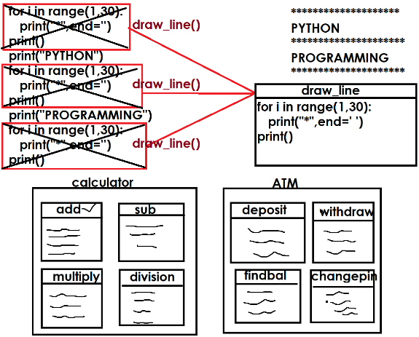
Advantage of writing function
- Modularity
- Readability
- Reusability
- Efficiency

Functions are 2 types
- Predefined functions
- User defined functions

Predefined functions
The existing functions are called predefined functions.
These predefined functions are also called library functions.
Example: print(),input(),oct(),hex(),bin(),chr(),ord(),int(),float(),…

User defined functions
The functions developed by programmer are called user defined functions.
These are application specific functions.

Basic steps for working functions
- Defining function (OR) Writing Function
- Invoking function (OR) Calling Function

Defining function (OR) Writing functions
In python a function is defined or written by using “def” keyword.

Syntax:
def function-name([parameters]):
statement-1
statement-2

A function is self contained block which contains set of instructions to perform some operations.

A function is defined,
- With parameters
- Without parameters

A function with parameters receives values.
A function without parameters does not receive values.

Example:
def fun1():
print("function without parameters")

def fun2(a,b):
print("function with parameters")

# writing function or defining function  def fun1():  print("Welcome to functions")  # calling function or invoking function  fun1()  fun1()  fun1()  fun1()  fun1() | Output  Welcome to functions  Welcome to functions  Welcome to functions  Welcome to functions  Welcome to functions
After defining the function or writing the function, it has be called as an executable statement. Function is not called or executed automatically.

def deposit():  print("inside deposit")  def withdraw():  print("inside withdraw")  def findbal():  print("inside findbal")  #ATM  #Main Program  while True:  print("1. Deposit")  print("2. Withdraw")  print("3. Finding Bal")  print("4. Exit")  opt=int(input("Enter your option "))  if opt==1:  deposit()  elif opt==2:  withdraw()  elif opt==3:  findbal()  elif opt==4:  break | Output  1. Deposit  2. Withdraw  3. Finding Bal  4. Exit  Enter your option 1  inside deposit  1. Deposit  2. Withdraw  3. Finding Bal  4. Exit  Enter your option 2  inside withdraw
Example:  def drawline():  for i in range(40):  print("*",end='')  print()  #Main Program  drawline()  print("PYTHON")  drawline()  print("PROGRAMMING")  drawline()  print("LANGUAGE")  drawline() | Output:  ****************************************  PYTHON  ****************************************  PROGRAMMING  ****************************************  LANGUAGE  ****************************************

Whenever function is called or invoked, the execution control switched from calling place to called function.
After execution of called function, it returns to calling place.
The memory for the function is allocated, whenever function is called or invoked and memory is de-allocated after execution of function.

Local variables
The variables created within function are called local variables.

Syntax:
def function-name([parameters]):
local-variable-name=value
local-variable-name=value

The scope of local variables is within function. This variable cannot accessible outside the function.
These variables are created within function memory area, when function is invoked or called. These variables are deleted after execution function.

Example  def add():  x=100 # Local Variable  y=200 # Local Variable  z=x+y # Local Variable  print(f'sum of {x} and {y} is {z}')  add()  # print(x) Error | Output  sum of 100 and 200 is 300
def fun1():  x=100 # Local Variable  def fun2():  print(x) # Error  fun1()  fun2() | Traceback (most recent call last):  File "D:/Backup/Python7PMOCT/test277.py", line 8, in <module>  fun2()  File "D:/Backup/Python7PMOCT/test277.py", line 5, in fun2  print(x) # Error  NameError: name 'x' is not defined
Global variables
The variables created outside the function are called global variables. These are global to module/program. These variables can be used inside one or more than one functions.
In application development global variables are used to share data between number of functions.

Syntax:
global-variable1=value
global-variable2=value
def function-name([parameters]):
local-variable-name=value
local-variable-name=value
def function-name([parameters]):
local-variable-name=value
local-variable-name=value

Example:
def add():
print(f'Sum of {a} and {b} is {a+b}')
def sub():
print(f'Diff of {a} and {b} is {a-b}')
def multiply():
print(f'Product of {a} and {b} is {a*b}')

#Main
a=100 # Global Variable
b=200 # Global Variable
add()
sub()
multiply()

Output
Sum of 100 and 200 is 300
Diff of 100 and 200 is -100
Product of 100 and 200 is 20000

Global variables must be created before calling the function.

def add():
print(f'Sum of {a} and {b} is {a+b}')
def sub():
print(f'Diff of {a} and {b} is {a-b}')
def multiply():
print(f'Product of {a} and {b} is {a*b}')

#Main
a=100 # Global Variable

add()
b=200 # Global Variable
sub()
multiply()

Output
Traceback (most recent call last):
File "D:/Backup/Python7PMOCT/test278.py", line 11, in <module>
add()
File "D:/Backup/Python7PMOCT/test278.py", line 2, in add
print(f'Sum of {a} and {b} is {a+b}')
NameError: name 'b' is not defined

Example:
x=100 # Global Variable
def fun1():
y=200 # Local Variable
print(f'Local variable y={y}')
print(f'Global variable x={x}')

def fun2():
x=300 # Local Variable
print(f'Local variable x={x}')

fun1()
fun2()
fun1()

Output
Local variable y=200
Global variable x=100
Local variable x=300
Local variable y=200
Global variable x=100

A function can access global variable directly but a function cannot modify or update value of global variable directly.

global keyword

“global” is a keyword, which is used to modify or update value of global variable with function.

Syntax:
global variable1,variable2,variable3

after this statement, list variable names are treated as global variables.

Example:
x=100 # global variable
def fun1():
print(x)
def fun2():
x=300 # Local variable
print(x)
def fun3():
global x
x=600
print(x)

fun1()
fun2()
fun3()
fun1()

Output
100
300
600
600

Example:
# finding area of triangle
base=0.0 # Global Variable
height=0.0 # Global Variable
def read():
global base,height
base=float(input("Enter Base of Triangle "))
height=float(input("Enter Height of Triangle "))

def find_area():
area=0.5*base*height
print(f'Area of triangle is {area:.2f}')

read()
find_area()

Output
Enter Base of Triangle 1.2
Enter Height of Triangle 1.5
Area of triangle is 0.90

The listed variables of global statement should not be before global statement.

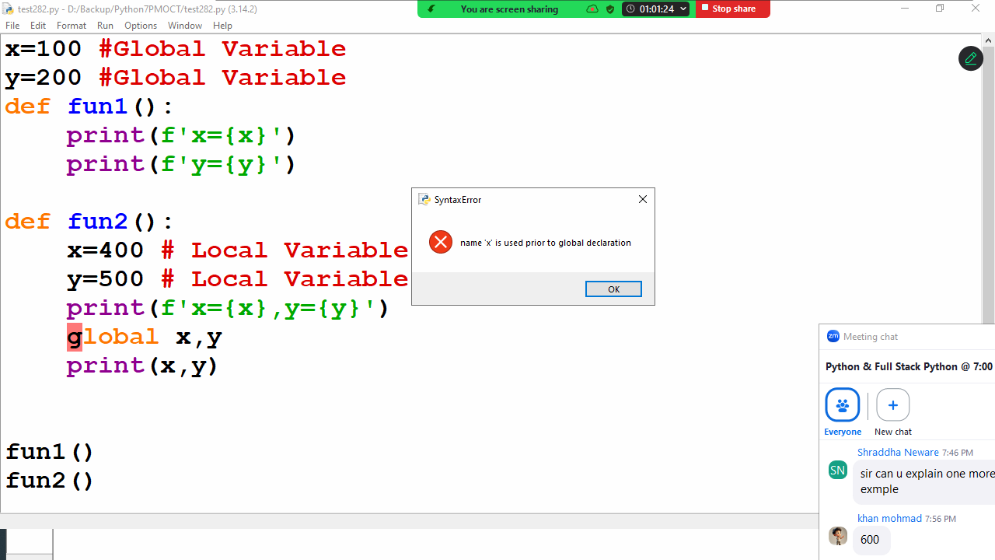

globals()
Return the dictionary implementing the current module namespace. For code within functions, this is set when the function is defined and remains the same regardless of where the function is called.

Example
x=100 #Global Variable
y=200 #Global Variable
def fun1():
print(f'x={x}')
print(f'y={y}')

def fun2():
x=400 # Local Variable
y=500 # Local Variable
print(f'Local x={x},Local y={y}')
d=globals()
print(f"Global x={d['x']},Global y={d['y']}")
d['x']=700
d['y']=800

fun1()
fun2()
fun1()

Output
x=100
y=200
Local x=400,Local y=500
Global x=100,Global y=200
x=700
y=800

Function with parameters or arguments

Function without parameters does not receives values
Function with parameters receives values
In application development a function defined with parameters to receive input/values in order to perform operation.
Python allows writing a function with 3 types of parameters/arguments.

- Function required parameters/arguments
  - Function with required positional arguments
  - Function with keyword arguments
- Function with default parameters/arguments
- Function with variable length parameters/arguments
  - Function with positional variable length arguments
  - Function with keyword variable length arguments

Parameters are local variables, which are used only within function but cannot accessible outside the function.

Function required parameters/arguments
If function is defined with required parameters, those parameters required values at the time of invoking function or calling function.

Syntax:
def function-name(param1,param2,param3,…):
statement-1
statement-2

Example:
def fun1(a,b,c): # required parameters
print(a,b,c,sep="\n")

fun1(100,200,300)
fun1(10,20,30) # Positional arguments
fun1(1,2,3)
fun1(a=100,b=200,c=300) # Keyword arguments
fun1(b=99,a=88,c=44) #Keyword arguments

Output
100
200
300
10
20
30
1
2
3
100
200
300
88
99
44

A function with required parameters receive values in 2 ways
- Using parameter positions
- Using parameter names (Keyword arguments)
- Example of function with required parameters

- def simple_interest(amt,t,rate):
- si=(amt*t*rate)/100
- print(f'Simple Interest is {si:.2f}')

- #Main Program
- simple_interest(5000,12,1.5)
- simple_interest(5000,24,2.5) # Positional arguments
- simple_interest(rate=1.6,amt=9000,t=24) #Keyword arguments

- Output
- Simple Interest is 900.00
- Simple Interest is 3000.00
- Simple Interest is 3456.00

- Example:
- users={'nit':'n123',
- 'naresh':'naresh1234',
- 'suresh':'suresh123@x'}

- def login(u,p):
- if u in users and users[u]==p:
- print(f'{u},welcome')
- else:
- print("invalid username or password")

- #Main
- print("*********Login***********")
- username=input("UserName :")
- password=input("Password :")
- login(username,password)

- Output
- UserName :naresh
- Password :naresh123
- invalid username or password

- *********Login***********
- UserName :naresh
- Password :naresh1234
- naresh,welcome

- return keyword
- A function return the value to the caller or calling function using “return” keyword.
- “return” is branching statement which is used to control the execution of function.
- “return” keyword/statement, after returning value, it terminates execution of function.

- Syntax:
- def function-name([parameters]):
- statement-1
- statement-2
- return expression/value

- whenever function returns value, it is assign to variable.

- Example:
- def fun1():
- x=100
- print(x)

- def fun2():
- x=100
- return x

- fun1()
- a=fun2()
- print(a)
- b=max(10,20,30)
- print(b)

- Output
- 100
- 100
- 30

- Example:
- def maximum(a,b):
- if a>b:
- return a
- else:
- return b

- #Main
- num1=int(input("Enter First Number "))
- num2=int(input("Enter Second Number "))
- num3=maximum(num1,num2)
- print(f'Max of {num1} and {num2} is {num3}')

- Output
- Enter First Number 10
- Enter Second Number 20
- Max of 10 and 20 is 20

- Example:
- def fun1():
- return 10
- print("Hello")

- x=fun1()
- print(x)

- Output
- 10

- Example:
- def fun1():
- return 10
- return 20
- return 30

- x=fun1()
- print(x)

- Output
- 10

- Example:
- def fun1():
- return 10,20,30

- x=fun1()
- print(x,type(x))

- Output
- (10, 20, 30) <class 'tuple'>

- Python functions are generic functions because these functions receive values of any type. Python is dynamically typed programming language the type variable is dynamic (based on value).

- def add(a,b):
- c=a+b
- return c

- r1=add(10,20)
- r2=add(1.5,2.5)
- print(r1,r2)
- r3=add(1+2j,1+3j)
- r4=add("PYTHON","PROGRAMMING")
- print(r3,r4)

- Output
- 30 4.0
- (2+5j) PYTHONPROGRAMMING

- Example:
- # Write a function add only integer values

- def add_int(a,b):
- if isinstance(a,int) and isinstance(b,int):
- return a+b
- else:
- return "NOTINT"

- res1=add_int(100,200)
- print(res1)
- res2=add_int(1.5,2.5)
- print(res2)

- Output
- 300
- NOTINT

- Pass by address or Pass by reference
- In pass by reference objects address is passed to function.

- 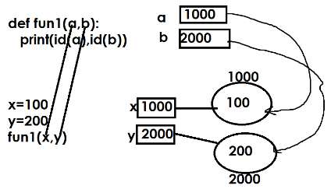
- In pass by reference/address, if object is mutable the changes done within function is applied to original object

- 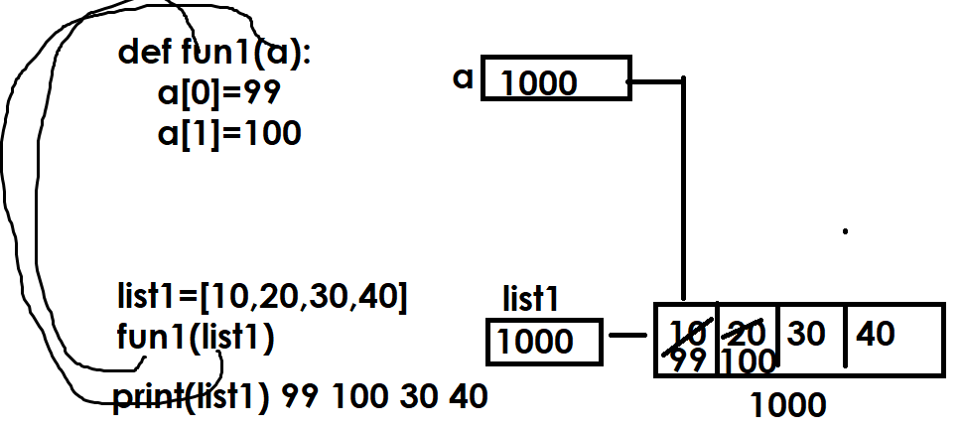

- Example:
- def sort_data(a):
- for i in range(len(a)):
- for j in range(len(a)-1):
- if a[j]>a[j+1]:
- a[j],a[j+1]=a[j+1],a[j]

- list1=[5,2,4,1,3]
- print(f'Before Sorting {list1}')
- sort_data(list1)
- print(f'After Sorting {list1}')

- Output
- Before Sorting [5, 2, 4, 1, 3]
- After Sorting [1, 2, 3, 4, 5]

- Function with required positional only parameters

- Syntax:
- def function-name(req-param1,req-param2,…,/):
- statement-1
- statement-2

- the parameters followed by / are called required positional only parameters.
- These parameters receives values using their positions but not using names.

- Example:
- def minimum(a,b,/):
- if a<b:
- return a
- else:
- return b

- def min2(a,b):
- if a<b:
- return a
- else:
- return b

- #Main Program
- res1=minimum(10,20)
- print(res1)
- #res2=minimum(a=100,b=200)
- res2=min2(100,200)
- res3=min2(a=1,b=2)
- print(res2)
- print(res3)

- Output
- 10
- 100
- 1

- Function with required keyword only arguments

- Syntax:
- def function-name(*,param,param,param…):
- statement-1
- statement-2

- *followed by any parameter is called keyword only parameter
- These parameters receive values using name

- Example:
- def fun1(a,b,/):
- print(a,b)

- def fun2(*,a,b):
- print(a,b)

- def fun3(a,b):
- print(a,b)

- def fun4(a,b,/,*,c,d):
- print(a,b,c,d)

- #def fun5(*,a,b,c,d,/):
- # print(a,b,c,d)

- fun1(100,200)
- fun2(b=1000,a=2000)
- fun3(1,2)
- fun3(a=1,b=2)
- fun2(a=50,b=60)
- fun4(10,20,d=30,c=40)

- Output
- 100 200
- 2000 1000
- 1 2
- 1 2
- 50 60
- 10 20 40 30

- Example:
- def str_upper(s):
- s1=""
- for ch in s:
- if ch>='a' and ch<='z':
- s1=s1+chr(ord(ch)-32)
- else:
- s1=s1+ch
- return s1

- str1=str_upper("python")
- print(str1)

- Output
- PYTHON

- Example:
- def is_prime(num):
- c=0
- for i in range(1,num+1):
- if num%i==0:
- c=c+1
- return c==2

- #Main
- number=int(input("Enter any number "))
- if is_prime(number):
- print("prime")
- else:
- print("not prime")
- Output
- Enter any number 5
- prime

- Enter any number 4
- not prime

- Function with default parameters or optional parameters
- Example of function with required parameters

- def simple_interest(amt,t,rate):
- si=(amt*t*rate)/100
- print(f'Simple Interest is {si:.2f}')

- #Main Program
- simple_interest(5000,12,1.5)
- simple_interest(5000,24,2.5) # Positional arguments
- simple_interest(rate=1.6,amt=9000,t=24) #Keyword arguments

- Output
- Simple Interest is 900.00
- Simple Interest is 3000.00
- Simple Interest is 3456.00

- Example:
- users={'nit':'n123',
- 'naresh':'naresh1234',
- 'suresh':'suresh123@x'}

- def login(u,p):
- if u in users and users[u]==p:
- print(f'{u},welcome')
- else:
- print("invalid username or password")

- #Main
- print("*********Login***********")
- username=input("UserName :")
- password=input("Password :")
- login(username,password)

- Output
- UserName :naresh
- Password :naresh123
- invalid username or password

- *********Login***********
- UserName :naresh
- Password :naresh1234
- naresh,welcome

- return keyword
- A function return the value to the caller or calling function using “return” keyword.
- “return” is branching statement which is used to control the execution of function.
- “return” keyword/statement, after returning value, it terminates execution of function.

- Syntax:
- def function-name([parameters]):
- statement-1
- statement-2
- return expression/value

- whenever function returns value, it is assign to variable.

- Example:
- def fun1():
- x=100
- print(x)

- def fun2():
- x=100
- return x

- fun1()
- a=fun2()
- print(a)
- b=max(10,20,30)
- print(b)

- Output
- 100
- 100
- 30

- Example:
- def maximum(a,b):
- if a>b:
- return a
- else:
- return b

- #Main
- num1=int(input("Enter First Number "))
- num2=int(input("Enter Second Number "))
- num3=maximum(num1,num2)
- print(f'Max of {num1} and {num2} is {num3}')

- Output
- Enter First Number 10
- Enter Second Number 20
- Max of 10 and 20 is 20

- Example:
- def fun1():
- return 10
- print("Hello")

- x=fun1()
- print(x)

- Output
- 10

- Example:
- def fun1():
- return 10
- return 20
- return 30

- x=fun1()
- print(x)

- Output
- 10

- Example:
- def fun1():
- return 10,20,30

- x=fun1()
- print(x,type(x))

- Output
- (10, 20, 30) <class 'tuple'>

- Python functions are generic functions because these functions receive values of any type. Python is dynamically typed programming language the type variable is dynamic (based on value).

- def add(a,b):
- c=a+b
- return c

- r1=add(10,20)
- r2=add(1.5,2.5)
- print(r1,r2)
- r3=add(1+2j,1+3j)
- r4=add("PYTHON","PROGRAMMING")
- print(r3,r4)

- Output
- 30 4.0
- (2+5j) PYTHONPROGRAMMING

- Example:
- # Write a function add only integer values

- def add_int(a,b):
- if isinstance(a,int) and isinstance(b,int):
- return a+b
- else:
- return "NOTINT"

- res1=add_int(100,200)
- print(res1)
- res2=add_int(1.5,2.5)
- print(res2)

- Output
- 300
- NOTINT

- Pass by address or Pass by reference
- In pass by reference objects address is passed to function.

- In pass by reference/address, if object is mutable the changes done within function is applied to original object

- Example:
- def sort_data(a):
- for i in range(len(a)):
- for j in range(len(a)-1):
- if a[j]>a[j+1]:
- a[j],a[j+1]=a[j+1],a[j]

- list1=[5,2,4,1,3]
- print(f'Before Sorting {list1}')
- sort_data(list1)
- print(f'After Sorting {list1}')

- Output
- Before Sorting [5, 2, 4, 1, 3]
- After Sorting [1, 2, 3, 4, 5]

- Function with required positional only parameters

- Syntax:
- def function-name(req-param1,req-param2,…,/):
- statement-1
- statement-2

- the parameters followed by / are called required positional only parameters.
- These parameters receives values using their positions but not using names.

- Example:
- def minimum(a,b,/):
- if a<b:
- return a
- else:
- return b

- def min2(a,b):
- if a<b:
- return a
- else:
- return b

- #Main Program
- res1=minimum(10,20)
- print(res1)
- #res2=minimum(a=100,b=200)
- res2=min2(100,200)
- res3=min2(a=1,b=2)
- print(res2)
- print(res3)

- Output
- 10
- 100
- 1

- Function with required keyword only arguments

- Syntax:
- def function-name(*,param,param,param…):
- statement-1
- statement-2

- *followed by any parameter is called keyword only parameter
- These parameters receive values using name

- Example:
- def fun1(a,b,/):
- print(a,b)

- def fun2(*,a,b):
- print(a,b)

- def fun3(a,b):
- print(a,b)

- def fun4(a,b,/,*,c,d):
- print(a,b,c,d)

- #def fun5(*,a,b,c,d,/):
- # print(a,b,c,d)

- fun1(100,200)
- fun2(b=1000,a=2000)
- fun3(1,2)
- fun3(a=1,b=2)
- fun2(a=50,b=60)
- fun4(10,20,d=30,c=40)

- Output
- 100 200
- 2000 1000
- 1 2
- 1 2
- 50 60
- 10 20 40 30

- Example:
- def str_upper(s):
- s1=""
- for ch in s:
- if ch>='a' and ch<='z':
- s1=s1+chr(ord(ch)-32)
- else:
- s1=s1+ch
- return s1

- str1=str_upper("python")
- print(str1)

- Output
- PYTHON

- Example:
- def is_prime(num):
- c=0
- for i in range(1,num+1):
- if num%i==0:
- c=c+1
- return c==2

- #Main
- number=int(input("Enter any number "))
- if is_prime(number):
- print("prime")
- else:
- print("not prime")
- Output
- Enter any number 5
- prime

- Enter any number 4
- not prime

- Function with default parameters or optional parameters
Function with default parameters or optional parameters

What is default parameter?
A parameter given value at the time of defining function is called default parameter. These parameters do not require give/input value at the time of invoking function or calling function.

Syntax:
def function-name(param-name,param-name,param-name=value,param-name-value,..):
statement-1
statement-2

Example:
def fun1(a,b):
print("function with required parameters")
print(f'a={a},b={b}')

def fun2(x=None,y=None):
print("function with default/optional parameters")
print(f'x={x},y={y}')

fun1(100,200)
fun2()
fun2(10,20)
fun2(y=99)
fun2(88)

Output
function with required parameters
a=100,b=200
function with default/optional parameters
x=None,y=None
function with default/optional parameters
x=10,y=20
function with default/optional parameters
x=None,y=99
function with default/optional parameters
x=88,y=None

Example:
def drawline(ch="*",length=20):
for i in range(length):
print(ch,end='')
print()

#main
drawline()
print("PYTHON")
drawline("$")
print("PROGRAMMING LANGUAGE")
drawline(length=30)
print("HIGH LEVEL LANGUAGE")
drawline("@",30)

Output
********************
PYTHON
$$$$$$$$$$$$$$$$$$$$
PROGRAMMING LANGUAGE
******************************
HIGH LEVEL LANGUAGE
@@@@@@@@@@@@@@@@@@@@@@@@@@@@@@

Example:
def simple_interest(amt,t,rate=1.5):
si=(amt*t*rate)/100
return si

#Main
si1=simple_interest(9000,12)
print(si1)
si2=simple_interest(15000,24,2.0)
print(si2)

Output
1620.0
7200.0

Example of function with default or optional parameters

def sort_list(a,ascending=True):
if ascending:
for i in range(len(a)):
for j in range(len(a)-1):
if a[j]>a[j+1]:
a[j],a[j+1]=a[j+1],a[j]
else:
for i in range(len(a)):
for j in range(len(a)-1):
if a[j]<a[j+1]:
a[j],a[j+1]=a[j+1],a[j]

#Main
A=[8,5,3,2,4,1,7,6]
print(f'Before Sorting {A}')
sort_list(A)
print(f'After Sorting in Ascending Order {A}')
sort_list(A,False)
print(f'After Sorting in Descending Order {A}')

Output
Before Sorting [8, 5, 3, 2, 4, 1, 7, 6]
After Sorting in Ascending Order [1, 2, 3, 4, 5, 6, 7, 8]
After Sorting in Descending Order [8, 7, 6, 5, 4, 3, 2, 1]

Example:
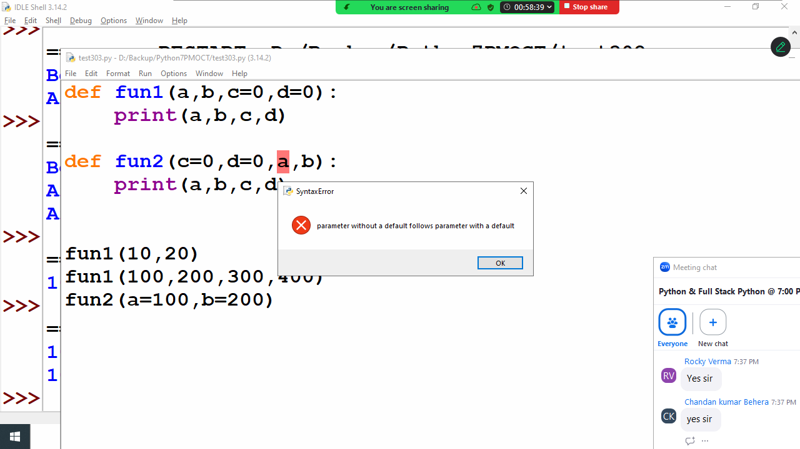
The above program generates syntax error because the order of defining required and default is, always required parameters follows default parameters.

Function with variable length parameters
Function with variable length parameter receives 0 or more values.
Python support 2 types of variable length parameters
- Variable length positional parameters
- Variable length keyword parameters

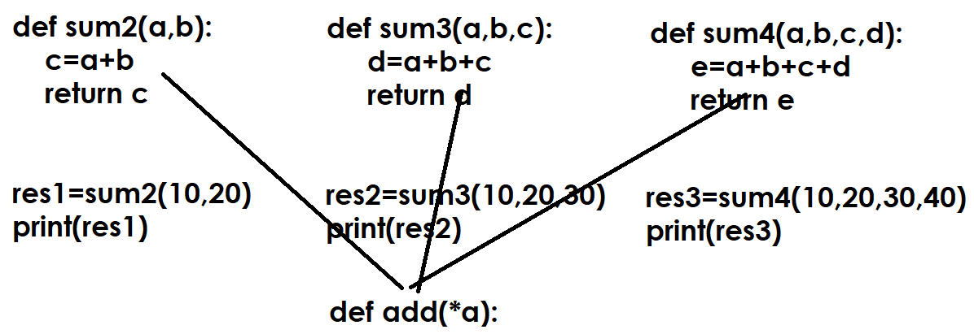

Variable length positional parameter
Variable length positional parameter is prefix with *
Variable length positional parameter is of type of tuple
This will organize data according to their position/index

Syntax:
def function-name(*param-name):
statement-1
statement-2

In application development a function is defined with variable length parameter if function required more than one value to perform operation.

Example  def fun1(*a):  print(a,type(a))  #Main  fun1()  fun1(10)  fun1(10,20)  fun1(10,20,30,40,50)  fun1(1,"naresh",1.5) | Output  () <class 'tuple'>  (10,) <class 'tuple'>  (10, 20) <class 'tuple'>  (10, 20, 30, 40, 50) <class 'tuple'>  (1, 'naresh', 1.5) <class 'tuple'>
Example:  def add_num(*values):  s=0  for value in values:  s=s+value  return s  #Main  res1=add_num()  print(res1)  res2=add_num(10,20)  print(res2)  res3=add_num(10,20,30,40,50,1.5,2.5)  print(res3) | Output  0  30  154.0
Example  def maximum(*values):  for i in range(len(values)):  if i==0:  max_value=values[0]  elif values[i]>max_value:  max_value=values[i]  if len(values)==0:  return None  else:  return max_value  #Main  res1=maximum()  print(res1)  res2=maximum(10)  print(res2)  res3=maximum(40,60,70)  print(res3) | Output  None  10  70

Variable length keyword arguments

Variable length keyword parameters are prefix with **
Variable length keyword parameter is of type dictionary
Variable length keyword parameter receives data as key and value pair.

Syntax:
def function-name(**parameter-name):
statement-1
statement-2
Variable length keyword arguments

Variable length keyword parameters are prefix with **
Variable length keyword parameter is of type dictionary
Variable length keyword parameter receives data as key and value pair.

Syntax:
def function-name(**parameter-name):
statement-1
statement-2

Example:
def fun1(**a):
print(a,type(a))

fun1(x=10,y=20,z=30)
fun1(rollno=1,name="naresh",course="python")
fun1()

Output
{'x': 10, 'y': 20, 'z': 30} <class 'dict'>
{'rollno': 1, 'name': 'naresh', 'course': 'python'} <class 'dict'>
{} <class 'dict'>

In application development keyword arguments are used to manipulate data by sending it as key and value pair (OR) to manipulate dictionary data.

Example:
def add(**kwargs):
total=0
for key,value in kwargs.items():
total=total+value
print(f'{key}={value}')
print(f"Sum of Values {total}")

add(a=10,b=20,c=30)
add(n1=100,n2=200,n3=300,n4=400,n5=500)

Output
a=10
b=20
c=30
Sum of Values 60
n1=100
n2=200
n3=300
n4=400
n5=500
Sum of Values 1500

Example:
def max_items(**kwargs):

max_item=None
for item in kwargs.items():
if max_item==None:
max_item=item
elif item[1]>max_item[1]:
max_item=item
return max_item

max_sales=max_items(jan=50000,feb=650000,mar=36000,apr=55000)
max_score=max_items(rohit=100,virat=70,surya=90)
print(max_sales)
print(max_score)

Output
('feb', 650000)
('rohit', 100)
Example:
def print_data(**kwargs):
for key,value in kwargs.items():
print(f'{key}\t{value}')

emp_dict={'naresh':45000,
'suresh':65000,
'ramesh':76000,
'kishore':32000}
print_data(**emp_dict)
stud_dict={'1':['naresh','python'],
'2':['suresh','java'],
'3':['ramesh','oracle']}
print_data(**stud_dict)

Output
naresh 45000
suresh 65000
ramesh 76000
kishore 32000
1 ['naresh', 'python']
2 ['suresh', 'java']
3 ['ramesh', 'oracle']

Example:
# defining order of multiple types of parameters
# 1. Required parameters
# 2. Default parameters
# 3. Variable length parameters
def fun1(a,b=None,*values,**kwargs):
print(a,values,kwargs,b)

fun1(10)
fun1(10,20,30,40,50)
fun1(10,x=100,y=200)
fun1(10,b=99)

Output
10 () {} None
10 (30, 40, 50) {} 20
10 () {'x': 100, 'y': 200} None
10 () {} 99

Nested Functions/Inner functions
Defining function inside function is called nested functions.

Why nested functions?
- Function hiding
- Developing special functions in python
  - Closures
  - Decorators
- Divide functionality of a function into sub functions.

Syntax:
def outer-function-name([parameters]):
def inner-function-name([parameters]):
statement-1
statement-2
statement-1
statement-2

Points to Remember
- Inner function is used within outer function but cannot accessible outside outer function.

def fun1():
print("outer function")
def fun2():
print("inner function")
fun2()

fun1()

Output
outer function
inner function

- Inner function can access local variables of outer function

def fun1():
x=100 #Local Variable
y=200 #Local Variable
def fun2():
print(x)
print(y)
fun2()

fun1()

Output
100
200

- Outer function cannot access local variables of inner function

def fun1():
def fun2():
x=100 # Local variable
y=200 # Local variable

print(x)
print(y)

fun1()

Output
File "D:/Backup/Python7PMOCT/test314.py", line 6, in fun1
print(x)
NameError: name 'x' is not defined

- Inner function can access local variables of outer function but cannot modify values directly

def fun1():
x=100 # Non Local
y=200 # Non Local
def fun2():
print(x)
print(y)
def fun3():
x=400 # Local Variable
y=500 # Local Variable
fun2()
fun3()
fun2()

fun1()

Output
100
200
100
200

- Inner function can modify or update values of outer function local variables using nonlocal keyword

nonlocal keyword

nonlocal keyword is used inside inner function to refer variables of outer function or outer block. Without nonlocal inner function cannot update or modify values of non local variables of outer function.

Syntax:
nonlocal variable-name,variable

After this statement, the given variable list refers to outer function.

def fun1():
x=100 # Non Local
y=200 # Non Local
def fun2():
print(x)
print(y)
def fun3():
nonlocal x,y
x=400
y=500
fun2()
fun3()
fun2()

fun1()

Output
100
200
400
500

LEGB

What is LEGB rule in python?
The LEGB rule is how Python determines the order in which it looks for a variable name when it's referenced in your code. It is an acronym for the four distinct scopes that Python checks sequentially: Local, Enclosing, Global, and Built-in

The Scope Resolution Order
When you use a variable name in your code, the Python interpreter follows this precise hierarchy to find the corresponding object:

L - Local: Python first checks the current, innermost scope. This includes variables defined within the current function or lambda expression. Function arguments also reside in the local scope.

E - Enclosing: If the name isn't found in the local scope, Python looks in the scope of any enclosing (outer) functions. This applies specifically to nested functions, allowing inner functions to access variables of their surrounding function.

G - Global: If the name is still not found, Python searches the global scope. This scope contains variables defined at the top level of your script or module, outside of any function or class.

B - Built-in: Finally, if the name is not found in any of the above scopes, Python checks the built-in scope. This is a special scope containing all of Python's pre-defined names, such as core functions like print(), len(), and standard exceptions.

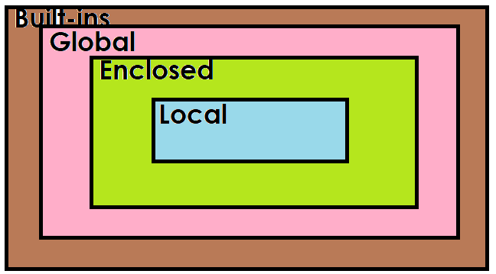
Example
x=100 # Global Variable
def fun1():
y=200 # Local Variable of fun1 and nonlocal of fun2
def fun2():
z=300 # Local variable
print(x)
print(y)
print(z)
print(__file__)

fun2()

fun1()

Output
100
200
300
D:/Backup/Python7PMOCT/test316.py

Example:
def calc(n1,n2,opr):
n3=None
def add():
nonlocal n3
n3=n1+n2
def sub():
nonlocal n3
n3=n1-n2
def multiply():
nonlocal n3
n3=n1*n2
def div():
nonlocal n3
n3=n1/n2
match opr:
case '+':add()
case '-':sub()
case '*':multiply()
case '/':div()
return n3

#main
while True:
num1=int(input("Enter First Number "))
num2=int(input("Enter Second Number "))
opr=input("Enter Operator ")
if opr not in "+-*/":
break
res=calc(num1,num2,opr)
print(f'{num1}{opr}{num2}={res}')

Output
Enter First Number 10
Enter Second Number 20
Enter Operator +
10+20=30
Enter First Number 5
Enter Second Number 4
Enter Operator *
5*4=20
Enter First Number 10
Enter Second Number 5
Enter Operator -
10-5=5
Enter First Number 5
Enter Second Number 2
Enter Operator **

Decorators

Decorators are special functions in python.
Decorators are used to extend functionality of existing function without modifying or without updating.
Decorators are developed using nested functions.

Advantage of decorators
- Function transforming (OR) Transforming one function to another function
- Extending functionality of existing function without modifying existing function (OR) Adding some extra code to existing function without modifying existing code.

Decorators are 2 types
- Predefined decorators
- User defined decorators

The decorators provided by python are called predefined decorators.
Example: @staticmethod,@classmethod,@property,@abstractmethod

The decorators build by programmer are called user defined decorators.

Basic steps for developing decorators
- Developing Decorator
- Applying Decorator

Develop Decorator or Create Decorator
Decorator is developed using nested functions.

Basic steps for developing decorator
- Define function with single parameter. This parameter receives function as input.
- Inside function, define another function (wrapper function/inner function). This wrapper function add new functionality to the existing function/the function which is received by outer function/decorator function
- Outer function returns wrapper function/inner function.

Applying decorator
Decorator is applied to function using @decorator-name syntax.

Syntax:
@decorator-name
def function-name([parameters]):
statement-1
statement-2

Example:
def box(function):
def wrapper_function():
print("*"*40)
function()
print("*"*40)
return wrapper_function

@box
def fun1():
print("PYTHON")
@box
def fun2():
print("JAVA LANGUAGE")

fun1()
fun2()

Output
****************************************
PYTHON
****************************************
****************************************
JAVA LANGUAGE
****************************************

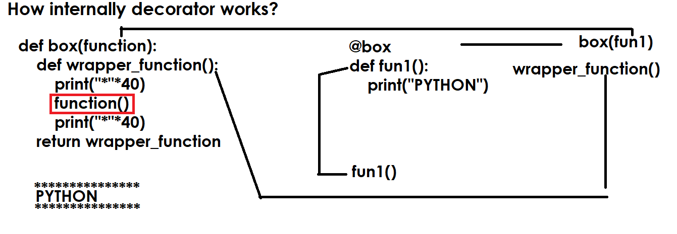

Example:
#decorator function
def box(function):
def wrapper_function():
print("*"*40)
function()
print("*"*40)
return wrapper_function

def fun1():
print("PYTHON")

@box
def fun2():
print("JAVA")

#Internal
f=box(fun1)
f()

fun2()
Output
****************************************
PYTHON
****************************************
****************************************
JAVA
****************************************

Applications of decorators
- Authentication decorator
- Authorization decorator
- Code debugging decorator
- Code Testing decorator
- Logging decorators/Loggers

Example:
import random
#Decorator
def otp_authentication(function):
def wrapper():
otp=random.randint(1000,9999)
print(f'Input OTP {otp} for authentication')
iotp=int(input("OTP :"))
if otp==iotp:
function()
else:
print("Invalid OTP No")
return wrapper

@otp_authentication
def deposit():
print("deposit function")

@otp_authentication
def withdraw():
print("withdraw function")
@otp_authentication
def login():
print("welcome")

Output
Input OTP 9800 for authentication
OTP :9800
deposit function
Input OTP 3270 for authentication
OTP :3270
withdraw function
Input OTP 5241 for authentication
OTP :5241
Welcome

Example:
def smart_division(function):
def wrapper(n1,n2):
if n2==0:
return 0
else:
return function(n1,n2)
return wrapper

@smart_division
def division(n1,n2):
n3=n1/n2
return n3

res=division(5,2)
print(res)
res=division(6,0)
print(res)

Output
2.5
0

decorator with parameters

decorator is having one required parameter called function.
A part of this it can receive other values. in order to receive, it required parameters

Syntax:
def outer-function(param,param,param,..):
def decorator-name(function):
def wrapper([parameters]):
statement-1
function()
statement-2
return wrapper
return decorator-name

Example:
def authentication(user,pwd):# Which receives values/outer layer
def authenticate(function): # actual decorator
def wrapper():
if user=='nit' and pwd=='n123':
function()
else:
print("invalid username or password")
return wrapper
return authenticate

@authentication(user='nit',pwd='n123')
def login():
print("welcome")

login()

Output
welcome

invalid username or password

Example:
def sort(order):
def sorting(function):
def wrapper(a):
if order=="ascending":
for i in range(len(a)):
for j in range(len(a)-1):
if a[j]>a[j+1]:
a[j],a[j+1]=a[j+1],a[j]
else:
for i in range(len(a)):
for j in range(len(a)-1):
if a[j]<a[j+1]:
a[j],a[j+1]=a[j+1],a[j]
function(a)
return wrapper
return sorting

@sort('descending')
def display_list(a):
print(f'List is {a}')

list1=[6,9,2,5,7,1,4,2,4]
display_list(list1)

Output
List is [9, 7, 6, 5, 4, 4, 2, 2, 1]
Decorator Chaining
Applying multiple decorators is called decorator chaining.
Decorating a decorator using another decorator is called decorating chaining.

Syntax:

@decorator2
@decorator1
def function-name(parameters):
statement-1
statement-2

def draw_dollars(function):  def wrapper():  print("$"*40)  function()  print("$"*40)  return wrapper  def draw_stars(function):  def wrapper():  print("*"*40)  function()  print("*"*40)  return wrapper  @draw_dollars  @draw_stars  def display():  print("PYTHON PROGRAMMING")  @draw_stars  @draw_dollars  def show():  print("JAVA PROGRAMMING")  display()  show() | Output  $$$$$$$$$$$$$$$$$$$$$$$$$$$$$$$$$$$$$$$$  ****************************************  PYTHON PROGRAMMING  ****************************************  $$$$$$$$$$$$$$$$$$$$$$$$$$$$$$$$$$$$$$$$  ****************************************  $$$$$$$$$$$$$$$$$$$$$$$$$$$$$$$$$$$$$$$$  JAVA PROGRAMMING  $$$$$$$$$$$$$$$$$$$$$$$$$$$$$$$$$$$$$$$$  ****************************************

Closures

A closure in Python is a function object that has access to variables in its enclosing scope/outer function, even after the outer (enclosing) function has finished executing. It essentially allows a function to "remember" the environment in which it was created, carrying some data around with it.

Basic steps for developing closure
- Define a function with parameters (outer function)
- Define a inner function which uses parameters/data of outer function to perform operations
- Return inner function outside outer function

Use of closures
- Function Factory
- Encapsulation (OR) Data Hiding

Example:
def power_factory(num):
def power(p):
return num**p
return power

pow5=power_factory(5)
res1=pow5(2)
res2=pow5(3)
res3=pow5(4)
print(res1,res2,res3)
pow2=power_factory(2)
pow7=power_factory(7)
res4=pow2(2)
res5=pow2(3)
res6=pow7(2)
res7=pow7(3)
print(res4,res5,res6,res7)
res8=pow5(5)
print(res8)

Output
25 125 625
4 8 49 343
3125

Example:
def calculator(n1,n2):
def calculate(opr):
match opr:
case '+':
return n1+n2
case '-':
return n1-n2
case '*':
return n1*n2
case '/':
return n1/n2
case _:
return None
return calculate

calc1=calculator(10,5)
res1=calc1('+')
res2=calc1('-')
print(res1,res2)
calc2=calculator(5,2)
res3=calc2('+')
res4=calc2('-')
res5=calc2('*')
res6=calc2('/')

print(res3,res4,res5,res6)

Output
15 5
7 3 10 2.5

Example:
def transaction(accno,balance):
def trans(ttype,tamt):
nonlocal balance
if ttype=="deposit":
balance=balance+tamt
elif ttype=="withdraw":
balance=balance-tamt

return balance
return trans

cust1=transaction(101,65000)
bal1=cust1("deposit",25000)
print(bal1)
bal2=cust1('withdraw',15000)
print(bal2)
cust2=transaction(102,50000)
bal3=cust2("deposit",10000)
print(bal3)
bal4=cust2("deposit",5000)
print(bal4)
bal5=cust2('withdraw',25000)
print(bal5)
bal6=cust1("deposit",50000)
print(bal6)

Output
90000
75000
60000
65000
40000
125000

Example:
# Data Hiding
def fun1():
num1=10
num2=5
def fun2(opr):
if opr=='+':
return num1+num2
elif opr=='-':
return num1-num2
return fun2

f=fun1()
res1=f('+')
res2=f('-')
print(res1,res2)

Output
15 5

Preventing data access from other functions is called data hiding.

Generators
Generators are used for creating iterators.
Generators are special functions which return iterators.
Iterators are used for generating values/data from existing collections.

Basic steps for creating generators
- Define a function which generate values (OR) defining generator function
- Creating iterator object using generator function

Defining Generator Function

Syntax:
def <generator-function-name>([parameters]):
yield value/expression

yield keyword

“yield” keyword is used to represent a function as a generator function.
“yield” keyword used by generator function for generating or returning values.
“yield” keyword after generating value does not terminate execution but it pause the execution function, when iterated again it resume back continue execution.
When generator function is called, it returns iterator object.

Example:
def fun1():
return 10
return 20
return 30
def fun2(): # Defining Generator
yield 10
yield 20
yield 30

x=fun1()
print(x)
y=fun2() # Creating iterator
value1=next(y)
print(value1)
value2=next(y)
print(value2)
value3=next(y)
print(value3)
z=fun2() # Creating iterator
for value in z:
print(value,end=' ')

Output
10
10
20
30
10 20 30

next() : next() receive iterator object and return next value generated by iterator object.

A=[10,20,30,40,50,60,70,80,90,100]  x=iter(A)  for value in x:  print(value,end=' ')  def backward_iter(sequence): # Generator Function  for value in sequence[::-1]:  yield value  print()  y=backward_iter(A)  for value in y:  print(value,end=' ') | Output  10 20 30 40 50 60 70 80 90 100  100 90 80 70 60 50 40 30 20 10
def even_iterator(iterable):  for value in iterable:  if value%2==0:  yield value  def odd_iterator(iterable):  for value in iterable:  if value%2!=0:  yield value  A=[1,2,3,4,5,6,7,8,9,10]  B=list(even_iterator(A))  C=list(odd_iterator(A))  print(A,B,C,sep="\n") | [1, 2, 3, 4, 5, 6, 7, 8, 9, 10]  [2, 4, 6, 8, 10]  [1, 3, 5, 7, 9]
def alpha_generator():  for value in range(65,91):  yield chr(value)  A=list(alpha_generator())  print(A)  B=set(alpha_generator())  print(B) | Output  ['A', 'B', 'C', 'D', 'E', 'F', 'G', 'H', 'I', 'J', 'K', 'L', 'M', 'N', 'O', 'P', 'Q', 'R', 'S', 'T', 'U', 'V', 'W', 'X', 'Y', 'Z']  {'L', 'K', 'O', 'H', 'V', 'G', 'A', 'P', 'M', 'I', 'T', 'D', 'E', 'R', 'N', 'U', 'B', 'Z', 'J', 'Q', 'X', 'C', 'F', 'S', 'Y', 'W'}
Lambda Functions or Lambda Expressions

What is lambda function?
A lambda function is anonymous function.
A function which does not have any name is called anonymous function.
Lambda function is having single statement (OR) Lambda expression is single line function.

Use cases of lambda functions or lambda expression
In application development lambda functions are used,
- With higher order functions (A function uses another function as input and perform operation)
- A function which is not used frequently.
- A function having single statement
- A function which performs read only operations.

Lambda function or lambda expression is defined using “lambda” keyword.

Syntax: lambda [parameter]:statement/expression

A lambda function is defined,
- Without parameters
- With parameter

Within lambda we cannot use “return” statement.

Example:
lambda1=lambda:print("this is lambda function")

def fun1():
print("this is function1")
print("this is statement-2")

fun1()
lambda1()

Output
this is function1
this is statement-2
this is lambda function

Example:
add=lambda a,b:a+b
sub=lambda a,b:a-b
max2=lambda a,b:a if a>b else b

res1=add(10,20)
res2=sub(10,5)
res3=max2(10,20)
print(f'Sum is {res1}')
print(f'Diff is {res2}')
print(f'Max of two numbers is {res3}')

Output
Sum is 30
Diff is 5
Max of two numbers is 20

Predefined higher order functions

What is higher order function?
A function which receives input as a function is called higher order function, this function having dynamic behavior.
These functions receive input as one function and perform operations.
- filter()
- map()
- reduce()
filter(),map() and reduce() are predefined higher order functions.
All these higher order functions are called generator functions. These functions returns iterator object.
filter(function, iterable, /)
Construct an iterator from those elements of iterable for which function is true. iterable may be either a sequence, a container which supports iteration, or an iterator. If function is None, the identity function is assumed, that is, all elements of iterable that are false are removed.

Example:
A=[1,8,3,7,3,6,12,43,68,98,45,76,79,15,13,25,73]
B=list(filter(lambda n:n%2==0,A))
print(f'A={A}')
print(f'B={B}')
C=list(filter(lambda n:n%2!=0,A))
print(f'C={C}')
D=list(filter(lambda n:n<=30,A))
print(f'D={D}')

Output
A=[1, 8, 3, 7, 3, 6, 12, 43, 68, 98, 45, 76, 79, 15, 13, 25, 73]
B=[8, 6, 12, 68, 98, 76]
C=[1, 3, 7, 3, 43, 45, 79, 15, 13, 25, 73]
D=[1, 8, 3, 7, 3, 6, 12, 15, 13, 25]

Example:
names=["naresh","suresh","ramesh","KISHORE","KIRAN","RAJESH"]

names1=list(filter(lambda name:name.isupper(),names))
names2=list(filter(lambda name:name.islower(),names))
print(names)
print(names1)
print(names2)

names=["kishore","raman","kiran","naresh","suresh","ramesh"]
names1=list(filter(lambda name:name[-1]=='h',names))
print(names)
print(names1)
names2=list(filter(lambda name:name[0]=='k',names))
print(names2)

def fun1(name):
if name[0] in 'ns':
return True

names3=list(filter(fun1,names))
print(names3)

Output
['naresh', 'suresh', 'ramesh', 'KISHORE', 'KIRAN', 'RAJESH']
['KISHORE', 'KIRAN', 'RAJESH']
['naresh', 'suresh', 'ramesh']
['kishore', 'raman', 'kiran', 'naresh', 'suresh', 'ramesh']
['naresh', 'suresh', 'ramesh']
['kishore', 'kiran']
['naresh', 'suresh']

map(function, iterable, /, *iterables)
Return an iterator that applies function to every item of iterable, yielding the results. If additional iterables arguments are passed, function must take that many arguments and is applied to the items from all iterables in parallel. With multiple iterables, the iterator stops when the shortest iterable is exhausted.

Example:
A=[1,2,3,4,5,6,7,8,9,10]
print(f'A={A}')
B=list(map(lambda n:n**2,A))
print(f'B={B}')
names=['naresh','ramesh','kishore','ramesh','raman']
names1=list(map(lambda name:name.upper(),names))
print(names)
print(names1)
L1=[1,2,3,4,5]
L2=[10,20,30,40,50]
L3=list(map(lambda a,b:a+b,L1,L2))
print(L1,L2,L3,sep="\n")
A=[1,2,3]
B=[10,20,30,40,50]
C=list(map(lambda a,b:[a,b],A,B))
print(A,B,C,sep="\n")
A=["10","20","30","40","50"]
B=list(map(int,A))
print(A)
print(B)
x,y=map(int,input().split())
print(x,y)

Output
A=[1, 2, 3, 4, 5, 6, 7, 8, 9, 10]
B=[1, 4, 9, 16, 25, 36, 49, 64, 81, 100]
['naresh', 'ramesh', 'kishore', 'ramesh', 'raman']
['NARESH', 'RAMESH', 'KISHORE', 'RAMESH', 'RAMAN']
[1, 2, 3, 4, 5]
[10, 20, 30, 40, 50]
[11, 22, 33, 44, 55]
[1, 2, 3]
[10, 20, 30, 40, 50]
[[1, 10], [2, 20], [3, 30]]
['10', '20', '30', '40', '50']
[10, 20, 30, 40, 50]
100 200
100 200

reduce()

“reduce()” function is exists in functools module.
It is a standard module which comes with python software.

Syntax
functools.reduce(function, iterable)
Apply function of two arguments cumulatively to the items of iterable, from left to right, so as to reduce the iterable to a single value.

example, reduce(lambda x, y: x+y, [1, 2, 3, 4, 5]) calculates ((((1+2)+3)+4)+5). The left argument, x, is the accumulated value and the right argument, y, is the update value from the iterable

Example:
>>> A=[1,2,3,4,5,6,7,8,9,10]
>>> import functools
>>> res1=functools.reduce(lambda x,y:x+y,A)
>>> print(res1)
55
>>> res2=functools.reduce(lambda x,y:x if x>y else y,A)
>>> print(res2)
10
>>> res3=functools.reduce(lambda x,y:x if x<y else y,A)
>>> print(res3)
1
>>> res3=functools.reduce(lambda x,y:str(x)+str(y),A)
>>> print(res3)
12345678910
Function Recursion
Calling the function within same function is called function recursion.
In function recursion calling function and called function both are same.

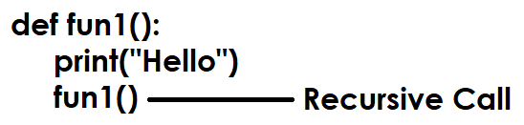

Function recursion is a programming technique where a function calls itself, directly or indirectly, to solve a problem by breaking it down into smaller, simpler instances of the same problem, requiring a base case to stop the self-calls and prevent infinite loops, and effectively solving complex tasks like factorial, tree traversals, or sorting algorithms.

Recursion required 2 statements or steps
- Base case
- Recursive step

Base Case: A crucial condition that, when met, stops the recursion and returns a value, preventing infinite calls.

Recursive Step: The part where the function calls itself with a simpler version of the problem.

If the base case is not define, python runtime repeats function call 1000 time. It is nothing the default base case used by python is 1000.

How to find base case or recursion depth?
>>> import sys
>>> sys.getrecursionlimit()
1000

How to change base case or recursion depth?
>>> import sys
>>> sys.getrecursionlimit()
1000
>>> sys.setrecursionlimit(10)
>>> sys.getrecursionlimit()
10

def fun1():  print("PYTHON")  fun1() # Recursive step  fun1() | Output  PYTHON  PYTHON  PYTHON  PYHTON  1000 times
import sys  sys.setrecursionlimit(10)  def fun1():  print("PYTHON")  fun1() # Recursive step  fun1() | Output  PYTHON  PYTHON  PYTHON  PYTHON  26 times
n=1  def fun1():  global n  if n<=5: # Base case  n=n+1  print("PYTHON")  fun1() # Recursive step  fun1() | PYTHON  PYTHON  PYTHON  PYTHON  PYTHON

In recursion output/result of one function is used as input for another function call.
def factorial(n):  if n==0: # Basecase  return 1  else:  return n*factorial(n-1) # Recursive Case  res=factorial(3)  print(res) | Output  6

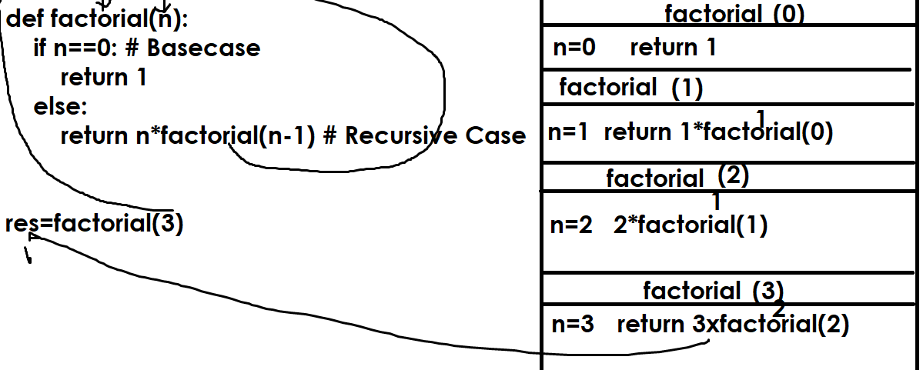

# Write a program to find sum of digits  # using function recursion  def sum_of_digits(num):  if num==0:  return 0  else:  return num%10+sum_of_digits(num//10)  res=sum_of_digits(123)  print(res) | Output  6

Modules and packages

What is module in python?
A module is nothing a python program
A module is a python file with extension .py
A python application or project is a collection of modules or programs.
Modular programming allows dividing the functionality of an application into number programs and each program is called module.

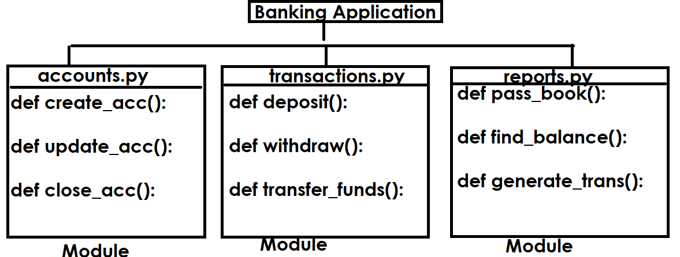
A python program or module is collection variables, functions and classes.
Advantage of modular programming
- Easy to understand
- Reusability
- Modularity

Python modules are 2 types
- Predefined modules
- User defined modules

Predefined modules
The existing modules or programs are called predefined modules. These modules/programs are provided by python or third party vendors

Example: math, sys, os, random, calendar, datetime,…
These inbuilt or predefined modules are also called libraries.

User defined modules
The modules or programs build by programmer are called user defined modules and these application specific modules.

Example: accounts.py, authentication.py, transations.py, reports.py

How to use the content of one module inside another module?

import statement or import keyword

import is a keyword, which is used to include the content of one module inside another module (OR) to use the content of one module inside another module.

Syntax-1: import module-name
Syntax-2: import module-name as alias-name
Syntax-3: from module-name import *
Syntax-4: from module-name import identifier-1,identifier-2
Syntax-5: from module-name import identifier-1 as alias-name

Module1.py | Module2.py
x=100 # Global Variable  def fun1():  print("inside fun1")  def fun2():  print("inside fun2") | import module1  print(module1.x)  module1.fun1()  module1.fun2()  Output  100  inside fun1  inside fun2

umath.py | mtest1.py
def isprime(num):  c=0  for i in range(1,num+1):  if num%i==0:  c=c+1  return c==2  def factorial(num):  if num==0:  return 1  else:  return num*factorial(num-1)  def sumofdigits(num):  s=0  while num>0:  d=num%10  s=s+d  num=num//10  return s | import umath  x=umath.isprime(5)  y=umath.isprime(6)  print(x,y)  f1=umath.factorial(4)  f2=umath.factorial(5)  print(f1,f2)  res1=umath.sumofdigits(123)  res2=umath.sumofdigits(5678)  print(res1,res2)

Syntax-2: import module-name as alias-name

This syntax allows importing module with another name or alias name. if any other name in current module with same name, to avoid conflict we use alias name. it is also used for giving shorter names.

Authentication.py | Mtest2.py
users={'naresh':'n123',  'suresh':'s321',  'ramesh':'r567'}  def login(u,p):  if u in users and users[u]==p:  return True  else:  return False | # Login Application  import authentication as au  username=input("UserName :")  password=input("Password :")  if au.login(username,password):  print(f'{username} welcome')  else:  print("invalid username or password")

Syntax-3: from module-name import *
This allows importing module content as a part of current module.

Transaction.py | Atm.py
customers={1:['naresh',45000],  2:['suresh',54000],  3:['ramesh',65000]}  def deposit(a,t):  if a in customers:  customers[a][1]=customers[a][1]+t  return True  else:  return False  def withdraw(a,t):  if a in customers:  if customers[a][1]>t:  customers[a][1]=customers[a][1]-t  return True  else:  return False  else:  return False  def findbal(a):  if a in customers:  return customers[a][1]  else:  return False | # ATM  from transaction import *  while True:  print("1.Deposit ")  print("2.Withdraw")  print("3.FindBalance")  print("4.Exit")  opt=int(input("Enter Your Option :"))  match opt:  case 1:  accn=int(input("AccountNo :"))  t=int(input("Amount :"))  if deposit(accn,t):  print("Transaction Completed")  else:  print("Error in transaction")  case 2:  accn=int(input("AccountNo :"))  t=int(input("Amount :"))  if withdraw(accn,t):  print("Transaction Completed")  else:  print("Error in transaction")  case 3:  accn=int(input("AccountNo :"))  b=findbal(accn)  if b==False:  print("Invalid Accountno")  else:  print(f'Balance is {b}')  case 4:  break

Syntax-4: from module-name import identifier,identifier,…

This syntax allows to use specific identifiers imported from module as part of current module.

Module3.py | Mtest3.py
def fun1():  print("this is fun1")  def fun2():  print("this is fun2")  def fun3():  print("this is fun3") | from module3 import fun2,fun1  fun2()  fun1()

Syntax-5 : from module-name import identifier-name as aliasname
This syntax allows to import identifier names with another name or alias name.

Module3.py | Mtest3.py
def fun1():  print("this is fun1")  def fun2():  print("this is fun2")  def fun3():  print("this is fun3") | from module3 import fun2,fun1 as f1  def fun1():  print("this is fun1 of current module")  fun1()  f1()

What is __pycache__ folder?
This folder is automatically created by python runtime system.
This folder contains pre-compiled module (.pyc)
Before importing module, it is compiled and stored inside pycache folder.
Imported module not compiled every time before importing. It is compiled once and stored inside __pycache__ folder.

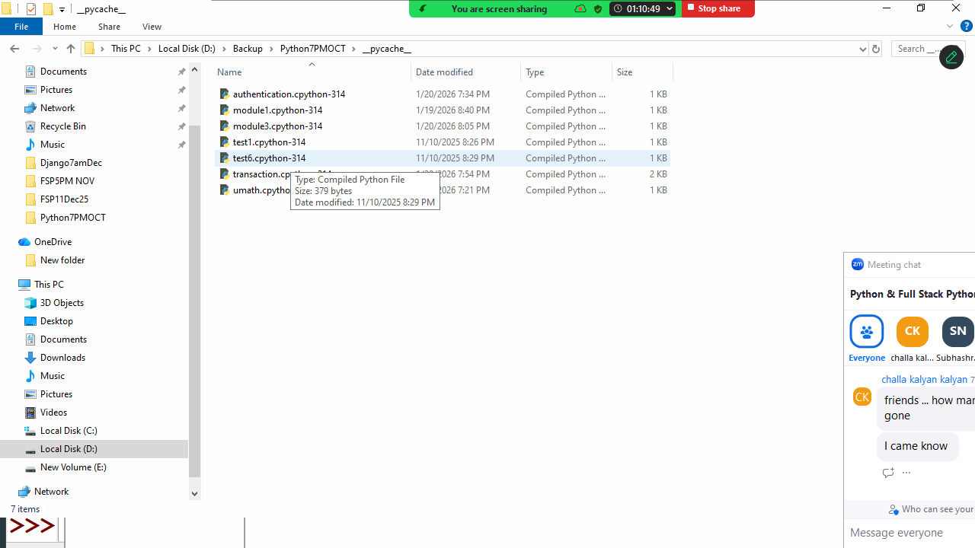

Package

What is package?
A package is collection of modules (.py)
A package is folder which contains .py files.
Packing is nothing but grouping related modules inside one folder (package).

How to create package?
Creating package is nothing but creating folder.
To recognize this folder as package, it contains one special module __init__.py

Basic steps for creating package
- Create folder
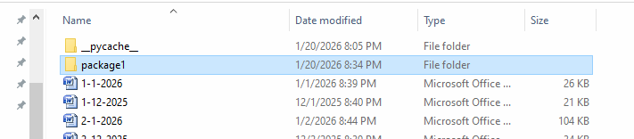
- Inside folder create a module with __init__.py
This is empty module.
It is called package configuration module or file.

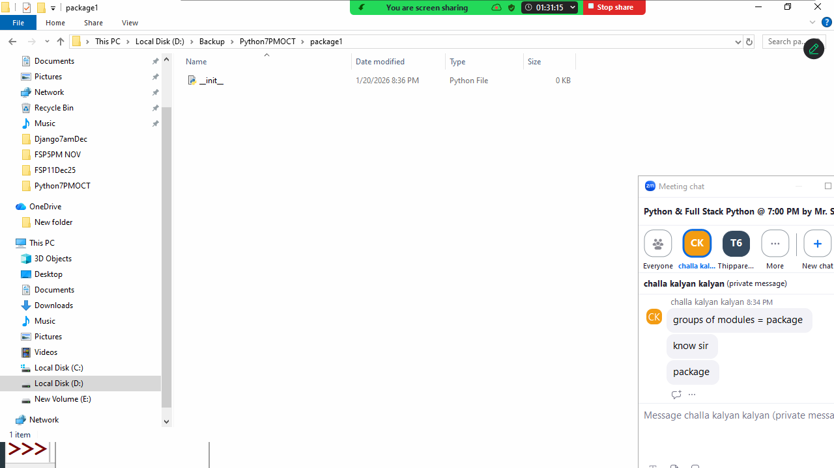
- Add another module inside package m1.py

m1.py
x=100
def fun1():
print("fun1 of m1 of package1")
def fun2():
print("fun2 of m1 of package1")

- Import m1 module outside the package. Create one module outside the package for testing

import package1.m1

package1.m1.fun1()
package1.m1.fun2()
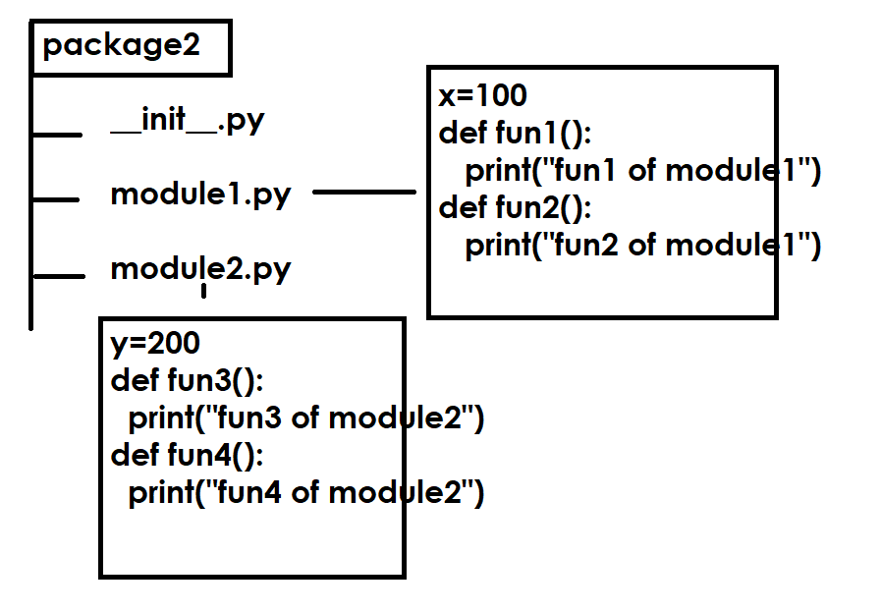
Write a program to use the content of package
import package2.module1
from package2 import module2
from package1.m1 import *
package2.module1.fun1()
package2.module1.fun2()
module2.fun3()
module2.fun4()
fun1()

Output
fun1 of module1 of package2
fun2 of module1 of package2
fun3 of module2 of package2
fun4 of module2 of package2
fun1 of m1 of package1

What is __init__.py?
__init__.py is called magic module and it is also called package configuration file or module.
This module is imported automatically when ever package is imported. This module is refers with package name.
This module is used for creating,
- Package level variables
- Package level functions
- Package level classes
- Hiding other modules and functionality

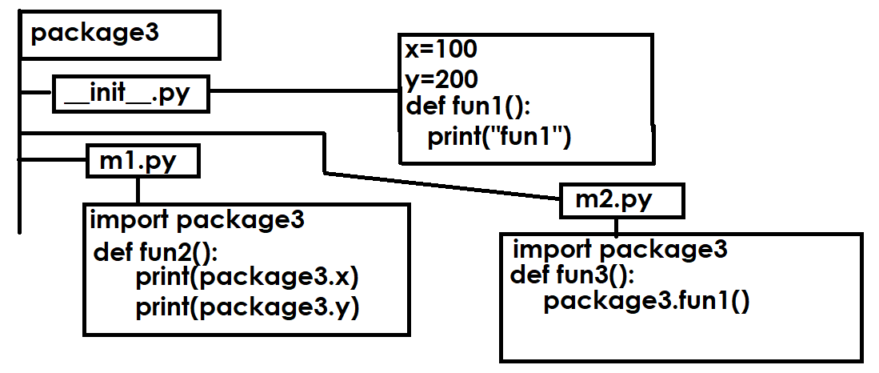
Write a program to test the package create a module outside the package

import package3
from package3 import m1,m2
print(package3.x)
print(package3.y)
package3.fun1()

m1.fun2()
m2.fun3()

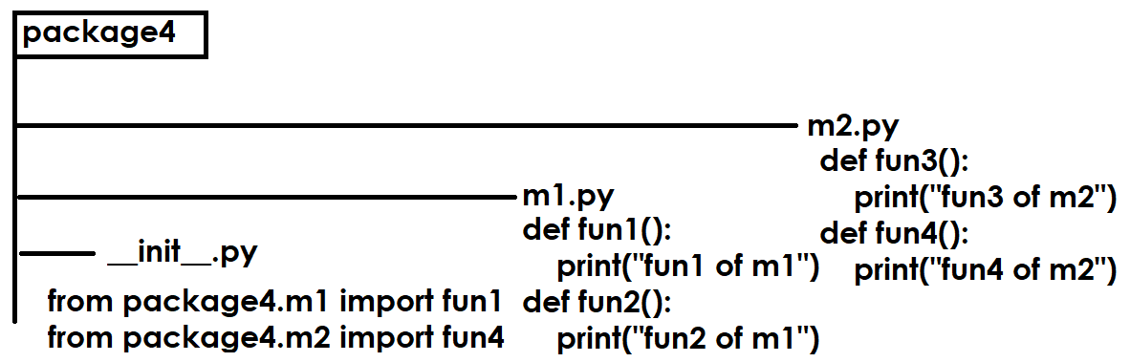

Write a program to test package, create program outside the package

import package4
package4.fun1()
package4.fun4()

Output
fun1 of m1
fun4 of m2

How to set module path?
sys.path
A list of strings that specifies the search path for modules. Initialized from the environment variable PYTHONPATH, plus an installation-dependent default.

Create a module and save in another location
In my system is saved inside d:\\backup

xmodule.py
def fun1():
print("fun1")

write a program to test, create this in other location
ptest.py
import sys
sys.path.append("d:\\backup")
import xmodule

xmodule.fun1()

How to manage predefined packages?
Predefined packages can be managed by using a predefined tool provided by python.

PIP command
PIP stands for preferred installer program
PIP stands for python installer package

Python software does not provide all the predefined packages, it will provides only standard packages but not provide application specific packages (numpy, pandas, keras, scipy, matplotlib, django, flask ,…)

installing the package

pip install package-name

all predefined packages are exists in a repository called www.pypi.org (Python Package Index)

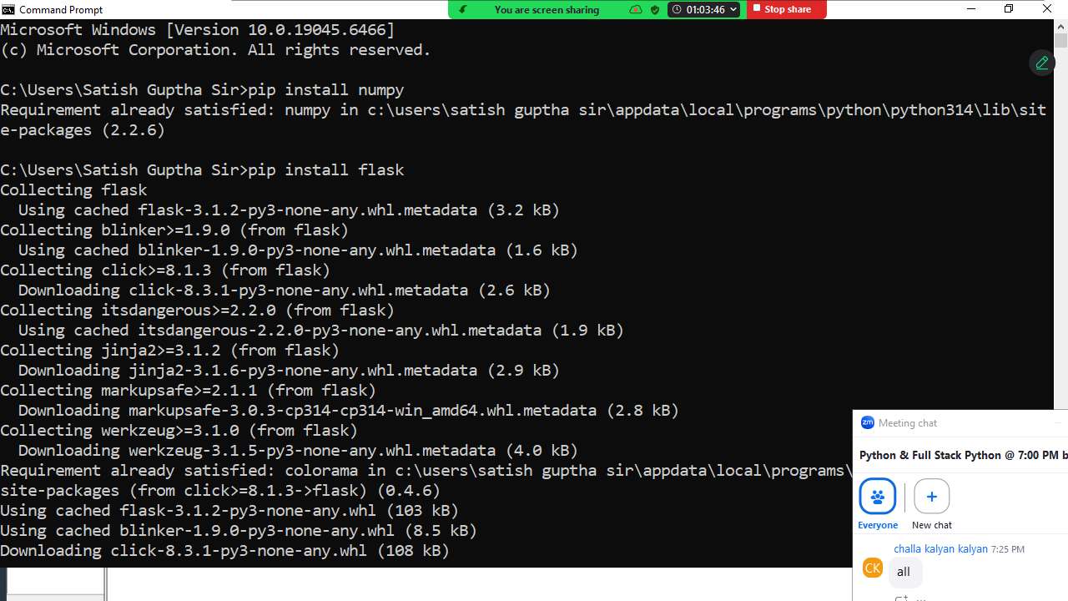

Listing installed packages

Installed packages can be viewed using,

Pip list

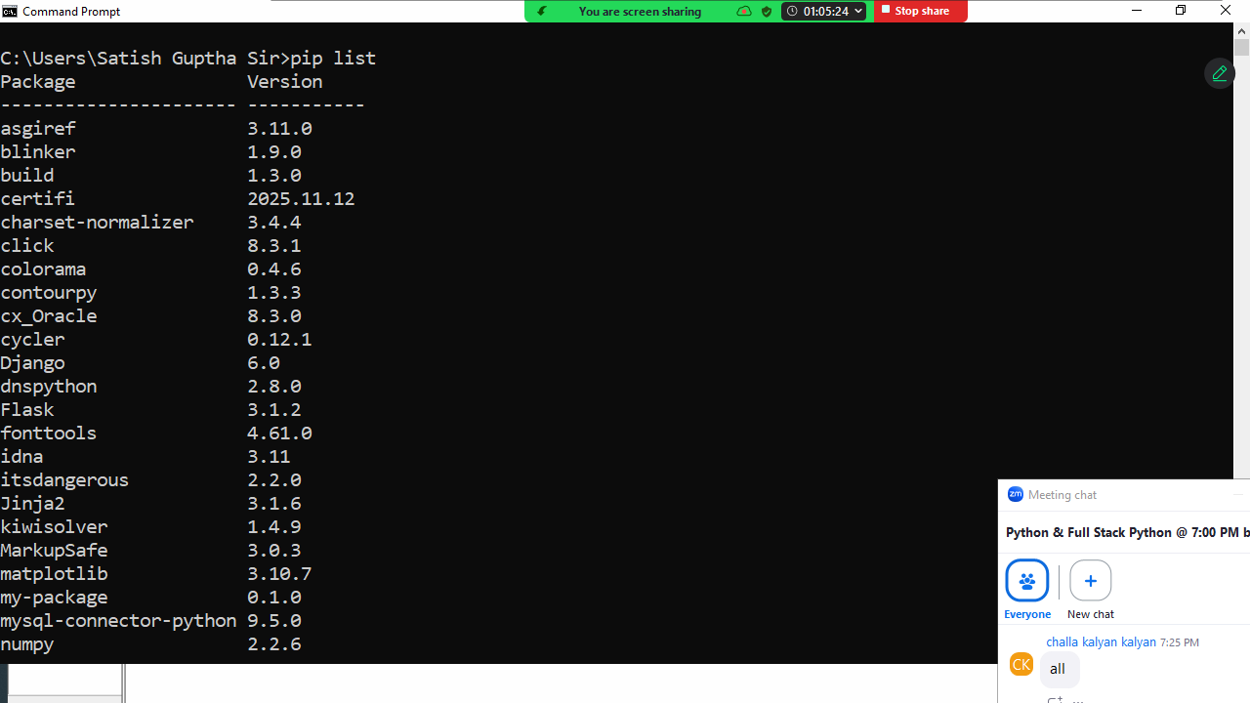

Uninstalling packages
Installed packages can be uninstalled using

pip uninstall packagename

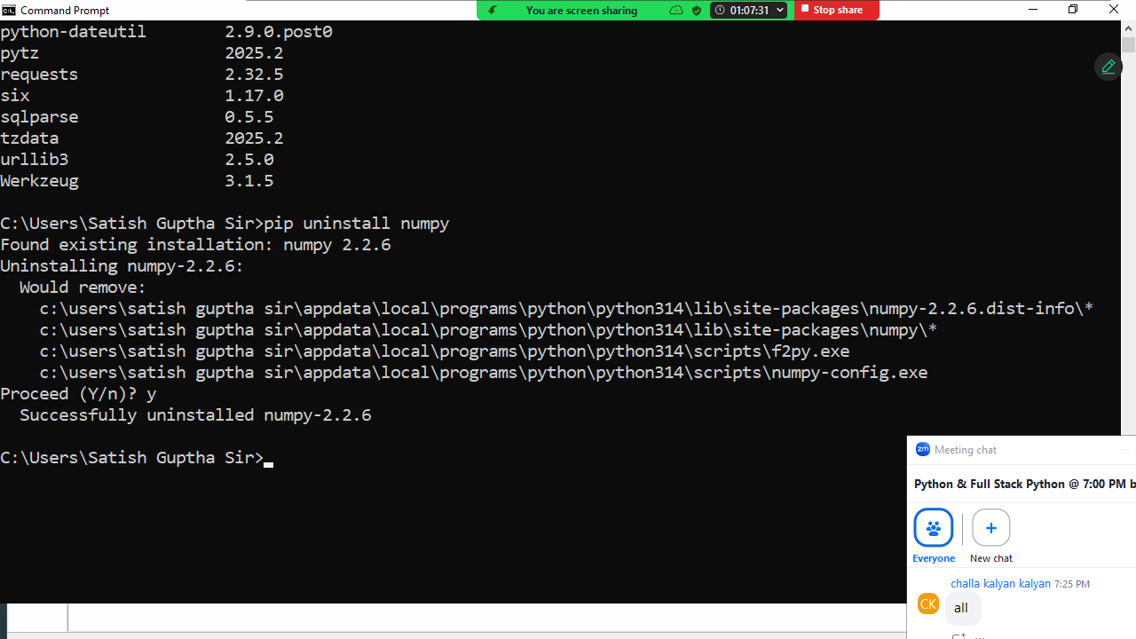

Displaying information about package

pip show package-name
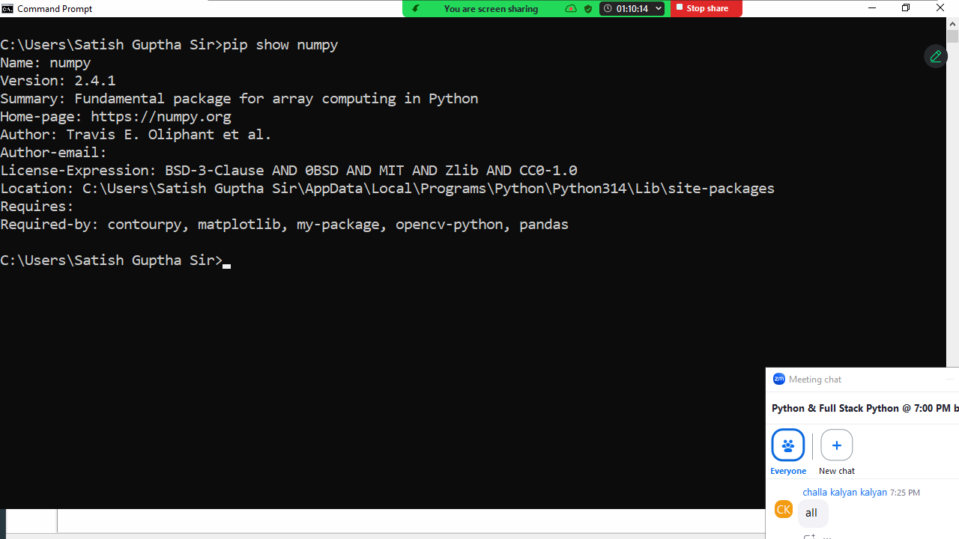

Object Oriented Programming (OOP)
The main objective of learning object oriented programming is creating user defined data types or building custom classes or data types.

Object Oriented Programming is not a language; it is a programming paradigm, which defines set of rules and regulations for building data types or classes.

Object oriented concepts
- Encapsulation
- Polymorphism
- Inheritance
- Abstraction
- Class
- Object

Python is object oriented programming language.
In object oriented programming languages data is represented as objects and every data type is class.

class
In object oriented programming a class represents data type.
Class is a collection of members and these members are 2 types
- Data members
- Member functions
Object Oriented Programming (OOP)
The main objective of learning object oriented programming is creating user defined data types or building custom classes or data types.

Object Oriented Programming is not a language; it is a programming paradigm, which defines set of rules and regulations for building data types or classes.

Object oriented concepts
- Encapsulation
- Polymorphism
- Inheritance
- Abstraction
- Class
- Object

Python is object oriented programming language.
In object oriented programming languages data is represented as objects and every data type is class.

class
In object oriented programming a class represents data type.
Class is a collection of members and these members are 2 types
- Data members
- Member functions
Defining class is nothing creating or developing one data type.
Data members are nothing but fields/attributes which define the properties of object (OR) data members are nothing but variables which hold data.
Member functions: a function defined inside class member function or method. Member functions define behavior or functionality of object.
Class is a blueprint of object
Class define the structure object
Class contains meta data (it describe about data/object)

Class allocates memory for object
Class encapsulate with data members and member functions.
Syntax:
class class-name/data-type-name:
DataMembers/Variables
MemberFunctions/Methods

object
object is an instance of a class
in object oriented programming data is represented as objects
These objects are created using class.

Syntax: object-name=class-name()

Whenever object is created it allocates for data members of the class.

Encapsulation
Encapsulation is process of grouping data members and member functions which operate on data members into single unit (class).
Binding data members with related member functions is called encapsulation.

Advantage
- Data Hiding: Preventing data access from unrelated operations is called data hiding. This allows to develop secured application
- Binding or organizing: allows organizing data members with related member functions.
- Modularity :dividing data and functionality into small pieces called class
- Reusability: Code and Data reusability

Member Functions/Methods
A function defined inside the class is called member function or method. This function define the behavior of object (OR) functionality of object.

The methods defined inside class are 3 types.
- Instance methods
- Class methods
- Static methods

Instance method
A method defined inside class with first parameter “self” is called instance method.
This method is accessible or binds with object name.
This method cannot call without creating object (OR) this method is called with object name.

class class-name:
def method-name(self,param,param,…):
statement-1
statement-2

“self” parameter name/local variable.
“self” refer to object (OR) “self” variable hold address of object which it is bind.

Example:
class Person:
def eat(self):
print("inside eat method")
def walk(self):
print("inside walk method")

ramu=Person()
ramu.eat()
ramu.walk()
kiran=Person()
kiran.eat()
kiran.walk()
#Person.eat()

a=list()
a.append(10)
b=list()
b.append(100)
#list.append(10)

Output
inside eat method
inside walk method
inside eat method
inside walk method

An instance method can be defined,
- Without parameters
- With parameters

Instance method with parameters
Instance method parameters receive values.

class Calculator:
def add(self,a,b):
print(self)
return a+b
def sub(self,a,b):
print(self)
return a-b

calc1=Calculator()
print(calc1)
res1=calc1.add(10,20)
res2=calc1.sub(10,5)
print(res1,res2)

Output
<__main__.Calculator object at 0x0000027F71B057F0>
<__main__.Calculator object at 0x0000027F71B057F0>
<__main__.Calculator object at 0x0000027F71B057F0>
30 5

Example:
class Robo:
def talk(self,msg):
print(f'Message :{msg}')

robo1=Robo()
robo1.talk("Hello Pythonist")
robo1.talk("Python is Simple")

Output
Message :Hello Pythonist
Message :Python is Simple

Example:
class Stack:
def push(self):
print("push method")
def pop(self):
print("pop method")

stack1=Stack() # Creating object
stack1.push()
stack1.pop()
stack2=Stack()
stack2.push()
stack2.pop()

Output
push method
pop method
push method
pop method
Data Member OR Properties OR Fields OR Attributes

The variables defined inside are called data members or properties of object.
The variables defined inside class are 2 types
- Instance Variables
- Class Variables

Instance variables
Instance variables are called object level variables.
These variables memory is allocated within object.
These variables define the properties of the object.

How to create instance variables?
- After Creating
- Within class

Creating instance variable after creating object OR outside the class
This is done in different ways
- object-name.instance-variable=value

if instance variable not exists within object, python creating instance variable within object and assign value
if instance variable exists within object, it modify or update the value.
This approach is used to add dynamically instance variables within object.

Example:
class Student:
pass

stud1=Student()
stud1.rollno=1
stud1.name="naresh"
print(stud1.rollno,stud1.name)
stud1.rollno=2
print(stud1.rollno,stud1.name)
stud2=Student()
stud2.rollno=3
stud2.name="suresh"
print(stud2.rollno,stud2.name)
stud3=Student()
stud3.rollno=4
stud3.name="kishore"
print(stud3.rollno,stud3.name)

Output
1 naresh
2 naresh
3 suresh
4 kishore

- object-name.__dict__={‘key’:value,’key’:value,…}

Key is nothing but instance variable
Value is variable of that instance variable

class Employee:
pass

emp1=Employee()
emp1.__dict__={'empno':1,'ename':'naresh'}
print(emp1.empno,emp1.ename)
emp2=Employee()
emp2.__dict__={'empno':2,'ename':'suresh'}
print(emp2.empno,emp2.ename)

Output
1 naresh
2 suresh

Defining instance variables within class
Inside the class instance variables bind with “self”.
Instance variables are created or accessed within instance method.

class class-name/datatype-name:
def instance-method(self,..):
self.variable-name=value
self.variable-name=value

Example:
class Student:
def store_data(self):
self.rollno=0
self.name=None

stud1=Student()
stud1.store_data()
print(stud1.rollno,stud1.name)
stud2=Student()
stud2.store_data()
print(stud2.rollno,stud2.name)

Output
0 None
0 None

Constructor
Constructor is a special instance method
Constructor is a magic method. This method is executed automatically on creation of object.
In application development constructor is used for creating instance variables (OR) block of code which has to be executed on creation of object is defined inside constructor.

Constructor is predefined method whose name is __init__
Constructor is used for object initialization.

Syntax:
class class-name/data-type:
def __init__(self,param,param,param,..):
self.instance-variable=value
self.instance-variable=value
self.instance-variable=value

Example:
class Date:
def __init__(self):
self.day=0
self.month=0
self.year=0

doj=Date()
print(doj.day,doj.month,doj.year)
dob=Date()
print(dob.day,dob.month,dob.year)
comp1=complex()
print(comp1.real,comp1.imag)

Output
0 0 0
0 0 0
- 0.0

Constructor can be defined,
- Without parameters
- With parameters

Constructor without parameters does not receive values at the time of creating object.
Constructor with parameters receives values at the time of creating object.

Example:
class Employee:
def __init__(self):
self.empno=1
self.ename="naresh"
self.job="manager"
self.salary=5000

emp1=Employee()
print(emp1.empno,emp1.ename,emp1.job,emp1.salary)
emp2=Employee()
print(emp2.empno,emp2.ename,emp2.job,emp2.salary)

Output
1 naresh manager 5000
1 naresh manager 5000

Example:
class Student:
def __init__(self,r,n,c):
self.rollno=r
self.name=n
self.course=c

stud1=Student(101,"naresh","python")
stud2=Student(102,"suresh","java")
print(stud1.rollno,stud1.name,stud1.course)
print(stud2.rollno,stud2.name,stud2.course)
print(stud1)
print(stud2)
comp1=complex()
print(comp1)

Output
101 naresh python
102 suresh java
<__main__.Student object at 0x00000200E0D257F0>
<__main__.Student object at 0x00000200E0C54B90>
Example:
class Complex:
def __init__(self):
self.real=0.0 # Instance Variable
self.imag=0.0 # Instance Variable

comp1=Complex()
print(comp1.real,comp1.imag)
comp2=complex()
print(comp2.real,comp2.imag)

Output
0.0 0.0
0.0 0.0

Example:
class Customer:
#Constructor with parameters
def __init__(self,a,cn,b):
self.accno=a
self.cname=cn
self.balance=b

cust1=Customer(101,"naresh",5000)
cust2=Customer(102,"suresh",6000)
print(cust1.accno,cust1.cname,cust1.balance)
print(cust2.accno,cust2.cname,cust2.balance)

Output
101 naresh 5000
102 suresh 6000

Constructor is used only for initialization and initialization is done only one time at the time of creating object. Constructor executed only once.
After initialization in order to perform other operations, it is done using instance methods. Instance methods operate on instance variables or object level variables or data members.

Example:
class Customer:
#Constructor with parameters
def __init__(self,a,cn,b):
self.accno=a
self.cname=cn
self.balance=b
def print_customer(self): # instance method
print(self.accno,self.cname,self.balance)

cust1=Customer(101,"naresh",5000)
cust2=Customer(102,"suresh",6000)
cust1.print_customer()
cust2.print_customer()

Output
101 naresh 5000
102 suresh 6000

Example:
class Triangle:
def __init__(self,b,h):
self.base=b
self.height=h
def find_area(self):
a=self.base*self.height*0.5
return a

t1=Triangle(1.5,1.2)
area1=t1.find_area()
print(f'Area of triangle is {area1:.2f}')
t2=Triangle(1.2,1.9)
area2=t2.find_area()
print(f'Area of triangle is {area2:.2f}')

Output
Area of triangle is 0.90
Area of triangle is 1.14

Instance method defines behavior or operations object.

Example:
class Account:
def __init__(self,a,cn,b):
self.accno=a
self.cname=cn
self.balance=b
def deposit(self,t):
self.balance=self.balance+t
def withdraw(self,t):
if t<self.balance:
self.balance=self.balance-t
else:
print("insuff balance")
def print_details(self):
print(f'''AccountNo {self.accno}
CustomerName {self.cname}
Balance {self.balance}''')

acc1=Account(1,"naresh",50000)
acc1.print_details()
acc1.deposit(10000)
acc1.print_details()
acc1.withdraw(20000)
acc1.print_details()

Output
AccountNo 1
CustomerName naresh
Balance 50000
AccountNo 1
CustomerName naresh
Balance 60000
AccountNo 1
CustomerName naresh
Balance 40000

The advantage of encapsulation is data hiding
Preventing data access from unrelated operations is called data hiding (The functions defined outside the class)

Access specifiers or Modifiers
Access modifiers define the accessibility of member of the class.
Python support 3 access modifiers
- Private
- Public
- Protected

 | Private | Protected | Public
Within Class | YES | YES | YES
Within Child Class/Sub Class | NO | YES | YES
Outside the class | NO | NO | YES

Private members of class are prefix __ (double underscore)
Protected members of class prefix _ (single underscore)
Public members of class are not prefix any thing

Example:
class Alpha:
def __m1(self):
print("private m1 method")
def m2(self):
print("public m2 method")
self.__m1()

obj1=Alpha()
#obj1.__m1()
obj1.m2()

Output
public m2 method
private m1 method

Example:
class Beta:
def __init__(self):
self.x=100 #public
self.__y=200 #private

obj1=Beta()
print(obj1.x)
print(obj1.__y)

Output
100
Traceback (most recent call last):
File "D:/Backup/Python7PMOCT/ooptest17.py", line 10, in <module>
print(obj1.__y)
AttributeError: 'Beta' object has no attribute '__y'

Data hiding in object oriented is done by declaring variables/data members as private.

Example:
class Student:
def __init__(self,r,n,c):
self.__rollno=r
self.__name=n
self.__course=c
def print_student(self):
print(f'''Rollno {self.__rollno}
StudentName {self.__name}
StudentCourse {self.__course}''')

stud1=Student(1,"kishore","c++")
#print(stud1.__rollno)
stud1.print_student()
stud2=Student(2,"ramesh","python")
stud2.print_student()

Output
Rollno 1
StudentName kishore
StudentCourse c++
Rollno 2
StudentName ramesh
StudentCourse python

Example:
class Rectangle: # Data Type
def __init__(self,l=0.0,b=0.0):
self.__length=l # Instance Variable
self.__breadth=b # Instance Variable
def find_area(self): # Instance Method
return self.__length*self.__breadth
def set_length(self,l): # Instance Method
self.__length=l
def set_breadth(self,b): # Instance Method
self.__breadth=b

rect1=Rectangle()
area1=rect1.find_area()
print(area1)
rect2=Rectangle(1.5,1.2)
area2=rect2.find_area()
print(area2)
rect1.set_length(2.0)
rect1.set_breadth(2.5)
area1=rect1.find_area()
print(area1)

Output
0.0
1.7999999999999998
5.0

Instance methods perform 2 operations
- Setter operation
- Getter operation

An operation which modifies or updates values of object is called setter operation.
An operation which does not modifies or updates values of object is getter operation.

class Player:
def __init__(self):
self.__name=None
self.__score=0
def setName(self,n):
self.__name=n
def setScore(self,s):
self.__score=s
def getName(self):
return self.__name
def getScore(self):
return self.__score

#Read Details of n players and display
players=[]
n=int(input("How many Players?"))
for i in range(n):
pname=input("PlayerName :")
pscore=int(input("PlayerScore :"))
p=Player()
p.setName(pname)
p.setScore(pscore)
players.append(p)

tot=0
for p in players:
tot=tot+p.getScore()
print(p.getName(),p.getScore())

print(f'Total Score {tot}')

Output
How many Players?2
PlayerName :sharma
PlayerScore :50
PlayerName :surya
PlayerScore :90
sharma 50
surya 90
Total Score 140

Class Level Variable OR class Variable
Class Level Variable OR class Variable
Variables defined inside the class are 2 types
- Instance variables
- Class level variables

Inside the class instance variables bind with “self”. Instance variables are accessible or manipulated only inside instance method.

The variables declared inside the class and outside the methods of the class are called class level variables.
These variables bind with class name and can be accessible without creating object.
Class level variables are global variables, which are global to more than one object.
Class level variables define the common property, which is common for more than one object.

Syntax:
class class-name:
class-variable-name=value
class-variable-name=value
def __init__(self):
self.instance-variable=value
self.instance-variable=value

Example:
class A:
x=100 #class level variable
def __init__(self):
self.y=200 #instance variable

print(A.x)
obj1=A()
print(obj1.y)

Output
100
200

Class level variables memory is allocated only once. The variable value is shared by all the objects.

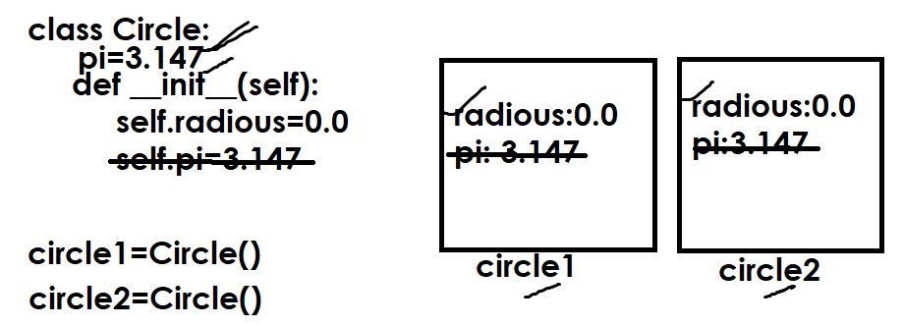

class Circle:
pi=3.14
def __init__(self,r):
self.__radious=r
def findArea(self):
area=Circle.pi*self.__radious*self.__radious
return area

circle1=Circle(1.5)
circle2=Circle(2.4)
area1=circle1.findArea()
area2=circle2.findArea()
print(f'Area of circle1 is {area1:.2f}')
print(f'Area of circle2 is {area2:.2f}')

Output
Area of circle1 is 7.06
Area of circle2 is 18.09

Example:
class Account:
min_balance=5000
def __init__(self,a,cn,b):
self.__accno=a
self.__cname=cn
self.__balance=b
def printAccount(self):
print(f'AccountNo {self.__accno}')
print(f'CustomerName {self.__cname}')
print(f'Balance {self.__balance}')
def deposit(self,t):
self.__balance+=t
def withdraw(self,t):
if t>(self.__balance-Account.min_balance):
print("Insuff Balance")
else:
self.__balance-=t

acc1=Account(101,"suresh",45000)
acc2=Account(102,"ramesh",55000)
acc1.printAccount()
acc2.printAccount()
acc1.deposit(10000)
acc2.withdraw(20000)
acc1.printAccount()
acc2.printAccount()

Output
AccountNo 101
CustomerName suresh
Balance 45000
AccountNo 102
CustomerName ramesh
Balance 55000
AccountNo 101
CustomerName suresh
Balance 55000
AccountNo 102
CustomerName ramesh
Balance 35000

Class level method
A method defined inside class with first parameter “cls” is called class level method. This method is bind with class name and can be called without creating object.
Class level method is used to manipulate class level variable.
Class level method is defined with @classmethod decorator.

Syntax:
class class-name:
class-level-variable-name=value
class-level-variable-name=value
@classmethod
def method-name(cls,param1,param2,param3,..):
statement-1
statement-2

def __init__(self):
self.instance-variable-name=value
self.instance-variable-name=value
self.instance-variable-name=value
def instance-method-name(self,..):
statement-1
statement-2

Example:
class A:
@classmethod
def m1(cls):
print("class method")
def m2(self):
print("instance method")

A.m1()
obj1=A()
obj1.m2()

Output
class method
instance method

Example:
# Count of objects created using class

class Employee:
__count=0
@classmethod
def getCount(cls):
return Employee.__count
def __init__(self):
Employee.__count+=1

print(Employee.getCount())
emp1=Employee()
print(Employee.getCount())
emp2=Employee()
print(Employee.getCount())

Output
0
1
2

Example:
# class method cannot access instance variables

class A:
def __init__(self):
self.__x=100
@classmethod
def printX(cls):
print(self.__x)

A.printX()

Output
Error

The above code generates an error because of class method access only class level members but cannot access object level members.

What is difference between instance method and class method?

Instance methods | Class level methods
A method defined inside class with first parameter “self” is called instance method | A method defined inside class with first parameter “cls” is called class method and this method defined with @classmethod decorator
Instance method is called or bind with object name and can be called by creating object | Class method is bind with class name can be called without creating object.
Instance method access instance members and class members. | Class method is able to access only class members but cannot access instance members

Static method
A method defined within class without implicit first parameter is called static method. This method is defined with @staticmethod decorator.

Syntax:
class class-name:
class-variable-name=value
class-variable-name=value
@classmethod
def class-method-name(cls):
statement-1
statement-2
def __init__(self):
self.instance-variable-name=value
self.instance-variable-name=value
def instance-method(self):
statement-1
statement-2
@staticmethod
def static-method-name():
statement-1
statement-2

static method is bind with class name and can be invoked without creating object.

class A:
x=100 # class level variable
@classmethod
def c1(cls):
print(cls.x)
def __init__(self):
self.y=200
def m1(self):
print(self.y)
@staticmethod
def sm1():
print("static method")

A.c1()
A.sm1()
obj1=A()
obj1.m1()

Output
100
static method
200

Example:
class Math:
@staticmethod
def factorial(num):
fact=1
for i in range(1,num+1):
fact=fact*i
return fact
@staticmethod
def isprime(num):
c=0
for i in range(1,num+1):
if num%i==0:
c=c+1
return c==2

res1=Math.factorial(4)
res2=Math.isprime(5)
print(res1)
print(res2)

Output
24
True

Inheritance
Inheritance is a process of acquiring the properties and behavior of one class inside another class.
Inheritance is process of using the content (variables and methods) of one class inside another class.
Inheritance allows developing new data type using existing data type.
Inheritance allows grouping all the classes which share common properties and behavior into one type.

Advantage of inheritance
- Reusability
- Extensibility
- Modularity

Reusability: This allows to use the variables and methods of one class inside another class.
Extensibility: This allows to extend the functionality or features of existing class without modifying it
Modularity: allows dividing content into number of classes.
Inheritance
Inheritance is a process of acquiring the properties and behavior of one class inside another class.
Inheritance is process of using the content (variables and methods) of one class inside another class.
Inheritance allows developing new data type using existing data type.
Inheritance allows grouping all the classes which share common properties and behavior into one type.

Advantage of inheritance
- Reusability
- Extensibility
- Modularity

Reusability: This allows to use the variables and methods of one class inside another class.
Extensibility: This allows to extend the functionality or features of existing class without modifying it
Modularity: allows dividing content into number of classes.

Inheritance generate “is-a” relationship between classes.
Inheritance in Python is a fundamental concept in object-oriented programming (OOP) that allows a new class (the child class) to derive properties and behaviors from an existing class (the parent class). This promotes code reusability and helps structure code in a hierarchical manner.

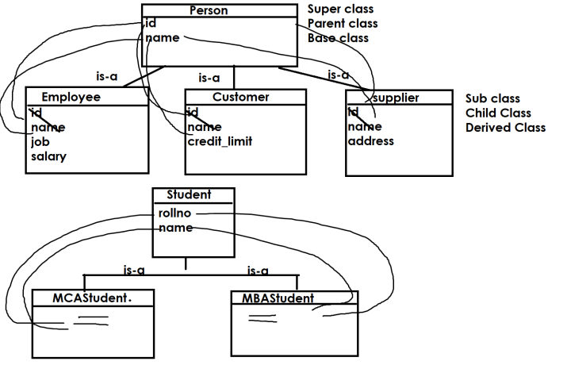
Based on the reusability and organization classes python support different types of inheritance
- Single Level Inheritance
- Multi Level Inheritance
- Multiple Inheritance
- Hierarchical Inheritance
- Hybrid Inheritance

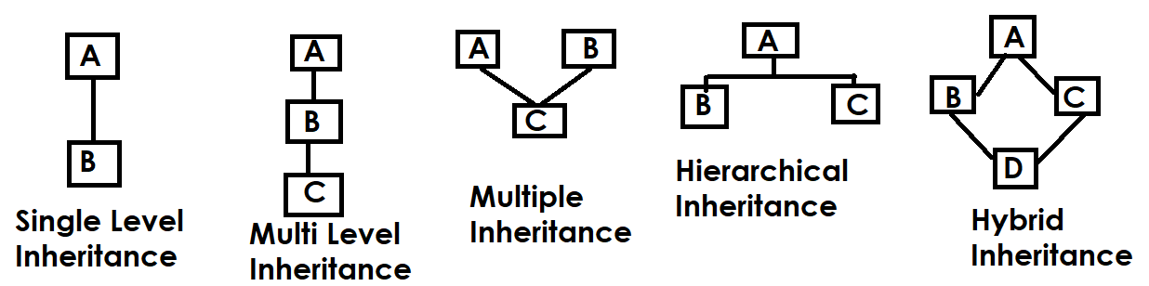

Syntax:
class derived-class-name(base-class-name,base-class-name,..):
variables
methods

Existing class is called base class (OR) parent class (OR) super class
The class which is created using existing class is called derived class (OR) child class (OR) sub class.

Single Level Inheritance
In single level inheritance there is one base class and derived class.

class A: # Parent Class
def m1(self):
print("m1 method of A class")
def m2(self):
print("m2 method of A class")

class B(A): # Child class
def m3(self):
print("m3 method of B class")

objb=B()
objb.m1()
objb.m2()
objb.m3()

Output
m1 method of A class
m2 method of A class
m3 method of B class

Methods of parent class or super class or base class are automatically inherited within child class or sub class or derived class.

class Parent:
def walk(self):
print("Parent Walk")

class Child(Parent):
def run(self):
print("Child Run")

c1=Child()
c1.walk()
c1.run()

Output
Parent Walk
Child Run

Example:
class A: # Parent class
def __init__(self):
self.x=100
self.y=200

class B(A): # Child class
def __init__(self):
A.__init__(self)
self.p=300
self.q=400

objb=B()
print(objb.p,objb.q)
print(objb.x,objb.y)

Output
300 400
100 200

The properties of parent class are not inherited automatically inside child class in order to inherit, child class constructor must call the constructor of parent class.

# Single Level Inheritance
class Person: # Super Class/Base class/Parent Class
def __init__(self):
self.__name=None
def setName(self,n):
self.__name=n
def getName(self):
return self.__name

class Student(Person): # Sub Class/Derived Class/Child Class
def __init__(self):
Person.__init__(self)
self.__course=None
def setCourse(self,c):
self.__course=c
def getCourse(self):
return self.__course

stud1=Student()
stud1.setName("Naresh")
stud1.setCourse("PYTHON")
print(f'{stud1.getName()},{stud1.getCourse()}')

Output
Naresh,PYTHON

Multi Level Inheritance
If a class is derived from another derived class, it is called multi level inheritance.

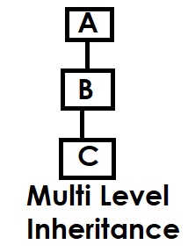

Example:
class A:
def m1(self):
print("m1 of A class")

class B(A):
def m2(self):
print("m2 of B class")

class C(B):
def m3(self):
print("m3 of C class")

objc=C()
objc.m1()
objc.m2()
objc.m3()

Output
m1 of A class
m2 of B class
m3 of C class

Example:
class Person: # Base class/Parent class
def __init__(self):
self.__name=None
def setName(self,n):
self.__name=n
def getName(self):
return self.__name

class Employee(Person): # Child class of Person/Parent class of Salaried Employee
def __init__(self):
Person.__init__(self)
self.__job=None
def setJob(self,j):
self.__job=j
def getJob(self):
return self.__job

class SalariedEmployee(Employee): # Child class
def __init__(self):
Employee.__init__(self)
self.__salary=None
def setSalary(self,s):
self.__salary=s
def getSalary(self):
return self.__salary

emp1=SalariedEmployee()
emp1.setName("Ramesh")
emp1.setJob("HR")
emp1.setSalary(45000)
print(f'{emp1.getName()},{emp1.getJob()},{emp1.getSalary()}')

Output
Ramesh,HR,45000

Multiple Inheritance
If a class is derived from more than one base class is called multiple inheritance.

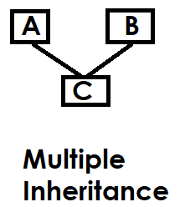

class A:
def m1(self):
print("m1 of A class")

class B:
def m2(self):
print("m2 of B class")

class C(A,B):
def m3(self):
print("m3 of C class")

objc=C()
objc.m1()
objc.m2()
objc.m3()

Output
m1 of A class
m2 of B class
m3 of C class

# Multiple Inheritance
class Person:
def __init__(self):
self.__name=None
def setName(self,n):
self.__name=n
def getName(self):
return self.__name

class Account:
def __init__(self):
self.__accno=None
def setAccno(self,ac):
self.__accno=ac
def getAccno(self):
return self.__accno

class SavingAccount(Person,Account):
def __init__(self):
Person.__init__(self)
Account.__init__(self)
self.__balance=None
def setBalance(self,b):
self.__balance=b
def getBalance(self):
return self.__balance

acc1=SavingAccount()
acc1.setAccno(1)
acc1.setName("Ramesh")
acc1.setBalance(45000)
print(f'''AccountNo {acc1.getAccno()}
CustomerName {acc1.getName()}
CustomerBalance {acc1.getBalance()}''')

Output
AccountNo 1
CustomerName Ramesh
CustomerBalance 45000

Inheritance allows to develop similar data types
In inheritance super class is called generalized class (which is developed based on commonality)
The class which is inherited from generalized class is called specialized class.

Hierarchical inheritance
If more than one class derived from same base class, it is called hierarchical inheritance.

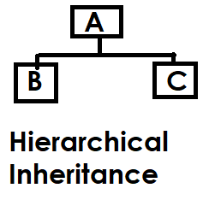

Example:
# Hierarchical Inheritance

class Person:
def __init__(self):
self.__name=None
def setName(self,n):
self.__name=n
def getName(self):
return self.__name

class Employee(Person):
def __init__(self):
Person.__init__(self)
self.__job=None
def setJob(self,j):
self.__job=j
def getJob(self):
return self.__job

class Customer(Person):
def __init__(self):
Person.__init__(self)
self.__creditlimit=None
def setCreditLimit(self,c):
self.__creditlimit=c
def getCreditLimit(self):
return self.__creditlimit

emp1=Employee()
cust1=Customer()
emp1.setName("ramesh")
emp1.setJob("HR")
cust1.setName("kishore")
cust1.setCreditLimit(45000)
print(f'''EmployeeDetails
EmploeeName :{emp1.getName()}
EmployeeJob :{emp1.getJob()}''')
print(f'''CustomerDetails
CustomerName :{cust1.getName()}
CustomerCreditlimit :{cust1.getCreditLimit()}''')

Output
EmployeeDetails
EmploeeName :ramesh
EmployeeJob :HR
CustomerDetails
CustomerName :kishore
CustomerCreditlimit :45000

Hybrid Inheritance
Organizing of classes using more than one type of inheritance is called hybrid inheritance

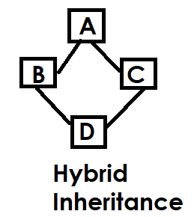

# Hybrid Inheritance

class A:
def m1(self):
print("m1 of A")

class B(A):
def m2(self):
print("m2 of B")
class C(A):
def m3(self):
print("m3 of C")
class D(B,C):
def m4(self):
print("m4 of D")

objd=D()
objd.m1()
objd.m2()
objd.m3()
objd.m4()

Output
m1 of A
m2 of B
m3 of C
m4 of D

Polymorphism

“Poly” means many and “morphism” is forms
Defining one thing in many forms is called polymorphism.
Polymorphism allows reusability and extensibility.
Python supports 2 types of polymorphism
- Method Overriding
- Operator Overloading

Method Overriding
Defining method in subclass with same signature (name, parameters) of method exists in super class is called method overriding.
(OR) defining method in sub class with same name and parameters of method exists in super class is called method overriding.
Method is override to modify or extend functionality of base class method within derived class.
Polymorphism

“Poly” means many and “morphism” is forms
Defining one thing in many forms is called polymorphism.
Polymorphism allows reusability and extensibility.
Python supports 2 types of polymorphism
- Method Overriding
- Operator Overloading

Method Overriding
Defining method in subclass with same signature (name, parameters) of method exists in super class is called method overriding.
(OR) defining method in sub class with same name and parameters of method exists in super class is called method overriding.
Method is override to modify or extend functionality of base class method within derived class.

class A: # Parent Class  def m1(self): # Overriden method  print("m1 method of A")  class B(A): # Child Class  def m2(self):  print("m2 method of B")  def m1(self): # Overriding method  print("overriding method")  objb=B()  objb.m1()  objb.m2() | Output  overriding method  m2 method of B
class Parent:  def eat(self): # Overriden method  print("Eat Veg")  class Child(Parent):  def eat(self): # Overriding method  print("Eat Non Veg")  child1=Child()  child1.eat() | Output  Eat Non Veg
class Parent:  def eat(self): # Overriden method  print("Eat Veg")  class Child(Parent):  def eat(self): # Overriding method  Parent.eat(self) # including functionality of parent  print("Eat Non Veg")  child1=Child()  child1.eat() | Output  Eat Veg  Eat Non Veg
class Person:  def __init__(self):  self.__name=None  def read(self):  self.__name=input("Enter Name :")  def print_info(self):  print(f'Name :{self.__name}')  class Student(Person):  def __init__(self):  Person.__init__(self)  self.course=None  def read(self): # Overriding method  super().read()  self.__course=input("Enter Course :")  def print_info(self): # Overriding method  super().print_info()  print(f'Course :{self.__course}')  stud1=Student()  stud1.read()  stud1.print_info() | Output  Enter Name :naresh  Enter Course :python  Name :naresh  Course :python

super()
super() is a type, which return reference or object of super class.
This super() is used within subclass to refer members of super class.

super().member-name (data member/member function)

Method overriding allows modify or extend functionality of super class methods within subclass.

object class
Every class in python automatically inherits a class called object.
“object” is root class or base class for all the classes in python.
Object class provides magic methods and these methods get executed automatically when performed certain operations on object.

Example:
class A:
pass

X=dir(A)
print(X)

Output
['__class__', '__delattr__', '__dict__', '__dir__', '__doc__', '__eq__', '__firstlineno__', '__format__', '__ge__', '__getattribute__', '__getstate__', '__gt__', '__hash__', '__init__', '__init_subclass__', '__le__', '__lt__', '__module__', '__ne__', '__new__', '__reduce__', '__reduce_ex__', '__repr__', '__setattr__', '__sizeof__', '__static_attributes__', '__str__', '__subclasshook__', '__weakref__']

Any name prefix and suffix with double underscore are called magic members (variables/methods).
These methods are used python runtime or functions to perform certain operations.

__new__(*args,**kwargs)

In python object is created by invoking new method of object class.
The method is executed before calling constructor
This method create object and return to constructor.
__new__ method can be override to customize the functionality of creating object.

Example:
# override __new__ method
class Student:
c=0
def __new__(*args,**kwargs): # Overriding Method
obj=object.__new__(Student)
Student.c+=1
if Student.c==1:
return obj
else:
return None
def __init__(self,r,n):
self.__rollno=r
self.__name=n

stud1=Student(1,"naresh")
stud2=Student(2,"suresh")
stud3=Student(3,"ramesh")
print(stud1)
print(stud2)
print(stud3)

Output
<__main__.Student object at 0x00000270F6925940>
None
None

__str__()
This method returns string representing of object.
This method is called automatically whenever str() or print function is called on object.

class Employee:
def __init__(self,e,en):
self.__empno=e
self.__ename=en
def __str__(self): # Overriding method
return f'{self.__empno},{self.__ename}'

emp1=Employee(1,"naresh")
print(emp1)
s1=str(emp1) # emp1.__str__()
print(s1,type(s1))

Operator Overloading (Polymorphism)
Operator overloading allows to define operators for user defined data types.
For every operator there is a magic method provided by object class.
Implementing magic methods (OR) operator methods of object class within user defined class is operator overloading.

Operator | Magic method
+ | __add__
- | __sub__
* | __mul__
/ | __div__
// | __floordiv__
> | __gt__
< | __lt__
>= | __ge__
<= | __le__
== | __eq__

Example:
class Marks:
def __init__(self,n,s1,s2):
self.__name=n
self.__sub1=s1
self.__sub2=s2
def __eq__(self,other): #Operator Overloading
if self.__sub1==other.__sub1 and self.__sub2==other.__sub2:
return True
else:
return False

stud1=Marks("naresh",50,60)
stud2=Marks("suresh",50,60)
b=stud1==stud2 # stud1.__eq__(stud2)
print(b)

Output
True

Example:
class Complex:
def __init__(self,r=0.0,i=0.0):
self.__real=r
self.__imag=i

def __add__(self,other): # + operator overloaded
t=Complex()
t.__real=self.__real+other.__real
t.__img=self.__imag+other.__imag
return t
def __sub__(self,other): # - operator overloaded
t=Complex()
t.__real=self.__real-other.__real
t.__imag=self.__imag-other.__imag
return t
def __str__(self): # overriding method
return f'{self.__real,self.__imag}'

comp1=Complex(1.2,1.5)
comp2=Complex(1.0,0.5)
comp3=comp1+comp2
comp4=comp1-comp2
print(comp1,comp2,comp3,comp4,sep="\n")
#comp5=comp1*comp2

Output
(1.2, 1.5)
(1.0, 0.5)
(2.2, 0.0)
(0.19999999999999996, 1.0)

Abstract classes and abstract methods (abc module)

“abc” is a standard module provided by python.
“abc” module provides the functionality to work with abstract classes and abstract methods.

What is abstract class?
A class derived from ABC class of abc module is called abstract class.
Abstract class defines set of rules and regulations or abstracts to develop class.
Abstract class define a protocol (rules and regulations)
Abstract class is collection of abstract methods and non abstract method.

What is an abstract method?
An abstract method defines protocol, which has to be implemented by every subclass or child class.
Method without implementation is called abstract method
An empty method is called abstract method
These abstract methods are defined inside abstract class.

Syntax:
class abstract-class-name(abc.ABC):
@abc.abstractmethod
def abstract-method-name(self,param,param,..):
pass
def method-name(self,param,param):
statement-1
statement-2

abstract class is an ADT (abstract data type), which allows to build similar data types.
The class which inherits abstract lass and provides implementation of abstract methods is called concrete class.
Abstract class is inherited but cannot create object of abstract class.
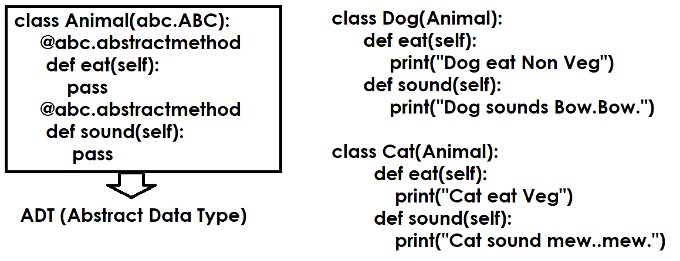
In application development abstract method is used when more than one method provides similar role with different implementation.
Abstract method must override by implemented class or inherited class.

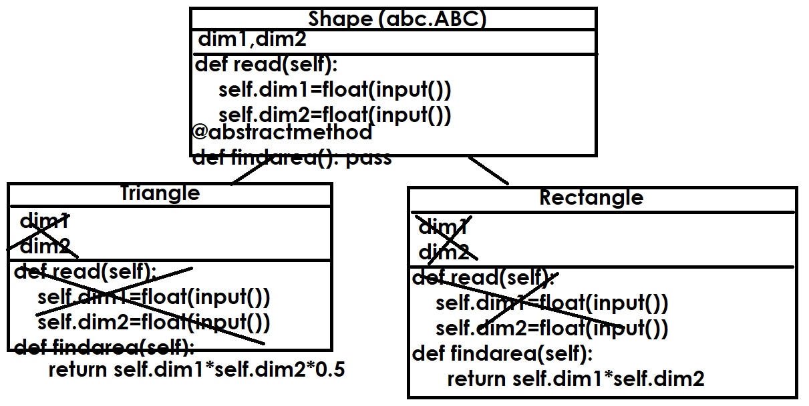
Example:
import abc
class Shape(abc.ABC):
def __init__(self):
self._dim1=None
self._dim2=None
def readDim(self):
self._dim1=float(input("Dim1 :"))
self._dim2=float(input("Dim2 :"))
@abc.abstractmethod
def findArea(self):
pass

class Triangle(Shape):
def findArea(self): # Overiding Method
return self._dim1*self._dim2*0.5

class Rectangle(Shape):
def findArea(self): # Overriding Method
return self._dim1*self._dim2

#s1=Shape()
t1=Triangle()
r1=Rectangle()
t1.readDim()
area1=t1.findArea()
r1.readDim()
area2=r1.findArea()
print(f'Area of Triangle is {area1}')
print(f'Area of Rectangle is {area2}')

Output
Dim1 :1.2
Dim2 :1.5
Dim1 :1.5
Dim2 :1.8
Area of Triangle is 0.8999999999999999
Area of Rectangle is 2.7

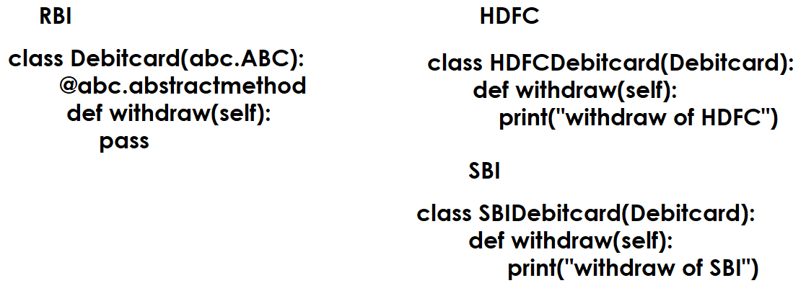
An abstract class which consists of only abstract methods is called interface (OR) interface is pure abstract class.

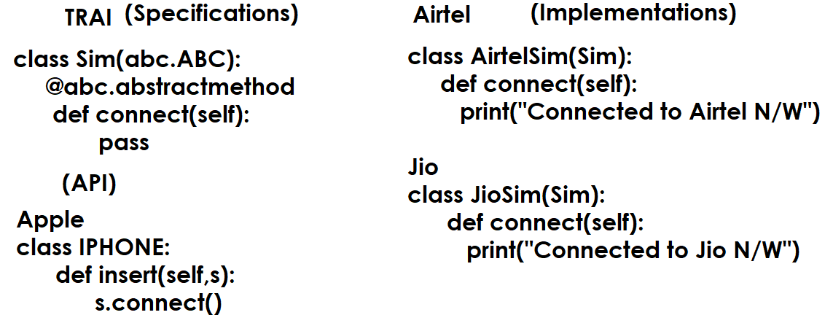

Example:
import abc
class Sim(abc.ABC):
@abc.abstractmethod
def connect(self):
pass

class AirtelSim(Sim):
def connect(self):
print("Connects to Airtel N/W")

class JioSim(Sim):
def connect(self):
print("Connects to Jio N/W")

class IPhone:
def insert(self,s):
s.connect()

sim1=AirtelSim()
sim2=JioSim()
mobile1=IPhone()
mobile1.insert(sim1)
mobile1.insert(sim2)

Output
Connects to Airtel N/W
Connects to Jio N/W

Example
import abc
class Debitcard(abc.ABC):
@abc.abstractmethod
def withdraw(self):
pass

class HDFCDebitcard(Debitcard):
def withdraw(self):
print("withdraw from HDFC")

class SBIDebitcard(Debitcard):
def withdraw(self):
print("withdraw from SBI")

class ICICIATM:
def swap(self,d):
d.withdraw()

atm1=ICICIATM()
card1=HDFCDebitcard()
card2=SBIDebitcard()
atm1.swap(card1)
atm1.swap(card2)

using abstract classes and abstract methods we can achieve abstraction.

What is abstraction?
Abstraction is process of hiding implementation details from caller by giving only specifications.
Caller calls the implementations without knowing specifications.

- A person who develop abstracts
- A person who implements abstract
- A person who calls the implementations using abstracts

Python is dynamically typed programming language, the type of variable changes based on object assigned.
Because python is dynamically typed programming language, using this we can achieve runtime polymorphism.
In runtime polymorphism the behavior of reference variable changes based on the type of object assigned.

Object Oriented Programming
- Encapsulation
- Polymorphism
- Inheritance
- Class
- Object
- Abstraction

Exception Handling (OR) Error Handling

In application development we come across 3 types of errors.

Types of Errors
- Compile time Errors
- Logical Errors
- Runtime Errors

Compile time Errors
The errors which occur during compilation of program are called compile time errors. All syntax errors are called compile time errors.
If there is syntax error within program, program is not executed.

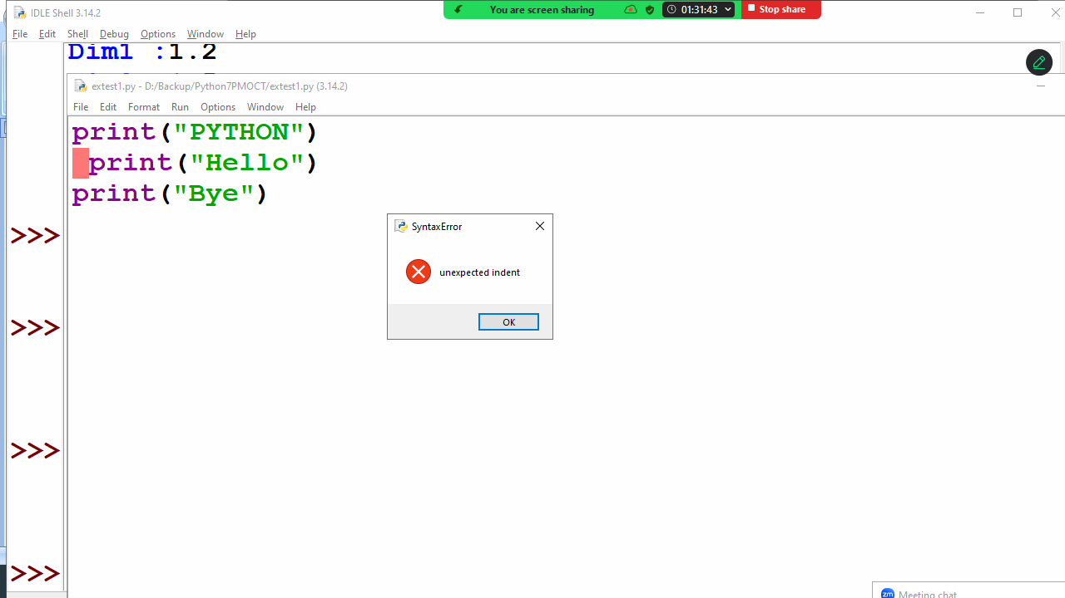
Syntax errors are rectified by programmer in order to execute program.

Logical Errors
A logical error is a programming logic error.
If there is logical error, program is executed but gives wrong result.

#Program to print sum of 2 numbers
n1=10
n2=5
n3=n1-n2 # Logical Error
print(n1,n2,n3)

Output
10 5 5

# finding max of two numbers
n1=10
n2=5
if n1>n2: # Logical Error
print(n2)
else:
print(n1)

Output
5

Logical errors are rectified by programmer in order to give accurate result.
Exception Handling (OR) Error Handling

In application development we come across 3 types of errors.

Types of Errors
- Compile time Errors
- Logical Errors
- Runtime Errors

Compile time Errors
The errors which occur during compilation of program are called compile time errors. All syntax errors are called compile time errors.
If there is syntax error within program, program is not executed.

Syntax errors are rectified by programmer in order to execute program.

Logical Errors
A logical error is a programming logic error.
If there is logical error, program is executed but gives wrong result.

#Program to print sum of 2 numbers
n1=10
n2=5
n3=n1-n2 # Logical Error
print(n1,n2,n3)

Output
10 5 5

# finding max of two numbers
n1=10
n2=5
if n1>n2: # Logical Error
print(n2)
else:
print(n1)

Output
5

Logical errors are rectified by programmer in order to give accurate result.

Runtime Errors
The errors which occur during execution of program are called runtime errors.
Runtime error occurs because of wrong input given to the program.

# division of two numbers
a=int(input("Enter First integer value :"))
b=int(input("Enter Second integer value :"))
c=a/b
print(a,b,c)

Output
Enter First integer value :12
Enter Second integer value :4
12 4 3.0

Enter First integer value :5
Enter Second integer value :0
Traceback (most recent call last):
File "D:/Backup/Python7PMOCT/extest2.py", line 4, in <module>
c=a/b
ZeroDivisionError: division by zero

What is exception?
Exception is a runtime error.
Exception is an error which occurs during the execution of program.
Exception is occurred because of wrong input given to program or function.
Whenever exception is occurred program execution is terminated.
Exception handling is a mechanism used to handle runtime errors or exceptions.

Advantage of exception handling
- Avoiding abnormal termination program
- Converting predefined error messages into user defined error messages (OR) converting technical error messages into user friendly error messages

Exception handling is done using the following keywords
- try
- except
- finally
- raise

Every exception is a class or data type, and generating exception is nothing but creating object of exception class/error class giving to python virtual machine.

Error types or exceptions are 2
- Predefined error types or classes
- User defined error types or classes

Errors are generated by functions.
Predefined functions of python generate predefined errors.
Example: ValueError, IndexError, KeyError, ZeroDivisionError, TypeError
Every error type is one class or data type, which inherits the properties of Exception class
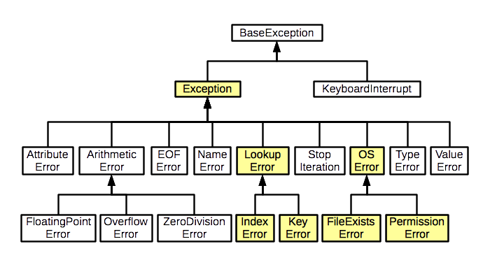
try block
try block contains the statements which generates error
The statements which have to monitor for error handling or exception handling are written inside try block.

Syntax:
try:
statement-1
statement-2

except block
except block is error handler block
if there is an error inside try block, it is handled using except block.
Try block followed by one or more than one except block.

Syntax:
try:
statement-1
statement-2
except exception-type:
statement-3
except exception-type:
statement-4

Example:
# Write a program to divide 2 numbers

while True:
n1=int(input("Enter first number :"))
n2=int(input("Enter second number :"))
try:
n3=n1/n2
print(n1,n2,n3)
break
except ZeroDivisionError:
print("Cannot divide number with zero, try again")

Output
Enter first number :5
Enter second number :0
Cannot divide number with zero, try again
Enter first number :8
Enter second number :0
Cannot divide number with zero, try again
Enter first number :4
Enter second number :2
4 2 2.0

Try block with multiple except blocks
If try block generates multiple exceptions, those exceptions are handled using multiple except blocks.

Example:
# program to divide 2 numbers

while True:
try:
n1=int(input("Enter First Number:"))
n2=int(input("Enter Second Number:"))
n3=n1/n2
print(n1,n2,n3)
break
except ValueError:
print("input only integer values")
except ZeroDivisionError:
print("cannot divide number with zero")

Output
Enter First Number:4
Enter Second Number:0
cannot divide number with zero
Enter First Number:5
Enter Second Number:abc
input only integer values
Enter First Number:6
Enter Second Number:1.5
input only integer values
Enter First Number:5
Enter Second Number:2
5 2 2.5

except block with multiple types of exceptions
one except block is able to handle by types exceptions or errors

Syntax:
try:
statement-1
statement-2
except (exception-type,exception-type,..) as object-name:
statement-3

Example:
# program to divide 2 numbers

while True:
try:
n1=int(input("enter first number :"))
n2=int(input("enter second number :"))
n3=n1/n2
print(n1,n2,n3)
break
except (ZeroDivisionError,ValueError) as obj:
if isinstance(obj,(ZeroDivisionError,)):
print("Cannot divide number with zero")
elif isinstance(obj,(ValueError,)):
print("Input only integer values")

Output
enter first number :ab
Input only integer values
enter first number :4
enter second number :0
Cannot divide number with zero
enter first number :5
enter second number :2
5 2 2.5

Generic except block
An except block without type is called generic except block.

try:
statement-1
statement-2
except:
statement-3

Example:
# program to divide 2 numbers
import sys
while True:
try:
n1=int(input("enter first number :"))
n2=int(input("enter second number :"))
n3=n1/n2
print(n1,n2,n3)
break
except:
t=sys.exc_info()
print(t)

Output
enter first number :5
enter second number :0
(<class 'ZeroDivisionError'>, ZeroDivisionError('division by zero'), <traceback object at 0x000001F721B71B80>)
enter first number :abc
(<class 'ValueError'>, ValueError("invalid literal for int() with base 10: 'abc'"), <traceback object at 0x000001F7218C01C0>)
enter first number :6
enter second number :3
6 3 2.0

finally block
finally is not an error handler block.
except block is called error handler block.
finally block is used to de-allocate the resources allocated by try block.
This block is executed,
- After execution of try block
- After execution of except block/Handled error
- Unhandled error
Critical statements are defined inside finally block.
Try block followed only one finally block.

try:  statement-1  statement-2  except error-type:  statement-3  finally:  statement-4 | try:  statement-1  statement-2  finally:  statement-3 | Invalid syntax  try:  statement-1  statement-2  finally:  statement-3  finally:  statement-3

print("inside program")
try:
print("inside try block")
a=int(input("enter first number :"))
b=int(input("enter second number :"))
c=a/b
print(a,b,c)
except ZeroDivisionError:
print("inside except block")
finally:
print("inside finally block")

Output
inside program
inside try block
enter first number :4
enter second number :2
4 2 2.0
inside finally block

inside program
inside try block
enter first number :4
enter second number :0
inside except block
inside finally block

inside program
inside try block
enter first number :5
enter second number :ab
inside finally block
Traceback (most recent call last):
File "D:/Backup/Python7PMOCT/extest6.py", line 5, in <module>
b=int(input("enter second number :"))
ValueError: invalid literal for int() with base 10: 'ab'

raise keyword
generating error is nothing but creating object of error class and giving to python runtime.
A function generates an error using raise keyword.

Syntax: raise errortype()

Example:
def multiply(n1,n2):
if n1==0 or n2==0:
raise ValueError()
else:
return n1*n2

while True:
num1=int(input("Enter first number :"))
num2=int(input("Enter second number :"))
try:
num3=multiply(num1,num2)
print(num1,num2,num3)
break
except ValueError:
print("cannot multiply number with zero")

Output
Enter first number :0
Enter second number :2
cannot multiply number with zero
Enter first number :9
Enter second number :0
cannot multiply number with zero
Enter first number :6
Enter second number :5
6 5 30

Predefined errortypes are used by predefined function or library functions of python.

User defined error type or custom error type or custom error class
User defined error type or custom error type or custom error class

Every exception or error is a class.
These error classes are 2 types
- Predefined error class
- User defined error class

Basic steps for creating user defined error class
- Create a class by inheriting Exception class
Exception is a base class or super class for all exception types (user defined or predefined)
- Add members (variables, methods) 🡺 Optional

Syntax:
class error-class-name(Exception):
pass

Example:
class ZeroMultiplyError(Exception):
pass

def multiply(n1,n2):
if n1==0 or n2==0:
raise ZeroMultiplyError()
else:
return n1*n2

while True:
try:
num1=int(input("Enter first integer:"))
num2=int(input("Enter second integer:"))
num3=multiply(num1,num2)
print(num1,num2,num3)
break
except ValueError:
print("input only integer values")
except ZeroMultiplyError:
print("cannot multiple number with zero")

Output
Enter first integer:5
Enter second integer:0
cannot multiple number with zero
Enter first integer:0
Enter second integer:6
cannot multiple number with zero
Enter first integer:ab
input only integer values
Enter first integer:6
Enter second integer:2
6 2 12

Example:
#Login Application

users={'naresh':'n123',
'ramesh':'r321',
'kishore':'k999',
'rajesh':'r587'}
class LoginError(Exception):
pass
def login(u,p):
if u not in users or users[u]!=p:
raise LoginError()

while True:
try:
user=input("UserName :")
password=input("Password :")
login(user,password)
print(f'{user} welcome')
break
except LoginError:
print("invalid username or password")

Output
UserName :naresh
Password :n321
invalid username or password
UserName :xyz
Password :abc
invalid username or password
UserName :suresh
Password :s123
invalid username or password
UserName :ramesh
Password :r321
ramesh welcome

Example:
# Banking Application

customers={1:["naresh",45000],
2:["suresh",50000],
3:["ramesh",70000],
4:["kiran",65000]}

class AccountError(Exception):
pass
class InsuffBalError(Exception):
pass

def isaccount_exists(accno):
if accno not in customers:
raise AccountError()

def deposit(accno,tamt):
customers[accno][1]=customers[accno][1]+tamt
def withdraw(accno,tamt):
if tamt>customers[accno][1]:
raise InsuffBalError()
else:
customers[accno][1]=customers[accno][1]-tamt
def getbalance(accno):
return customers[accno][1]

while True:
try:
print("1.Deposit ")
print("2.Withdraw ")
print("3.Find Balance")
print("4.Exit")
opt=int(input("Enter Your option:"))
if opt==1:
accno=int(input("Accno:"))
isaccount_exists(accno)
tamt=int(input("Amount to Deposit:"))
deposit(accno,tamt)
print("Transaction Completed")
elif opt==2:
accno=int(input("Accno:"))
isaccount_exists(accno)
tamt=int(input("Amount to withdraw"))
withdraw(accno,tamt)
print("Transaction Completed")
elif opt==3:
accno=int(input("Accno:"))
isaccount_exists(accno)
balance=getbalance(accno)
print(f'Balance {balance}')
elif opt==4:
break
except ValueError:
print("input only integer value")
except AccountError:
print("invalid account number")
except InsuffBalError:
print("insuff balance")

Output
1.Deposit
2.Withdraw
3.Find Balance
4.Exit
Enter Your option:1
Accno:1
Amount to Deposit:20000
Transaction Completed
1.Deposit
2.Withdraw
3.Find Balance
4.Exit
Enter Your option:3
Accno:1
Balance 65000
1.Deposit 2.Withdraw
3.Find Balance
4.Exit
Enter Your option:2
Accno:3
Amount to withdraw90000
insuff balance
1.Deposit
2.Withdraw
3.Find Balance
4.Exit
Enter Your option:2
Accno:3
Amount to withdraw25000

Files

Every application required to store or save data permanently.
To store or save data permanently we are using 2 systems
- File System
- Database system
The data stored within RAM or Main Memory is not permanent.

What is file?
A file is named memory location on secondary storage device (disk)
Files are used to save or store data permanently
Inside file data can be stored in 2 formats
- Text format
- Binary format
Based on the format in which data is stored inside, files are 2 types
- Text file
- Binary file

Text file allows only strings( text)
Binary file allow only bytes (bytes type of data)
Example of binary files is images, audio, video files.

Text files
Text file is collection of characters or text
Text file allows only string type of data
Based on the organization of data or text, these text files are classified into different categories/types

- .txt file
- .csv file (comma separated values)
- .json file (java scripting object notation)
- .xml file (Extensible markup language)

Each extension of file defines, the format of storing or organizing.

Basic steps to work with files
- Open file
- Write/Read data
- Close file

open() function
open() is a predefined function in python.
This function opens a given file and return corresponding file object.

Syntax:
Variable-name=open(“filename”,”mode”)

A file can be opened in different modes
Mode | Description
w | Write mode, It is used to write data inside file  If file is opened in write, it always create a new file  If filename exists, it truncates data and create new  If filename not exists, it creates new file
r | Read mode, it is used to read data from existing file  If given filename not exists, it raise FileNotFoundError  If given filename exists, it opens file in read mode
a | append mode, it is used to add more data to existing file  if given filename exists, it allows to add more data  if given filename not exists, it creates new file and add more data
x | Exclusive creation, it is used to write data inside file  If filename not exists, it will create new file to write data  If filename exists, it raises FileExistsError
w+ | Writing and Reading
r+ | Reading and Writing
t | Text file (default)  w🡪 wt  r🡪 rt  a 🡪 at  x 🡪 xt
b | Binary file  wb  rb  ab  xb

Following methods are used for reading and writing data inside text file (.txt)

write(s, /)
Write the string s to the stream and return the number of characters written.

read(size=-1, /)
Read and return at most size characters from the stream as a single str. If size is negative or None, reads until EOF.

readline(size=-1, /)
Read until newline or EOF and return a single str. If the stream is already at EOF, an empty string is returned.
If size is specified, at most size characters will be read.

Example:
# Write a program to create text file (.txt)

fobj=open("file1.txt","w") # wt
fobj.write('''Python is a
Programming langauge
It is high level programming
language''')
fobj.close()
fobj1=open("d:\\file2.txt","w")
fobj1.write('''django is a webframework
used to develop
web applications''')
fobj1.close()

Output
Output is saved inside files

Example:
# Write a program to read data from file1.txt

fobj=open("file1.txt","r")
s=fobj.read()
print(s)
fobj.close()
fobj1=open("d:\\file2.txt","r")
s=fobj1.read(5)
print(s)
fobj1.close()

Output
Python is a
Programming langauge
It is high level programming
language
djang
# Write a program to count vowels in given file

fobj=open("file1.txt","r")
c=0
while True:
ch=fobj.read(1)
if ch=='':
break
if ch in "aeiouAEIOU":
c=c+1

print(f'Count of vowels {c}')

Output
Count of vowels 22

Example:
# Write a program to copy content of one file inside another file

fobj1=open("file1.txt","r")
fobj2=open("file2.txt","w")

s=fobj1.read()
fobj2.write(s)

print("File Copied")
fobj1.close()
fobj2.close()

Output
File Copied

Example:
# Write a program to save student marks details inside
# marks.txt file

try:
fobj1=open("marks.txt","a")
while True:
rollno=int(input("Rollno:"))
name=input("Name:")
sub1=int(input("Subject1Marks:"))
sub2=int(input("Subject2Marks:"))
fobj1.write(f'{rollno},{name},{sub1},{sub2}\n')
ans=input("Add another student?")
if ans=="no":
break
except OSError:
print("unable to create file")
except ValueError:
print("input only integer values")
finally:
fobj1.close()

Output
Rollno:1
Name:naresh
Subject1Marks:50
Subject2Marks:60
Add another student?yes
Rollno:2
Name:suresh
Subject1Marks:70
Subject2Marks:80
Add another student?yes

Example
# Write a program to find result of all the students
# exists within marks.text

try:
fobj=open("marks.txt","r")
while True:
stud=fobj.readline()
if stud=='':
break
rollno,name,sub1,sub2=stud.split(",")
total=int(sub1)+int(sub2)
avg=total/2
result="PASS" if int(sub1)>=40 and int(sub2)>=40 else "FAIL"
print(f'{rollno}\t{name}\t{int(sub1)}\t{int(sub2)}\t{total}\t{avg:.2f}\t{result}')

Output
1 naresh 50 60 110 55.00 PASS
2 suresh 70 80 150 75.00 PASS
3 kiran 30 40 70 35.00 FAIL
4 kishore 60 80 140 70.00 PASS
5 raman 20 30 50 25.00 FAIL

CSV files
CSV stands for Comma Separated Values
A CSV (Comma-Separated Values) file is a plain text file, identified by the .csv extension, used to store structured, tabular data like spreadsheets or databases. Each line represents a row, with commas separating data fields (columns). It is a widely supported, human-readable format for importing/exporting data between different applications.
For working with csv files, python is provided a predefined module called “csv”.

The csv module implements classes to read and write tabular data in CSV format. It allows programmers to say, “write this data in the format preferred by Excel,” or “read data from this file which was generated by Excel,” without knowing the precise details of the CSV format used by Excel. Programmers can also describe the CSV formats understood by other applications or define their own special-purpose CSV formats.

“csv” module provides the following classes for reading and write data in csv format.

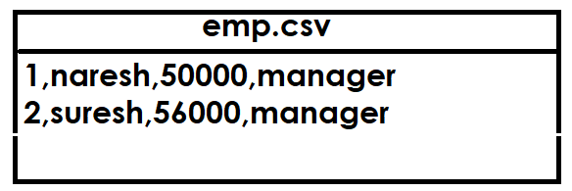

- Writer class
- Reader class
- DictWriter class
- DictReader class

The csv module’s reader and writer objects read and write sequences. Programmers can also read and write data in dictionary form using the DictReader and DictWriter classes.

Writer class
csv.writer(csvfile)
Return a writer object responsible for converting the user’s data into delimited strings on the given file-like object. csvfile can be any object with a write() method. If csvfile is a file object, it should be opened with newline=''

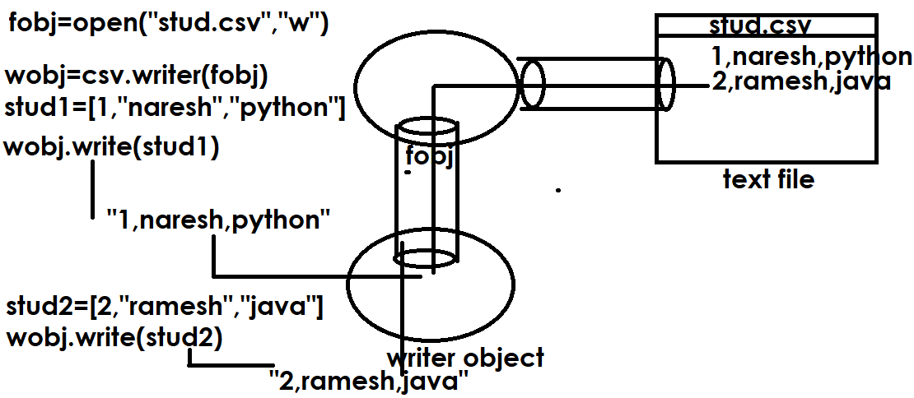
# Write a program to create student.csv file
# and store student details, each student is having
# rollno,name,course
import csv
try:
fobj=open("student.csv","a",newline='')
wobj=csv.writer(fobj)
while True:
rollno=int(input("Enter Rollno :"))
name=input("Enter Name :")
course=input("Enter Course :")
stud=[rollno,name,course]
wobj.writerow(stud)
ans=input("Add another student?")
if ans=="no":
break
except OSError:
print("not able to create file")
except ValueError:
print("input only integer values")
finally:
fobj.close()

Output
Enter Rollno :1
Enter Name :naresh
Enter Course :python
Add another student?yes
Enter Rollno :2
Enter Name :suresh
Enter Course :java
Add another student?yes
Enter Rollno :3
Enter Name :kishore
Enter Course :c++

reader object

Return a reader object that will process lines from the given csvfile. A csvfile must be an iterable of strings, each in the reader’s defined csv format. A csvfile is most commonly a file-like object or list. If csvfile is a file object, it should be opened with newline=''

reader(csvfile)

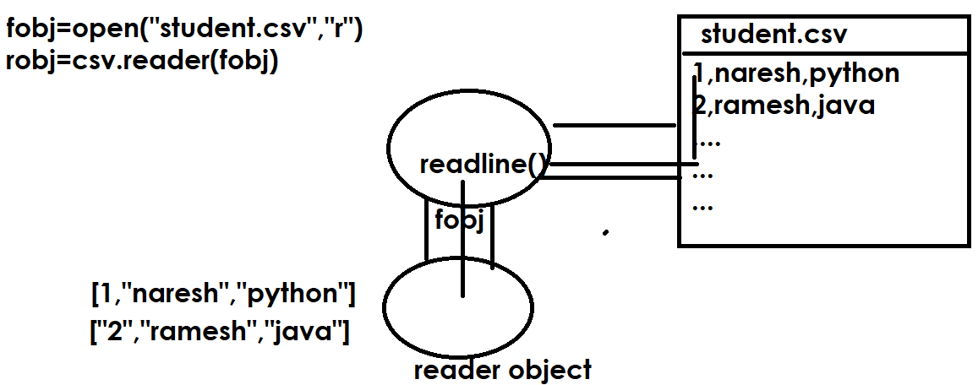

Example:
# Write a program read data from student.csv file

import csv
fobj=open("student.csv","r",newline='')
robj=csv.reader(fobj) # iterator
for stud in robj:
print(stud)

fobj.close()

Output
['1', 'naresh', 'python']
['2', 'suresh', 'java']
['3', 'kishore', 'c++']
['4', 'raman', 'oracle']
['5', 'kiran', 'mysql']

DictWriter object
class csv.DictWriter(f, fieldnames)
Create an object which operates like a regular writer but maps dictionaries onto output rows. The fieldnames parameter is a sequence of keys that identify the order in which values in the dictionary passed to the writerow() method are written to file f.

Example:
# Write a program create employees.csv file
import csv
fobj=open("employees.csv","a",newline='')
dwobj=csv.DictWriter(fobj,fieldnames=['empno','ename','salary'])
dwobj.writeheader()
while True:
empno=int(input("Enter EmployeeNo :"))
ename=input("Enter EmployeeName :")
salary=float(input("Enter EmployeeSalary :"))
emp={'empno':empno,'ename':ename,'salary':salary}
dwobj.writerow(emp)
ans=input("Add another employee?")
if ans=="no":
break

fobj.close()

Output
Enter EmployeeNo :1
Enter EmployeeName :Naresh
Enter EmployeeSalary :45000
Add another employee?yes
Enter EmployeeNo :2
Enter EmployeeName :Suresh
Enter EmployeeSalary :56000
Add another employee?yes
Enter EmployeeNo :3
Enter EmployeeName :kishore
Enter EmployeeSalary :45000
Add another employee?no

DictReader object
class csv.DictReader(f, fieldnames=None)
Create an object that operates like a regular reader but maps the information in each row to a dict whose keys are given by the optional fieldnames parameter.

# Write a program read data from employees.csv file

import csv
fobj=open("employees.csv","r",newline='')
drobj=csv.DictReader(fobj,fieldnames=['empno','ename','salary'])

for emp in drobj:
print(emp['empno'],emp['ename'],emp['salary'])

fobj.close()

Output
empno ename salary
1 Naresh 45000.0
2 Suresh 56000.0
3 kishore 45000.0

Json files

.
Json files

JSON stands for Java Script Object Notation.
J SON (JavaScript Object Notation) is a lightweight, text-based, language-independent data-interchange format used for storing and exchanging data. It is human-readable, machine-parsable, and commonly used in web applications for API communication, featuring key-value pairs (objects) and ordered lists (arrays).

Json file is a text file with extension .json
To work with json files python provided a predefined module called “json”. It is standard module which comes with python software.
This module provides encoders and decoders.
Encoding is nothing but converting python objects into json
Decoding is nothing but converting json into python objects

Python Datatypes | Json Datatypes
Int,float | Number
List | Array
Dictionary or object | object

Json module provides the following functions for encoding and decoding

- dump(): convert python object into json string and write inside file
- load(): read json string from file and convert into python object
- dumps() : convert python object type into json string without writing inside file
- loads() : converting json string into python object without reading from file

Example:
import json
x=15
y=1.5
z=[10,20,30,40,50]
print(x,type(x))
print(y,type(y))
print(z,type(z))
s1=json.dumps(x)
s2=json.dumps(y)
s3=json.dumps(z)
print(s1,type(s1))
print(s2,type(s2))
print(s3,type(s3))
a=json.loads(s1)
b=json.loads(s2)
c=json.loads(s3)
print(a,type(a))
print(b,type(b))
print(c,type(c))

Output
15 <class 'int'>
1.5 <class 'float'>
[10, 20, 30, 40, 50] <class 'list'>
15 <class 'str'>
1.5 <class 'str'>
[10, 20, 30, 40, 50] <class 'str'>
15 <class 'int'>
1.5 <class 'float'>
[10, 20, 30, 40, 50] <class 'list'>

Example:
# Create student.json file for storing student data
import json

fobj=open("student.json","a")
student=[]
while True:
rollno=int(input("Rollno:"))
name=input("Name:")
course=input("Course:")
student.append({'rollno':rollno,
'name':name,'course':course})
ans=input("Add naother student?")
if ans=="no":
break
json.dump(student,fobj)
fobj.close()

Output
Rollno:1
Name:naresh
Course:python
Add naother student?yes
Rollno:2
Name:suresh
Course:java
Add naother student?yes
Rollno:3
Name:kishore
Course:c++
Add naother student?yes
Rollno:4
Name:kiran
Course:c
Add naother student?yes
Rollno:5
Name:raman
Course:oracle
Add naother student?no

Example:
# Write program to read data from student.json file

import json
fobj=open("student.json","r")
student=json.load(fobj)
print(student,type(student))
for stud in student:
print(stud['rollno'],stud['name'],stud['course'])

fobj.close()

Output
[{'rollno': 1, 'name': 'naresh', 'course': 'python'}, {'rollno': 2, 'name': 'suresh', 'course': 'java'}, {'rollno': 3, 'name': 'kishore', 'course': 'c++'}, {'rollno': 4, 'name': 'kiran', 'course': 'c'}, {'rollno': 5, 'name': 'raman', 'course': 'oracle'}] <class 'list'>
1 naresh python
2 suresh java
3 kishore c++
4 kiran c
5 raman oracle

Binary files
Binary file is a collection of bytes.
Binary file allows only bytes data or bytes data types( bytes, bytearray).
Example of binary files: images, audio files, videos files

In order to work with binary files, the file must be opened binary mode.

Syntax1: open(“filename”,”wb”)
Syntax2: open(“filename”,”rb”)
Syntax3: open(“filename”,”ab”)

“b” suffix given for working with binary files
If no suffix is given, default to text type or text file

Example:
# Write a program to create binary file

try:
fobj=open("file1","wb")
b=bytes([65,66,67,68,69,70])
fobj.write(b)

except OSError:
print("unable to create file")
finally:
fobj.close()

Output
Output is saved inside file1

Example:
# Write a program to read data from file1 (binary file)

try:
fobj=open("file1","rb")
b=fobj.read()
for value in b:
print(value,end=' ')
except FileNotFoundError:
print("file1 not exists")
finally:
fobj.close()

Output
65 66 67 68 69 70

Example:
# Write a program to create copy of the image

fobj1=open("image1.jpg.jpg","rb")
fobj2=open("image2.jpg","wb")
b=fobj1.read()
fobj2.write(b)

fobj1.close()
fobj2.close()

Output
Output is saved inside file

Pickling and unpickling (pickle module)
The pickle module implements binary protocols for serializing and de-serializing a Python object structure. “Pickling” is the process whereby a Python object hierarchy is converted into a byte stream, and “unpickling” is the inverse operation, whereby a byte stream (from a binary file or bytes-like object) is converted back into an object hierarchy. Pickling (and unpickling) is alternatively known as “serialization”, “marshalling,” or “flattening”; however, to avoid confusion, the terms used here are “pickling” and “unpickling”.

Pickle module provides the following functions for pickling and unpickling

- dumps(): This convert python objects type into bytes type without saving inside file
- loads(): This converts bytes type into python object type without reading from file
- dump(): This convert python objects type into bytes type and save inside file
- load(): This read bytes object from file and convert into python object

Example
import pickle

#pickling
b1=pickle.dumps(1.5)
b2=pickle.dumps(1+2j)
b3=pickle.dumps(65)
print(b1,b2,b3,type(b1),type(b2),type(b3),sep="\n")
#unpickling
f1=pickle.loads(b1)
c1=pickle.loads(b2)
i1=pickle.loads(b3)
print(f1,c1,i1,type(f1),type(c1),type(i1),sep="\n")

Output
b'\x80\x05\x95\n\x00\x00\x00\x00\x00\x00\x00G?\xf8\x00\x00\x00\x00\x00\x00.'
b'\x80\x05\x95.\x00\x00\x00\x00\x00\x00\x00\x8c\x08builtins\x94\x8c\x07complex\x94\x93\x94G?\xf0\x00\x00\x00\x00\x00\x00G@\x00\x00\x00\x00\x00\x00\x00\x86\x94R\x94.'
b'\x80\x05KA.'
<class 'bytes'>
<class 'bytes'>
<class 'bytes'>
1.5
(1+2j)
65
<class 'float'>
<class 'complex'>
<class 'int'>

Example:
# example of pickling
import pickle

with open("file2.ser","wb") as fobj:
pickle.dump(1.5,fobj)
pickle.dump(1+2j,fobj)
pickle.dump(65,fobj)

Output
Data is saved file

Example:
# unpickling

import pickle

with open("file2.ser","rb") as fobj:
f1=pickle.load(fobj)
c1=pickle.load(fobj)
i1=pickle.load(fobj)

print(f1,c1,i1)

Output
1.5 (1+2j) 65

Emp.py
class Employee:
def __init__(self):
self.__empno=None
self.__ename=None
self.__salary=None
def setData(self,e,en,s):
self.__empno=e
self.__ename=en
self.__salary=s
def printData(self):
print(f'EmployeeNo {self.__empno}')
print(f'EmployeeName {self.__ename}')
print(f'EmployeeSalary {self.__salary}')

# program to save employee objects into binary format
import pickle
import emp

with open("employee.ser","wb") as fobj:
emp1=emp.Employee()
emp1.setData(1,"naresh",5000)
emp2=emp.Employee()
emp2.setData(2,"suresh",6000)
pickle.dump(emp1,fobj)
pickle.dump(emp2,fobj)

print("employees are saved")

# Program to read employee objects

import pickle
import emp

with open("employee.ser","rb") as fobj:
emp1=pickle.load(fobj)
emp2=pickle.load(fobj)
emp1.printData()
emp2.printData()

Output
EmployeeNo 1
EmployeeName naresh
EmployeeSalary 5000
EmployeeNo 2
EmployeeName suresh
EmployeeSalary 6000
Python Database Communication (PDBC)
Every application required to store or save data permanently.
This data can be saved permanently using 2 systems.
- File System
- Database System

Limitations of file system
- Files can hold large amount data
- Files are not secured because files are managed by operating system
- File system does not provides any query language

Advantage of database system
- Database can hold large amount data
- Data stored inside database is secured, this security is provided database manage system
- Database system provides a query language (SQL)

Database applications or database software’s
- MySQL 🡺 Oracle Corporation
- Oracle 🡺 Oracle Corporation
- SQL Server 🡺 Microsoft
- PostgreSQL 🡺 Postgres
- Mongodb (no-SQL) 🡺 Mongo
- SQlite 🡺 PSF (python software foundation)

Database understands only one language, SQL (Structured Query Language).
SQL provides set of commands to perform operations on database
Based on the types of operations, these SQL commands are classified into different categories

- DDL (Data Definition Language)
  - Create
  - Alter
  - Drop
- DML (Data Manipulation Language)
  - Insert
  - Update
  - Delete
- DRL (OR) DQL (Data Query Language)
  - Select
- TCL (Transaction Control Language)
  - Commit
  - Rollback
- DCL (Data Control Language)
  - Grant
  - Revoke

Installing MySQL Database

https://dev.mysql.com/downloads/installer/

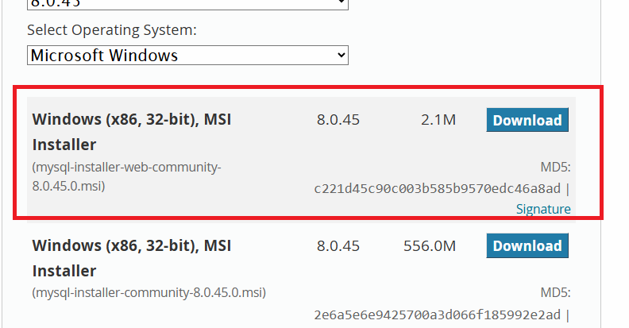

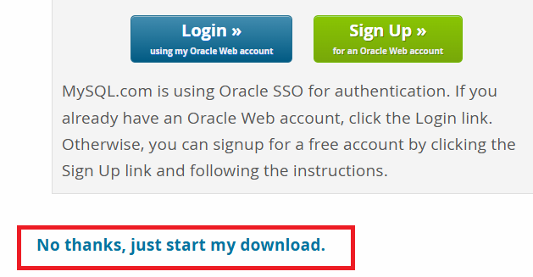

Open mysql command line client
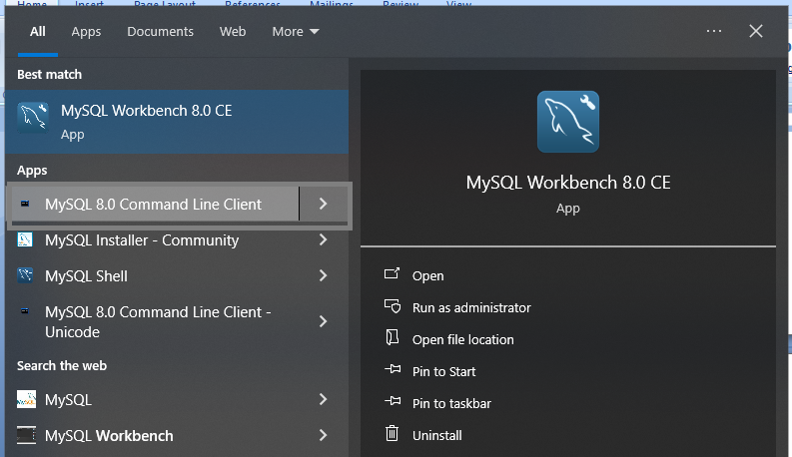
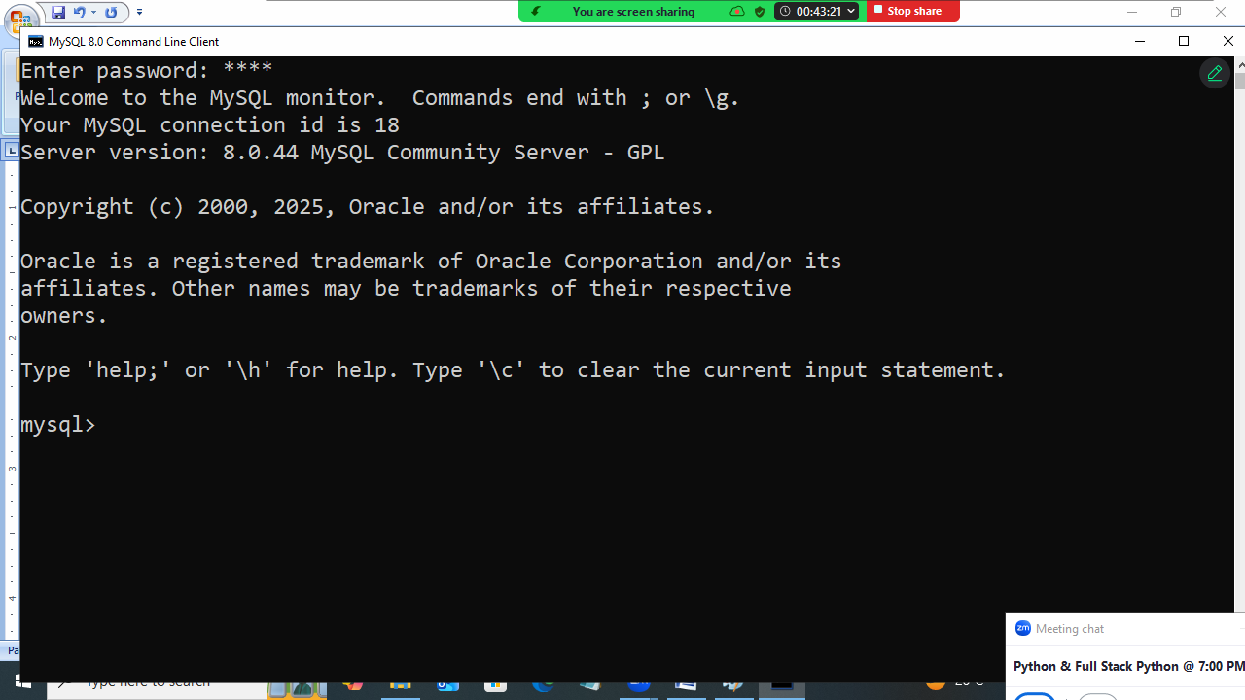

How to create database?
Database is created using “create” command.

Syntax:
create database database-name

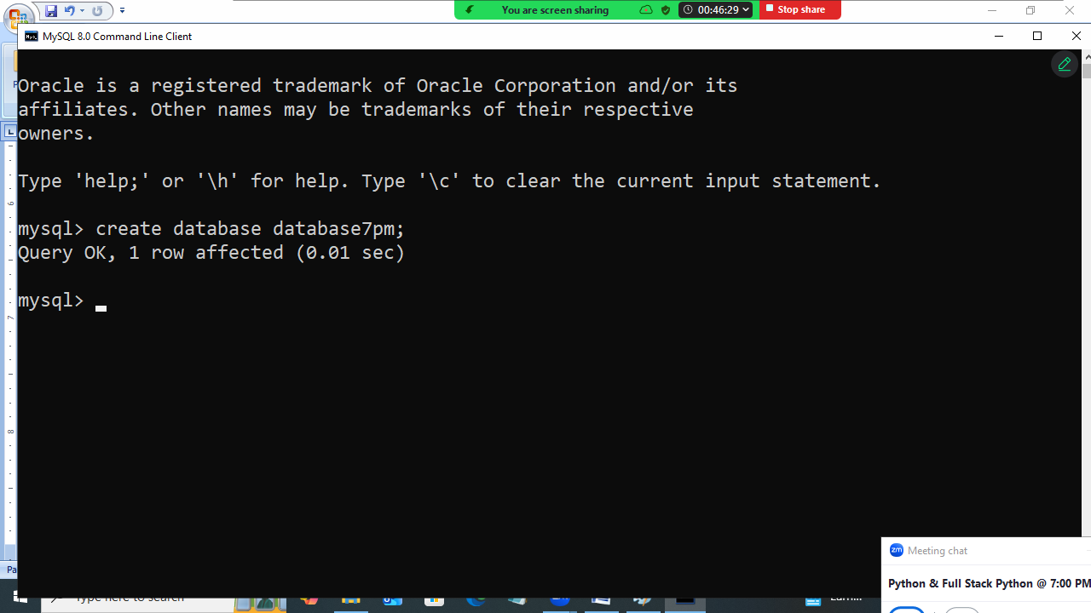

How to list databases created?
Show databases
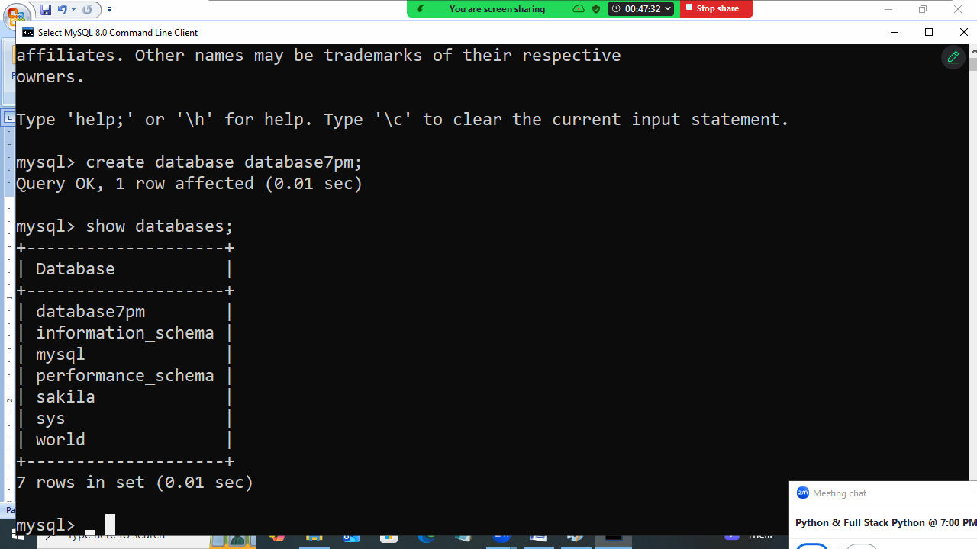

Within database data is organized inside tables.
How to create table?
ceate table <table-name> (column-name datatype,
column-name datatype,
Column-name datatype,…)

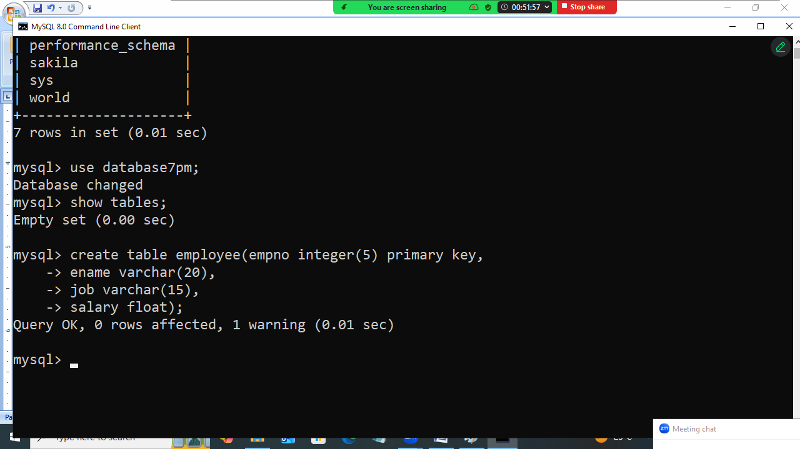

How list tables exists within database?
Show tables
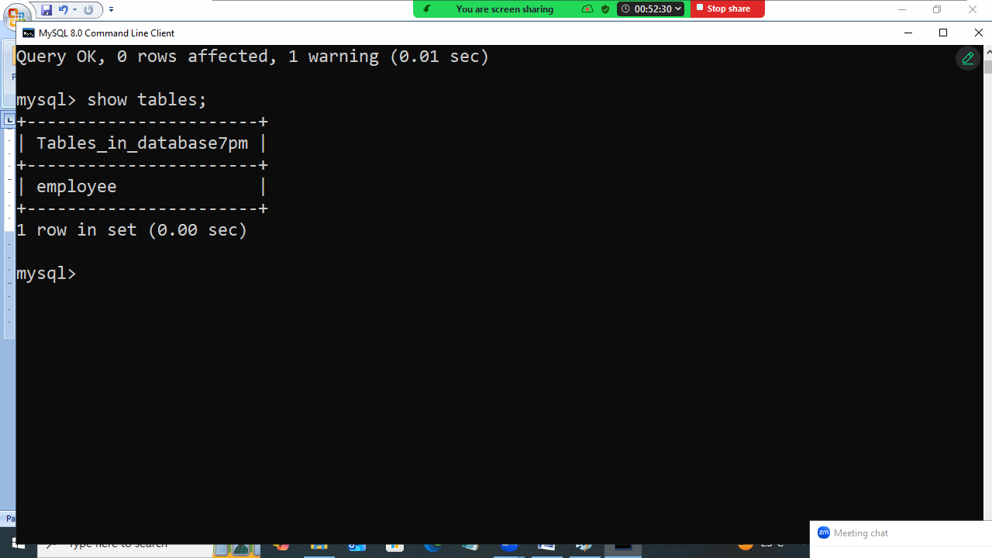

How to insert data within database table?
“INSERT” command is used for inserting values within database table

Syntax:
Insert into table-name values(value-of-col1,value-of-col2,…)

Syntax:
Insert into table-name(col1,col2,col3,) values (value-of-col1,value-of-col2,…)

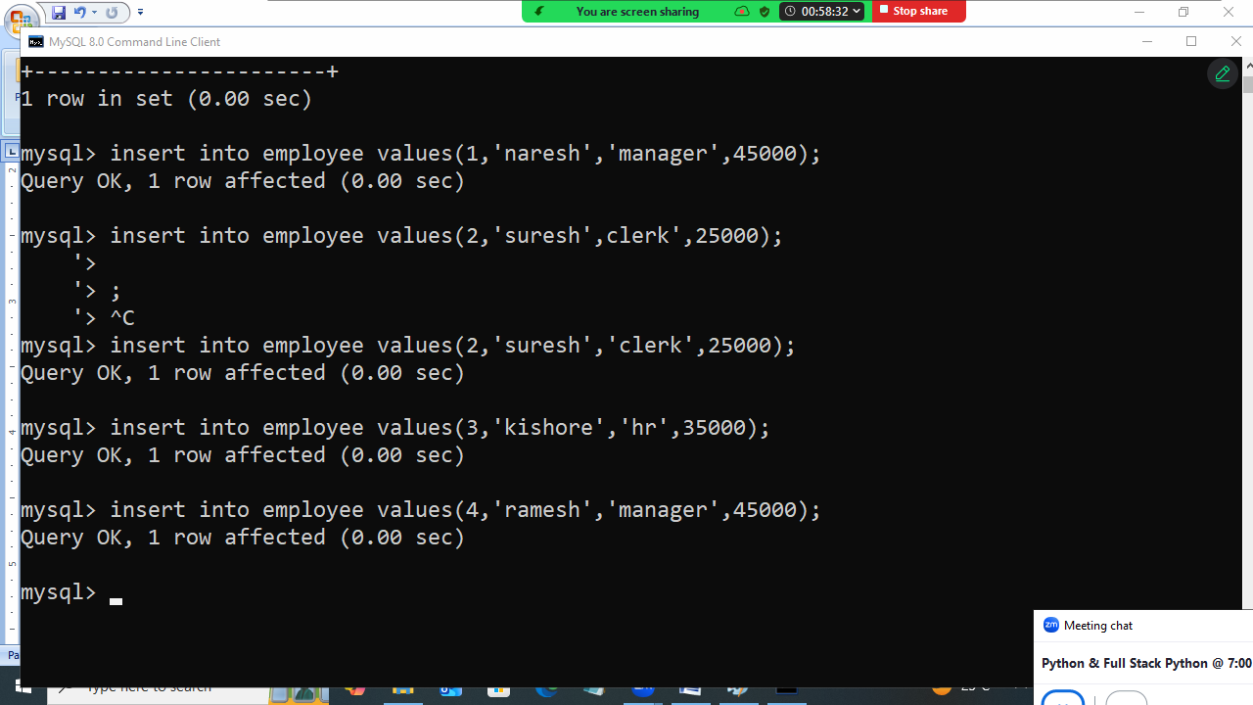

How to read data from database table?
“SELECT” command is used for reading data from database table.

SELECT * from table-name
SELECT column-name,column-name from table-name
SELECT * from table-name where condition

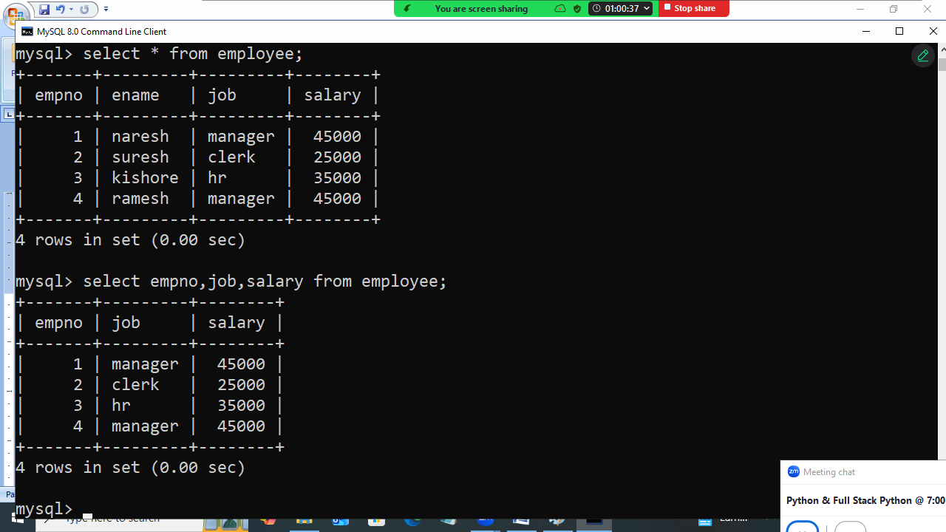

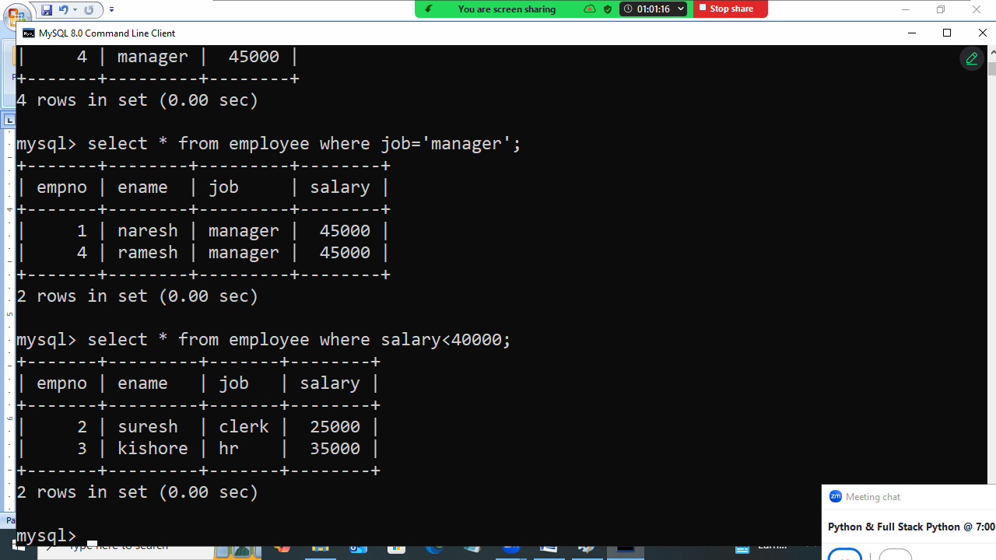

Update command
This command is used for replacing values within database table.

Syntax:
Update <table-name> set column-name=value where condition
Update <table-name> set column-name=value,column-name=value where condition

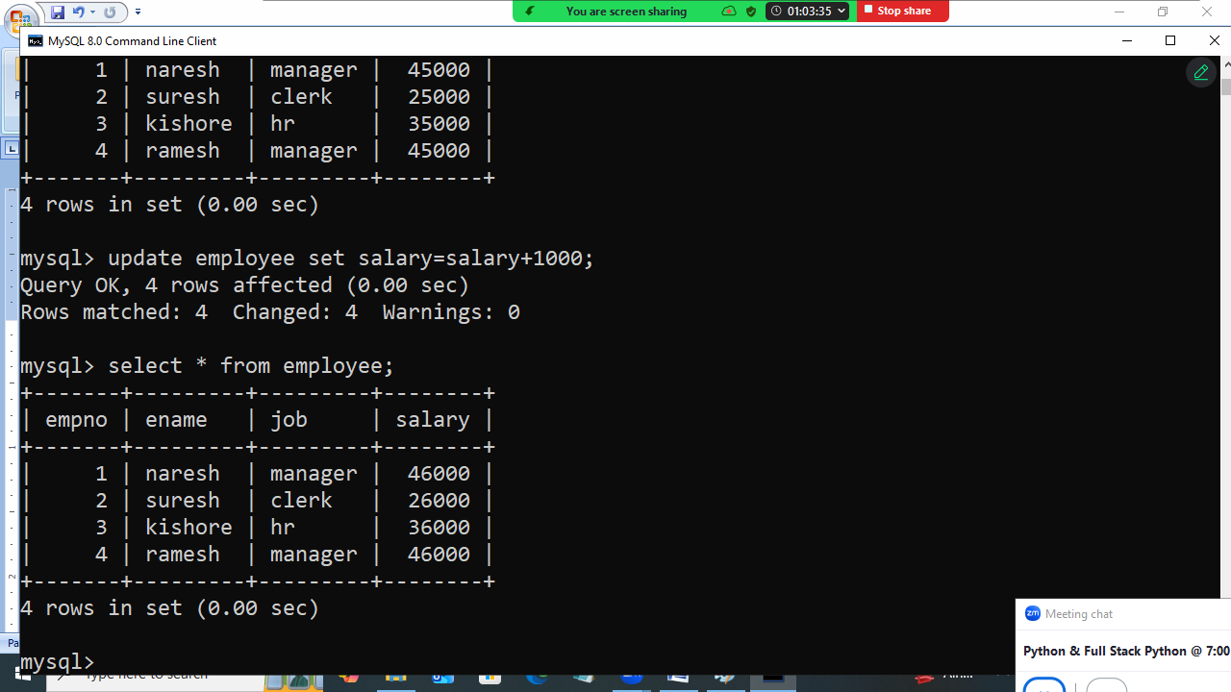
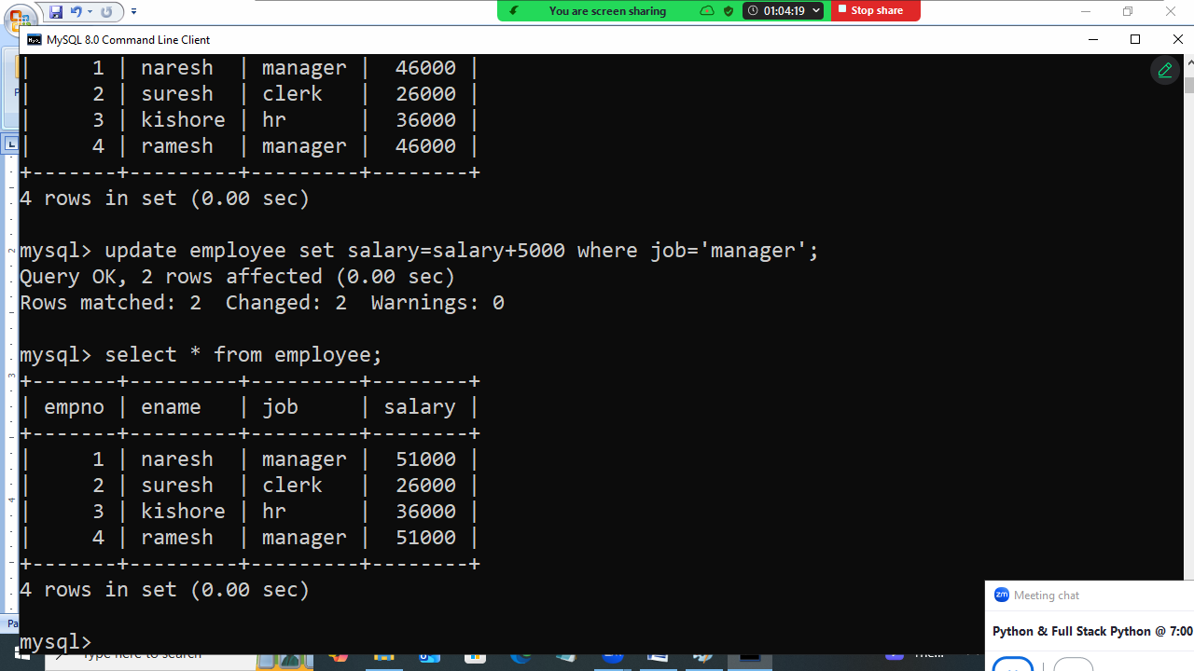

DELETE command
This command is used to delete rows from database table

Syntax:
Delete from table-name; 🡪 delete all rows
Delete from table-name where condition; 🡪 delete only rows based on condition

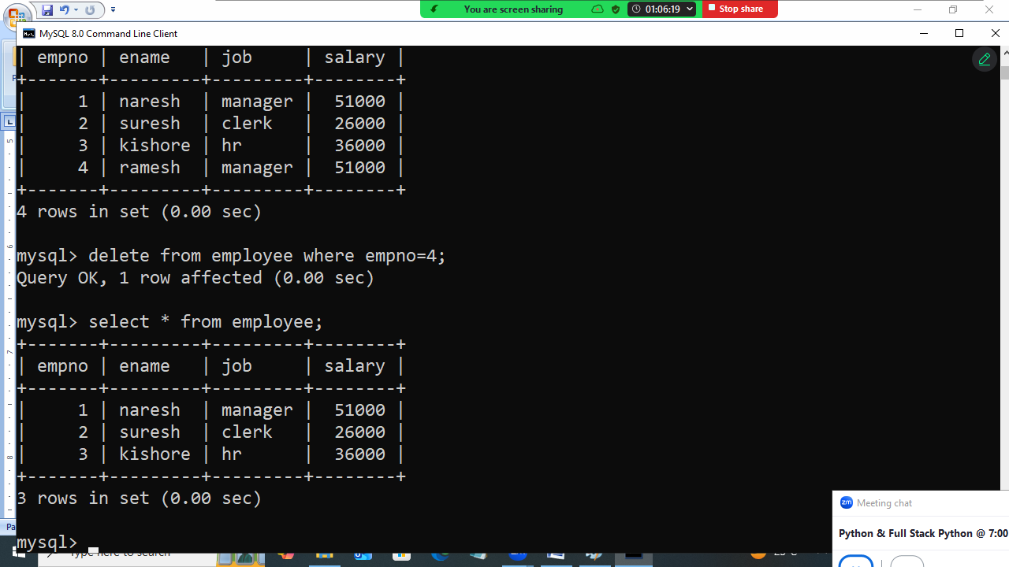

Python and MySQL communication

In order to communicate with any database by python program it required drivers or libraries.
Each database vendor provided one library to communicate with databases.

Database | Libraries/Driver
Mysql | Mysql-connector-python
Oracle | Cx_Oracle (OR) oracledb
SQLite | Sqlite3
SQL Server | pymssql
Mongodb | Pymongo
PostgreSQL | psycopg

In order to communicate mysql database, install mysql-connector-python

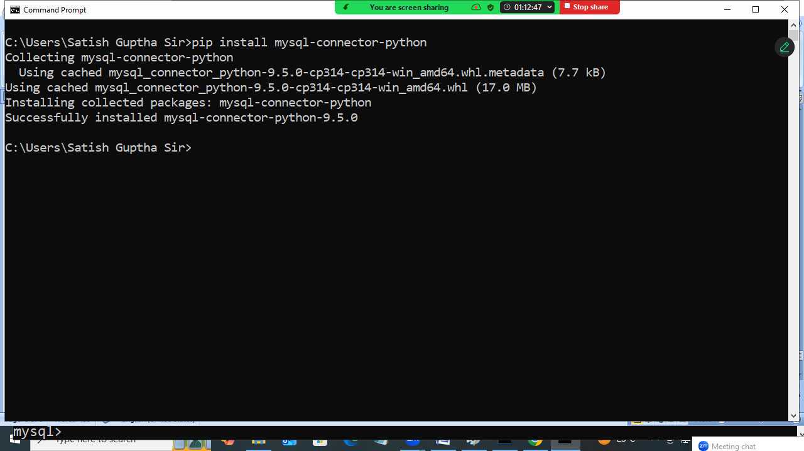
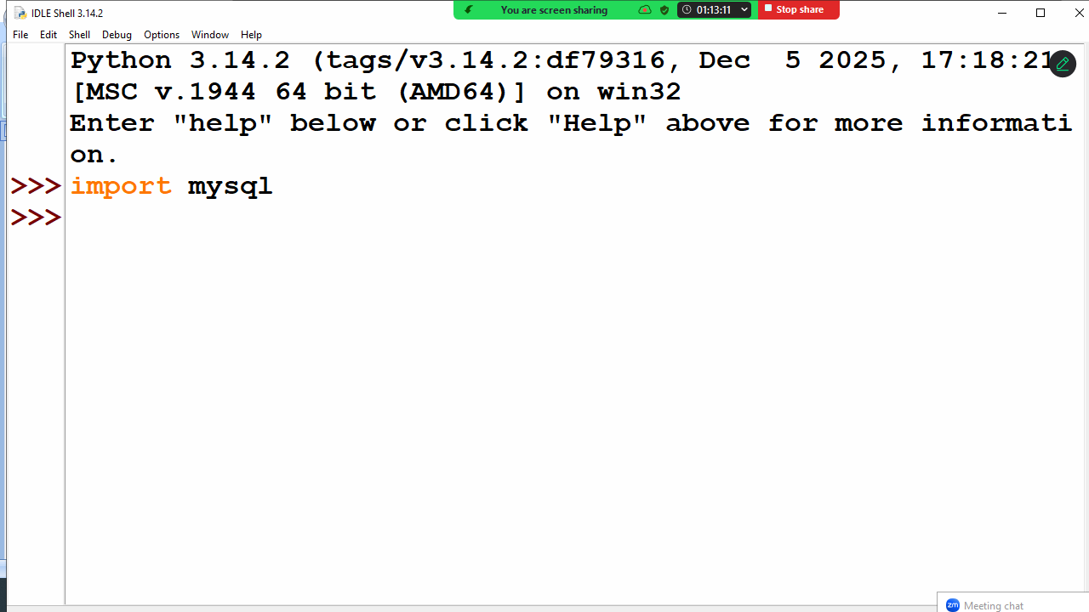

Basic steps to communicate with database
- Establish connection to database
- Create cursor object for sending SQL statements
- Send SQL statements using cursor object
- Read result stored inside cursor object
- Close connection

Establishing connection to database
mysql.connector.connect() function is used to establish connection to database.

Syntax:
connect(database,user,password,host,port)

database 🡺 database name
user 🡺 database user name
password 🡺 database password
host 🡺 ip-address of system where database is running
port🡺 database server portno

default portno of mysql is 3306

Example:
# Write a program to establish connection to database

import mysql.connector

cn=mysql.connector.connect(database="database7pm",
user="root",
password="root",
host="localhost",
port="3306")
print("Connection is Established")

Output
Connection is Established

Cursor object
Cursor object is used for sending SQL statement to database

How to create cursor object?
connection-object.cursor()

cursor object provide the following methods for sending SQL statements to database
- execute()
- executemany()

execute()
This method is used for sending SQL statements to Database.
Database receives SQL statement , process it and generate result. This result is written inside cursor object.

# Write a program to create table within database

import mysql.connector

cn=mysql.connector.connect(database="database7pm",
user="root",
password="root",
host="localhost",
port="3306")
c=cn.cursor()
SQL='''create table student(rollno integer primary key,
name varchar(20),
course varchar(20))'''
c.execute(SQL)
print("Table Created")
cn.close()

Example:
# Write a program to insert data into student table
import mysql.connector
cn=mysql.connector.connect(database="database7pm",
user="root",
password="root",
host="localhost",
port="3306")
c=cn.cursor()
SQL="insert into student values(%s,%s,%s)"
while True:
rollno=int(input("Rollno:"))
name=input("StudentName:")
course=input("StudentCourse:")
c.execute(SQL,params=(rollno,name,course))
print("Student Created")
ans=input("Add another student?")
if ans=="no":
cn.commit()
break
cn.close()

Output
Rollno:1
StudentName:naresh
StudentCourse:python
Student Created
Add another student?yes
Rollno:2
StudentName:suresh
StudentCourse:java
Student Created
Add another student?yes
Rollno:3
StudentName:kishore
StudentCourse:c++
Student Created
Add another student?no

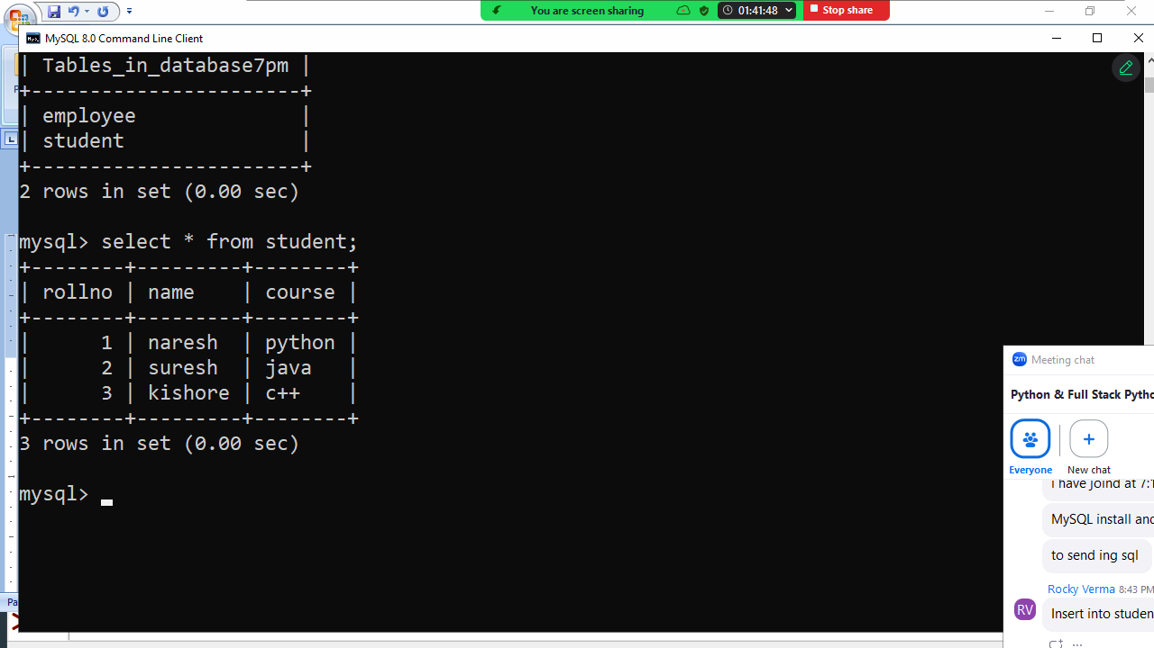
How to read data from database table?
To read data from database table, python program send “SELECT” statement.
SELECT command read data from database table and store inside cursor object.

How to read data from cursor object?
In order to read data from cursor object, cursor object provides the following methods.
- fetchone()
- fetchmany()
- fetchall()

fetchone(): This method read single row from cursor. This method returns each row as tuple. If there are no rows inside cursor object it returns None.

Example:
import mysql.connector as mysql
cn=mysql.connect(database="database7pm",
user="root",
password="root",
host="localhost",
port="3306")
c=cn.cursor()
c.execute("select * from student")
r1=c.fetchone()
print(r1)
r2=c.fetchone()
print(r2)
r3=c.fetchone()
print(r3)
r4=c.fetchone()
print(r4)
cn.close()

Output
(1, 'naresh', 'python')
(2, 'suresh', 'java')
(3, 'kishore', 'c++')
None

fetchmany(n)
This method fetch/read “n” row from cursor object.
This method returns list contains each row as tuple
If there are no row to fetch it returns empty list.

Example:
import mysql.connector as mysql
cn=mysql.connect(database="database7pm",
user="root",
password="root",
host="localhost",
port="3306")
c=cn.cursor()
c.execute("select * from student")
rows=c.fetchmany(2)
print(rows)
rows=c.fetchmany(2)
print(rows)
rows=c.fetchmany(2)
print(rows)
cn.close()

Output
[(1, 'naresh', 'python'), (2, 'suresh', 'java')]
[(3, 'kishore', 'c++')]
[]

fetchall()
This method read all the rows from cursor object.
This method returns list contains each row as one tuple.
If no rows to fetch, it returns empty list

Example:
import mysql.connector as mysql
cn=mysql.connect(database="database7pm",
user="root",
password="root",
host="localhost",
port="3306")
c=cn.cursor()
c.execute("select * from student")
rows=c.fetchall()
print(rows)
rows=c.fetchall()
print(rows)
cn.close()

Output
[(1, 'naresh', 'python'), (2, 'suresh', 'java'), (3, 'kishore', 'c++')]
[]

Example:
# Write a program to read the details of given empno

import mysql.connector as mysql

cn=mysql.connect(database="database7pm",
user="root",
password="root",
host="localhost",
port="3306")
c=cn.cursor()
empno=int(input("EmployeeNo:"))
SQL="select * from employee where empno=%s"
c.execute(SQL,params=(empno,))
emp=c.fetchone()
if emp==None:
print("Invalid EmployeeNo")
else:
print(emp)

cn.close()

Output
EmployeeNo:1
(1, 'naresh', 'manager', 51000.0)

EmployeeNo:3
(3, 'kishore', 'hr', 36000.0)

EmployeeNo:4
Invalid EmployeeNo

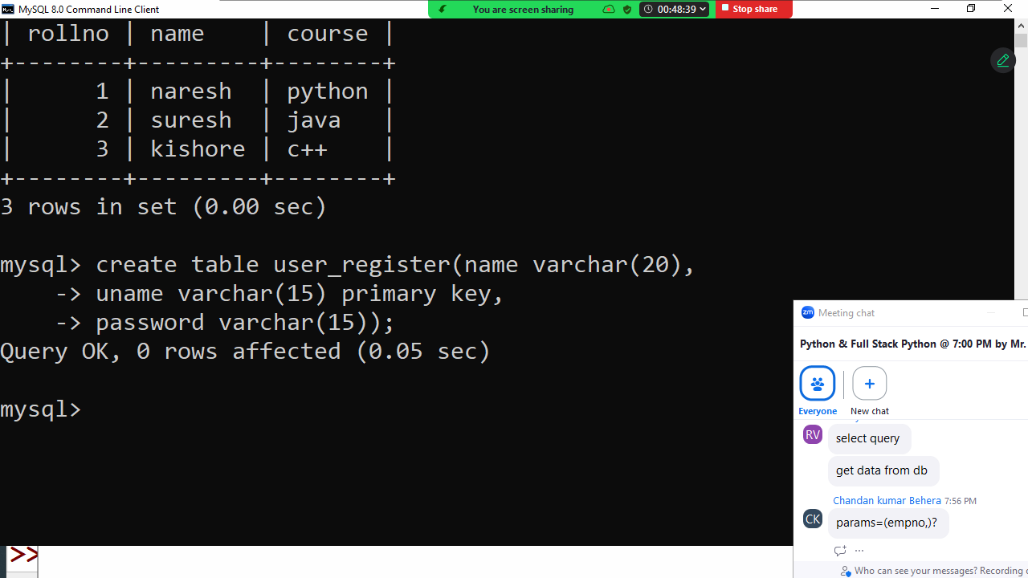

Example:
# Write a program to register user
import mysql.connector as mysql
cn=mysql.connect(database="database7pm",
user="root",
password="root",
host="localhost",
port="3306")
c=cn.cursor()
name=input("Name :")
uname=input("UserName :")
pwd=input("Password :")
SQL="insert into user_register values(%s,%s,%s)"
try:
c.execute(SQL,params=(name,uname,pwd))
print("User Registered")
cn.commit()
except:
print("Error in Registering User")
finally:
cn.close()

Output
Name :naresh
UserName :nit
Password :nit123
User Registered

Name :ramesh
UserName :nit
Password :xyz123
Error in Registering User

Example:
# Login program
import mysql.connector as mysql
cn=mysql.connect(database="database7pm",
user="root",
password="root",
host="localhost",
port="3306")
c=cn.cursor()
SQL="select * from user_register where uname=%s and password=%s"
for i in range(3):
uname=input("UserName :") # nit
pwd=input("Password :") # nit123
c.execute(SQL,params=(uname,pwd))
row=c.fetchone()
if row!=None:
print(f'{uname},welcome')
break
print("Invalid username or password")

if i==2:
print("Maximum attempts are completed")
print("Your account is blocked")

Output
UserName :nit
Password :nit123
nit,welcome

Example:
# Write a program to change password of user
import mysql.connector as mysql
cn=mysql.connect(database="database7pm",
user="root",
password="root",
host="localhost",
port="3306")
c=cn.cursor()
uname=input("UserName :")
opwd=input("Old Password:")
npwd=input("New Password:")
SQL="update user_register set password=%s where uname=%s and password=%s"
c.execute(SQL,params=(npwd,uname,opwd))
a=c.rowcount
if a>0:
print("password is updated")
else:
print("Invalid username or password")
cn.commit()
cn.close()

Output
UserName :nit
Old Password:nit123
New Password:nit321
password is updated

UserName :nit
Old Password:nit123
New Password:nit321
Invalid username or password

Example:
# write a program to delete an employee
import mysql.connector as mysql
cn=mysql.connect(database="database7pm",
user="root",
password="root",
host="localhost",
port="3306")
c=cn.cursor()
empno=int(input("Employeeno delete :"))
SQL="delete from employee where empno=%s"
c.execute(SQL,params=(empno,))
k=c.rowcount
if k>0:
print("Employee Deleted")
cn.commit()
else:
print("Invalid EmployeeNo")
cn.close()

Output
Employeeno delete :3
Invalid EmployeeNo

Employeeno delete :1
Employee Deleted

Python and Oracle database communication
In order to communicate with oracle database, python program required libraries.
- cx_Oracle
- oracledb

These libraries are provided Oracle Corporation.

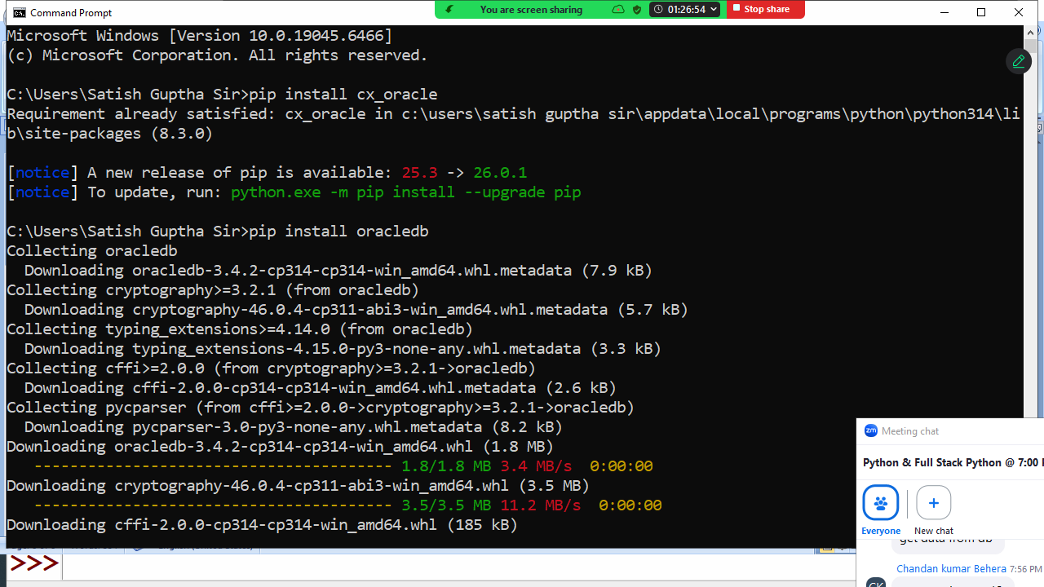

Before installing oracle libraries first install oracle database software.
Python and Oracle database communication
In order to communicate with oracle database, python program required libraries.
- cx_Oracle
- oracledb

These libraries are provided Oracle Corporation.

Before installing oracle libraries first install oracle database software.

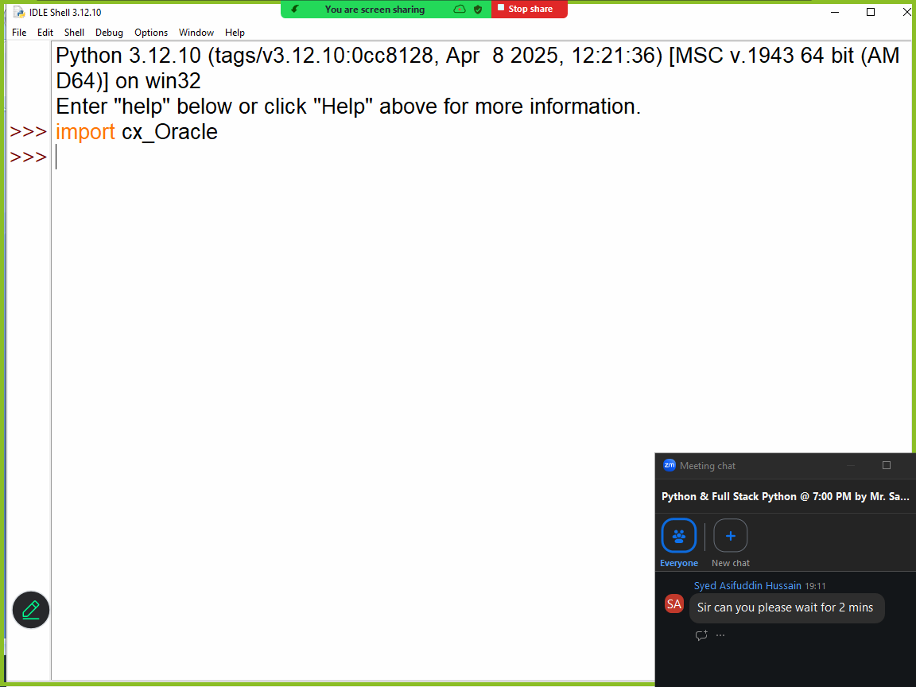

Example:
# Write a program to establish connection to oracle database

import cx_Oracle

cn=cx_Oracle.connect("system/tiger@localhost:1521/XE")
print("Connection Established")
cn.close()

# system --> username
# tiger --> password
# host --> localhost/ipaddress
#port : 1521
# databasename: XE

Output
Connection Established

Example:
# Write a program to create table within oracle database

import cx_Oracle

cn=cx_Oracle.connect("system/tiger@localhost:1521/XE")
c=cn.cursor()
SQL='''create table emp(empno number(5) primary key,
ename varchar2(20),
salary number(10,2))'''
c.execute(SQL)
print("Table Created")
cn.close()

Output
Table Created

Example:
# Write a program to insert data inside emp table

import cx_Oracle
cn=cx_Oracle.connect("system/tiger@localhost:1521/XE")
c=cn.cursor()
SQL="insert into emp values(:1,:2,:3)"
while True:
empno=int(input("EmployeeNo :"))
ename=input("EmployeeName :")
sal=float(input("EmployeeSalary:"))
c.execute(SQL,[empno,ename,sal])
cn.commit()
ans=input("Add another employee?")
if ans=="no":
break
cn.close()

Output
EmployeeNo :1
EmployeeName :naresh
EmployeeSalary:45000
Add another employee?yes
EmployeeNo :2
EmployeeName :suresh
EmployeeSalary:25000
Add another employee?yes
EmployeeNo :3
EmployeeName :kishore
EmployeeSalary:15000
Add another employee?yes
EmployeeNo :4
EmployeeName :kiran
EmployeeSalary:21000
Add another employee?no

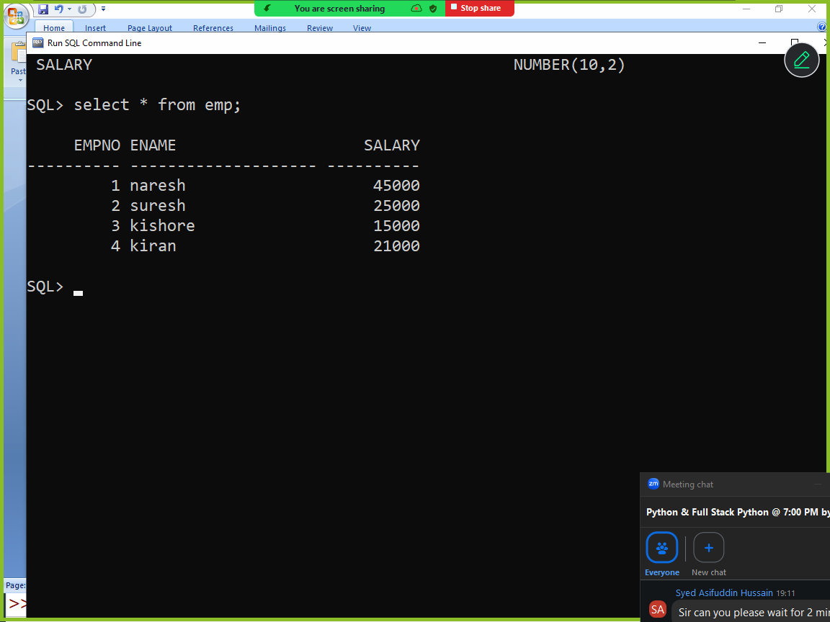

Example:
# Write a program to read data from emp table

import cx_Oracle
cn=cx_Oracle.connect("system/tiger@localhost:1521/XE")
c=cn.cursor()
SQL="SELECT * FROM EMP"
c.execute(SQL)
employees=c.fetchall()
for row in employees:
print(row)

cn.close()

Output
(1, 'naresh', 45000.0)
(2, 'suresh', 25000.0)
(3, 'kishore', 15000.0)
(4, 'kiran', 21000.0)

MongoDB database
Mongodb is NO SQL database
MongoDB is a document database. It stores data in a type of JSON format called BSON.
A record in MongoDB is a document, which is a data structure composed of key value pairs similar to the structure of JSON objects.

To work with mongodb,
- install mongodb software
- install pymongo (library)

install mongodb software
https://www.mongodb.com/try/download/community

install pymongo

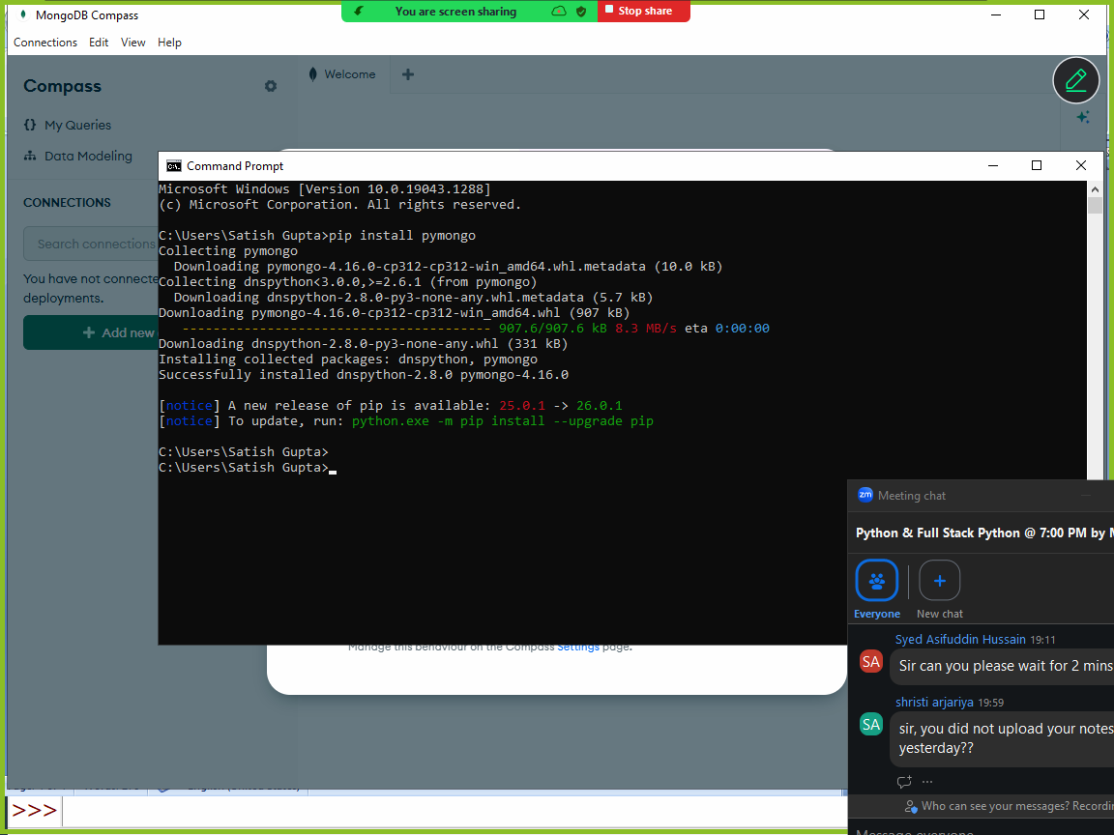

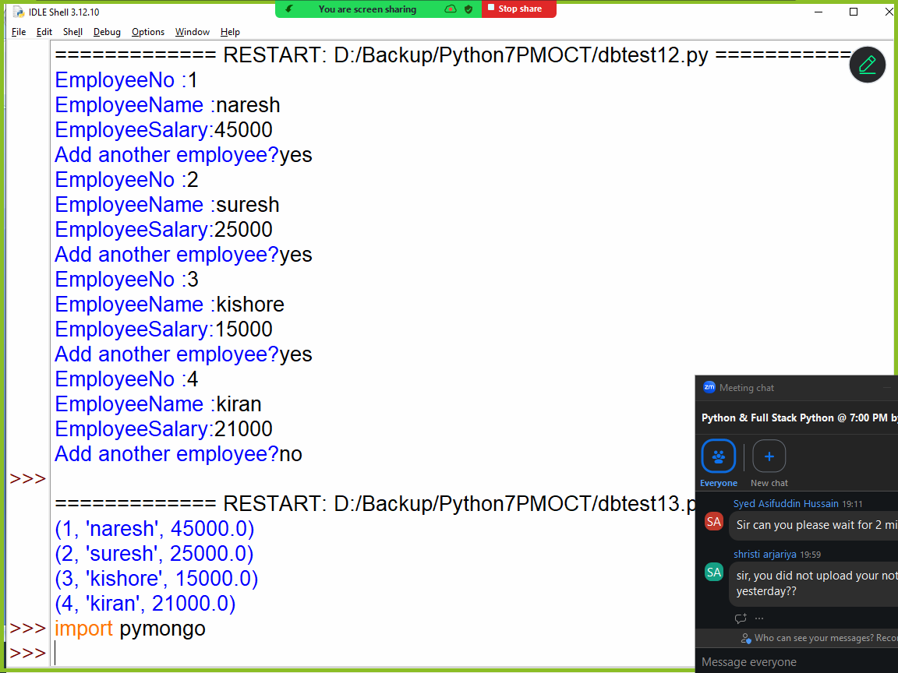

Example:
# Write a program to create database and collection (table) and insert data(document)

import pymongo
cn = pymongo.MongoClient("mongodb://localhost:27017/")
mydb = cn["database2"]
collection=mydb["student"]
collection.insert_one({'rollno':1,'name':'naresh','course':'python'})
collection.insert_one({'rollno':2,'name':'suresh','course':'java'})

Example:
# Write a program to insert multiple documents

import pymongo
cn = pymongo.MongoClient("mongodb://localhost:27017/")
mydb = cn["database2"]
collection=mydb["student"]
collection.insert_many([{'rollno':3,'name':'kiran','course':'c++'},
{'rollno':4,'name':'kishore','course':'c'}])
print("documents are inserted")

# Write a program to read data from mongodb collection(table)
import pymongo
cn = pymongo.MongoClient("mongodb://localhost:27017/")
mydb = cn["database2"]
collection=mydb["student"]
documents=collection.find()
print(documents)
for doc in documents:
print(doc['rollno'],doc['name'],doc['course'])

document=collection.find_one()
print(document)
document=collection.find_one({'rollno':2})
print(document)

Output
<pymongo.synchronous.cursor.Cursor object at 0x00000226FB379FA0>
1 naresh python
2 suresh java
3 kiran c++
4 kishore c
{'_id': ObjectId('698600fc60a7e45c6ac9f54e'), 'rollno': 1, 'name': 'naresh', 'course': 'python'}
{'_id': ObjectId('698600fc60a7e45c6ac9f54f'), 'rollno': 2, 'name': 'suresh', 'course': 'java'}

Example:
# Write a program to delete from mongodb collection(table)
import pymongo
cn = pymongo.MongoClient("mongodb://localhost:27017/")
mydb = cn["database2"]
collection=mydb["student"]
collection.delete_one({'rollno':2})
document=collection.find()
for s in document:
print(s['rollno'],s['name'],s['course'])

Output
1 naresh python
3 kiran c++
4 kishore c

# Write a program to update mongodb collection(table)
import pymongo
cn = pymongo.MongoClient("mongodb://localhost:27017/")
mydb = cn["database2"]
collection=mydb["student"]
old_stud={'course':'python'}
new_stud={'$set':{'course':'ds'}}
collection.update_one(old_stud,new_stud)
doc=collection.find()
for s in doc:
print(s['rollno'],s['name'],s['course'])

Output
1 naresh ds
3 kiran c++
4 kishore c
OS Module

“os” is a standard module of python, which comes with python software. Using “os” module functions python program is able to communicate with operating system.

Use of “OS” module
- Operating system environment (module path or path settings)
- Managing files and folders
  - Creating files
  - Deleting files
  - Renaming files
  - Creating folders
  - Copying files from one folder to another
  - Deleting folder
- Examine the files
- Finding properties of files
- Executing external applications
- Shutdown or restart

“os” stands for operating system
“os” module functions are operating system dependent.

os.name
The name of the operating system dependent module imported. The following names have currently been registered: 'posix', 'nt', 'java'.

Windows 🡪 nt
Unix 🡪 posix
Solaries 🡪 java

>>> import os
>>> os.name
'nt'

Working with files and directories

os.getcwd()
Return a string representing the current working directory.

>>> os.getcwd()
'C:\\Users\\Satish Gupta\\AppData\\Local\\Programs\\Python\\Python312'
>>> f=open("file1","w")

os.chdir(path)
Change the current working directory to path.

# Program to find current working directory and changing current working directory

import os

print(f'Current Working Directory {os.getcwd()}')
os.chdir("d:\\")
print(f'Current Working Directory {os.getcwd()}')
f=open("file1","w")

Output
Current Working Directory D:\Backup\Python7PMOCT
Current Working Directory d:\

os.mkdir(path)
Create a directory named path

# Write a program to create directory or folder

import os

fname=input("FolderName OR Directory Name to Create :")
try:
os.mkdir(fname)
print(f'{fname} Folder is created')
except OSError:
print(f'{fname} is Exists')

os.rmdir(path)
Remove (delete) the directory path. If the directory does not exist or is not empty, a FileNotFoundError or an OSError is raised respectively.

Example:
# Write a program to delete or remove directory or folder

import os

fname=input("Enter Folder Name to Delete ")
try:
os.rmdir(fname)
print("Folder Deleted")
except FileNotFoundError:
print("FolderName not Exists")
except OSError:
print("Folder is not empty")

Output
Enter Folder Name to Delete d:\\folder1
Folder Deleted

Enter Folder Name to Delete d:\\oracle23a
Folder is not empty

Enter Folder Name to Delete d:\\abc
FolderName not Exists

shutil.rmtree()
shutil module provided rmtree(), this function removes the complete directory tree

>>> import shutil
>>> shutil.rmtree("d:\\__pycache__")

This function removes or deletes non empty folders.

os.listdir(path='.')
Return a list containing the names of the entries in the directory given by path. The list is in arbitrary order, and does not include the special entries '.' and '..' even if they are present in the directory.

# Write a program to list the content of folder or directory

import os

fname=input("FolderName to List Content :")
try:
A=os.listdir(fname)
for name in A:
print(name)
except FileNotFoundError:
print("Folder Name not Exists")

output
FolderName to List Content :d:\
$RECYCLE.BIN
14-7-2025.pdf
Backup
Config.Msi
Downloads
DumpStack.log.tmp

os.rename(src, dst)
Rename the file or directory src to dst. If dst exists, the operation will fail with an OSError

# Write a program to rename a file
import os

try:
oldname=input("Old FileName :")
newname=input("New FileName :")
os.rename(oldname,newname)
print("File Renamed")
except OSError:
print("Unable to Rename File")

Output
Old FileName :d:\\file1.txt
New FileName :d:\\file9.txt
File Renamed

Old FileName :d:\\file9.txt
New FileName :d:\\file2.txt
Unable to Rename File

File examination functions
File examination functions are exists in os.path module

os.path.exists(path)
Return True if path refers to an existing path or an open file descriptor else return False.

# Write a program to find given filename exists or not

import os.path

fname=input("FileName to Find ")
if os.path.exists(fname):
print("FileName Found")
else:
print("FileName Not Found")

Output
FileName to Find d:\\file2.txt
FileName Found

FileName to Find d:\\file1.txt
FileName Not Found

os.path.isfile(path)
Return True if path is an existing regular file.

os.path.isdir(path)
Return True if path is an existing directory.

Example:
# Write a program to find given name is file or directory

import os.path
fname=input("Enter FileName or FolderName :")
if os.path.exists(fname):
if os.path.isfile(fname):
print(f'{fname} regular file')
else:
print(f'{fname} folder')
else:
print(f'{fname} not exists')

Output
Enter FileName or FolderName :d:\\file9.txt
d:\\file9.txt regular file

Enter FileName or FolderName :d:\\backup
d:\\backup folder

Example:
# Write a program to delete a file

import os.path
import os

fname=input("Enter FileName :")
if os.path.exists(fname):
if os.path.isfile(fname):
os.remove(fname)
print("File Deleted")
else:
print("Not a regular file")
else:
print("FileName not found")

Output
Enter FileName :d:\\file9.txt
File Deleted

Enter FileName :d:\\file9.txt
FileName not found

Example:
# Write a program to count files and folders exists in a given folder

import os
import os.path

fname=input("FolderName :")
if os.path.exists(fname):
if os.path.isdir(fname):
A=os.listdir(fname)
os.chdir(fname)
fc,dc=0,0
for name in A:
if os.path.isfile(name):
fc=fc+1
else:
dc=dc+1
print(f'File Count {fc}')
print(f'Directory Count {dc}')
else:
print("Given name not a folder")
else:
print("Given name is not exists")

Output
FolderName :d:\\backup
File Count 97
Directory Count 72

FolderName :d:\\backup\\python7pmoct
File Count 555
Directory Count 5

FolderName :d:\abc
Given name is not exists

os.system(command)
Execute the command (a string) in a subshell.
Execute external command or other windows applications from python program.

Example:
import os
os.system("calc")
os.system("mspaint")

How to shutdown,logout and restart operating system?

os.system(“shutdown /s /t 5”) 🡪 showdown operating system
os.system(“shutdown /r /t 10”) 🡪 Restart operating system
os.system(“shutdown /l /t 3”) 🡪 Logout from OS within 3 seconds

/s 🡪 shutdown
/r 🡪 Restart
/l 🡪 Logout
/t 🡪 Time

“re” module (OR) Regular Expressions module

What is regular expression?
Regular expression is a special string which define search pattern or match pattern.

Regular expressions are used for finding or searching given pattern within string.

Applications of regular expressions
In application development regular expressions are used,
- Input validations
  - Username validation
  - Password validation
  - Mobile number validation
  - Email validation
  - url validation
  - ip-address validation
  - domain name validation
  - ifsc code validation
- dividing string into tokens
- for developing parsers

To work with regular expressions python provided a standard module called “re”. This module comes with python software.
“re” module provides various functions to work with regular expressions.

The following functions provides by “re” module
- match()
- search()
- findall()
- fullmatch()
- split()
- replace()

re.match(pattern, string, flags=0)
If zero or more characters at the beginning of string match the regular expression pattern, return a corresponding Match. Return None if the string does not match the pattern;

re.search(pattern, string, flags=0)
Scan through string looking for the first location where the regular expression pattern produces a match, and return a corresponding Match. Return None if no position in the string matches the pattern;

re.fullmatch(pattern, string, flags=0)
If the whole string matches the regular expression pattern, return a corresponding Match. Return None if the string does not match the pattern;

re.findall(pattern, string, flags=0)
Return all non-overlapping matches of pattern in string, as a list of strings or tuples. The string is scanned left-to-right, and matches are returned in the order found. Empty matches are included in the result.
Regular expression is a special string which contains alphabets, digits and special characters which define pattern

Regular expression is prefix with r or R
The string which is prefix with r is called raw string or regular expression string.

The string which does not interprets escape sequences is called raw string.

>>> str1="python\njava"
>>> print(str1)
python
java
>>> str2=r"python\njava"
>>> print(str2)
python\njava

Example:
import re

str1="python programming"
m=re.match(r"py",str1)
print(m)
m=re.match(r'pr',str1)
print(m)
m=re.match(r'PY',str1)
print(m)
m=re.match(r'PY',str1,re.IGNORECASE)
print(m)

Output
<re.Match object; span=(0, 2), match='py'>
None
None
<re.Match object; span=(0, 2), match='py'>

Example:
import re

str1="python java python oracle mysql oracle"
m=re.search(r'oracle',str1)
print(m)
m=re.search(r'java',str1)
print(m)
m=re.search(r'mongodb',str1)
print(m)
m=re.search(r'JAVA',str1,re.I)
print(m)

Output
<re.Match object; span=(19, 25), match='oracle'>
<re.Match object; span=(7, 11), match='java'>
None
<re.Match object; span=(7, 11), match='java'>

Example:
import re

str1="python java python oracle mysql oracle"
A=re.findall(r'oracle',str1)
print(A)
B=re.findall(r'python',str1)
print(B)
C=re.findall(r'mongodb',str1)
print(C)

output
['oracle', 'oracle']
['python', 'python']
[]

Example:
import re

str1="python"
m=re.fullmatch(r'python',str1)
print(m)
m=re.fullmatch(r'jython',str1)
print(m)E

Output
<re.Match object; span=(0, 6), match='python'>
None

Special characters used for creating regular expression pattern
Each special character is having special meaning in regular expression pattern.

.
(Dot.) In the default mode, this matches any character except a newline. If the DOTALL flag has been specified, this matches any character including a newline.

Example:
import re

str1="programming python arjariya"
A=re.findall(r'm',str1)
print(A)
B=re.findall(r'.',str1)
print(B)
C=re.findall(r'p.',str1)
print(C)
D=re.findall(r'.r.',str1)
print(D)
E=re.findall(r'..',str1)
print(E)
F=re.findall(r'..o',str1)
print(F)
str2="python\njava\nc++"
G=re.findall(r'.',str2)
print(G)
H=re.findall(r'.',str2,re.DOTALL)
print(H)

Output
['m', 'm']
['p', 'r', 'o', 'g', 'r', 'a', 'm', 'm', 'i', 'n', 'g', ' ', 'p', 'y', 't', 'h', 'o', 'n', ' ', 'a', 'r', 'j', 'a', 'r', 'i', 'y', 'a']
['pr', 'py']
['pro', 'gra', 'arj', 'ari']
['pr', 'og', 'ra', 'mm', 'in', 'g ', 'py', 'th', 'on', ' a', 'rj', 'ar', 'iy']
['pro', 'tho']
['p', 'y', 't', 'h', 'o', 'n', 'j', 'a', 'v', 'a', 'c', '+', '+']
['p', 'y', 't', 'h', 'o', 'n', '\n', 'j', 'a', 'v', 'a', '\n', 'c', '+', '+']

^
(Caret.) Matches the start of the string, and in MULTILINE mode also matches immediately after each newline.

import re

names=['naresh','ramesh','kishore','rajesh','kiran']
for name in names:
m=re.search(r'^ra',name)
if m!=None:
print(name)

Output
ramesh
rajesh
kiran

$
Matches the end of the string or just before the newline at the end of the string, and in MULTILINE mode also matches before a newline

import re

names=['naresh','ramesh','kishore','rajesh','kiran']
for name in names:
m=re.search(r'sh$',name)
if m!=None:
print(name)

Output
naresh
ramesh
rajesh

*
Causes the resulting RE to match 0 or more repetitions of the preceding RE, as many repetitions as are possible. ab* will match ‘a’, ‘ab’, or ‘a’ followed by any number of ‘b’s.

import re

str1="ab abb abbb a acb"
A=re.findall(r'ab*',str1)
print(A)

Output
['ab', 'abb', 'abbb', 'a', 'a']

+
Causes the resulting RE to match 1 or more repetitions of the preceding RE. ab+ will match ‘a’ followed by any non-zero number of ‘b’s; it will not match just ‘a’.

Example:
import re

str1="ab abb abbb a acb"
A=re.findall(r'ab*',str1)
print(A)
B=re.findall(r'ab+',str1)
print(B)

Output
['ab', 'abb', 'abbb', 'a', 'a']
['ab', 'abb', 'abbb']

?
Causes the resulting RE to match 0 or 1 repetitions of the preceding RE. ab? will match either ‘a’ or ‘ab’.

Example:

import re

str1="ab abb abbb a acb"
A=re.findall(r'ab*',str1)
print(A)
B=re.findall(r'ab+',str1)
print(B)
C=re.findall(r'ab?',str1)
print(C)

Output
['ab', 'abb', 'abbb', 'a', 'a']
['ab', 'abb', 'abbb']
['ab', 'ab', 'ab', 'a', 'a']

{m}
Specifies that exactly m copies of the previous RE should be matched; fewer matches cause the entire RE not to match. For example, a{6} will match exactly six 'a' characters, but not five.

import re

str1="ab abb abbb a acb"
A=re.findall(r'ab*',str1)
print(A)
B=re.findall(r'ab+',str1)
print(B)
C=re.findall(r'ab?',str1)
print(C)
D=re.findall(r'ab{3}',str1)
print(D)

Output
['ab', 'abb', 'abbb', 'a', 'a']
['ab', 'abb', 'abbb']
['ab', 'ab', 'ab', 'a', 'a']
['abbb']

{m,n}
Causes the resulting RE to match from m to n repetitions of the preceding RE, attempting to match as many repetitions as possible. For example, a{3,5} will match from 3 to 5 'a' characters. Omitting m specifies a lower bound of zero, and omitting n specifies an infinite upper bound.

import re

str1="ab abb abbb a acb"
A=re.findall(r'ab*',str1)
print(A)
B=re.findall(r'ab+',str1)
print(B)
C=re.findall(r'ab?',str1)
print(C)
D=re.findall(r'ab{3}',str1)
print(D)
E=re.findall(r'ab{2,3}',str1)
print(E)

Output
['ab', 'abb', 'abbb', 'a', 'a']
['ab', 'abb', 'abbb']
['ab', 'ab', 'ab', 'a', 'a']
['abbb']
['abb', 'abbb']

[]
Used to indicate a set of characters. In a set:
- Characters can be listed individually, e.g. [amk] will match 'a', 'm', or 'k'.
- Ranges of characters can be indicated by giving two characters and separating them by a '-', for example [a-z] will match any lowercase ASCII letter, [0-5][0-9] will match all the two-digits numbers from 00 to 59, and [0-9A-Fa-f] will match any hexadecimal digit. If - is escaped (e.g. [a\-z]) or if it’s placed as the first or last character (e.g. [-a] or [a-]), it will match a literal '-'.
- Special characters except backslash lose their special meaning inside sets. For example, [(+*)] will match any of the literal characters '(', '+', '*', or ')'.

import re

names=['naresh','ramesh','kishore','rajesh','kiran','RAMESH']
for name in names:
m=re.search(r'^[nr]',name)
if m!=None:
print(name)

for name in names:
m=re.search(r'[en]$',name)
if m!=None:
print(name)

for name in names:
m=re.fullmatch(r'[a-z]+',name)
if m!=None:
print(name)

for name in names:
m=re.fullmatch(r'[A-Z]+',name)
if m!=None:
print(name)

Output
naresh
ramesh
rajesh
kishore
kiran
naresh
ramesh
kishore
rajesh
kiran
RAMESH

import re

str1="date joining 12-02-2026"
m=re.search(r'([0-9]{2})-([0-9]{2})-([0-9]{4})',str1)
print(m)
print(m.group(0))
print(m.group(1))
print(m.group(2))
print(m.group(3))

Output
<re.Match object; span=(13, 23), match='12-02-2026'>
12-02-2026
12
02
2026

Backslash characters or character classes

\b
Matches the empty string, but only at the beginning or end of a word. A word is defined as a sequence of word characters. Note that formally, \b is defined as the boundary between a \w and a \W character (or vice versa), or between \w and the beginning or end of the string. This means that r'\bat\b' matches 'at', 'at.', '(at)', and 'as at ay' but not 'attempt' or 'atlas'.

import re

str1="python programming cpython python. python;"

A=re.findall(r'\bpython\b',str1)
print(A)

Output
['python', 'python', 'python']

\B
Matches the empty string, but only when it is not at the beginning or end of a word. This means that r'at\B' matches 'athens', 'atom', 'attorney', but not 'at', 'at.', or 'at!'. \B is the opposite of \b

import re

str1="python programming cpython python. python;"

A=re.findall(r'\Bpython',str1)
print(A)

Output
['python']

\d
Matches any decimal digit in the ASCII character set; this is equivalent to [0-9].

import re

str1="python3.14"
A=re.findall(r'\d',str1)
print(A)
str2="current time is 12:45:20"
B=re.search(r'(\d{2}):(\d{2}):(\d{2})',str2)
print(B)
print(B.group(0))
print(B.group(1))
print(B.group(2))
print(B.group(3))

Output
['3', '1', '4']
<re.Match object; span=(16, 24), match='12:45:20'>
12:45:20
12
45
20
\D
Matches any character which is not a decimal digit. This is the opposite of \d.

import re

str1="python3.14"
A=re.findall(r'\D',str1)
print(A)

Output
['p', 'y', 't', 'h', 'o', 'n', '.']

\s
Matches characters considered whitespace in the ASCII character set; this is equivalent to [ \t\n\r\f\v].

import re

name=input("Enter Name ")
m=re.fullmatch(r'[a-z]+\s[a-z]+',name)
if m!=None:
print(name)
else:
print("invalid name")

Output

Enter Name rocky verma
rocky verma

Enter Name rocky
invalid name

\S
Matches any character which is not a whitespace character. This is the opposite of \s.

import re

str1="python\tjava\noracle c++"
A=re.split(r'\s',str1)
print(A)
B=re.findall(r'\S',str1)
print(B)
C=re.findall(r'\s',str1)
print(C)

Output
['python', 'java', 'oracle', 'c++']
['p', 'y', 't', 'h', 'o', 'n', 'j', 'a', 'v', 'a', 'o', 'r', 'a', 'c', 'l', 'e', 'c', '+', '+']
['\t', '\n', ' ']

\w
Matches [a-zA-Z0-9_] if the ASCII flag is used.

import re

uname=input("UserName :")
m=re.fullmatch(r'\w+',uname)
if m!=None:
print(uname)
else:
print("invalid")

UserName :naresh123
naresh123

UserName :n123$
Invalid

import re

email=input("EmailID:")
m=re.fullmatch(r'\w+@\w+\.\w{2,3}',email)
if m!=None:
print("valid")
else:
print("invalid")

output
EmailID:nareshit@nareshit.com
valid

EmailID:nareshit.com
Invalid

\W
Matches any character which is not a word character. This is the opposite of \w

import re

s="python$.3.14"
A=re.findall(r'\W',s)
print(A)
Networking (socket module)

Python is general purpose programming language. It allows developing different types of applications.
Python allows to develop networking enabled applications or networking applications.

What is networking?
Networking is logical or physical link between two or more devices.
Advantage of networking is sharing resources (hardware or software) and communication.

For developing networking application python provided a standard module (socket)

Basics of networking

What is ip-address?
In networking every device is identified with unique number called ip-address.

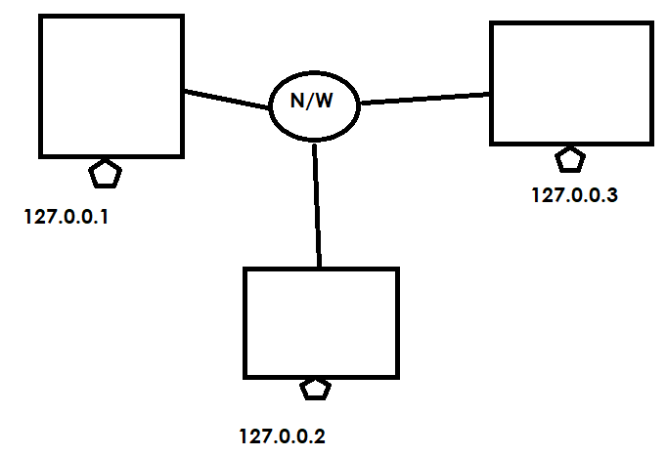

Networking application is having 2 programs
- Client
- Server

Client is a program which send/input data to server
Server is a program which receives input given by client, processes it and generates output (response).

What is protocol?
A protocol defines set of rules and regulations to exchange data between two applications.

- HTTP (Hyper Text Transfer Protocol)
- FTP (File Transfer Protocol)
- SMTP (Simple Object Mail transfer protocol)
- POP (Post Office Protocol)
- TCP (transmission control protocol)

What is portno?
Every server program is identified with one unique number called portno. Portno is integer value which range from 1 to 65535

What is a socket?
A socket is an end point communication between 2 programs
- Client
- Server

Client or server programs are implementation of sockets.

Network communication can be,
- Connection oriented (TCP 🡪 Transmission Control Protocol)
- Connection less (UDP 🡪 User Datagram Protocol)

In connection oriented communication, client program connect to server program. Server program must accept connection of client program.

In connection less communication client send data to server using packets (data+address).

Socket module provides predefined sockets for developing networking applications.

class socket.socket(family=AF_INET, type=SOCK_STREAM)
create socket object for communicating with client or server

type of socket
- SOCK_STREAM 🡪 TCP implementation or connection oriented
- SOCK_DGRAM 🡪 UDP implementation or connection less

Methods
socket.accept()
Accept a connection. The socket must be bound to an address and listening for connections.

socket.bind(address)
Bind the socket to address. The socket must not already be bound.

socket.close()
Mark the socket closed.

socket.connect(address)
Connect to a remote socket at address

socket.recv(bufsize[, flags])
Receive data from the socket. The return value is a bytes object representing the data received.

socket.send(bytes[, flags])
Send data to the socket. The socket must be connected to a remote socket.

Srever1.py
# Server Program
import socket

s=socket.socket()
s.bind(("127.0.0.1",60))
s.listen(5)
print("Server is running....")
s.accept()
print("Server Accepted connection of client")
s.close()

client1.py
#Client Program
import socket

s=socket.socket()
s.connect(("127.0.0.1",60))
s.close()

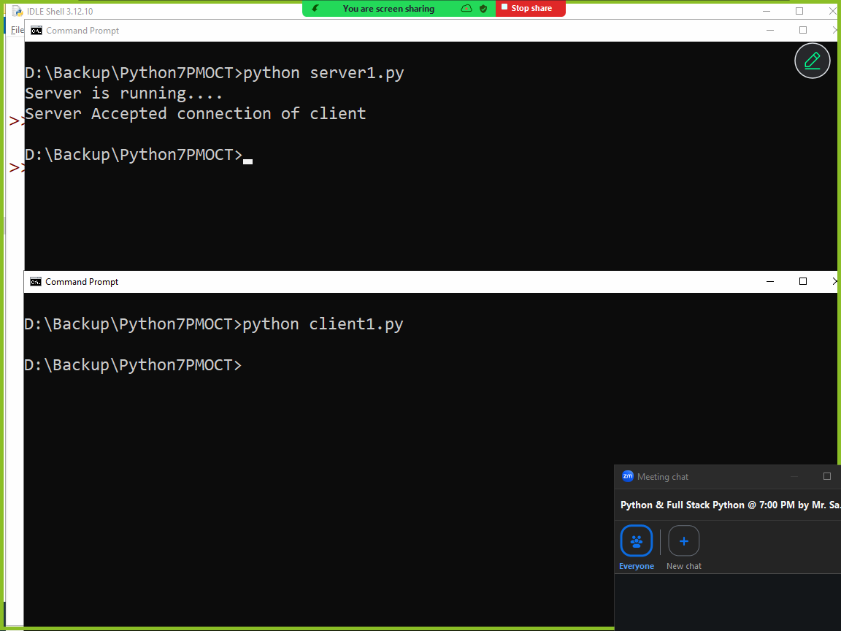

Server1.py
# Server Program
import socket

s=socket.socket()
s.bind(("127.0.0.1",60))
s.listen(5)
print("Server is running....")
t=s.accept()
print("Server Accepted connection of client")
c=t[0]
b=c.recv(1024)
msg=b.decode()
print(msg)
msg="Hello Client"
b=msg.encode()
c.send(b)
s.close()

Client1.py
#Client Program
import socket

s=socket.socket()
s.connect(("127.0.0.1",60))
message="Hello Server"
b=message.encode()
s.send(b)
b=s.recv(1024)
msg=b.decode()
print(msg)
s.close()
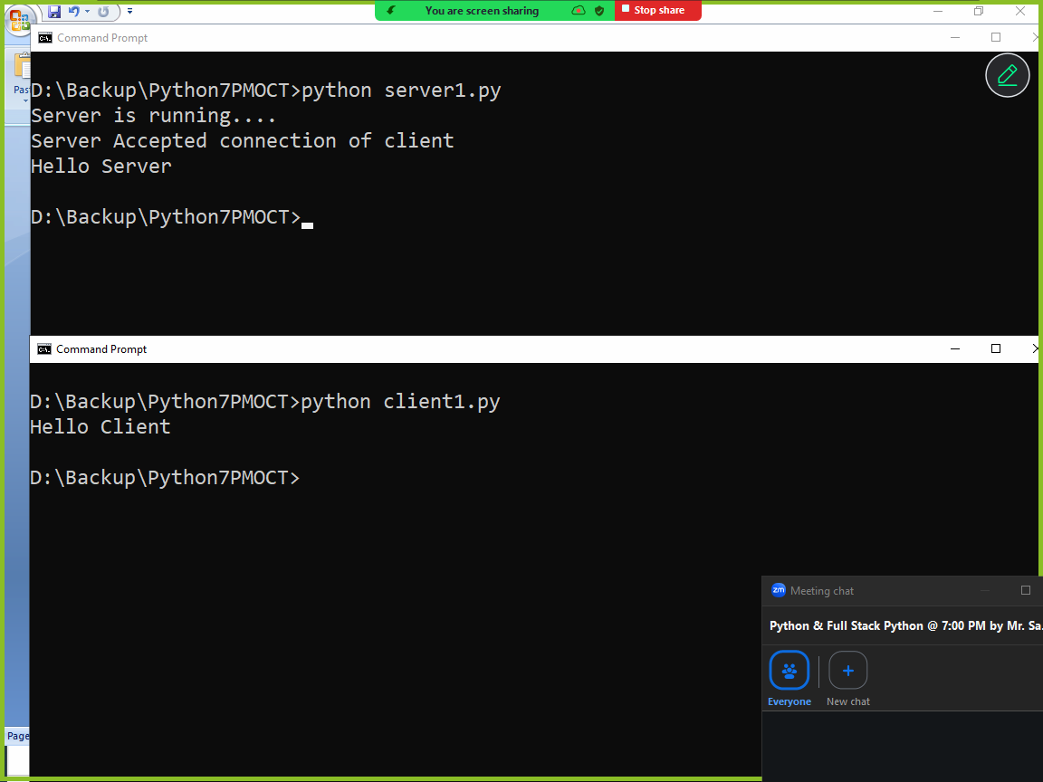

Resultserver.py
# Result Processing Server
import socket
marks={1:["naresh",50,60],
2:["suresh",70,80],
3:["ramesh",90,70],
4:["kishore",40,30],
5:["rajesh",20,90]}

s=socket.socket()
s.bind(("localhost",60))
s.listen(5)
print("Server is Running...")

while True:
t=s.accept()
c=t[0]
rollno=c.recv(1024)
rollno=int(rollno.decode())
if rollno in marks:
m=marks[rollno]
name,s1,s2=m
if s1<40 or s2<40:
result="Fail"
else:
result="Pass"

output=f''''Rollno:{rollno}
StudentName:{name}
Subject1Marks:{s1}
Subject2Marks:{s2}
Resut:{result}
Total:{s1+s2}'''
b=output.encode()
c.send(b)
else:
msg="Invalid Rollno"
b=msg.encode()
c.send(b)

studentclient.py
# student client program

import socket

s=socket.socket()
s.connect(("localhost",60))
rollno=input("Rollno :")
b=rollno.encode()
s.send(b)
b=s.recv(1024)
output=b.decode()
print(output)

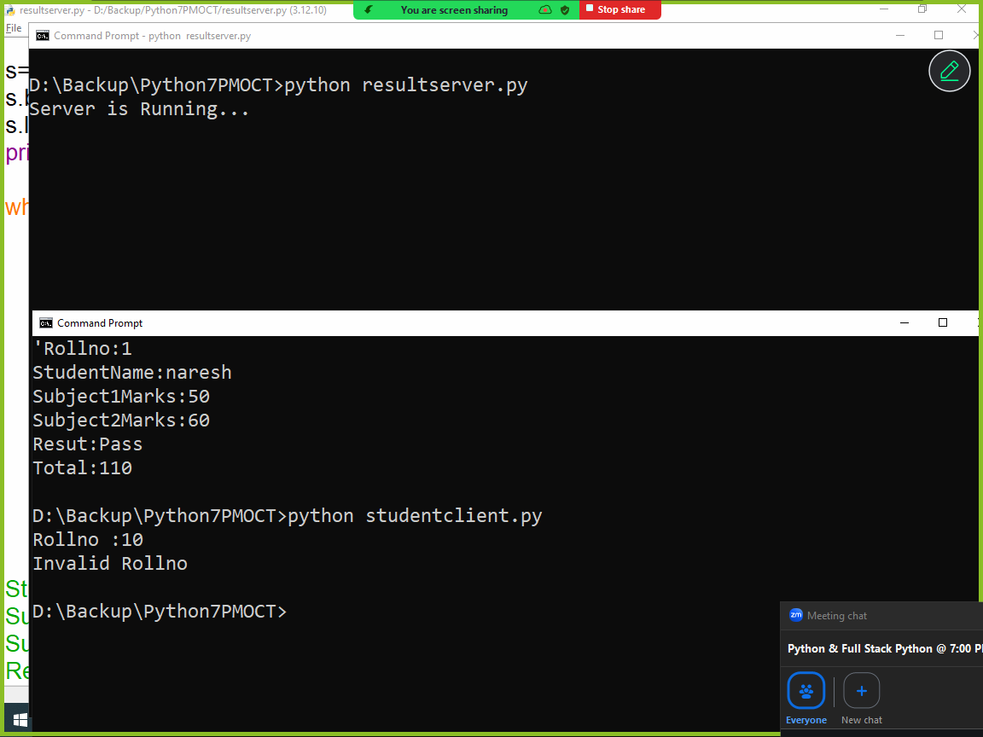

datetime module (OR) working with date and time data types

datetime module is a standard module which comes with python software. This module provides the following classes or data types to work with date and time

- date
- time
- datetime
- timedelta

date datatype
This data type or class represents date object.
Date object is created using 3 attributes
- day
- month
- year
date object is an immutable object, which cannot modified after creation.

Syntax: date(year,month,day)

Day value must be based numbers of day in given month.
Month value must >=1 and <=12
Year value must be 9999

If given values are not with given range it generates ValueError.

Example:
import datetime

d=datetime.date(2026,2,10)
print(d)
print(d.day)
print(d.month)
print(d.year)

Output
2026-02-10
10
2
2026

Datetime.date.today()

today() is static method date class, which returns current date or system date.

import datetime

d=datetime.date.today()
print(d)

time class or data type
This class or data type is used for represent time, which is independent of any particular day

Datetime.time(hour=0,minuts=0,seconds=0,millseconds=0)

Time object is immutable, after creating time changes cannot done

Example
import datetime

t1=datetime.time()
print(t1)
print(t1.hour)
print(t1.minute)
print(t1.second)

Output
00:00:00
0
0
0

datetime class or datatype
datetime class object represents date and time
A single object represents two objects (date and time)

Syntax: datetime.datetime(year,month,day,hour=0,second=0,minute=0)

>>> import datetime
>>> dt=datetime.datetime(2026,2,10)
>>> print(dt)
2026-02-10 00:00:00
>>> dt1=datetime.datetime(2026,2,10,8,40,57)
>>> print(dt1)
2026-02-10 08:40:57
>>> dt2=datetime.datetime.today()
>>> print(dt2)
2026-02-10 20:42:24.801424
>>> d1=dt2.date()
>>> t1=dt2.time()
>>> print(d1)
2026-02-10
>>> print(t1)
20:42:24.801424

timedelta class
timedelta represents the difference between two dates and times

>>> timedelta(days,weeks)

>>> d1=datetime.date.today()
>>> print(d1)
2026-02-10
>>> days=datetime.timedelta(days=5)
>>> d1=d1+days
>>> print(d1)
2026-02-15
>>> d1=d1-days
>>> print(d1)
2026-02-10
>>> m=datetime.timedelta(weeks=4)
>>> d1=d1+m
>>> print(m)
28 days, 0:00:00
>>> print(d1)
2026-03-10
>>> d1=d1-m
>>> print(d1)
2026-02-10
>>> y=datetime.timedelta(days=365)
>>> d1=d1+y
>>> print(d1)
2027-02-10
>>> d1=d1-y
>>> print(d1)
2026-02-10

Formatting date and time
Formatting date and time done using strftime() method of datetime

Directive | Meaning | Example
%a | Weekday as locale’s abbreviated name. | Sun, Mon, …, Sat (en_US);  So, Mo, …, Sa (de_DE)
%A | Weekday as locale’s full name. | Sunday, Monday, …, Saturday (en_US);  Sonntag, Montag, …, Samstag (de_DE)
%w | Weekday as a decimal number, where 0 is Sunday and 6 is Saturday. | 0, 1, …, 6
%d | Day of the month as a zero-padded decimal number. | 01, 02, …, 31
%b | Month as locale’s abbreviated name. | Jan, Feb, …, Dec (en_US);  Jan, Feb, …, Dez (de_DE)
%B | Month as locale’s full name. | January, February, …, December (en_US);  Januar, Februar, …, Dezember (de_DE)
%m | Month as a zero-padded decimal number. | 01, 02, …, 12
%y | Year without century as a zero-padded decimal number. | 00, 01, …, 99
%Y | Year with century as a decimal number. | 0001, 0002, …, 2013, 2014, …, 9998, 9999
%H | Hour (24-hour clock) as a zero-padded decimal number. | 00, 01, …, 23
%I | Hour (12-hour clock) as a zero-padded decimal number. | 01, 02, …, 12
%p | Locale’s equivalent of either AM or PM. | AM, PM (en_US);  am, pm (de_DE)
%M | Minute as a zero-padded decimal number. | 00, 01, …, 59
%S | Second as a zero-padded decimal number. | 00, 01, …, 59
%f | Microsecond as a decimal number, zero-padded to 6 digits. | 000000, 000001, …, 999999
%z | UTC offset in the form ±HHMM[SS[.ffffff]] (empty string if the object is naive). | (empty), +0000, -0400, +1030, +063415, -030712.345216
%Z | Time zone name (empty string if the object is naive). | (empty), UTC, GMT
%j | Day of the year as a zero-padded decimal number. | 001, 002, …, 366
%U | Week number of the year (Sunday as the first day of the week) as a zero-padded decimal number. All days in a new year preceding the first Sunday are considered to be in week 0. | 00, 01, …, 53
%W | Week number of the year (Monday as the first day of the week) as a zero-padded decimal number. All days in a new year preceding the first Monday are considered to be in week 0. | 00, 01, …, 53
%c | Locale’s appropriate date and time representation. | Tue Aug 16 21:30:00 1988 (en_US);  Di 16 Aug 21:30:00 1988 (de_DE)
%x | Locale’s appropriate date representation. | 08/16/88 (None);  08/16/1988 (en_US);  16.08.1988 (de_DE)
%X | Locale’s appropriate time representation. | 21:30:00 (en_US);  21:30:00 (de_DE)
%% | A literal '%' character. | %

Example:
import datetime

dt=datetime.datetime.today()
print(dt.strftime("%d"))
print(dt.strftime("%a"))
print(dt.strftime("%A"))
print(dt.strftime("%d %A"))
print(dt.strftime("%m"))
print(dt.strftime("%b"))
print(dt.strftime("%B"))
print(dt.strftime("%d %a %B"))
print(dt.strftime("%y"))
print(dt.strftime("%Y"))
print(dt.strftime("%d %B %A %Y"))
print(dt.strftime("%H"))
print(dt.strftime("%M"))
print(dt.strftime("%S"))
print(dt.strftime("%H:%M:%S"))
print(dt.strftime("%I:%M:%S %p"))
print(dt.strftime("%j"))
print(dt.strftime("%U"))
print(dt.strftime("%c"))
print(dt.strftime("%x"))

Output
10
Tue
Tuesday
10 Tuesday
02
Feb
February
10 Tue February
26
2026
10 February Tuesday 2026
20
58
47
20:58:47
08:58:47 PM
041
06
Tue Feb 10 20:58:47 2026
02/10/26
Multithreading (threading module)

Types of applications
- Single tasking applications
- Multitasking applications

Task is nothing but an operation performed by application.

Single tasking applications
An application or program allows to perform single operation at a time is called single task application.

Default flow of execution of program is sequential

def task1():
print("this is task1")

def task2():
print("this is task2")

def task3():
print("this is task3")

task1()
task2()
task3()

Output
this is task1
this is task2
this is task3

until execution of one task, it cannot call another task

Multitasking application
An application which allows to perform more than task or operation simultaneously or concurrently is called multitasking application.

Advantage of multitasking applications
- Efficiency
- Utilization of CPU idle time

These multitasking applications are developed using thread concept.
In multitasking application each task is defined as thread (OR) each operation represented as thread.

What is thread?
A thread is independent part of execution within program
A thread perform operation independent of other operations or threads
Execution of more than one thread simultaneously or concurrently is called multithreading

How to create a thread?
For creating or working threads, python provided a default module called threading. Threading module provides infrastructure for building or creating threads.

In python threads are created in 2 ways
- Function based thread
- Class based thread

For developing threads, threading module provided Thread class.

Function based thread
A thread can be created using function.
Basic steps for developing function based threads
- Create a function
- Create Thread class object with target as created function
- Start the thread
Example:
import threading
def even():
for num in range(1,21):
if num%2==0:
print(f'EvenNo:{num}')

def odd():
for num in range(1,21):
if num%2!=0:
print(f'OddNo:{num}')

t1=threading.Thread(target=even)
t2=threading.Thread(target=odd)
t1.start()
t2.start()

Output
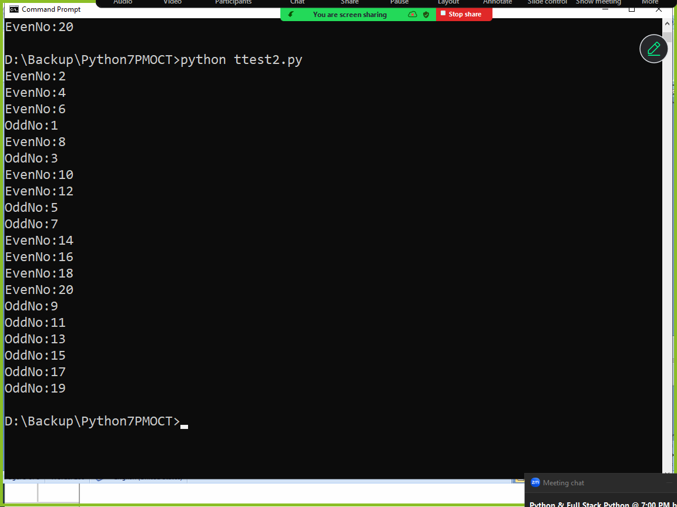

Thread scheduling is done by thread scheduler provided by python runtime (python virtual machine)

Types of thread schedulers
- Time Slicing
- Priority based
In time slicing every thread is given a predefined time
Thread executed using predefined time, after execution it schedule again by giving predefined time.

There will be context switching between one thread and another thread.

Example:
import threading
def even(x,y):
for num in range(x,y):
if num%2==0:
print(f'EvenNo:{num}')

def odd(x,y):
for num in range(x,y):
if num%2!=0:
print(f'OddNo:{num}')

t1=threading.Thread(target=even,args=(1,21))
t2=threading.Thread(target=odd,args=(1,21))
t1.start()
t2.start()

Output
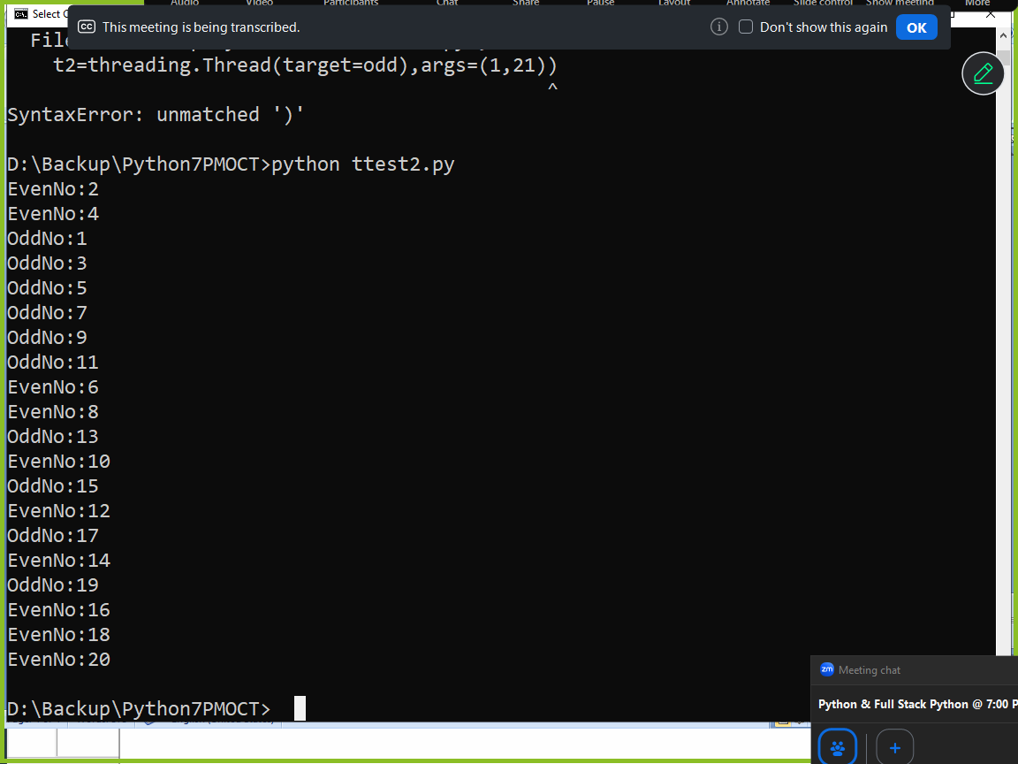

Example:
import threading
def even(x,y):
for num in range(x,y):
if num%2==0:
print(f'EvenNo:{num}')

def odd(x,y):
for num in range(x,y):
if num%2!=0:
print(f'OddNo:{num}')

t1=threading.Thread(target=even,kwargs={'x':1,'y':21})
t2=threading.Thread(target=odd,kwargs={'x':1,'y':21})
t1.start()
t2.start()

Output
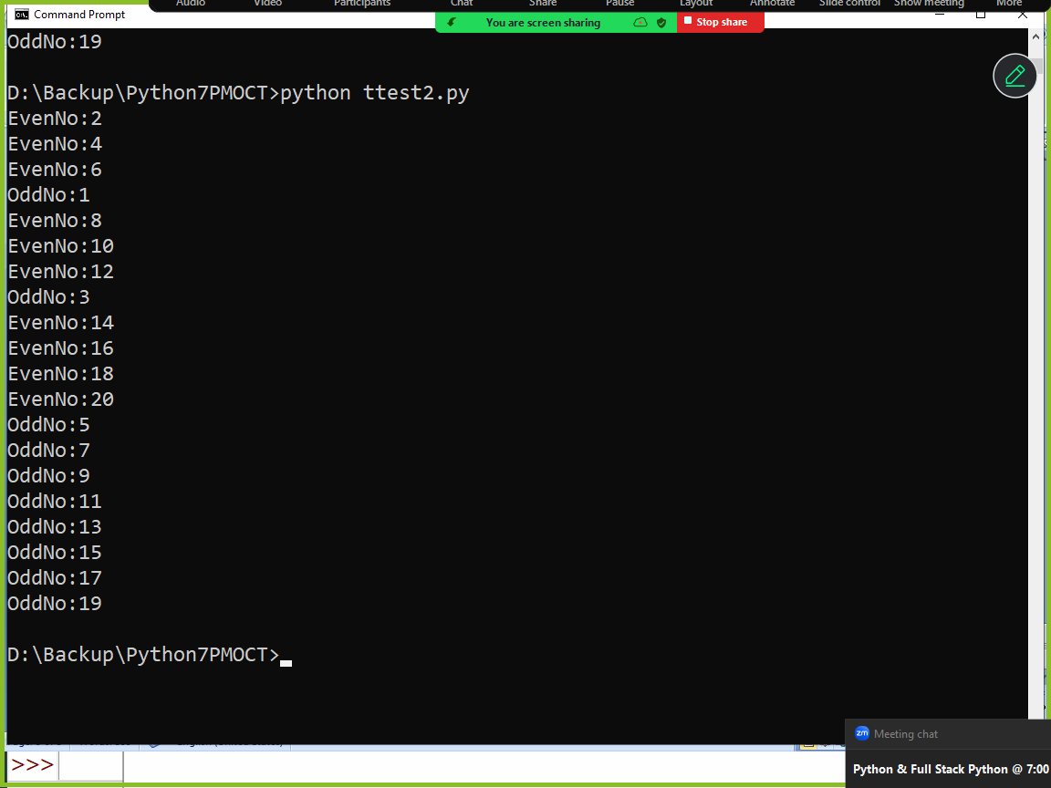

Class based thread
A thread can be developed using class (object oriented programming)

Basic steps for creating class based thread
- Develop a class by inheriting Thread class
- Override run() method of Thread class, which contain the operation performed by thread
- Create object of sub class
- Start the thread

Example:
import threading

class EvenThread(threading.Thread):
def run(self):
for num in range(1,21):
if num%2==0:
print(f'EvenNo {num}')

class OddThread(threading.Thread):
def run(self):
for num in range(1,21):
if num%2!=0:
print(f'OddNo {num}')

t1=EvenThread()
t2=OddThread()
t1.start()
t2.start()

Output
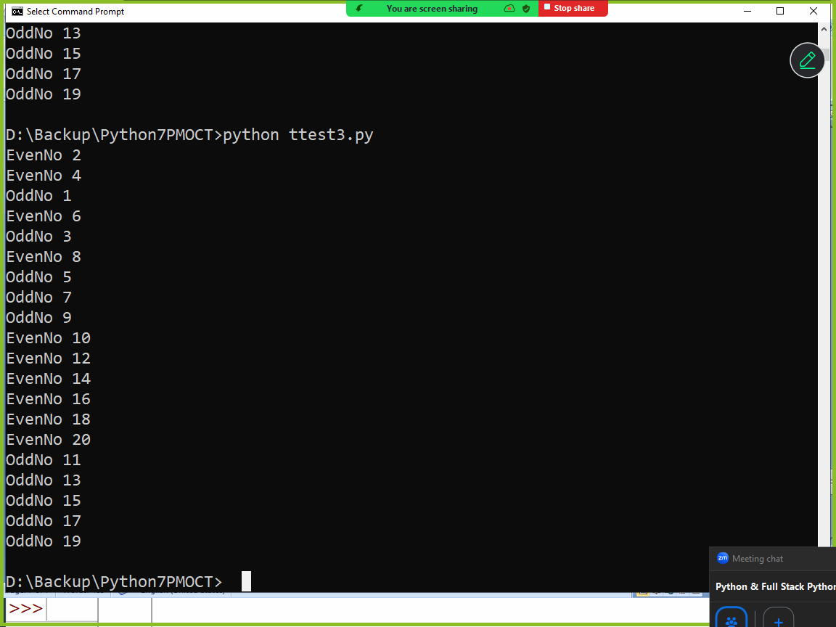

Life Cycle of Thread
Thread execution is managed by python runtime system and thread is having different stages or states

- New Born State
- Runnable State
- Running State
- Idle State
- Dead State

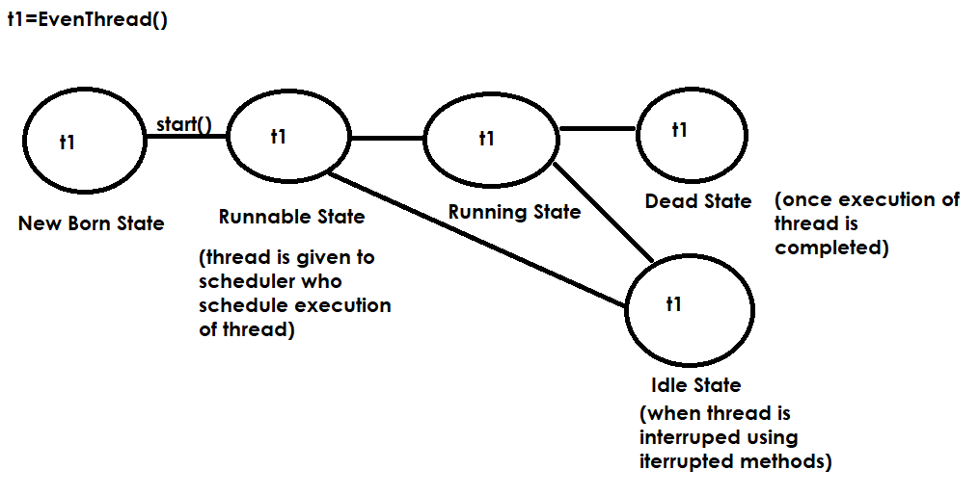

join()
join() method is interrupted method
if join method of thread is called, it waits until execution another thread is completed.
If thread1 calls join method of thread2, thread1 stops until thead2 execution is completed.

Note: every program is executed as one thread within PVM process.

Example:
import threading

t=threading.current_thread()
print(t.name)

Output
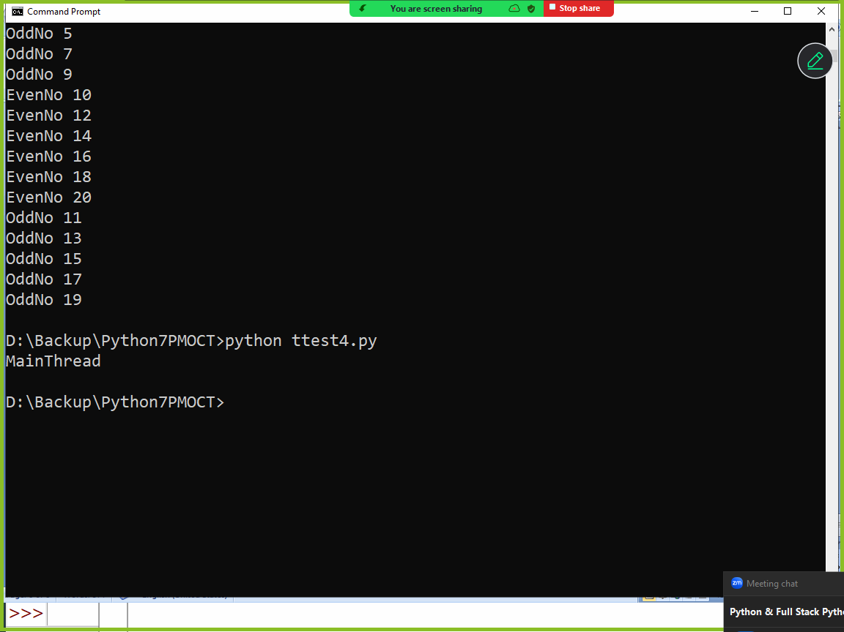

Example:
import threading

def hello():
for i in range(10):
print("Hello")

t1=threading.Thread(target=hello)
t1.start()
for j in range(10):
print("Bye")

Output
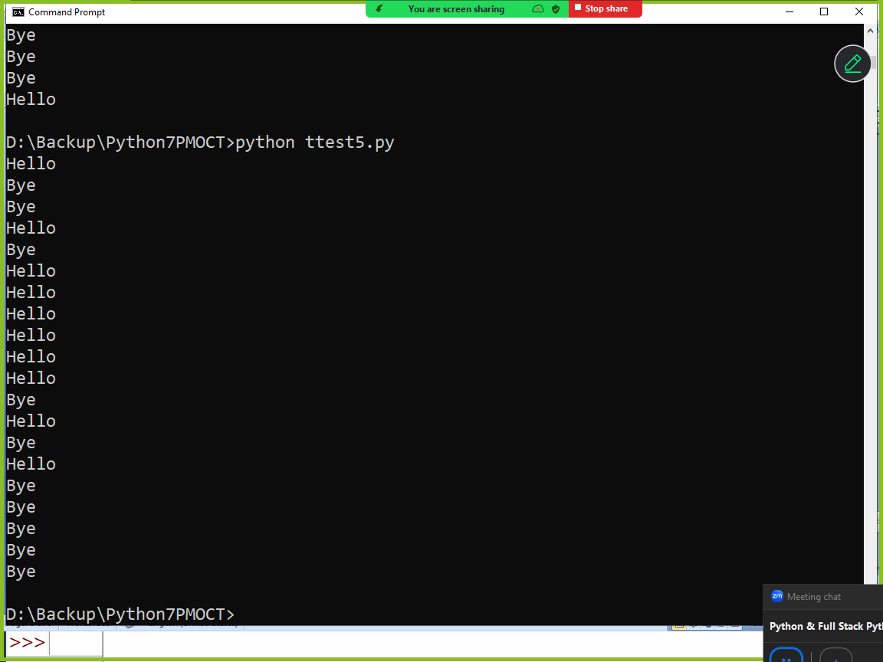

Example:
import threading

def hello():
for i in range(10):
print("Hello")

t1=threading.Thread(target=hello)
t1.start()
t1.join()
for j in range(10):
print("Bye")

Output
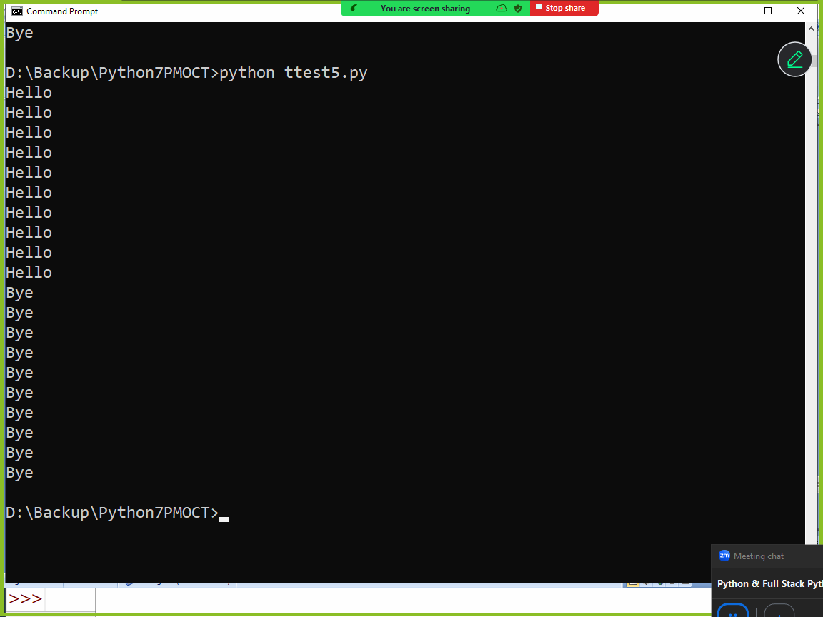

Example:
import threading

total=0
def sum_values():
global total
for num in range(1,1000):
total+=num

#MainThread
t1=threading.Thread(target=sum_values)
t1.start()
t1.join()
print(f'Total of 1-1000 numbers is {total}')

Output
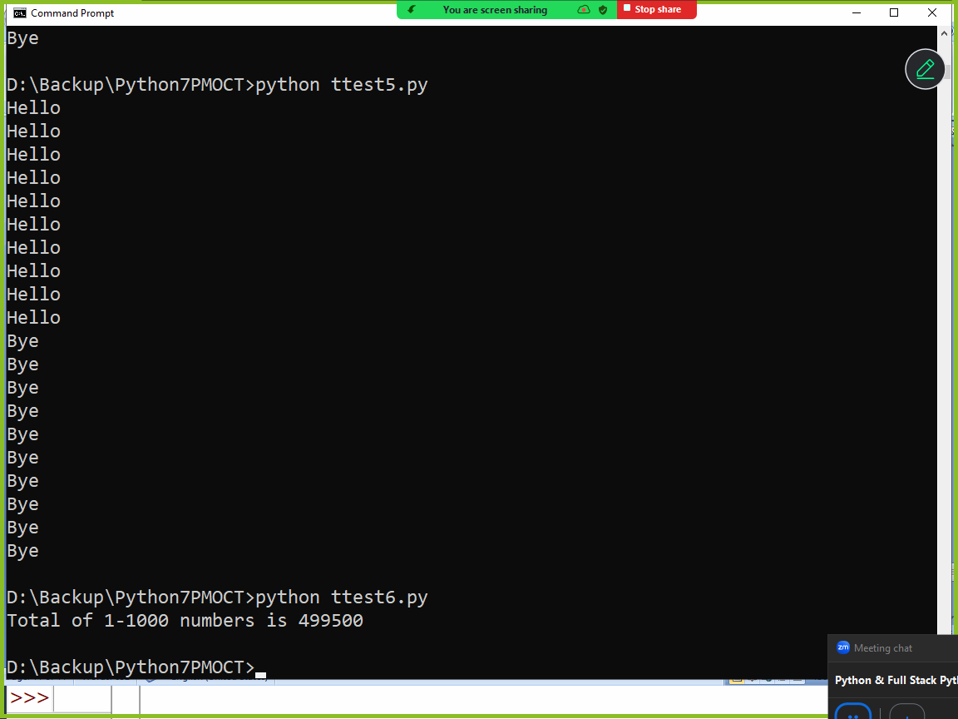

Thread Synchronization
In Python, thread synchronization is a mechanism used to coordinate the execution of multiple threads to ensure they do not interfere with each other when accessing shared resources.
Without synchronization, threads can experience race conditions, where the final outcome depends on the unpredictable timing of thread execution, often leading to data corruption or inconsistent results or wrong result.

Why Synchronization is Necessary
Prevent Race Conditions: Ensures that only one thread can modify shared data at a time.
Data Consistency: Coordinates access so threads don't read or write data in ways that lead to incorrect results.
Ordered Execution: Allows you to control the sequence in which certain tasks are completed.

Synchronization allows developing thread safe applications.
In python synchronization is done using Lock class or object

Lock class or object
Lock object provided 2 methods
- acquire()
- release()
A thread acquires lock and performs operations and releases lock using release method.
If a thread acquires the lock of object other threads cannot access lock, until this thread release the lock.

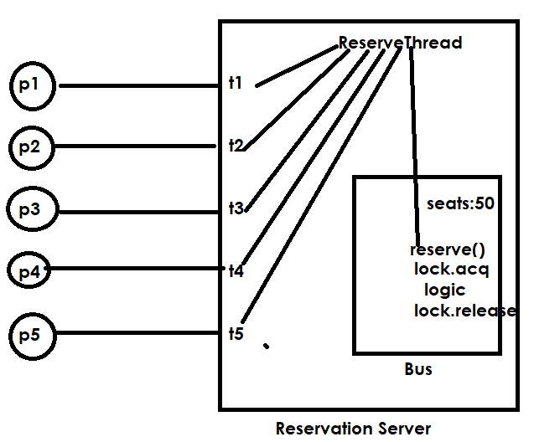

import threading
class Bus:
def __init__(self):
self.seats=50
self.l=threading.Lock()
def reserve(self,name,n):
self.l.acquire()
for i in range(n):
self.seats=self.seats-1
print(f'{name} your seats reserved available seats are {self.seats}')
self.l.release()

class ReserveThread(threading.Thread):
def __init__(self,b,name,s):
super().__init__()
self.bus=b
self.name=name
self.s=s
def run(self):
self.bus.reserve(self.name,self.s)

# Reservation Server
bus1=Bus()
t1=ReserveThread(bus1,"naresh",10)
t2=ReserveThread(bus1,"suresh",15)
t1.start()
t2.start()

Output
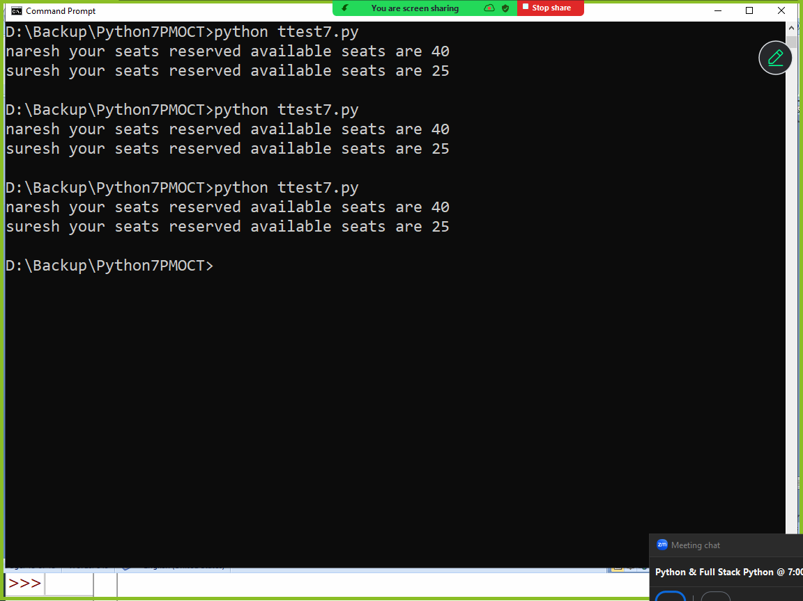

Garbage Collection
In python memory management is done automatically.
Memory management consist of 2 things
- Allocation of memory (Creating objects)
- De-allocation of memory (Deleting objects)

In python creating of objects done by python programmer
In python deleting of objects are not done by python programming, it is done a service provided by python called garbage collector

In python memory management or deleting of objects are done automatically.

Garbage collector works using a concept called reference count
Garbage collector removes or deletes all the objects whose reference count is zero.
An object whose reference count is zero is called unreferenced objects or unused objects.
An object bind with variable is called referenced object
An object which dose bind with any variable is called unreferenced and these objects are removed by garbage collector.

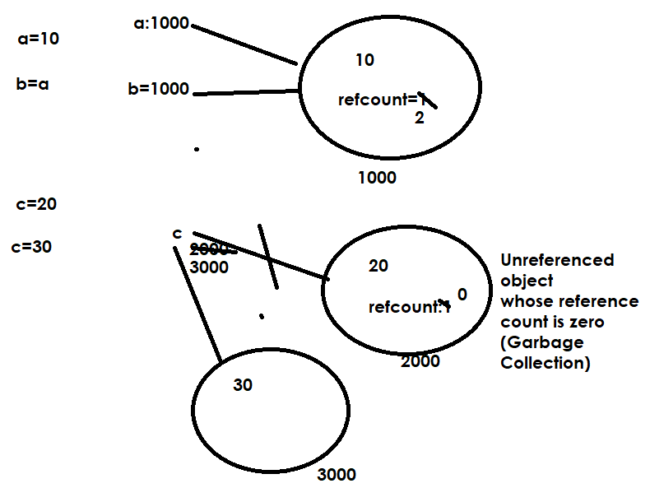

# Creating objects and finding reference count
import sys

class Employee:
def __init__(self,eno,en):
self.empno=eno
self.ename=en
print("Employee object is created")

emp1=Employee(1,"naresh")
emp2=Employee(2,"suresh")
emp3=emp1
c1=sys.getrefcount(emp1)
print(c1)
c2=sys.getrefcount(emp2)
print(c2)

Output
Employee object is created
Employee object is created
3
2

Example:
# Creating objects and finding reference count
import sys

class Employee:
def __init__(self,eno,en):
self.empno=eno
self.ename=en
print("Employee object is created")

emp1=Employee(1,"naresh")
emp2=Employee(2,"suresh")
emp3=emp1
c1=sys.getrefcount(emp1)
print(c1)
c2=sys.getrefcount(emp2)
print(c2)
emp1=None
emp2=None
emp3=None

Destructor
Destructor is a magic method which is executed automatically before object is deleted by garbage collector
The name of the destructor is __del__
Destructor is used to de-allocate resources allocated by constructor.

Example:
class Alpha():
def __init__(self):
print("Alpha object is created")
def __del__(self):
print("Alpha object is deleted")

a1=Alpha()
a2=Alpha()
a1=None
a2=None

Output
Alpha object is created
Alpha object is created
Alpha object is deleted
Alpha object is deleted

Example:
class Alpha():
def __init__(self):
print("Alpha object is created")
def __del__(self):
print("Alpha object is deleted")

def fun1():
a1=Alpha()
a2=Alpha()

fun1()

Output
Alpha object is created
Alpha object is created
Alpha object is deleted
Alpha object is deleted

Example:
class Alpha():
def __init__(self):
print("Alpha object is created")
def __del__(self):
print("Alpha object is deleted")

a1=Alpha()
a3=a1
a2=Alpha()
del a1
del a2

Output
Alpha object is created
Alpha object is created
Alpha object is deleted

pythonbygupta@gmail.com

